**STEP ONE** *(Add-In Manager)***:**

1. Open any new or existing ArcPro 2.x project,
2. Select ***Project>Add-In Manager>Options*** from the menu, and
3. Click the **Add Folder…** button.

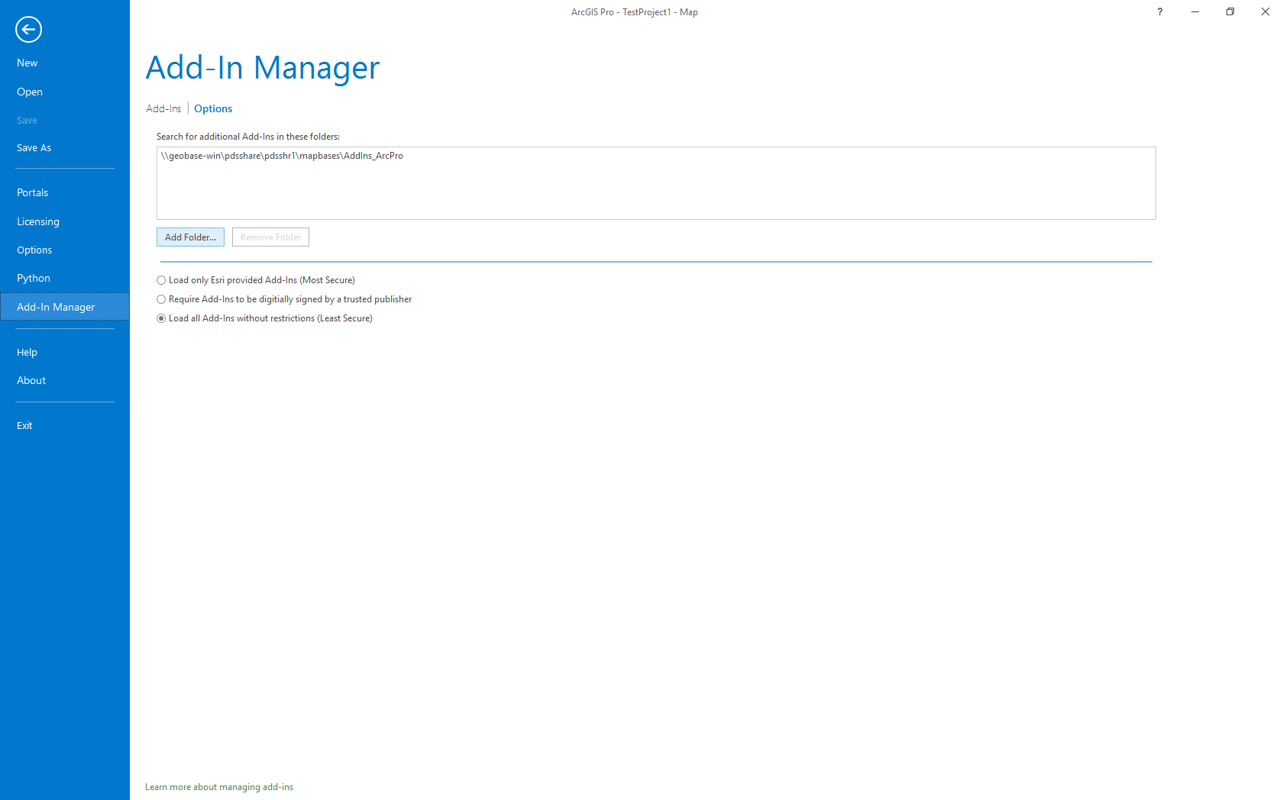

Leave the default option ‘*Load all Add-Ins without restriction (Least Secure)*’ enabled.

**STEP TWO** (*Add shared folder*):

1. Paste **\\geobase-win\pdsshare\pdsshr1\mapbases\** into **Select Folder** address box,
2. Select the **AddIns_ArcPro** folder, and
3. Click the **Select Folder** button.

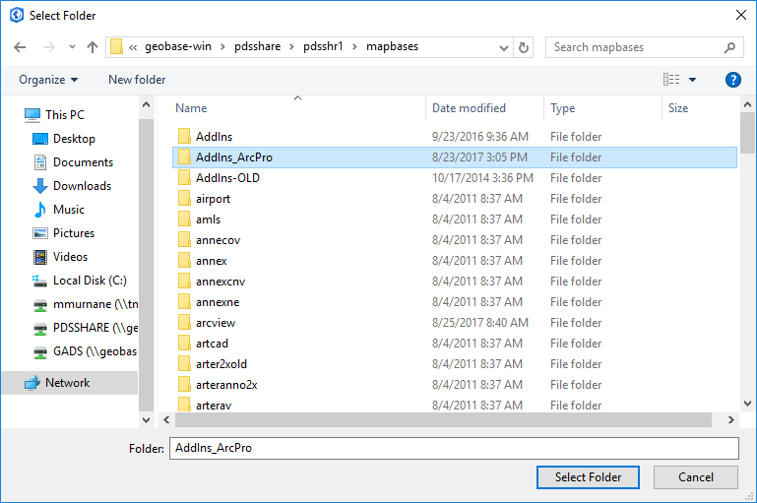

**STEP THREE** (*Use)*:

**MapsRUs_AddData** will appear in the list of Shared Add-Ins.

1. Use the back arrow to get to an active map,
2. Click the Add-In menu tab, and
3. Click the Add Data button to activate the Add Data Tool.

A:

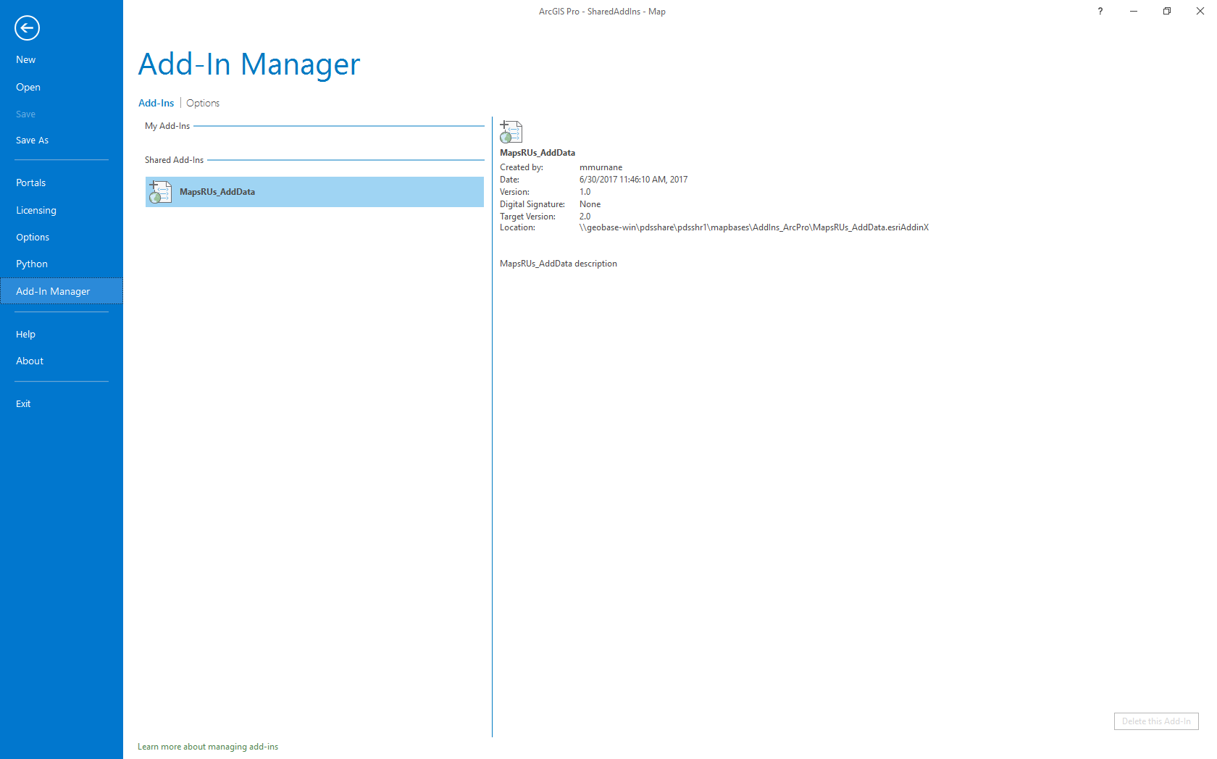

B:

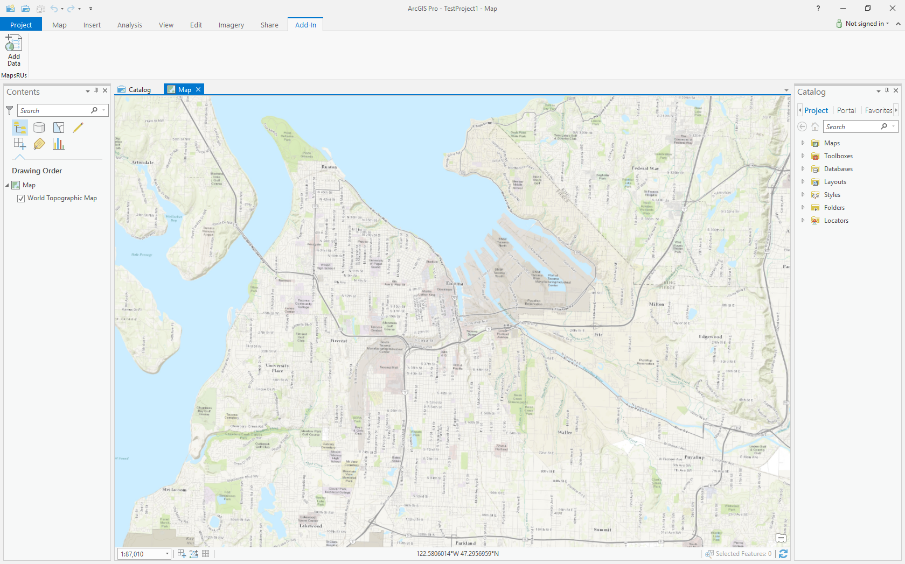

C:

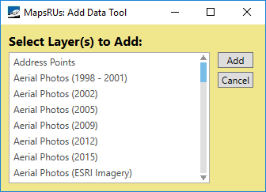

**ADDITIONAL ESRI HELP (Manage add-ins):**

<http://pro.arcgis.com/en/pro-app/get-started/manage-add-ins.htm>