# Lab #1: Week2: December 10, 2018

# GEOG 677: Internet GIS

# Student: Mike Murphy

## Part I - An Example of Internet GIS:

## Title: NORAD Tracks Santa: (<http://www.noradsanta.org>)

This application is hosted by the North American Aerospace Defense Command (NORAD) as a public relations site. (<https://www.cnn.com/2012/12/24/world/norad-santa-tracker/index.html>). The site actually started by accident in 1959, when local Colorado Springs newspapers encouraged kids to call a special number to determine the location of Santa Clause during his “Christmas Eve flights around the world.” The number posted unintentionally routed to NORAD. Instead of ignoring multiple kids’ requests, the commanders decided to service their request and give Santa’s location through the night.

This tradition continued through the years and is now predominantly via a website. This site is targeted for kids, starting at 6:00AM EST December 24 of any year, to track on a map Santa’s progress. The site generally keeps a whimsical animated theme throughout, and contains many online games, videos, and holiday references.

### NORAD Santa Tracker

But the main attraction of the site is only available for 24 hours of the year. This involves a web application showing a globe tracker. <https://cesiumjs.org/demos/noradtrackssanta/>

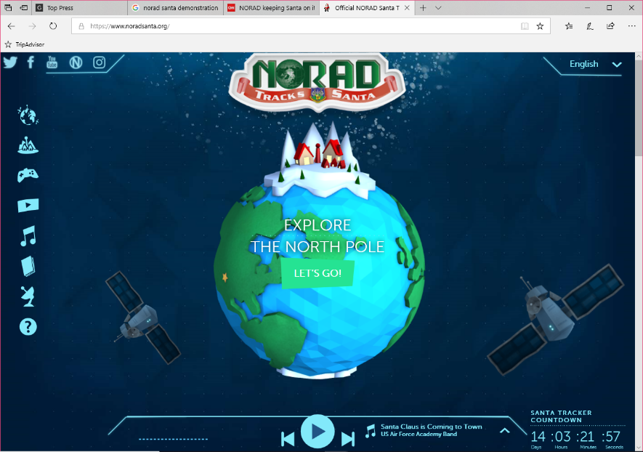

This component takes an artful rendition of Santa and his sleigh superimposed on a KML object. Over time, the sleigh object is fed into a server to track origins and destinations, with elapsed time between points. Each destination is “estimated” with the number of gifts delivered, and in some special destinations, a video is posted about Santa’s adventures at those locations. As Santa rides the night, the sleigh KML is shown moving over the globe with breadcrumb waypoints. Destinations have hyperlinks left behind with educational facts about them. In some special cases, these hyperlinks have special place markers and videos of “what NORAD has been tracking of Santa’s adventures.” (All this data is preset within a database and replayed over 24 hours. But do not tell this to younger kids, as this may spoil the magic!)

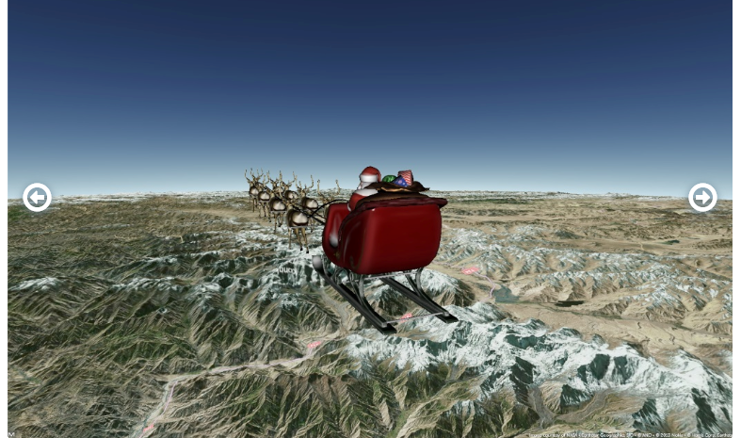

### Tracker Software Construct

The globe application is implemented with AGI CesiumJS component which has a Google Earth-like look-and-feel. The terrain and imagery is rendered to standard NASA SRTM, with terrain sampling at 1 arc second. The application (<https://cesium.com/blog/2013/12/23/building-a-webgl-santa-with-cesium-and-gltf/>) is built on a WebGL-based engine (<https://cesiumjs.org/>), with the sled and reindeer modeled in 3D with gITF (<https://www.khronos.org/gltf/>). GITF Described in: <https://youtu.be/l7TB1O51X_M>

