# Michael P Murphy

# GEOG677: Lab 4: WI19

# January 15, 2019

## Task 1: ArcGIS Enterprise Components

### Portal for ArcGIS

The ArcGIS Portal provides the main user and machine interface to the enterprise. The ArcGIS Portal is responsible for hosting all maps, services, and data layer access. The Portal provides the equivalent dashboard seen on ArcGIS Online. Services and layers managed by ArcGIS Server can be configured for access in ArcGIS Portal. This process is called “federating”, and together with ArcGIS Server, this creates a “hosting server”. Federating makes these assets available both publicly and throughout the enterprise, governed by access roles.

### ArcGIS Server

The ArcGIS Server manages the base applications which provide GIS processing, analysis, data access, security, and workflows. It is the server which transforms the data stores into maps, processing services, and analytic tools. ArcGIS Server also provides advance application services to manage large volume imagery (Image), large volume vector (GeoAnalytics), real time event data (GeoEvents) and business intelligence (Business Analyst). When configured in tandem with an existing role-based access control system, ArcGIS Server can automatically geo-enable applications, provide locational analysis to an existing infrastructure, and control full access to locational content, based on existing or new roles. When the ArcGIS Server is “federated” with the ArcGIS Portal, these product assets become available throughout an enterprise and public.

### ArcGIS Data Store

The ArcGIS Data Store provides the direct data management layer for the enterprise. The data store can be configured to manage geodata in relational databases, provide image tiling, and manage spatiotemporal data, via big data or noSQL systems. This layer provides all the data abstract ArcGIS Server requires for all processing described above, as well as managing the scaling and/or load balancing of the data access.

### ArcGIS Web Adaptor

The Web Adapter acts as a domain controller for the Portal(s) configured in the enterprise. The Web Adapter manages all access points to the enterprise from public systems and users, as well as balancing network traffic throughout the system. While the ArcGIS Server provides the Roles and rules for access, it is the Web Adapter managing the authentication of each external request.

## Task 2: Seattle, Washington GIS Infrastructure Proposal

### System Description

The new systems shall be an ArcGIS Enterprise implementation, reusing an existing network configuration. The ArcGIS Portal shall be used to host both existing data layers, as well as new data created by the Data Editors. Data viewing by the public shall be performed by WebApps and Story Map. Data viewing and access by city analysts shall be performed via WebApps, as well as direct access to ArcGIS Portal. Field collection shall be performed via interface between ArcGIS Workforce and ArcGIS Portal, brokering synchronization of changes through ArcSDE Versioning with Workforce. All applications shall be brokered via ArcGIS Servers, with direct connections to an ArcGIS Datastore. ArcGIS Server shall also implement Image Server to manage the city base mapping and caching. The data shall be stored in both relational databases and tile cache system. The vector data products shall also require a Big Data Storage, in this implementation to use Hadoop File System, as well as GeoAnalytics Server implemented on one of the ArcGIS Servers.

The system shall implement three user groups within the enterprise Active Directory. A Data Editor (DE) group is given full read, write, create access to all the data layers in ArcGIS Enterprise. A Data Consumer (DC) is given read only access to all data layers in ArcGIS Enterprise. A Public Viewer (PV) shall be given read access but only to Map Layers to be hosted on web apps. All existing groups accessing data shall be added to one of these three groups.

### System Architecture

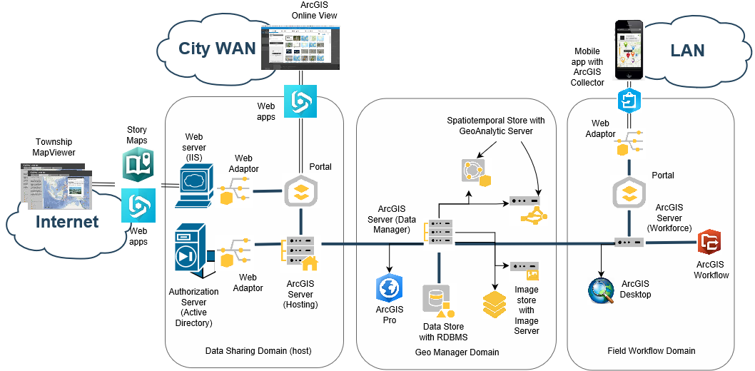

The initial system shall implement three Server domains:

1. Data Sharing Domain: This domain shall manage all data product viewing outside the GIS organization, including public viewing. This server shall be the hosting server, the web server, as well as the direct connect to the authorization (Active directory) server. Authentication is performed from the Web Adapter interface with the Portal.
2. Geo Manager Domain: This domain shall manage all data product editing. This node shall also manage all Data Stores (Spatiotemporal, tile cache, and RDBMS-Oracle).
3. Field Workflow Domain: This domain shall manage the workflow of daily field collection activities. Data Editors managing field data shall deploy ArcGIS Desktop, where field teams shall deploy ArcGIS Collector on mobile devices. Authentication is performed from the Web Adapter interface with the Portal.

### Software Components Required

1. Data Sharing Domain: ArcGIS Server, Portal, Web Adaptor, Web Apps, Story Maps, (existing) Active Directory, (existing) IIS Web Server.
2. Geo Manager Domain: ArcGIS Server, GeoAnalytic Server, Spatiotemporal Data Store, Image Server, Tile Cache, RDBMS Data Store (Oracle), ArcGIS Pro
3. Field Workflow Domain: ArcGIS Server, Portal, Web Adaptor, Workforce, Collector, ArcGIS Desktop

### New Requirements Execution

* **Create internal user/department groups where internal users can share content and maps between users and departments**: Given the groups defined above, departments may be added to the DC group. As data comes on line, they can be shared to an organization or to DC.
* **Create different web viewers per department showing data pertaining to that department**: Each department may receive a view within ArcGIS Portal, and are ion the DC group. If specialized data viewing tools needed, then a WebApp for a department may be created.
* **Edit and publish data for both current and new GIS data layers:** The Geo Manager Domain exists for those managing existing layers as well as the creation of new layers. Data will be published via the Portal
* **Replace the Adobe Flex MapViewer with a modern web GIS technology**: Data hosted on Portal data layers. Public data viewing may be performed via WebApps, by custom applications ingesting Portal data layers, and/or Story Maps. Existing Township MapViewer reimplemented with WebAppBuilder.
* **Collect Mobile Data from the field**: ArcGIS Workforce with ArcGIS Collector shall be deployed to a field team, where field workforce managers with ArcGIS Desktop will manage the integration of new field data to the enterprise.
* **Build Information products to share with the public users**: Data created by the Geo Manager Domain may be automatically hosted on Portal, via federation to its ArcGIS Server. From the Portal , data may be viewed via WebApps, by custom applications ingesting Portal data layers, and/or Story Maps.

### Implementation Timeline

Each Domain shall require 1 week for implementation of the ArcGIS components, for 3 weeks base deployment. Initial ArcGIS Workforce shall take about 1 week to setup for all clients, and to configure an initial workflow. Web server, role creation, and Active Directory integration shall take 2 days given the existing system. Migration of existing data to usable layers should take about 1 week. Reimplementing Township Mapview should take about 1 week. The system is ready for further custom apps and layers. Total setup time level of effort is about 6 ½ weeks.

### Legacy System Migration Plan

Tasks will include upgrading ArcGIS server nodes, (and likely adding one), upgrading ArcGIS Desktops. Also, will deploying new Portal nodes, Web Adaptors, Spatiotemporal stores, ArcGIS Pro nodes, ArcGIS Workforce server, and ArcGIS Collector mobile apps. Existing data layers shall be ported from ArcGIS Server 10.2 to new Portal 10.6. Existing network roles shall be integrated with new Geodata roles (described above). Applications using web services for data connect transfer to new Portal/Web Adaptor domains.