WHERE ARE AUSTRALIA'S NEXT
COMMUNITY CRICKETERS?
A Data-Driven Analysis of Community Cricket Participation Growth Opportunities Across Australia
Final Analytical Report
Prepared by Md Musa
August 2026
PORTFOLIO / APPLICATION PROTOTYPE
Important interpretation boundary
This report identifies relative demographic Opportunity Potential for community cricket acquisition. It does not directly measure cricket demand, participation penetration, or Cricket System Readiness.

Executive Summary
Purpose. This project asks a practical participation-strategy question: which Australian communities warrant deeper investigation for future community cricket acquisition, and what evidence should determine the appropriate response?
Approach. Using Australian Bureau of Statistics population, age/sex and socioeconomic data, Cricket Australia strategy and participation context, state cricket evidence and local case-study sources, the project builds a transparent LGA-level Community Cricket Opportunity Potential model. The model deliberately separates demographic opportunity from Cricket System Readiness.
Headline finding
The strongest demographic growth signals are concentrated in a small number of metropolitan growth systems. The top 20 LGAs for absolute growth in the 5-14 population added 106,387 children between 2019 and 2024; 94.6% of that Top-20 increase was concentrated in four broad growth systems: outer Melbourne, western/south-west Sydney, South East Queensland and the Perth growth belt.

Key findings
- Market size, youth concentration and junior growth provide distinct information. Raw total population, junior population and girls' junior population are too highly correlated to be weighted independently.
- The balanced Model V1 ranks Wyndham, Melton, Blacktown, Ipswich, Camden, Casey, Logan, Hume and The Hills among the strongest demographic opportunity areas nationally.
- The Top 20 is highly stable under alternative weighting scenarios and reasonable eligibility thresholds, indicating that the shortlist is not an artefact of one arbitrary specification.
- External case studies support different management responses: Blacktown shows a plausible capacity-gap pattern; Ipswich shows growth alongside new capacity; Armadale requires stronger participation validation before scaling.
- The recommended national decision process is: Opportunity screening -> Readiness diagnosis -> Problem classification -> Intervention -> Outcome measurement.
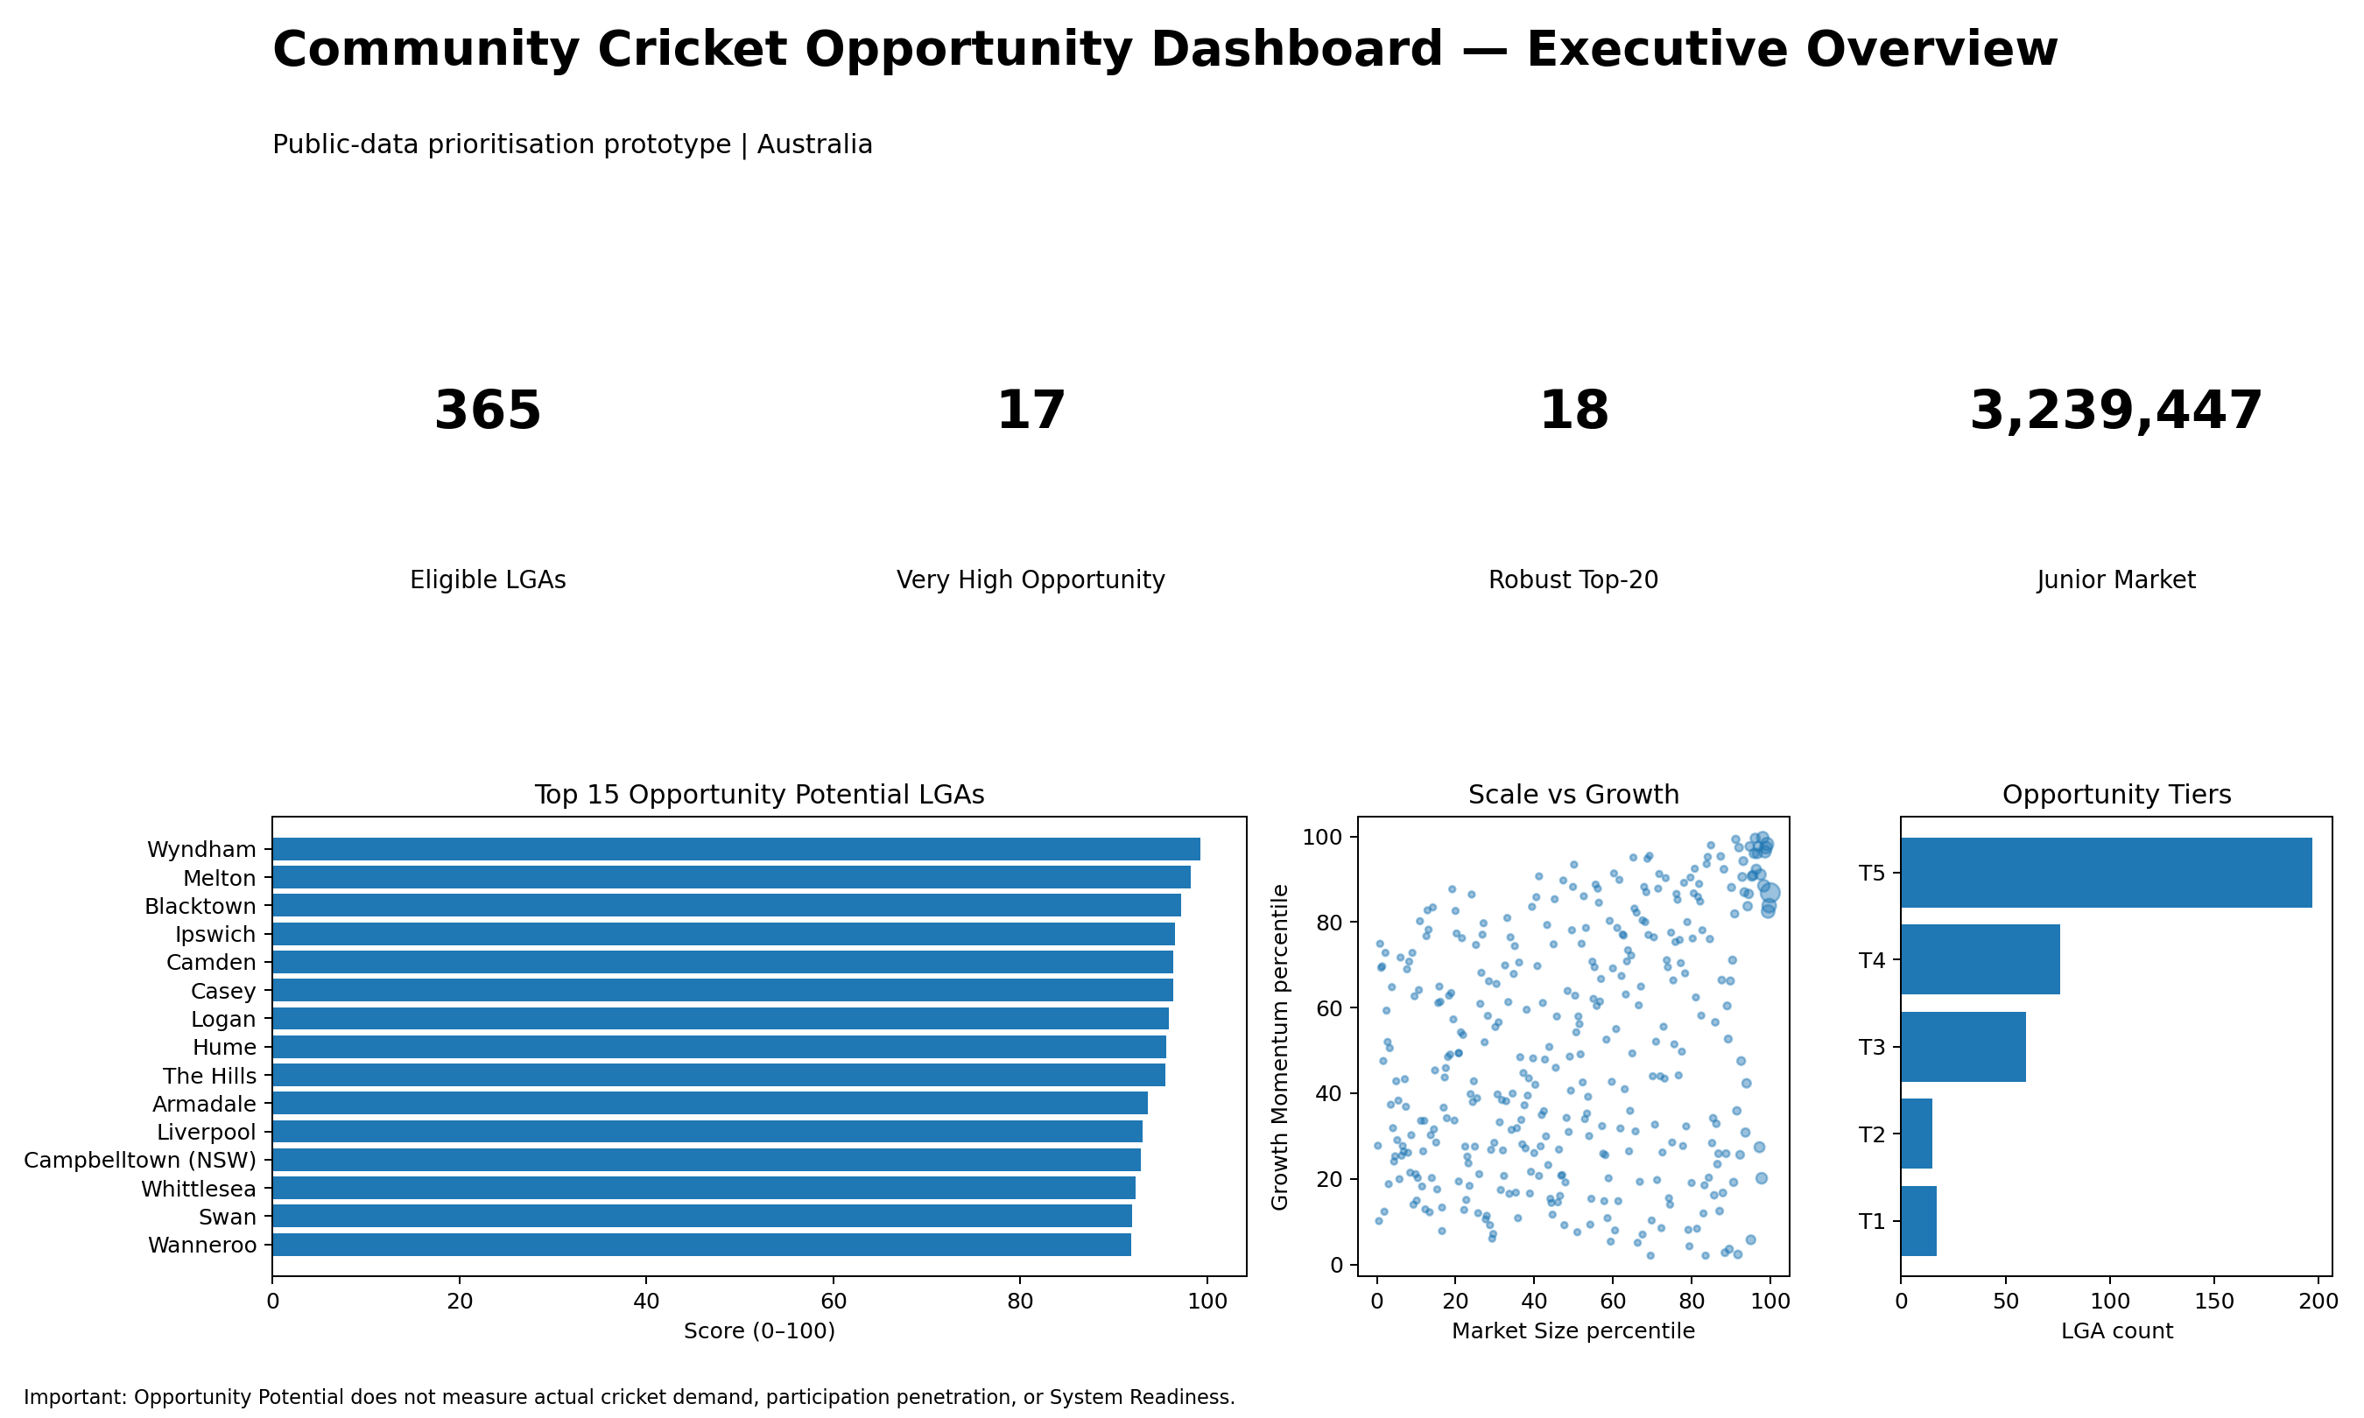
Figure 1. Executive dashboard prototype developed from the Opportunity Potential model.

Contents
1. Business Problem and Strategic Context
2. Research Question and Scope
3. Data and Methodology
4. Exploratory Findings
5. Geographic Analysis
6. Opportunity Potential Model
7. Ranking and Segmentation
8. Priority Case Studies
9. Strategic Recommendations
10. Validation and Limitations
11. Power BI Dashboard Design
12. Conclusion
Appendix A. Top 20 Model V1 Rankings
Appendix B. Model Specification
Appendix C. Validation and Limitations Register
Appendix D. Selected Sources

1. Business Problem and Strategic Context
The Community Cricket Data & Insights Manager role requires more than reporting participation totals. The underlying business problem is how to integrate fragmented participation, customer, demographic, research and operational evidence so Australian Cricket can decide where to invest, whom to target, how to retain participants and how to measure whether participation strategies are working.

Strategic context
- Australian Cricket's 2022-2027 strategy places strong emphasis on participation growth, junior participation, women and girls, multicultural inclusion and a sport-for-all vision.
- Published participation ambitions include 210,000 registered participants aged 5-12 by 2027, including 60,000 girls, and more than 850,000 overall registered participants by 2027.
- The Women & Girls Action Plan 2024-2034 sets a longer-term ambition to grow girls aged 5-12 from roughly 25,000 to 100,000 by 2034.
- The Multicultural Action Plan focuses on creating opportunities, reducing barriers and increasing South Asian participation, reinforcing the need for place-based, community-specific decision support.
Strategic source set: Cricket Australia strategy, Women & Girls Action Plan, Multicultural Action Plan, Australian Cricket Census and state association participation reporting.

2. Research Question and Scope
Primary research question
Which Australian communities show the strongest potential for community cricket participation growth, and what factors should Cricket Australia and State/Territory associations consider when prioritising participation-acquisition initiatives?
The primary unit of analysis is the Local Government Area (LGA). The analysis covers all Australian states and territories, with 2025 LGA geography used as the master structure. The model focuses on general acquisition opportunity, with particular strategic attention to junior participation, women and girls, multicultural growth and local delivery capacity.

What is intentionally out of scope
- Individual churn prediction
- Professional cricket performance
- Exact ROI or participant forecasts
- Causal claims about demographic characteristics
- Direct claims of low participation penetration where LGA registration data are unavailable

3. Data and Methodology

3.1 Data sources
Source | Reference period | Use in analysis
ABS Regional Population | 2025 / time series | Current population, one-year and five-year population growth
ABS Regional Population by Age and Sex | 2024 / 2001-2024 | Current 5-14 population, girls 5-14, historical junior growth
ABS SEIFA | 2021 | Socioeconomic context
Cricket Australia / State Associations | Various | Strategy, participation benchmarks and contextual validation
Council / local cricket sources | 2024-2026 | Case-study evidence on capacity, infrastructure and programs
Power BI-ready model output | Phase 17 | Dashboard implementation dataset and DAX measures

3.2 Geographic and age decisions
The master dataset contains 548 current LGA records. Age data are available for 546, with East Arnhem and Groote Archipelago affected by a documented 2025 geographic restructure. For national Model V1 ranking, 365 LGAs meet the minimum-population guardrails and valid-age criteria.
The latest public ABS age workbook provides five-year bands rather than exact single-year ages. The model therefore uses the directly observed 5-14 population as the current junior-market measure rather than constructing a false-precision 5-12 estimate.

3.3 Analytical architecture
Core design principle
Opportunity Potential and Cricket System Readiness remain separate. A community can have strong demographic opportunity but insufficient local capacity, or strong cricket supply but weaker future demographic growth.
- Market Size - current scale of the 5-14 population.
- Youth Concentration - share of the local population aged 5-14.
- Growth Momentum - combination of absolute and percentage growth in the 5-14 population from 2019 to 2024.
- Context - SEIFA and geographic factors used for interpretation rather than direct scoring.
- System Readiness - intended future layer covering clubs, programs, facilities, capacity and workforce.

4. Exploratory Findings
Exploratory data analysis materially simplified the model. The raw absolute population measures are highly redundant: total population and 5-14 population have a Spearman rank correlation of approximately 0.993, while girls 5-14 and total 5-14 counts are effectively the same ranking signal. This means a model that weighted each of those counts independently would substantially double-count LGA size.
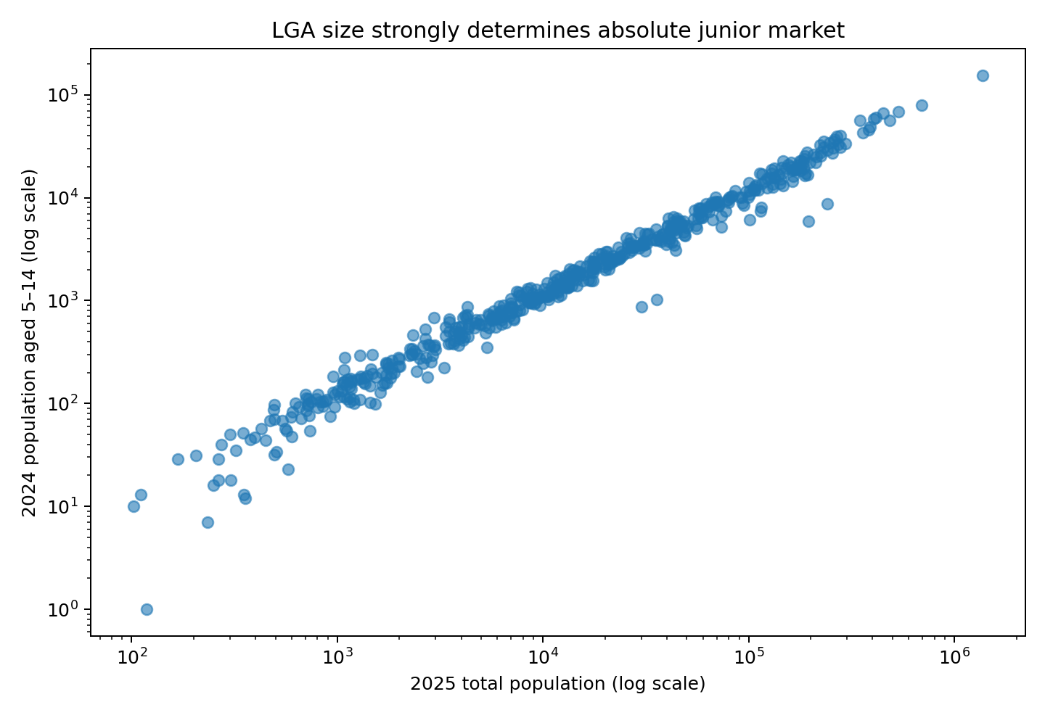
Figure 2. LGA size strongly determines absolute junior-market size.
Growth is different. Overall population growth and junior growth are related but not interchangeable (Spearman approximately 0.57), supporting a separate Growth Momentum pillar. Large current junior markets can be stagnant or shrinking, while smaller markets can be expanding rapidly.
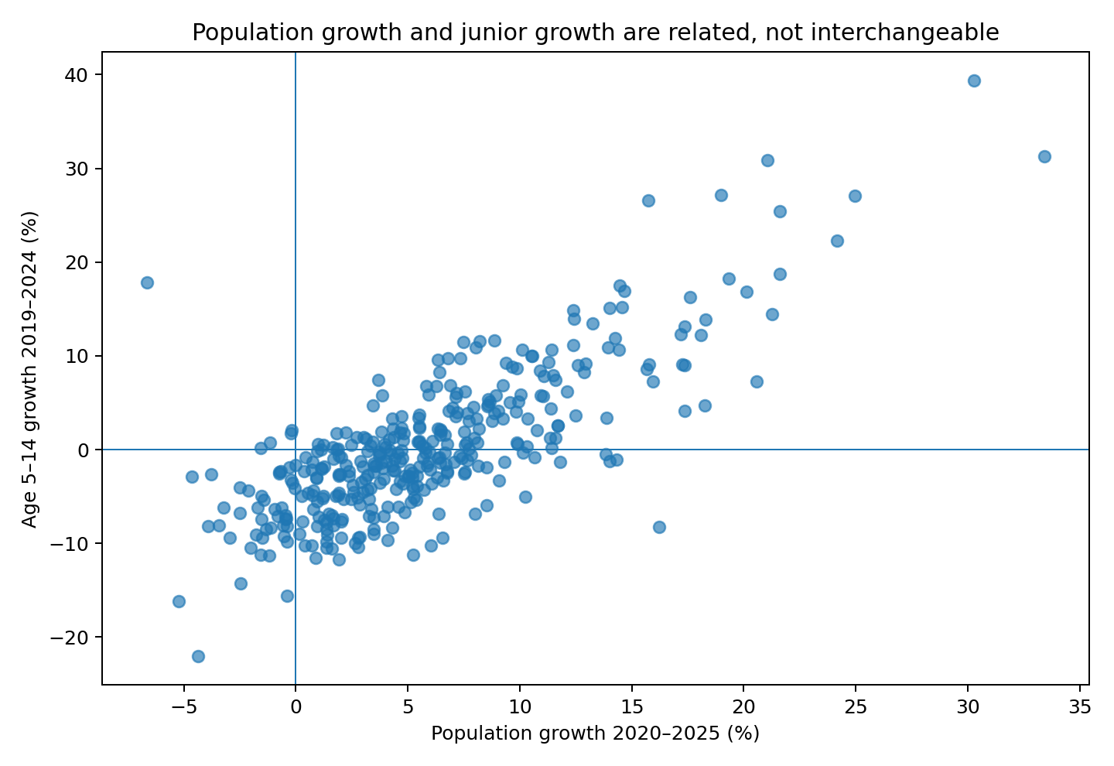
Figure 3. Total population growth and junior growth provide related but distinct signals.

4.1 Examples of strong absolute junior growth
Rank | LGA | State | Additional 5-14 | Growth %
1 | Wyndham | Victoria | 13,313 | 30.9%
2 | Blacktown | New South Wales | 9,571 | 17.0%
3 | Melton | Victoria | 8,438 | 31.3%
4 | Casey | Victoria | 7,925 | 15.1%
5 | Logan | Queensland | 6,746 | 13.1%
6 | Camden | New South Wales | 6,449 | 39.3%
7 | Hume | Victoria | 5,973 | 17.5%
8 | Brisbane | Queensland | 5,730 | 3.9%
9 | The Hills | New South Wales | 4,994 | 18.2%
10 | Ipswich | Queensland | 4,829 | 13.9%

5. Geographic Analysis
The strongest absolute increases in the junior market are geographically concentrated rather than scattered randomly. The national Top 20 for absolute 5-14 growth collectively added 106,387 children between 2019 and 2024. Four broad growth systems account for approximately 100,671 of that increase (94.6%).
Growth system | Top-20 LGAs | Additional 5-14 | Member LGAs
Melbourne outer growth belt | 6 | 42,505 | Wyndham, Melton, Casey, Hume, Whittlesea, Cardinia
Western / south-west Sydney | 5 | 26,982 | Blacktown, Camden, The Hills, Liverpool, Campbelltown (NSW)
South East Queensland | 4 | 20,784 | Logan, Brisbane, Ipswich, Sunshine Coast
Perth growth belt | 3 | 10,400 | Swan, Armadale, Wanneroo

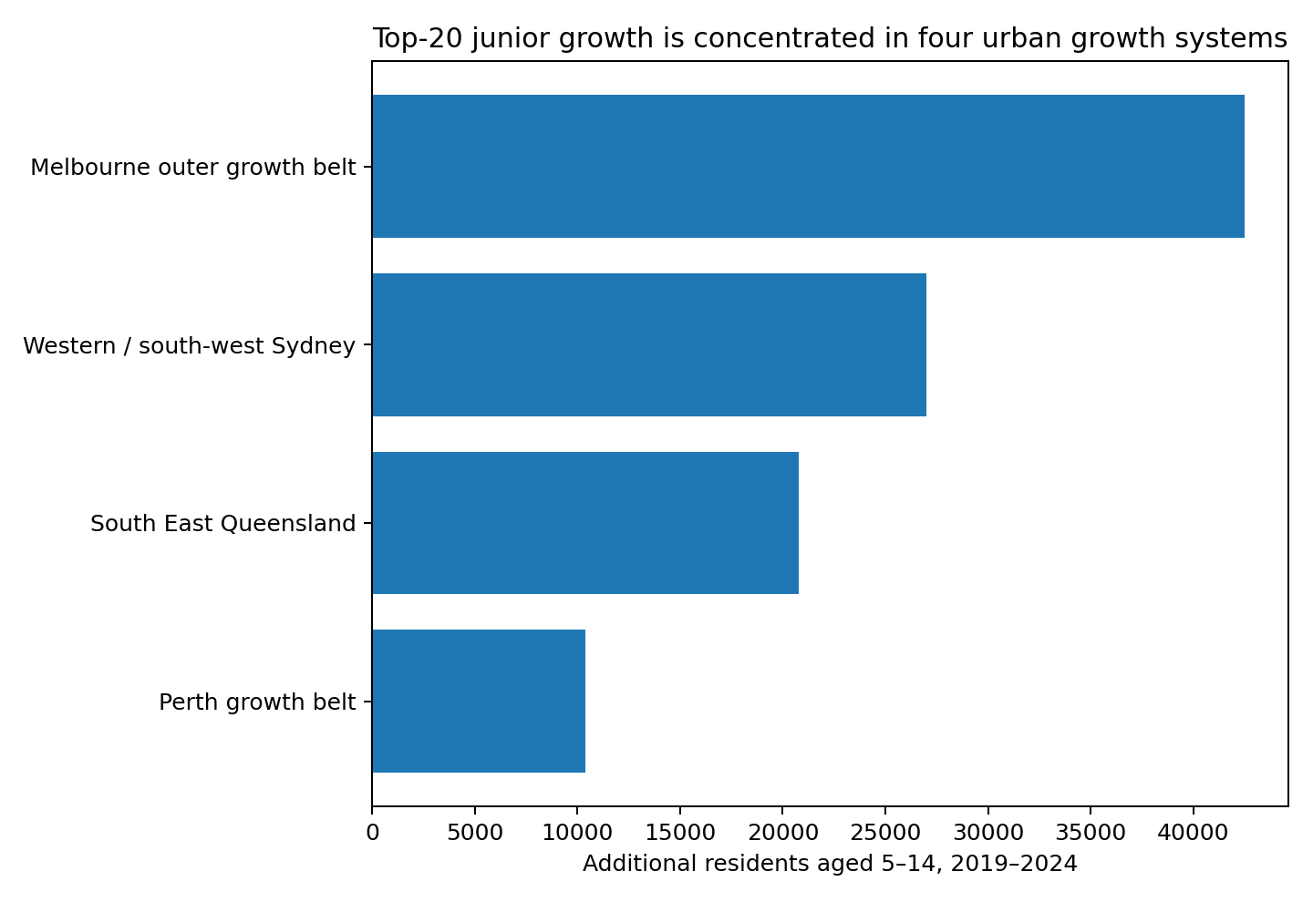
Figure 4. Contribution of the four major growth systems to Top-20 junior-market growth.
Management implication
Participation planning should not treat high-growth LGAs only as isolated councils. Adjacent high-growth areas can form shared participation systems, suggesting a role for corridor-level club, facility, school and program planning.

6. Community Cricket Opportunity Potential Model
Model V1 converts the Phase 10 evidence into a transparent national prioritisation index. Every input is transformed to a national percentile among eligible LGAs. Because there is no LGA-level outcome variable with which to estimate empirically optimal weights, the model uses equal weights across three conceptually distinct pillars and then tests sensitivity to alternative scenarios.
Pillar | Input | Weight | Interpretation
Market Size | AGE_5_14_2024 | 33.33% | Current scale of the addressable junior market
Youth Concentration | AGE_5_14_SHARE_TOTAL_PCT | 33.33% | Young demographic structure, reducing large-LGA bias
Growth Momentum | 50% absolute growth percentile + 50% percentage growth percentile | 33.33% | Balances growth scale and growth rate

Model formula
Opportunity Potential = (Market Size percentile + Youth Concentration percentile + Growth Momentum percentile) / 3
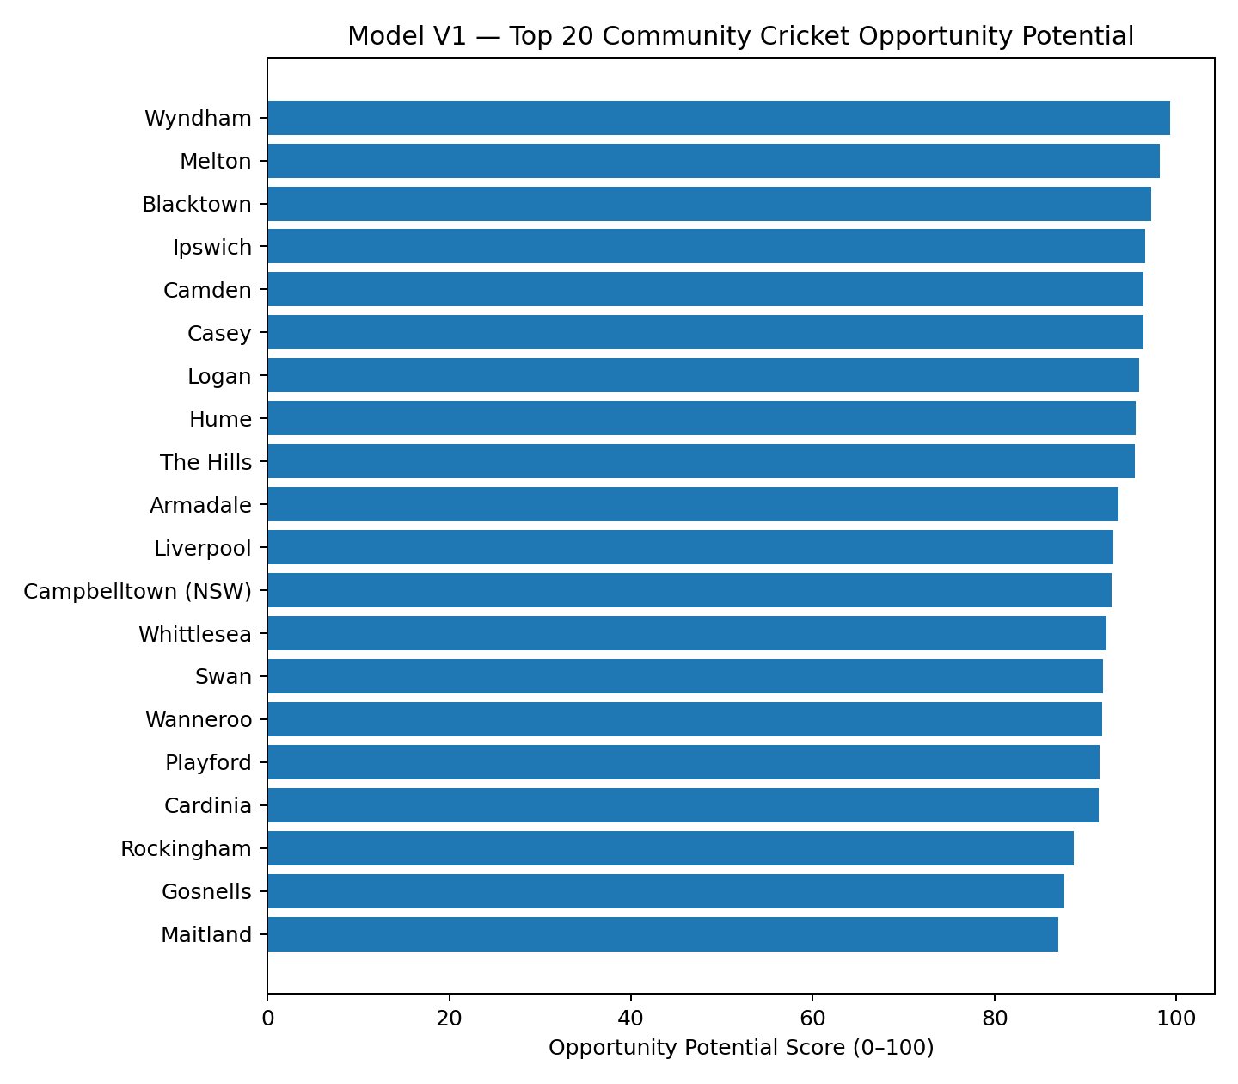
Figure 5. Model V1 Top 20 Community Cricket Opportunity Potential LGAs.
Rank | LGA | State | Score | 5-14 population | 5-year growth
1 | Wyndham | Victoria | 99.27 | 56,395 | 30.9%
2 | Melton | Victoria | 98.22 | 35,427 | 31.3%
3 | Blacktown | New South Wales | 97.21 | 66,024 | 17.0%
4 | Ipswich | Queensland | 96.58 | 39,679 | 13.9%
5 | Camden | New South Wales | 96.39 | 22,838 | 39.3%
6 | Casey | Victoria | 96.39 | 60,353 | 15.1%
7 | Logan | Queensland | 95.89 | 58,211 | 13.1%
8 | Hume | Victoria | 95.57 | 40,078 | 17.5%
9 | The Hills | New South Wales | 95.48 | 32,413 | 18.2%
10 | Armadale | Western Australia | 93.65 | 17,292 | 27.2%

6.1 Robustness
The Top 20 is highly stable under alternative weights. The Growth-led model preserves all 20, the Scale-led model preserves 18, and the Intensity-led model preserves 19. Alternative eligibility thresholds also retain 19-20 of the baseline Top 20. This supports the interpretation that the leading candidate set is driven by the underlying data structure rather than a narrow modelling choice.
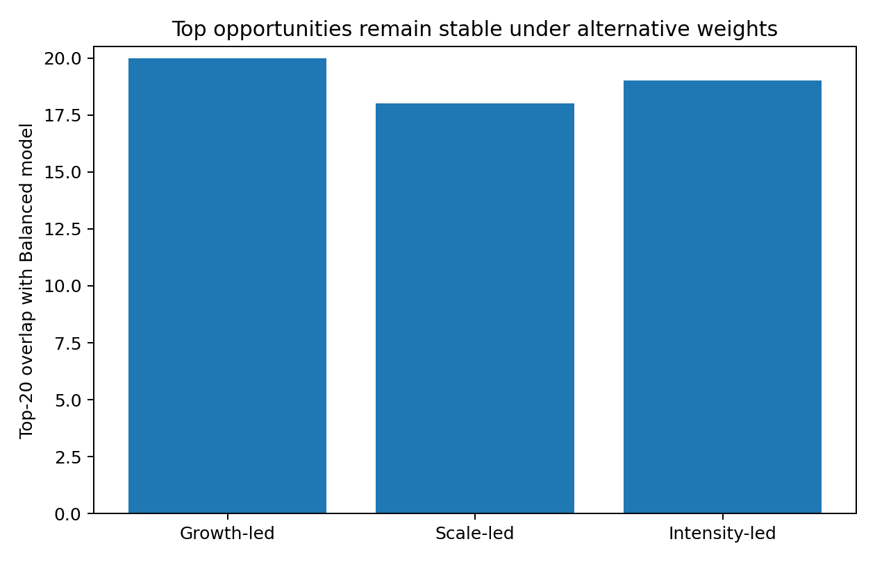
Figure 6. Top-20 overlap under alternative weighting scenarios.

7. Ranking and Strategic Segmentation
A ranking answers where; segmentation begins to answer what kind of opportunity is present. The model therefore groups LGAs based on the pattern of Market Size, Youth Concentration and Growth Momentum rather than treating every high score as the same business problem.
Segment | Typical profile | Implication
Balanced High-Opportunity Market | Strong scale, youth intensity and growth | Priority acquisition investigation; test capacity before scaling
Large Growth Market | Large junior market plus strong growth | Scale acquisition where delivery capacity exists
Emerging Young Growth Market | Young and fast-growing, smaller current scale | Build delivery capacity early
Young High-Intensity Market | Young demographic structure, less scale/growth | Validate demand and access
Large Established / Slower-Growth | Large current market, weaker growth | Retention, conversion and utilisation
Rapid Growth Market | Strong growth from a smaller base | Seed entry pathways and monitor
Mixed / Moderate Opportunity | No dominant pillar profile | Selective local investigation

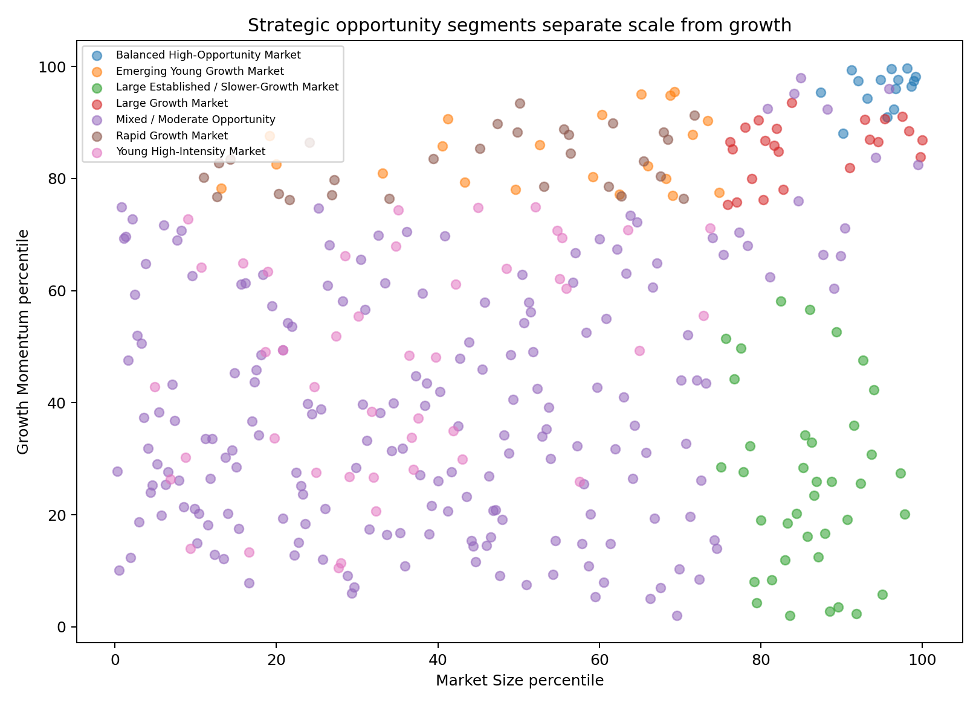
Figure 7. Strategic opportunity segments separate current scale from growth momentum.

8. Priority Case Studies
Five cases were selected to represent different growth systems and analytical situations rather than simply taking the national top five. The purpose was to test whether local cricket and infrastructure evidence supports, complicates or contradicts Model V1.

8.1 Wyndham, Victoria
Model rank #1 | Opportunity score 99.27 | 5-14 population 56,395 | 2019-24 change +13,313 (30.9%).
Local evidence. Cricket Victoria reported 8% year-on-year overall cricket participation growth and 18% women/girls growth in Wyndham in July 2025. Wyndham City also reported lighting upgrades at Truganina and Tarneit intended to increase sportsground carrying capacity, while Council's venue pages note some existing-user availability constraints.
Working interpretation. Priority acquisition and capacity-audit case
Priority management question. Are club, oval, net and entry-program capacities growing quickly enough in Wyndham's western growth areas?

8.2 Blacktown, New South Wales
Model rank #3 | Opportunity score 97.21 | 5-14 population 66,024 | 2019-24 change +9,571 (17.0%).
Local evidence. Blacktown City Council stated in August 2024 that requests for year-round cricket competitions could not be met because of a shortage of fields. Blacktown City & District Cricket Association then won Cricket NSW's 2025/26 Junior Initiative award for its Under-9s Transition Competition.
Working interpretation. High-priority capacity-constrained candidate
Priority management question. Which western/north-west Blacktown catchments have the largest mismatch between junior growth and playable cricket-field capacity?

8.3 Ipswich, Queensland
Model rank #4 | Opportunity score 96.58 | 5-14 population 39,679 | 2019-24 change +4,829 (13.9%).
Local evidence. Ipswich forecasts very rapid future population growth. In 2026 Council sought cricket/AFL users for a new South Ripley sports oval. Queensland Cricket reported Ipswich's Strollers Cricket Club had grown to more than 110 juniors and Blasters, with new cricket grounds established in Springfield.
Working interpretation. Activate/accelerate candidate with ongoing capacity build
Priority management question. Can new facilities in Ripley/Springfield be matched with junior, Blast and girls' participation programs fast enough?

8.4 Armadale, Western Australia
Model rank #10 | Opportunity score 93.65 | 5-14 population 17,292 | 2019-24 change +3,696 (27.2%).
Local evidence. The City of Armadale forecasts continued substantial population growth. WA Cricket reported the Gwynne Park Pavilion upgrade, home to Armadale Cricket Club in summer, will provide four all-gender changerooms and improved club amenities.
Working interpretation. Promising acquisition case requiring demand validation
Priority management question. Does Armadale's fast-growing junior market translate into registration growth, and is existing club/program coverage sufficient outside Gwynne Park?

8.5 Maitland, New South Wales
Model rank #20 | Opportunity score 86.99 | 5-14 population 13,946 | 2019-24 change +1,481 (11.9%).
Local evidence. Maitland City Council began construction in 2025 on Chisholm's first $10m sportsground, including a turf cricket wicket, specifically citing the area's growing population. Cricket NSW also highlighted a six-week all-girls cricket clinic in Maitland for ages 7–14 in 2025, and its competition framework includes Maitland district senior and junior associations.
Working interpretation. Strong regional comparator / targeted growth case
Priority management question. Can Chisholm and surrounding growth areas convert new facility supply into sustained junior and girls' registrations?
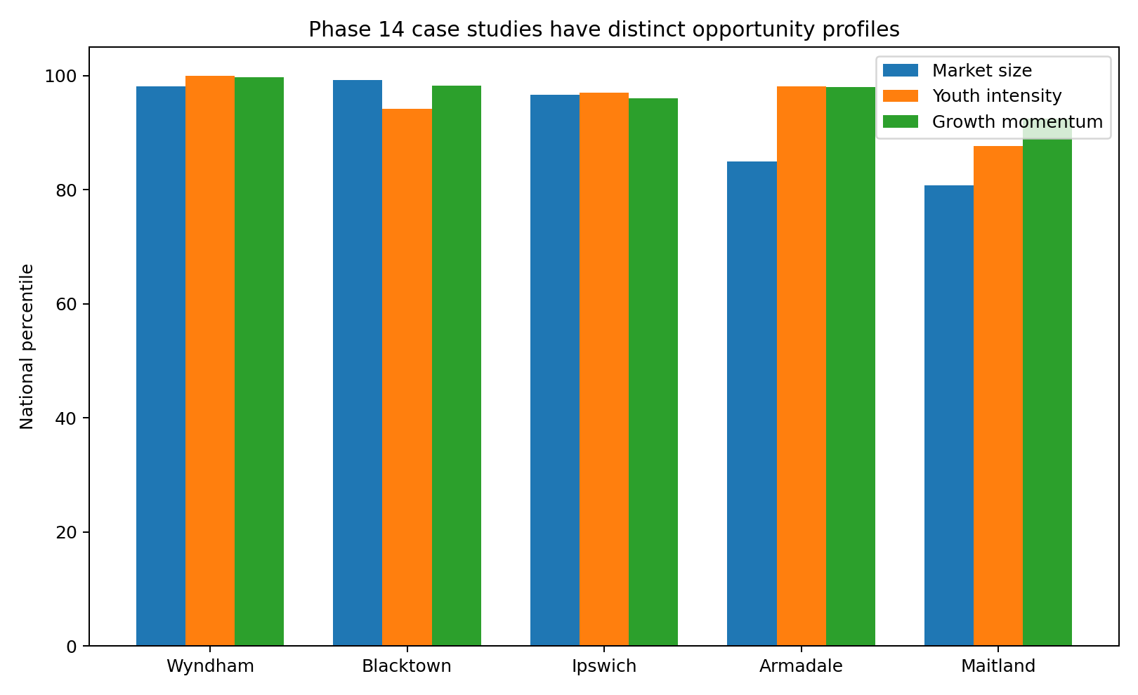
Figure 8. Pillar profiles for the five Phase 14 case studies.

9. Strategic Recommendations
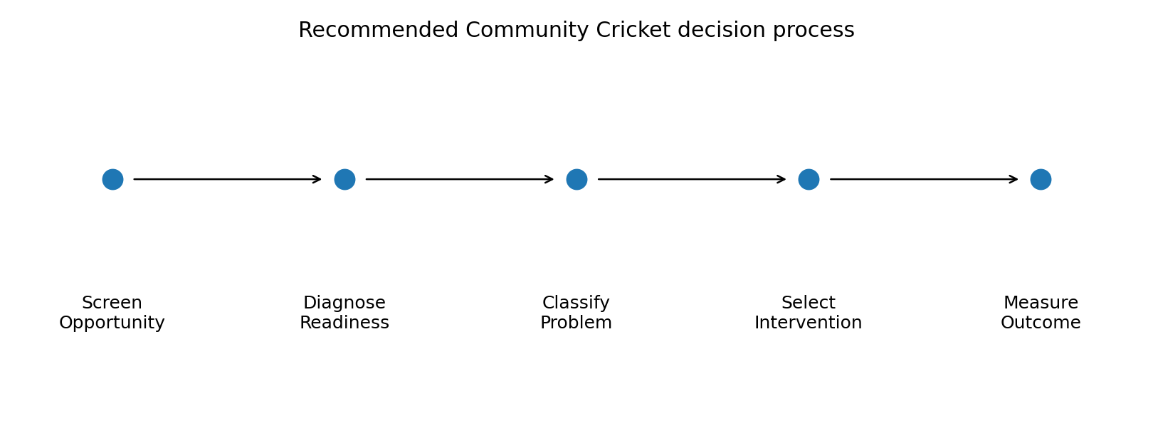
Figure 9. Recommended decision process from opportunity screening to outcome measurement.
Core recommendation
Use demographic Opportunity Potential to decide where to investigate, cricket-system evidence to diagnose the local constraint, and intervention-specific KPIs to determine what action works.

9.1 National recommendations
N1 - Adopt a two-stage national prioritisation process. Use Opportunity Potential as a screening layer, then require cricket-specific readiness evidence before investment decisions.
N2 - Create a national Community Cricket Opportunity & Readiness dataset. Join PlayHQ/registration history, club/program locations, facility access, participant age/gender, and demographic growth at LGA/SA2 or club-catchment level.
N3 - Prioritise growth corridors, not only individual LGAs. Create corridor views for Melbourne outer growth belt, western/south-west Sydney, South East Queensland and Perth growth belt.
N4 - Build an annual junior-growth early-warning dashboard. Track target-age population growth, registrations, programs and facility capacity to flag areas where demographic growth is outpacing cricket supply.
N5 - Separate acquisition, capacity and retention KPIs. Do not judge every LGA on total registrations alone; distinguish new-player acquisition, returning players, transition/conversion and capacity constraints.
N6 - Overlay women/girls and multicultural strategic priorities. Add direct registration and demographic layers for girls and culturally diverse communities rather than using broad demographic counts as demand assumptions.
N7 - Require intervention-specific evaluation. Every targeted program/facility intervention should define baseline, target, comparison period and conversion/retention metrics.

9.2 Strategic response framework
Evidence pattern | Response | Action
High opportunity + capacity pressure | Build Capacity First / Protect Access | Audit facilities/club capacity; quantify unmet demand; protect access before acquisition campaigns
High opportunity + new/available capacity | Activate / Accelerate | Expand Blast/junior/girls pathways and school-to-club conversion
High opportunity + weak demand evidence | Validate Before Scaling | Use registrations, club/school evidence and pilots before major investment
Large market + slower growth | Retain / Convert | Prioritise participant return, churn and pathway conversion
Smaller market + rapid growth | Seed and Monitor | Establish low-cost entry pathways and reserve future capacity

10. Validation and Limitations
The model is suitable as a transparent public-data prioritisation prototype, but its validation is strongest for data integrity, construct logic and robustness - not for prediction. There is no future LGA-level new-registration outcome against which Model V1 can be tested.
Validation dimension | Assessment | Interpretation
Internal data integrity | Strong | Supports confidence in extraction and joins, not in causal interpretation.
Weight sensitivity | Strong | Shows leading candidates are not created by one arbitrary weight set.
Eligibility-threshold sensitivity | Strong | Shows candidate set is robust to reasonable small-base guardrails.
Construct validity — redundancy control | Strong | Supports simplified three-pillar architecture.
Construct validity — distinct growth signal | Moderate/Strong | Supports keeping Growth Momentum separate from Market Size.
Geographic face validity | Moderate/Strong | Plausible spatial coherence, but not predictive validation.
External case-study validation | Moderate | Useful triangulation, but cases are purposive rather than a random validation sample.
Predictive validity | Not established | Model must not be described as predicting registrations or demand.
Criterion validity using current participation penetration | Not established | Cannot identify true low-penetration or 'untapped' cricket markets.
System Readiness validity | Not established | Final Opportunity × Readiness framework remains incomplete.

10.1 Critical claim boundaries
The model CAN support
Relative statements such as: an LGA combines a large junior market, a young population structure and strong recent junior growth compared with other eligible Australian LGAs.
The model CANNOT support
Claims that an LGA has the highest untapped cricket demand, low participation penetration, a predicted number of future registrations, or a guaranteed return from a specific facility/program investment.

10.2 Highest-severity limitations
- Outcome-data gap: No national LGA-level cricket registration/acquisition outcome.
- Readiness-data gap: No consistent national club/program/facility capacity dataset.
- Age-band mismatch: Current ABS age/sex data supports 5–14, not exact CA strategic 5–12.
- Cultural strategic-alignment gap: South Asian/cultural Census layer not integrated into Model V1.
- LGA as market proxy: Players can live, attend school and play across council boundaries.
- Infrastructure evidence inconsistency: Local facility evidence varies in quality/availability by council/state.
- Demand vs demographic opportunity: Population attributes do not prove willingness to play cricket.
- Causal inference: Observational geographic model identifies associations only.
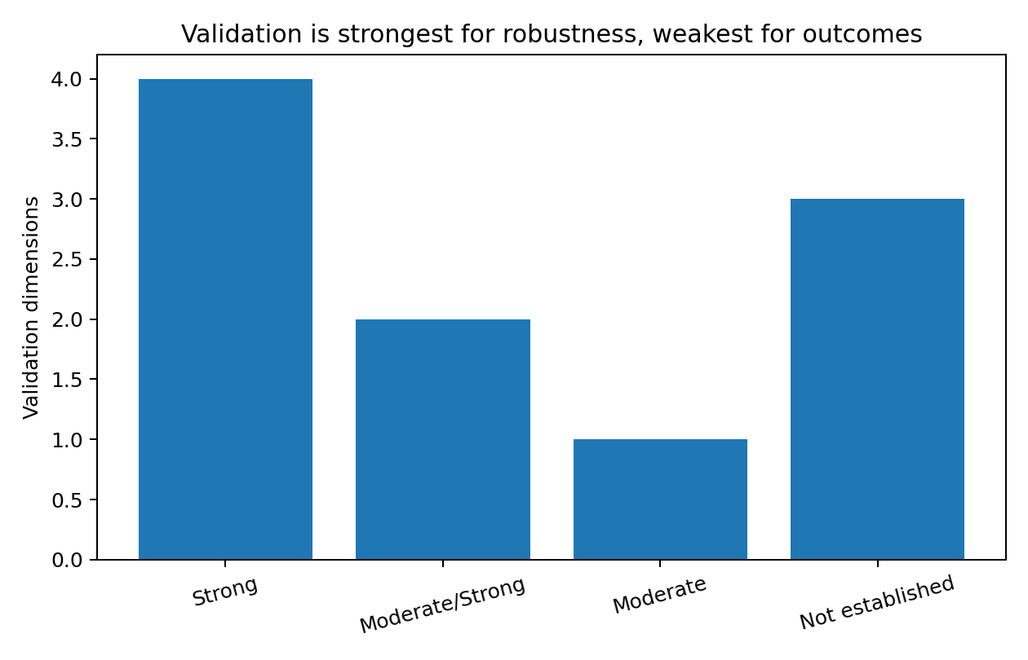
Figure 10. Validation is strongest for robustness and weakest for outcome/predictive validity.

11. Power BI Dashboard Design
The final analytical workflow has been translated into a Power BI-ready dashboard package. The dashboard is designed for a hiring manager or participation leader to move from national screening to LGA-level diagnosis while keeping the model limitation visible.
- Executive Overview - KPIs, Top 15 ranking, opportunity tiers and scale-vs-growth view.
- Geographic Opportunity - LGA choropleth using official ABS 2025 boundaries.
- LGA Deep Dive - rank, score, current junior market, growth and pillar profile.
- Strategic Segmentation - why each LGA ranks highly.
- Case Studies - Wyndham, Blacktown, Ipswich, Armadale and Maitland.
- Validation & Limitations - sensitivity tests, limitations and claim boundaries.

Figure 11. Static prototype of the dashboard Executive Overview page.

12. Conclusion
The strongest contribution of this project is not the specific rank order of LGAs. It is the decision structure created around the ranking. Public demographic data can identify where participation conditions justify deeper investigation; local cricket evidence then determines whether the relevant problem is acquisition, capacity, retention, conversion or demand validation.
Final conclusion
The defensible use of Model V1 is to identify where Australian Cricket should investigate first. A production-grade version should combine Opportunity Potential with PlayHQ registrations, club/program capacity, facilities, waitlists, volunteer/workforce data and participant research to build the full Opportunity x Readiness system.
This prototype demonstrates a complete analytical workflow: strategic problem definition, public-data audit, data engineering, exploratory analysis, geographic interpretation, transparent modelling, sensitivity testing, case-study validation, strategic recommendations and dashboard implementation design.

Appendix A. Top 20 Model V1 Rankings
Rank | LGA | State | Score | Market | Youth | Growth
1 | Wyndham | Victoria | 99.27 | 98.1 | 100.0 | 99.7
2 | Melton | Victoria | 98.22 | 96.2 | 98.9 | 99.6
3 | Blacktown | New South Wales | 97.21 | 99.2 | 94.2 | 98.2
4 | Ipswich | Queensland | 96.58 | 96.7 | 97.0 | 96.0
5 | Camden | New South Wales | 96.39 | 91.2 | 98.6 | 99.3
6 | Casey | Victoria | 96.39 | 98.9 | 92.9 | 97.4
7 | Logan | Queensland | 95.89 | 98.6 | 92.6 | 96.4
8 | Hume | Victoria | 95.57 | 97.0 | 92.1 | 97.7
9 | The Hills | New South Wales | 95.48 | 94.8 | 94.0 | 97.7
10 | Armadale | Western Australia | 93.65 | 84.9 | 98.1 | 97.9
11 | Liverpool | New South Wales | 93.06 | 96.4 | 90.4 | 92.3
12 | Campbelltown (NSW) | New South Wales | 92.88 | 93.2 | 91.2 | 94.2
13 | Whittlesea | Victoria | 92.28 | 95.9 | 84.9 | 96.0
14 | Swan | Western Australia | 91.92 | 92.1 | 86.3 | 97.4
15 | Wanneroo | Western Australia | 91.87 | 95.6 | 89.0 | 91.0
16 | Playford | South Australia | 91.55 | 84.1 | 95.3 | 95.2
17 | Cardinia | Victoria | 91.51 | 87.4 | 91.8 | 95.3
18 | Rockingham | Western Australia | 88.72 | 90.1 | 87.9 | 88.1
19 | Gosnells | Western Australia | 87.67 | 88.2 | 82.5 | 92.3
20 | Maitland | New South Wales | 86.99 | 80.8 | 87.7 | 92.5

Appendix B. Model Specification
- Eligibility: valid age data, current total population >= 5,000, 2019 5-14 population >= 500, residual unincorporated records excluded except ACT.
- Normalisation: average-rank percentile scores among eligible LGAs.
- Market Size = percentile of AGE_5_14_2024.
- Youth Concentration = percentile of AGE_5_14_SHARE_TOTAL_PCT.
- Growth Momentum = average of percentiles for AGE_5_14_CHANGE_5Y and AGE_5_14_GROWTH_5Y_PCT.
- Balanced Opportunity Potential = equal average of Market Size, Youth Concentration and Growth Momentum.
- SEIFA is contextual only. Cultural strategic alignment and System Readiness are excluded from Model V1 because those layers were not fully integrated.

Appendix C. Validation and Limitations Register
Severity | Limitation | Risk | Mitigation
Critical | Outcome-data gap | Cannot validate whether high scores lead to more cricket registrations. | Use CA/PlayHQ new registrations, retention and conversion by geography.
Critical | Readiness-data gap | Cannot calculate formal System Readiness or final Phase 6 strategic quadrant. | Integrate clubs, programs, fields, hours, utilisation, waitlists and volunteer capacity.
High | Age-band mismatch | Junior market is an approximation of the strategic target cohort. | Use exact-age internal registration/ABS TableBuilder where feasible; sensitivity-test 5–12 vs 5–14.
High | Cultural strategic-alignment gap | Model omits one explicit CA strategic-priority dimension. | Add responsibly defined Census/registration measures; keep demographic identity separate from assumed cricket demand.
Moderate | Temporal misalignment | Scores combine best-available data from different reference years. | Retain year metadata; refresh annually; avoid calling the dataset '2026 data'.
Moderate | LGA boundary change | Some records cannot be compared perfectly through time. | Use ABS correspondences and current boundary standards; flag changed areas.
High | LGA as market proxy | LGA may not equal true club/program catchment. | Use SA2/postcode and drive-time/club-catchment analysis with internal data.
Moderate | Urban-scale bias | National model may understate small but locally important regional opportunities. | Use peer-group/remoteness benchmarking alongside national percentiles.
Moderate | Small-base volatility | Growth-rate rankings can overstate tiny markets. | Retain minimum-size guardrails and pair rates with absolute change.
Moderate | Percentile-score relativity | A score of 95 does not mean 95% demand or 95% probability. | Label clearly as relative percentile-based Opportunity Potential.
Moderate | Equal-weight assumption | Balanced model is defensible but not uniquely 'correct'. | Retain scenario analysis; calibrate weights only when outcome data exists.
Moderate | Case-study selection bias | External validation can overrepresent confirming cases. | Test lower-ranked and contradictory cases in future validation.
High | Infrastructure evidence inconsistency | Qualitative readiness comparisons are not nationally standardised. | Create consistent national facility schema and data-sharing process.
Critical | Demand vs demographic opportunity | Risk of overclaiming 'untapped demand', especially for cultural groups. | Use direct behaviour/registration evidence and participant research.
Critical | Causal inference | Cannot claim demographic growth causes cricket participation growth. | Use experimental/quasi-experimental program evaluation for causal claims.
Moderate | Pandemic-period effects | Some five-year changes may reflect unusual demographic movements. | Compare multiple windows when later releases allow.
Moderate | Unincorporated/remote coverage | Model is not a complete remote-community prioritisation framework. | Create separate remote/First Nations/community-specific approach rather than forcing national LGA ranking.

Appendix D. Selected Sources
Cricket Australia. Australian Cricket Strategy 2022-2027 / Governing the Game. https://www.cricket.com.au/governing-the-game/ca-strategy
Cricket Australia. Women and Girls Action Plan 2024-2034. https://www.cricket.com.au/social-impact-and-sustainability/women-and-girls
Cricket Australia. Multicultural Action Plan / Diversity and Inclusion. https://www.cricket.com.au/social-impact-and-sustainability/diversity-and-inclusion/multicultural
Australian Bureau of Statistics. Regional Population, 2024-25. https://www.abs.gov.au/statistics/people/population/regional-population/latest-release
Australian Bureau of Statistics. Regional Population by Age and Sex. https://www.abs.gov.au/statistics/people/population/regional-population-age-and-sex/latest-release
Australian Bureau of Statistics. Socio-Economic Indexes for Areas (SEIFA), 2021. https://www.abs.gov.au/statistics/people/people-and-communities/socio-economic-indexes-areas-seifa-australia/latest-release
Australian Sports Commission. AusPlay results and data tables. https://www.ausport.gov.au/clearinghouse/research/ausplay/results
Cricket Australia. 2022-23 Australian Cricket Census. https://www.cricket.com.au/news/3646243/cricket-census-reveals-cricket-participation-continues-to-grow
Cricket Victoria. Wyndham cricket participation +8% YoY; women/girls +18%. https://www.cricketvictoria.com.au/news/news/cricket-victoria-welcomes-new-state-government-investment-in-community-access-to-school-sporting-grounds/
Wyndham City. Lighting at Truganina/Tarneit to increase carrying capacity. https://www.wyndham.vic.gov.au/sites/default/files/2025-07/Quarterly%20Community%20Report%20-%20Quarter%201%20%28Jul%20Aug%20Sept%29%202024.25.pdf
Blacktown City Council. Year-round cricket requests cannot be met due to field shortage. https://www.blacktown.nsw.gov.au/News-Media/Infrastructure-must-be-priority-in-rezoning-Sydney%E2%80%99s-north-west
Cricket NSW. Blacktown association won Junior Initiative award. https://www.cricketnsw.com.au/news/4437876/202526-nsw-community-cricket-awards-announced
Ipswich City Council. New South Ripley sports oval seeking cricket/AFL users. https://www.ipswich.qld.gov.au/News-Articles-Folder/2026/Brand-new-South-Ripley-sports-oval-looks-for-clubs-to-call-it-home
Queensland Cricket. Strollers >110 juniors/Blasters; new Springfield grounds. https://www.qldcricket.com.au/news/3943341/south-east-queensland-volunteer-of-the-year
WA Cricket. Gwynne Park Pavilion upgrade incl. four all-gender changerooms. https://www.wacricket.com.au/news/3790282/infrastructure-upgrades-providing-equal-facilities-for-all
City of Armadale. Gwynne Park largest recreation reserve / master-plan context. https://my.armadale.wa.gov.au/service/master-plans
Maitland City Council. $10m Chisholm sportsground incl. turf cricket wicket. https://www.maitland.nsw.gov.au/news/breaking-ground-work-underway-on-chisholms-first-sportsground
Cricket NSW. All-girls 7–14 winter cricket clinic in Maitland. https://www.cricketnsw.com.au/news/4278574/winter-cricket-programs-surge-across-nsw
End of report

