In this section we depict the proposed process for generate reliable service composition. The process essentially consist of generate the PEWS Code starting from the p-servicecomposition model. However it must be note that the service composition model is not modeled from scratch at this level, but it is the result of a general process defined by SOD-M method in which a set of models are built following a service oriented approach [].
To achieve the whole model transformation process, the Eclipse Modelling Framework (EMF) has been used. The EMF project is a modeling framework and code generation facility for building tools and other applications based on a structured data model. From a model specification described in XMI, EMF provides tools and runtime support to produce a set of Java classes for the model, along with a set of adapter classes that enable viewing and command-based editing of the model, and a basic editor.
In order to automate the transformation we specify the transformation rules using ATL model transformation language Error: Reference source not found. An ATL program is basically a set of rules that define how source model elements are matched and navigated to create and initialize the elements of the target models.
Finally, in order to generate code we have used Acceleo [http://www.acceleo.org/pages/home/en]. Acceleo
Figure 1 depicts a general overview of the proposed process showing the set of plug-ins which have been developed in order to support the proposed framework:
- First, we have implemented using EMF, the metamodels of the p- servicecomposition model and PEWSCT model. After that, starting form these metamodels, we have developed the models plug-ins needed to support the graphical representation of the p-servicecomposition and PEWSCT model (P-ServiceCompostion Model and PEWSCT Model plug-ins).
- Then, we have developed using ATL, the mapping plug-in need to carry out the mappings between models (P-ServiceComposition2PEWSCT Plug-in).
- Finaly, we have create the code generation plug-in using Acceleo. To this end, the pews.mt program was codified including the entire model to text transformation needed to generate a PEWS code starting form a PEWSCT model; and then a chain execution was created in order to execute the model to text transformation.
As is show in Figure 1, once an instance of a PEWS code is obtained starting form a particular p-service composition model it can be executed over …..
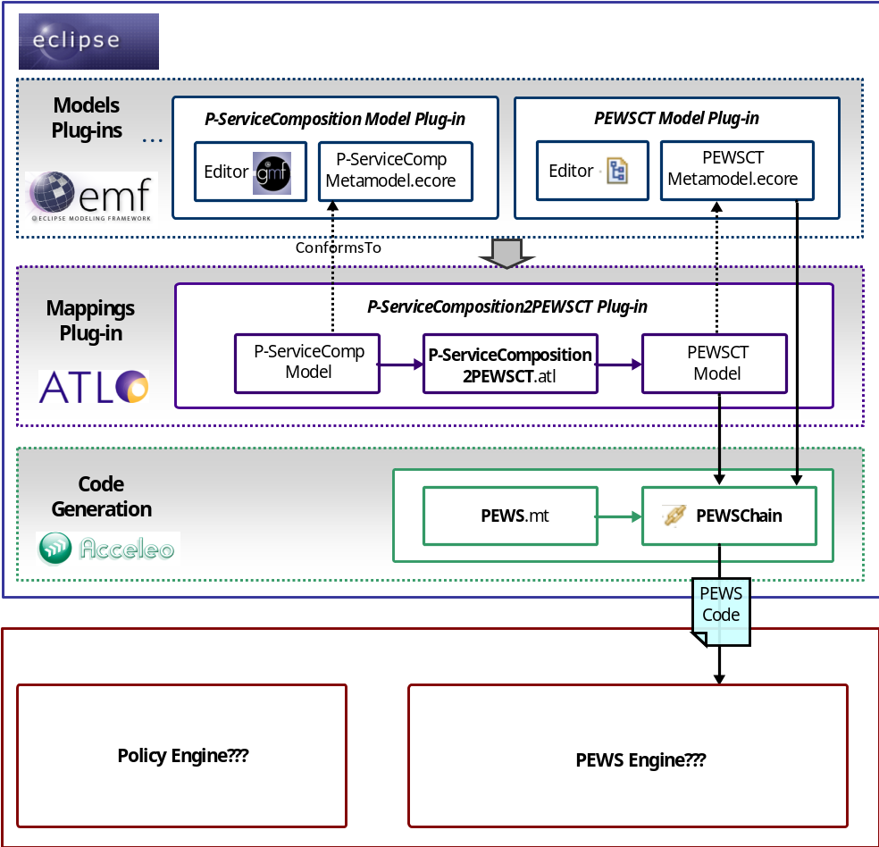
Fig. 1. General overview of the reliable service composition process

