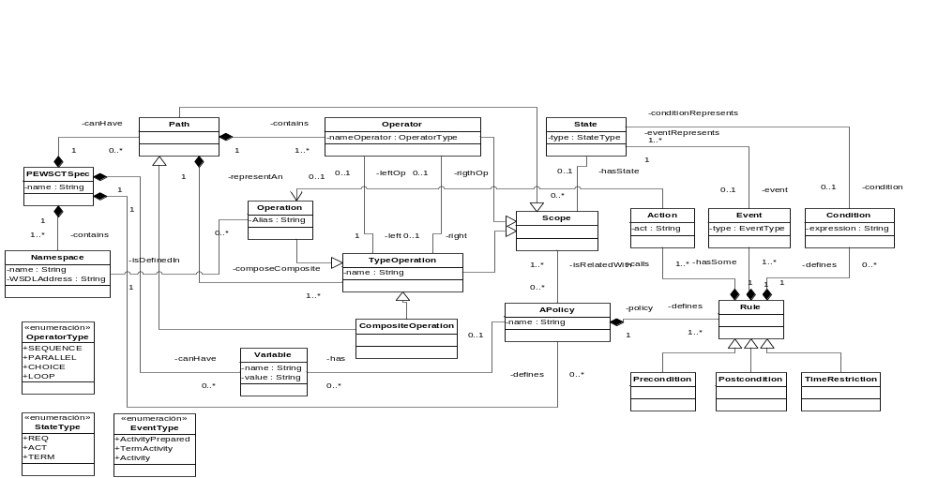





. . .
Mappings
Plug-in
Models
Plug-ins
P-ServiceComposition Model Plug-in
Editor
P-ServiceComp
Metamodel.ecore

PEWSCT Model Plug-in
Editor
PEWSCT
Metamodel.ecore

P-ServiceComposition2PEWSCT Plug-in
P-ServiceComposition 2PEWSCT.atl
PEWSCT
Model

P-ServiceComp
Model

ConformsTo
ConformsTo
Code Generation
PEWS.mt

PEWS Engine???
Policy Engine???
PEWS
Code

PEWSChain

