SOD-M

SOD-M defines a service-oriented approach for the development of information systems (IS) [1, 2]. As main characteristics, it provides with a set of guidelines to build IS based exclusively on services. SOD-M proposes to use services as first-class objects for the whole process of the IS development. This approach facilitates the development of service-oriented applications as well as their implementation using current technologies such as Web services, for example.
The method provided in SOD-M follows a MDA-based approach. It proposes a set of models, extending from the highest level of abstraction of the MDA, the CIM level, to the PIM and PSM levels. SOD-M provides the benefits related to the alignment of high-level business processes with the application of current technologies to deploy the Service-Oriented paradigm by means of different mapping rules between the models [3].
SOD-M focuses on the development of behavioral aspects of IS and defines the guidelines to build behavioral models from high-level business modelling. Figure 1 depicts the modelling process of SOD-M. It includes models that are in correspondence with: i) the three different abstraction levels considered by MDA: CIM, PIM and PSM; and ii) SOD-M views: business and information system views.
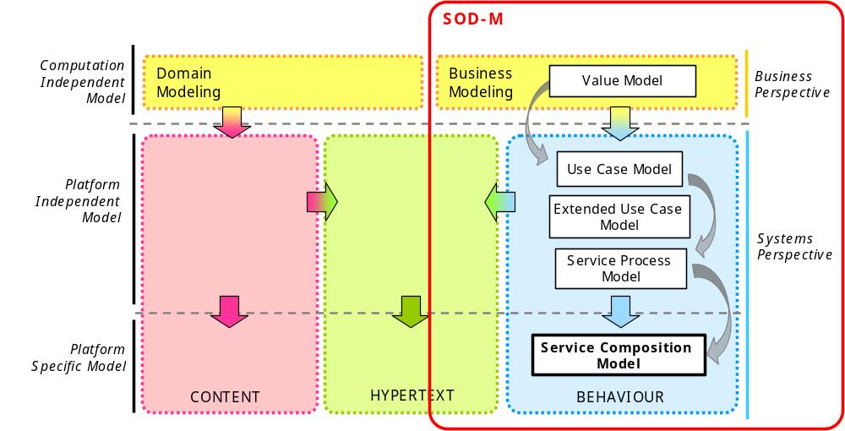
Figure 1: SOD-M development process.
As shown in Figure 1, the SOD-M model-driven process begins by building the high-level computational independent models and enables specific models for a service platform to be obtained as a result.
For the sake of simplicity, in this work we are going to focus on the service composition model of SOD-M (highlighted in Figure 1). The service composition model is the model which will be taken as input for the transformation process to generate the corresponding PEWS model. Note that SOD-M proposes representing this model using the UML activity diagram technique [Error: Reference source not found]. This model repesents the workflow needed to carry out a business service by identifying activities and entities collaborating in the business processes (called business collaborators) and performing them. Activities identified in the model describes a fundamental behaviour unit which represents some transformation or processing in the system being modelled. There are two types of activities in this model: i) a WebService (stereotiped as WS); and ii) a simple operation not supported by a Web Service, called an ActivityOperation (stereotiped as AOP). The business collaborators are displayed in this model as a partition in the activity diagram. A more detailed description about the other different models of SOD-M can be found in [1]. Next section describe the service composition model for the running example.

Figure 2 shows the composition service model for our Spotify example which represents the composition process of the different activities needed to carry out the business service “To publish music”. In order to build this model, the elements identified in a previous service process model as well as some elements identified in the value model such as business actors were taken as input.
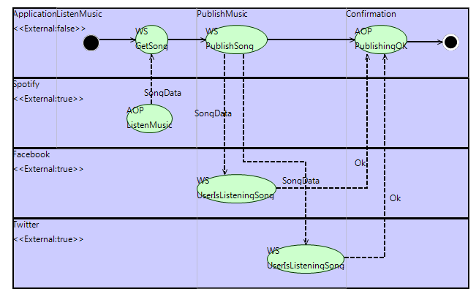
Figure 2: Service Compostion Model for the business service To publish music.
As shown, the composition service model contains four different collaborators: the Application, which owns the application and is responsible for implementing the fundamental operations; the Spotify, which is responsible for the listening service and which owns the songs data; and finally, the Facebook and Twitter, which are responsible for publishing any specific song.
The Application need to carry out several service activities. First, a login is required to access the business service. When a user wants ot publish a music the Application ask to Spotify for the song data using GetSong WS. Spotify return the song data and then the Application execute the PublishSong WS which call to UpdateSong WS of Facebook and Twitter respectively. Once the song is updated in both sites the Application inform the PublisingOk and the process ends.

3.1 Extended Service Composition Metamodel:
Figure 3 shows the extension to the service composition metamodel. Figure shows remarked the new elements defined. The Policy class has a name and has associated 1 to N variables (Variable class). A policy contains 1 to N rules (class Rule). The Rule class has also a name plus attributes event, condition and action. Event attribute is an string and describe….. Condition attribute is an string and describe…. . Action attribute is an string and describe…
Elements which can have associated a policy are Service Activity, Actions and Activity Partition (esto habria que jsutificarlo porque… )
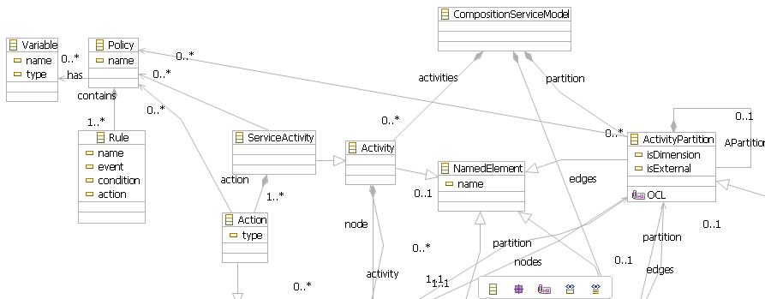
Figure 3: Extended Service Composition Metamodel

3.2 PEWS Metamodel:
El metamodelo se extiende…..

3.3 Transformation Rules:
El metamodelo se extiende…..

Source Model | Mapping Rule | Target Model | Autom- atization
Activity |  | Operation
Service Activity |  | Compostion Operation
Activity Edge |  | Operator
Control Node
Activity Partition
Policy
Rule
Variable

Case Study

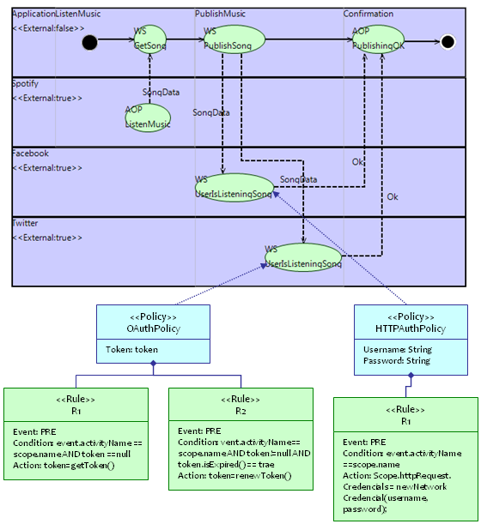

References:

- V. De Castro, E. Marcos, R. Wieringa, Towards a service-oriented MDA-based approach to the alignment of business processes with IT systems: From the business model to a web service composition model, International Journal of Cooperative Information Systems 18 (2) (2009) 225–260.
- V. De Castro, E. Marcos, J.M. Vara, Applying cim-to-pim model transformations for the service-oriented development of information systems, Information and Software Technology 53 (19) (2011) 87–105.
- V. De Castro, E. Marcos, M.L. Sanz, A model driven method for service composition modelling: a case study, International Journal on Web Engineering Technology 2 (4) (2006) 335–353.

