Case Study: GesIMED
The case study presented in this paper consists of a Web IS for medical image management and processing called GesIMED [], which we are developing in collaboration with the GTEBIM research group at Rey Juan Carlos University (RJCU).
At present, medical image modalities such as Positron Emission Tomography (PET) and Functional Magnetic Resonance Imaging (FMRI), allow us to obtain images of quantitative and qualitative cerebral activity. Neuroscience researchers, especially in the clinical field, such as neuroradiologists, neurologists and neuropsychiatrists and neuropsychologists carry out FMRI and PET studies. To do their work, they first need to obtain images and then have them processed in very different ways for improvement, correction and statistical analysis.
GesIMED [] is a Web IS operating successfully in several medical and research centres in Madrid, Spain, facilitating the work of neuroscientists and clinicians. It aims to offer neuroscience researchers (a) an easy-to-access historical medical image store and (b) a duly standardized method for processing and analysing the images. It also stores the processed and original images together in a database. Figure 3 shows a layout of the GesIMED system.
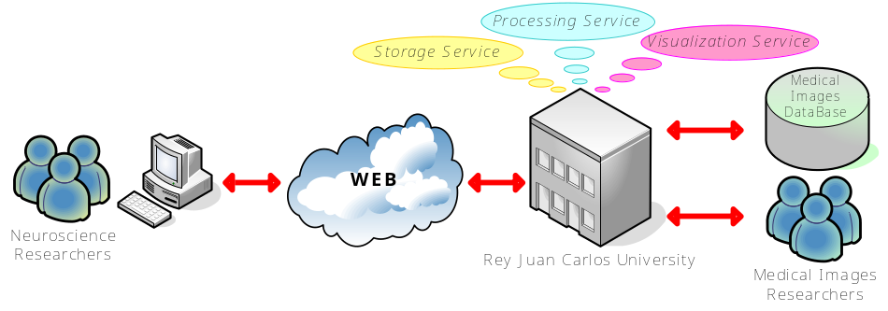
Fig. 3. Layout of the GesIMED System
The medical images researchers at RJCU offer three specific services to neuroscience researchers:
- Storage Service: A database that stores the images and the results of the processes performed on them. Neuroscience researchers may access and consult them (by study, pathology, etc.) for diagnostic purposes, research or even teaching.
- Processing Service: Two kinds of processing are offered to neuroscience researchers: analysis and segmentation. The former consists of the measurement of physical and physiological parameters, while the latter refers to image segmentation, a typical example of which would be the extraction of the bony part from a radiological image. Researchers can request processing of images stored in the database and upload medical images to be processed.
- Visualization Service: The visualization process consists of image reconstructions (e.g., creation of 3D images from 2D images) and multimodality functions (e.g., creation of both anatomical and functional image views within a single image). Following the same procedures as in the processing service, researchers may request visualizations of medical images stored in the database or upload them for viewing later.

Business Modelling: CIM Level
CIM models are used to describe the environment in which the system will be used, with no direct reference to how the system will be implemented []. In this section we shall describe the CIM models using the techniques proposed by SOD-M (see Figure 2): the value model, the business process model and the business service list.

Value Model
This model represents a business case graphically as a set of value exchanges and value activities performed by business actors and allows us to understand the business environment in which the IS will be used. It also allows us to identify the end-users of the business, the business services that will be offered by the systems to satisfy the needs of the consumers and the business collaborators, those entities that collaborate in providing the business services.
The value model is obtained by applying the e³value business modelling method [], which defines a set of concepts, originating in business administration sciences and marketing, and proposes its own specific notation for their representation in a value model. A value model shows actors exchanging things of economic value (value objects) with each other. It is also possible to represent a market segment, a set of actors that ascribe value to objects from an economic perspective. The value model furthermore shows value activities, activities performed by an actor who expects them to be profitable. A value activity may be, for example, a service offered to an actor.
Using the e³value method, we have explored the business model of the GesIMED system, representing actors who wish to exchange values with another actor. Figure 4 shows the value model obtained, where RJCU is shown as an actor. Neuroscience researchers (i.e. clinicians, neuroradiologists, neurologists, etc.) and radiologists at medical centres are identified as market segments. The services offered by the University (storage [SS], processing [PS] and visualization [VS]) are value activities, which it expects to be profitable. The value objects are the images, the results of image processing and of the visualization process, the access and querying possibilities, and the fees. Usually neuroscience researchers request research projects to finance the acquisition of medical images and their studies. They therefore pay fees (directly or indirectly) to the University for processing and visualizing the medical images, as well as for accessing and querying the database. They also pay fees to medical centres to obtain the images.
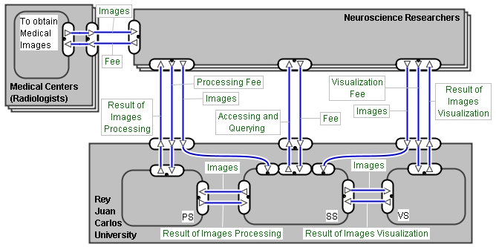
Fig. 4. Value Model of the GesIMED system
A value model permits the representation of dependency paths, which enhance the understanding of a business idea by showing all value exchanges triggered by the occurrence of an end-consumer need. A dependency path has a direction and consists of dependency nodes. A dependency node is a start stimulus (represented by a bullet), an AND-fork or AND-join (short line), an OR-fork or OR-join (triangle), or an end node (bull’s eye). A stimulus represents a trigger for the exchange of economic value objects, and an end node represents a model boundary. Figure 5 shows the dependency paths for the GesIMED system.
The dependency paths identified in Figure 5 show the followings situations. Firstly, neuroscience researchers need to obtain the images from medical centres in return for a fee; this path is indicated by the letter (a) in Figure 5. Then they contact the University to obtain processed images and visualizations. Therefore, to obtain processed images from the University – the path indicated by the letter (b) in Figure 5 – researchers send the images to be processed and pay the fee. The images are sent to the storage service where they are stored. The processing service obtains them from the storage service and in return the results are then stored in the database. A similar dependency path occurs when a neuroscience researcher needs visualizations – the path indicated by the letter (c) in Figure 5. Finally, researchers may access and query the database in return for an access and inquiry fee; this path is labelled (c) in Figure 5.
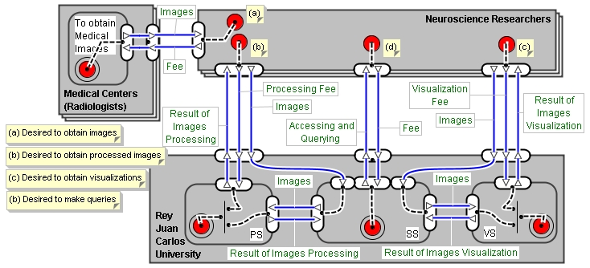
Fig. 5. Dependency paths of the GesIMED system

System Modelling: PIM level
The PIM models are used to model the functionality and structure of the system, but independently of the technological details of the platform upon which it will be implemented []. SOD-M proposes different models for the behaviour modelling of the system at the PIM level. Given that SOD-M defines a service-oriented approach for the development of ISs, such models focus on the identification of the business services to be offered by the system, and on the identification of the functionalities and processes needed to carry them out. The models proposed by SOD-M at PIM level, described in the following lines, are the use case model, extended use case model, service process model and service composition model.

Use Case Model
As a first model of the system, SOD-M proposes building a use case model, representing only the business services to be implemented in the system, along with their relations with the end consumers or users of the WIS. So, SOD-M proposes representing this model by means of the UML use case diagram technique [], but with a different building approach, that is by identifying business services instead of typical use cases.
In this model we identify the concepts of end consumer, represented as an actor; and business service, represented as a use case. It must be underlined that, in this model, only the business services to be offered through the system are represented.
Figure 7 shows the use case model for the GesIMED WIS, where the “neuroscience researcher” is represented as an actor who is the end consumer of the services to be implemented. The model also represents as use cases the different business services that will be offered by the GesIMED WIS to the neuroscience researchers: “obtain processed images”, “obtain visualizations” and “make queries”. Such business services have been identified by taking into account those on the list provided by the GesIMED WIS.
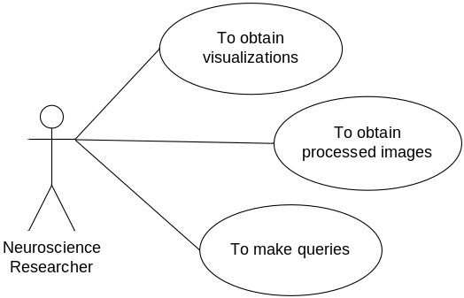
Fig. 7. Use case model of GesIMED WIS

Service Composition Model
This model extends the representation of the service process modelled in the previous model. The service composition model represents the workflow needed to carry out a service, but in a more detailed way, i.e. identifying those entities that collaborate in the business processes, performing some of the actions that are necessary to carry out the business services (the business collaborators) and the actions each of them performs. Each action identified in this model describes a fundamental behaviour unit that is part of a service activity, and which represents some transformation or processing in the system being modelled.
SOD-M proposes representing this model using the UML activity diagram technique []. In the model, the workflow needed to carry out a business service is represented and three of the concepts previously presented in section 3.1 are identified: the service process - the workflow itself -, the actions - represented in the model as an activity - and finally the business collaborators - displayed as a partition in the activity diagram. The actions identified in this model are distributed between the different collaborators of the business (partitions) represented in it. As said above, a business collaborator can be either internal or external to the system being modelled. When the collaborator of the business is external to the system, the partition of the activity diagram that represents this collaborator is stereotyped with the word <<external>>.
Figure 10 shows the service composition model, which represents the composition processes of the different actions needed to carry out each “obtain processed images” business service. To build this model, we took as input the element identified in the service delivery process model as well as some elements identified in the value model, such as business actors, market segments and value activities.
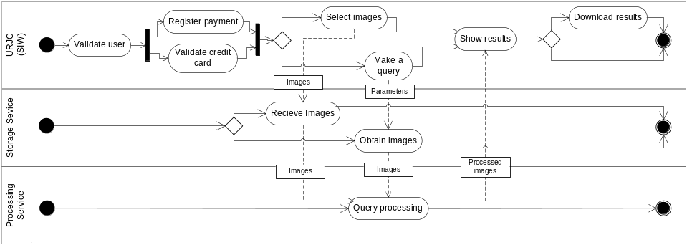
Fig. 10. Service composition model for the business service “obtain processed images”
The first step required to build this model is to identify the business collaborators who carry out operations related to the services offer by the WIS. The business collaborators are obtained from the value model, taking into account the actors, market segment or value activities that offer or receive value objects when an end-consumer need occurs. In our case, we have identified three business collaborators: RJCU, which owns the IT system and is responsible for implementing the fundamental operations of the GesIMED WIS, the “storage service” (a value activity in the value model), which performs the query processing and medical image management; and the “processing service”, which processes the images.
The next step is to break down the service activity identified in the service process model into the activity operations supported by each service activity. In our example, the service activity ‘pay querying fee’ is divided into two activity operations: ‘validate credit card’ and ‘register payment’; and the ‘make a query’ service activity is divided into: ‘make a query’ and ‘query processing’. The rest of the service activities involve single activity operations only. Once the activity operations have been identified, they have to be distributed within the partition.
The actions are obtained from the service activities, and those needed for the operation of each one are identified. Thus, for example, for the activity “perform service payment”, two actions are identified: “validate credit card” and “register payment”. Once all of the actions are identified, they are distributed among the different partitions of the activity diagram according to the business collaborator carrying out the operation.

