Dear Editors of the Journal of Systems and Software,

Please find in anexe the manuscript of our paper with the following data:
Title: πSOD-M: A Methodology for Building Service-Oriented Applications inthe Presence of Non-Functional Properties.
Author names and affiliations:
- Khalid Belhajjame, Université de Paris - Dauphine – Paris, France.
- Valeria de Castro, Universidad Rey Juan Carlos – Móstoles, Spain.
- Umberto Souza da Costa, Universidade Federal do Rio Grande do Norte – Natal, Brazil.
- Javier A. Espinosa-Oviedo, CNRS, LIG-LAFMIA, Saint Martin d’Hères, France.
- Martin A. Musicante, Universidade Federal do Rio Grande do Norte – Natal, Brazil.
- Plácido A. Souza Neto, Instituto Federal de Educação, Ciência e Tecnologia do Rio Grande do Norte – Natal, Brazil.
- Genoveva Vargas-Solar, Universidad de las Américas-Puebla, LAFMIA – Cholula, Mexico and CNRS, LIG-LAFMIA, Saint Martin d’Hères, France.
- José-Luis Zechinelli-Martini, Universidad de las Américas-Puebla, LAFMIA – Cholula, Mexico.
Corresponding author:
- Martin A. Musicante
Universidade Federal do Rio Grande do Norte – Natal, Brazil.
email: mam@dimap.ufrn.br
postal address: Cx Postal 1647, Campus Universitário Lagoa Nova
59078-970, Natal, RN
Brazil
phone number: +55 84 3215 3814 ext 1.208
+55 84 9653 4331 (mobile)
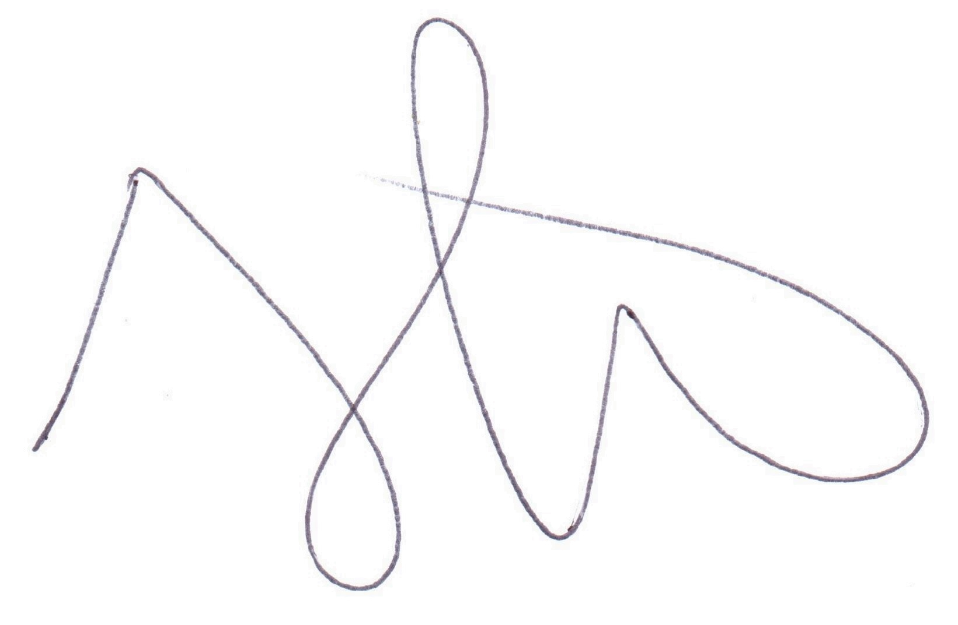

Martin A. Musicante

