**Toros University**

**Faculty of Engineering**

**Department of Computer and Software Engineering**

**Image Processing**

**-MUHAMMED MUSTAFA KAPICI-**

# LIBRARIES

## OpenCV

OpenCV (Open Source Computer Vision Library) is a library of programming functions primarily aimed at real-time computer vision. It is written in C++ and has interfaces for C++, Python, and Java. OpenCV can be used to process images and videos, perform feature detection and extraction, and implement machine learning algorithms for image and video analysis. Some of the most common use cases for OpenCV include object detection and tracking, face recognition, and image restoration.

## MATPLOTLIB

Matplotlib is a plotting library for the Python programming language. It provides an object-oriented API for embedding plots into applications using general-purpose GUI toolkits like Tkinter, wxPython, Qt, or GTK. Matplotlib is also a popular library for creating static, animated, and interactive visualizations in Python. It supports various types of plots, including line plots, scatter plots, bar plots, histograms, and 3D plots. It also provides a wide range of customization options for creating high-quality visualizations.

## NUMPY

NumPy is a library for the Python programming language, adding support for large, multi-dimensional arrays and matrices, along with a large collection of high-level mathematical functions to operate on these arrays. With NumPy, users can perform mathematical and logical operations on arrays, including basic mathematical operations like addition, subtraction, multiplication, and division. It also supports various forms of indexing and slicing of arrays, which allows users to easily extract and manipulate specific parts of an array. Additionally, NumPy provides support for linear algebra, Fourier transformation, and random number generation. It is a fundamental library for scientific computing with Python and widely used in various data science and machine learning libraries.

## PANDAS

Pandas is a Python library for data manipulation and analysis. It provides data structures and functions for working with structured data, including data frames (similar to tables in a relational database) and series (similar to arrays). Some of the key features of Pandas include powerful indexing and selection capabilities, handling of missing data, and support for merging, grouping, and reshaping data. Pandas is widely used in data science and analytics, and is a fundamental tool for working with data in Python.

# DATASET

# 

# SHAPE DESCRIPTORS

## Eccentricity

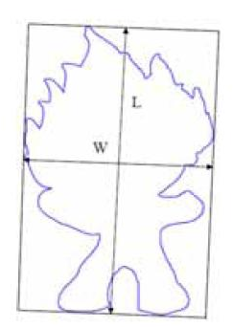Eccentricity is the measure of aspect ratio.

It’s ratio of length of major axis to minor axis (think ellipse for example)

Calculated by principal axes method or minimum bounding rectangular box

Eccentricity: E = L/W

L: length of bounding box

W: width of bounding box

Elongation: Elo = 1 - W/L

## Circularity Ratio

Circularity ratio: How similar to a circle is the shape.

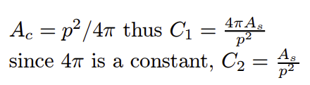C1 = As /Ac = (Area of a shape)/(Area of circle)

where circle has the same perimeter

## Ellipse Variance

Ellipse Variance Eva: Mapping error of shape to fit an ellipse with same covariance matrix as shape: Cellipse = Cshape

## Rectangularity

Rectangularity represents how rectangular a shape is how much it fills its minimum bounding rectangle

Where As is the area of a shape, Ar is the area of minimum bounding rectangle.

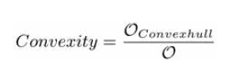

## Convexity

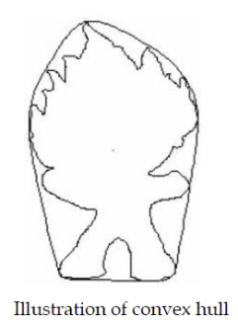

Convexity is defined as ratio of perimeters of the convex hull Oconvexhull over that of the original contour

# SHAPE DESCRIPTORS CALCULATING METHODS TO CODE

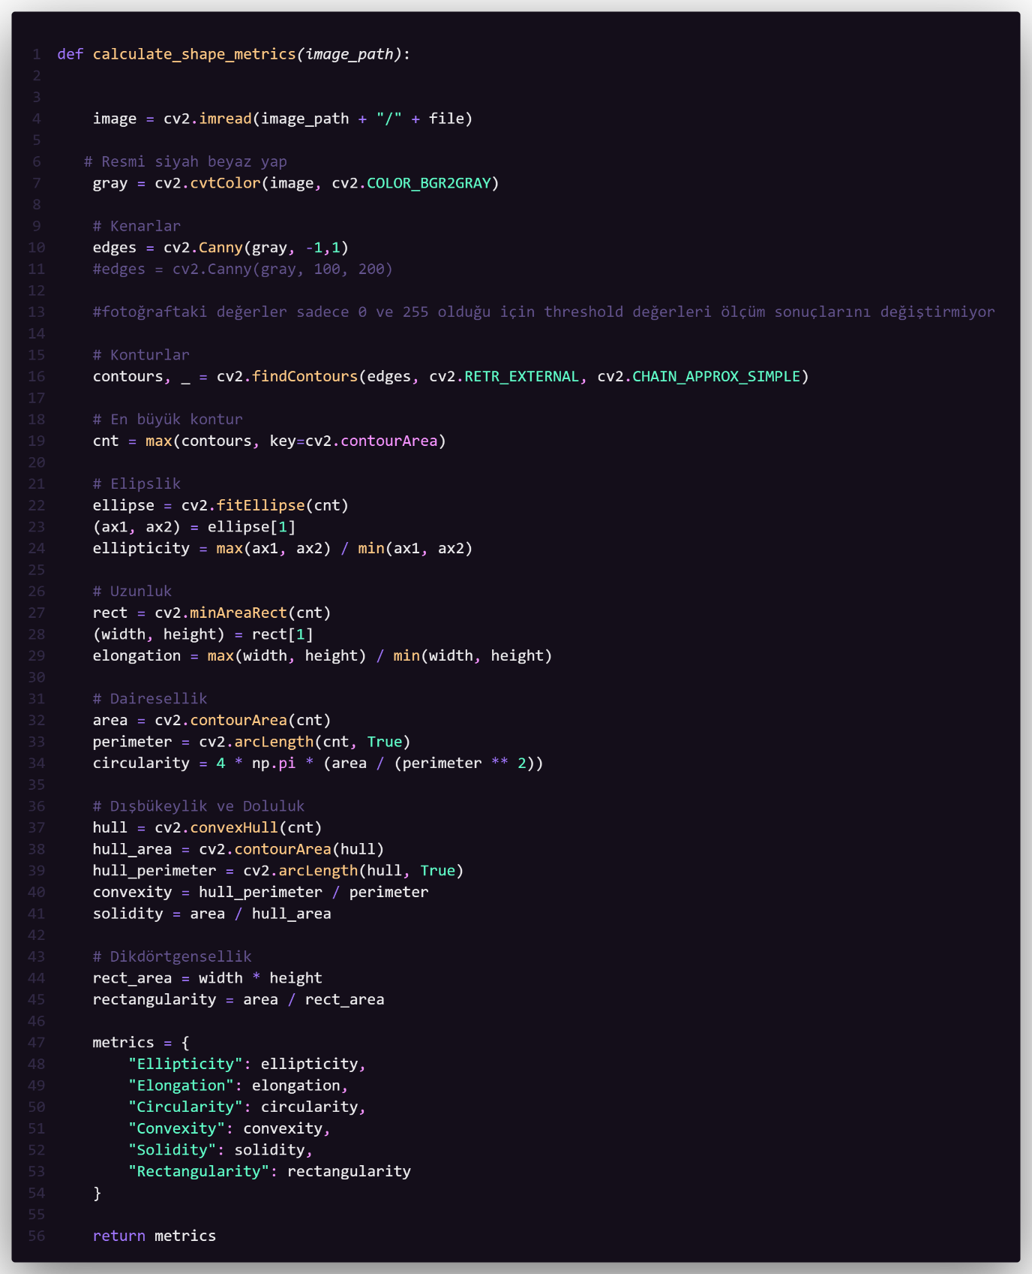

# CIRCULARITY

# CONVEXITY

# 

# ELLIPTICITY

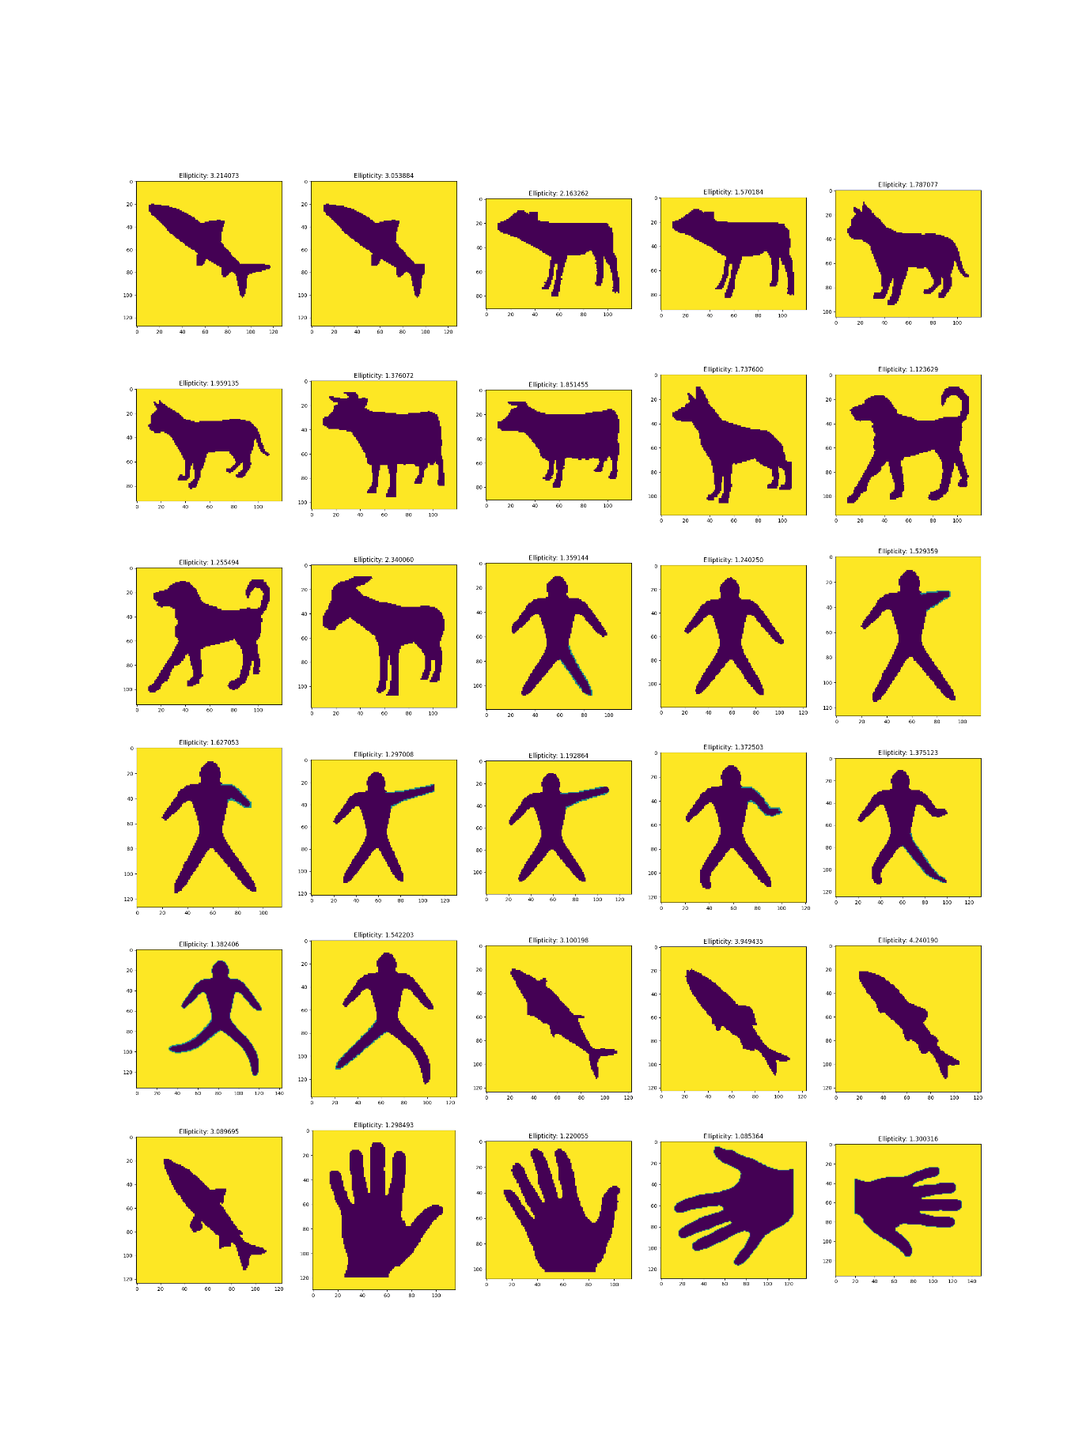

# ELONGATION

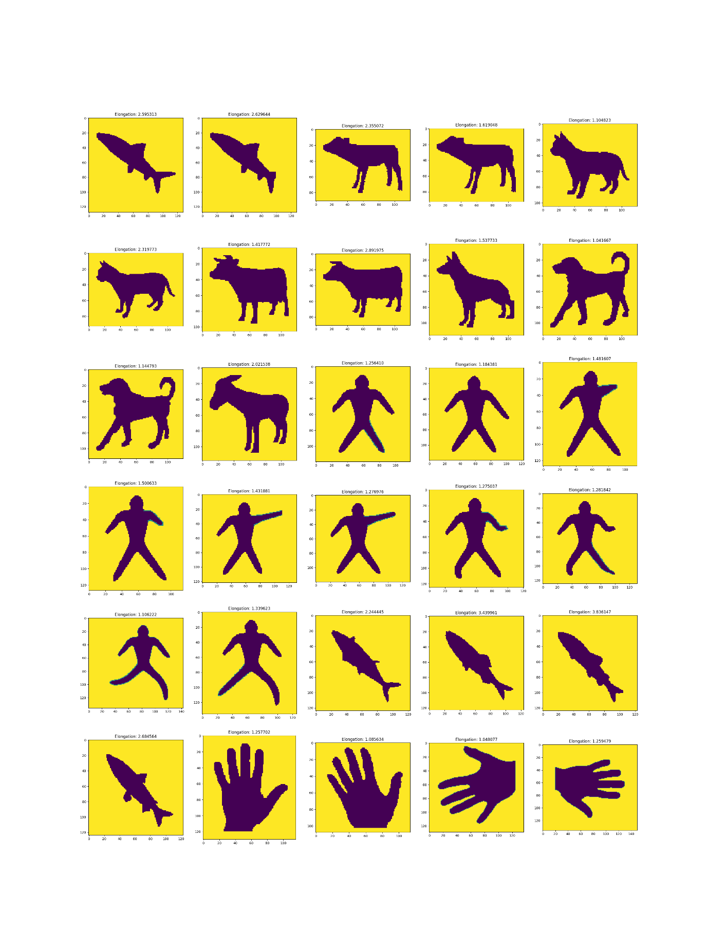

# RECTANGULARITY

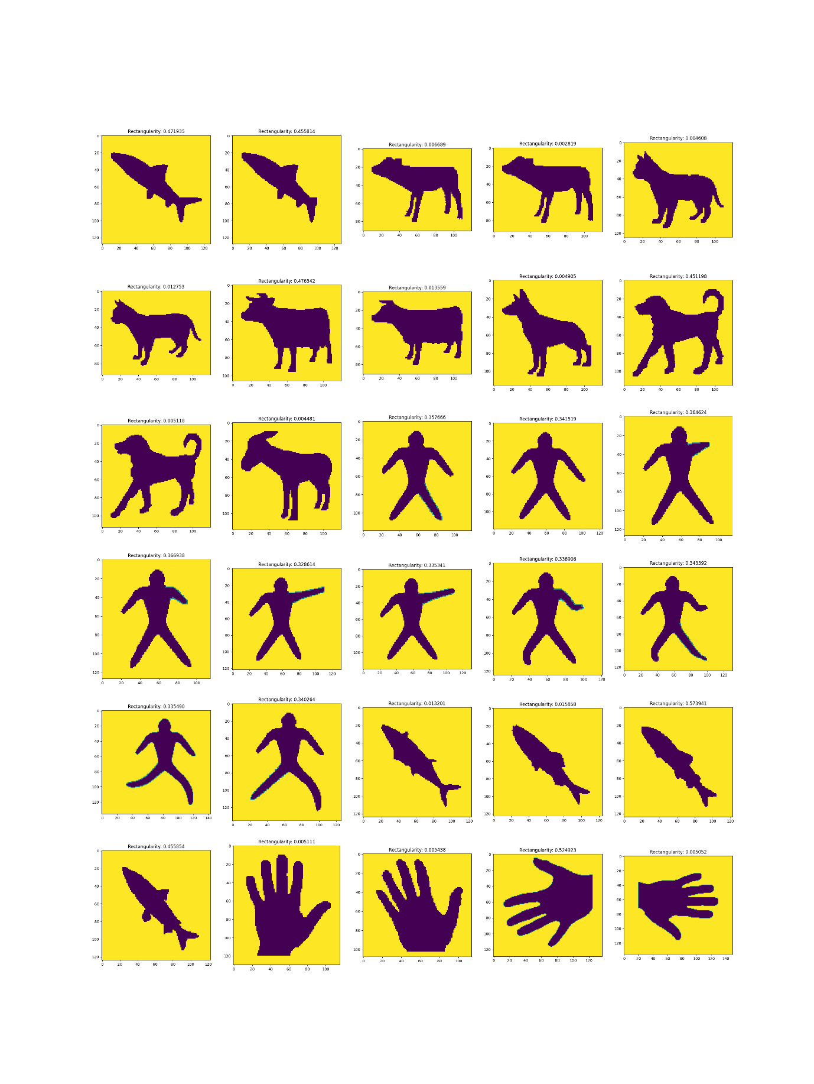

# SOLIDITY

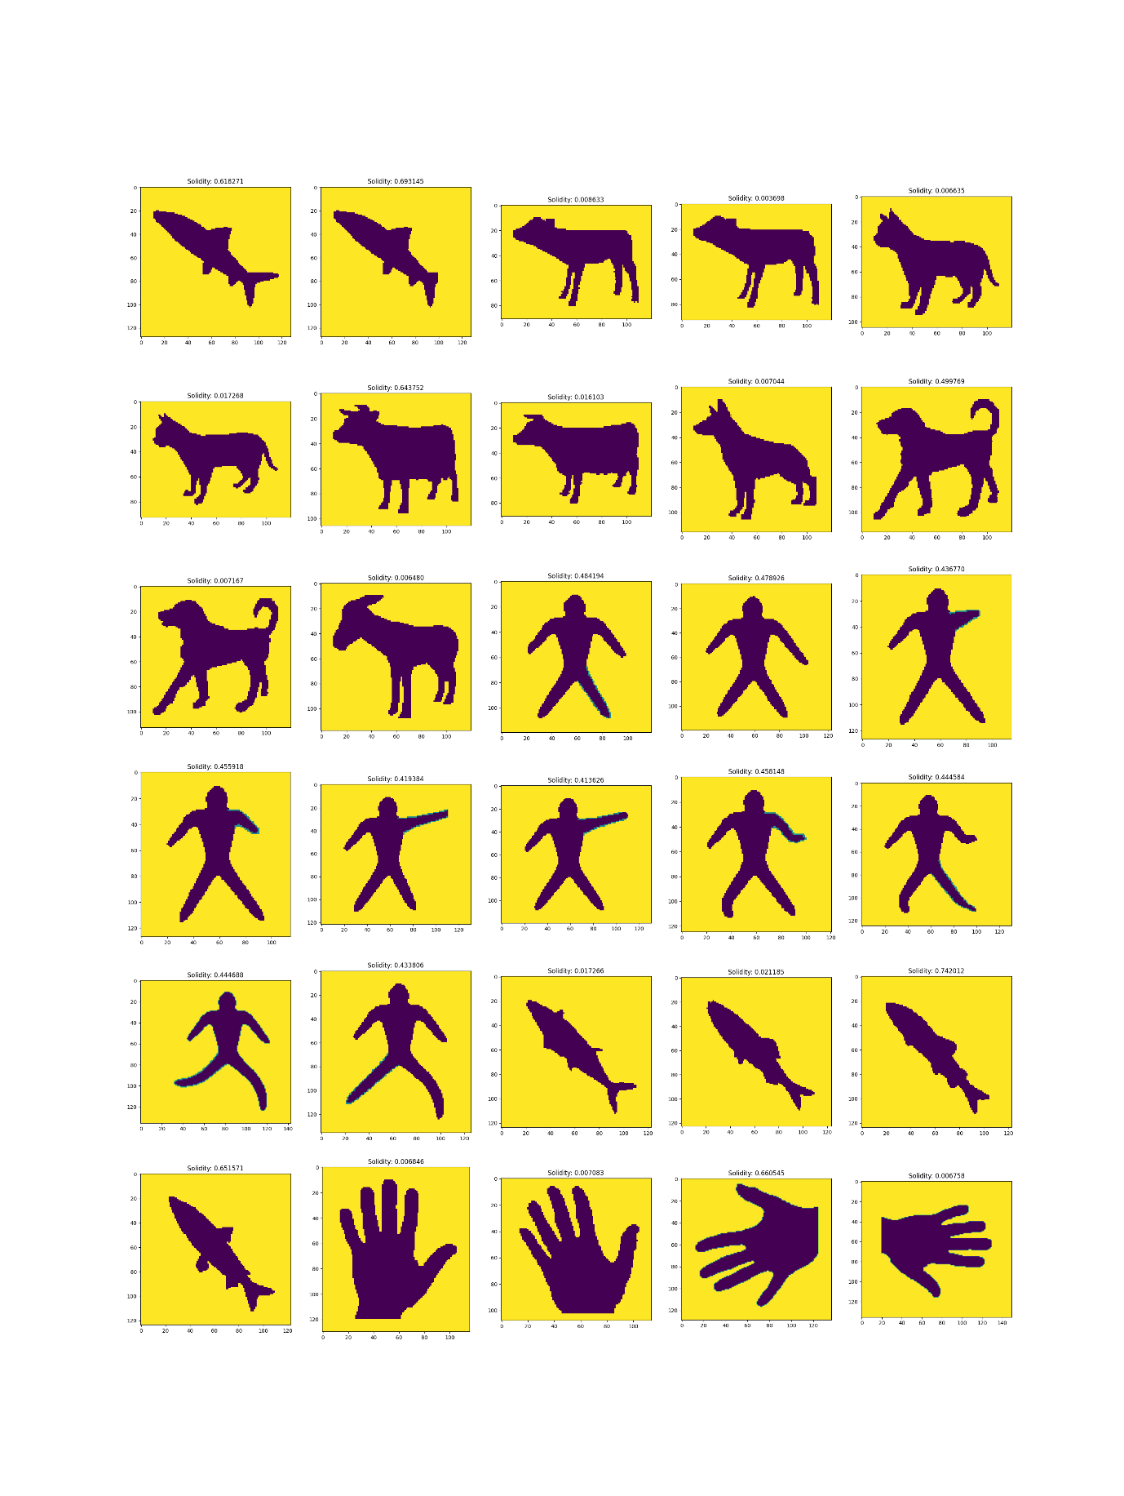

# ALL SHAPE DESCRIPTORS IN TABLE

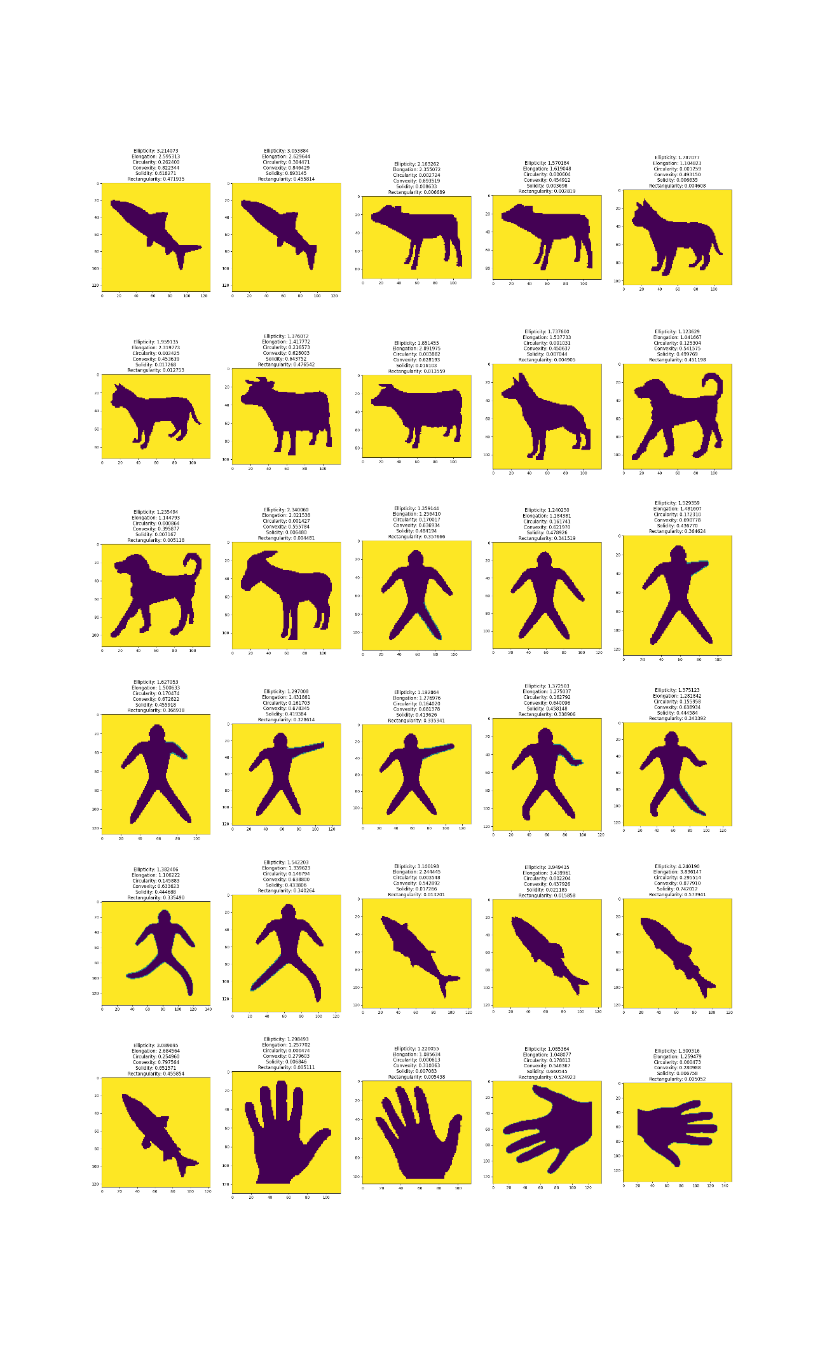

## MUHAMMED MUSTAFA KAPICI - 195050013