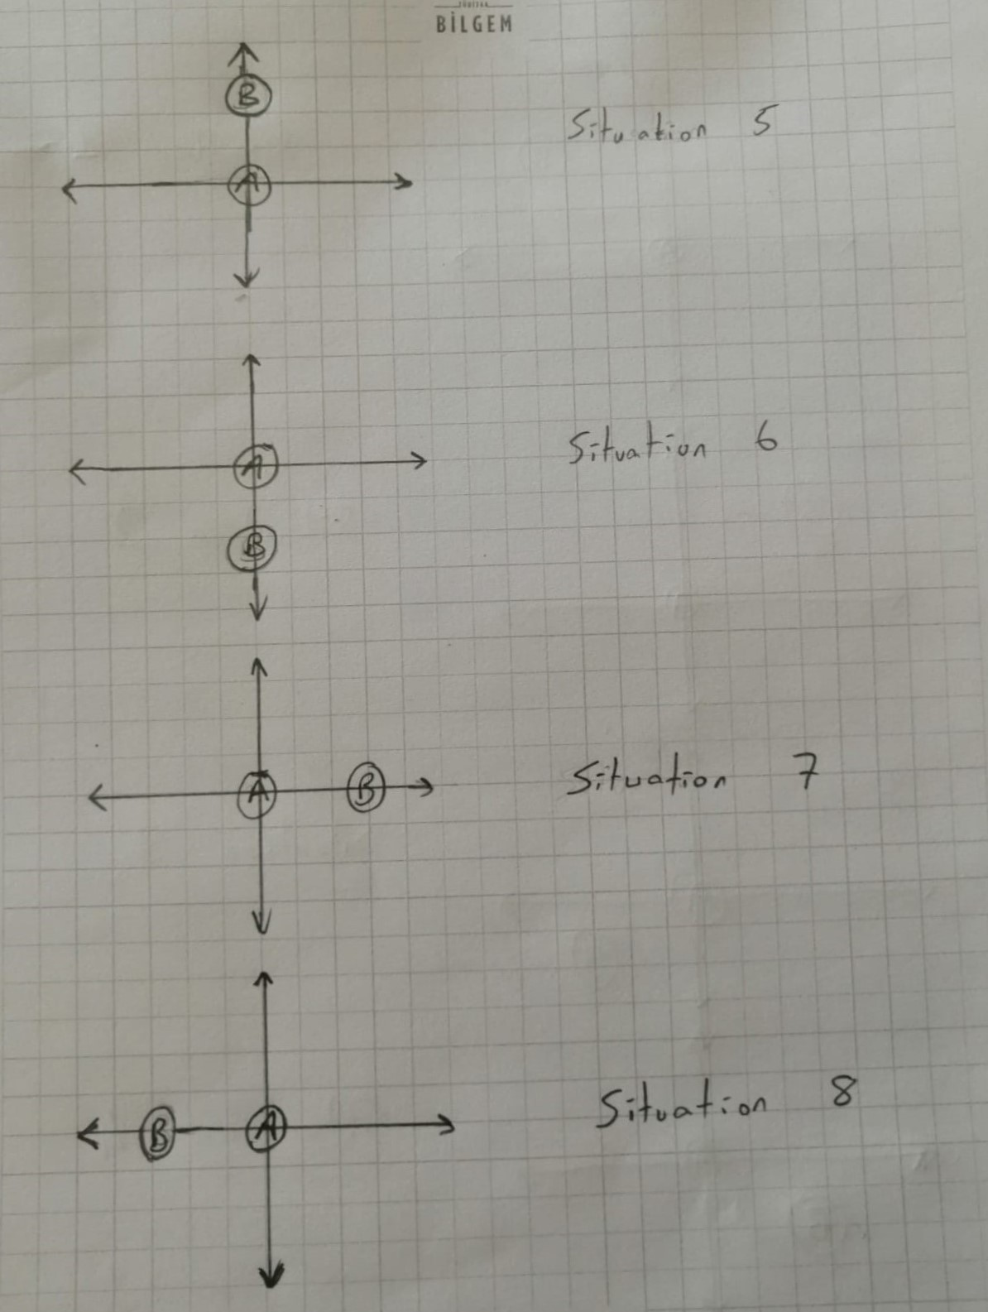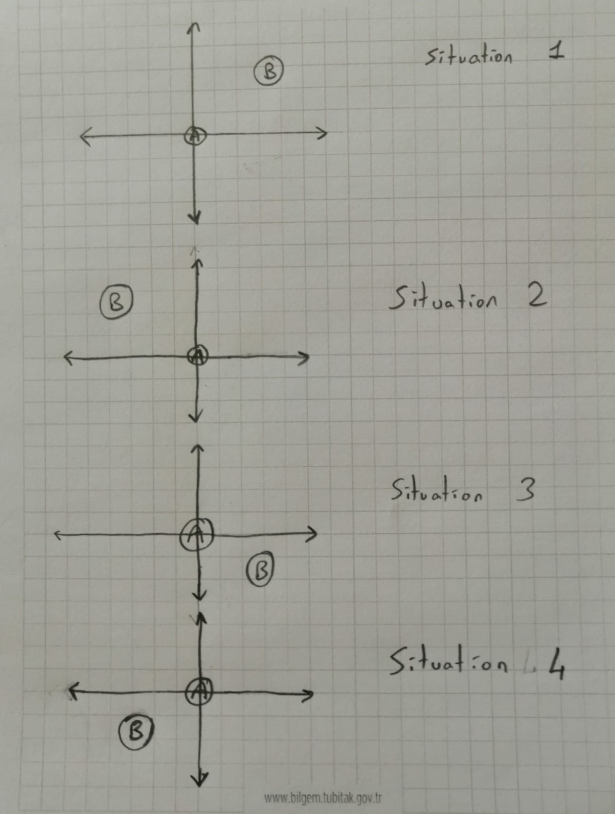The positions can be thought of as opposites. This format shows the classification of the situation and how to edit the new compass degrees.