Mahitha Valluru

CS 4800 – Algorithms and Data

Homework 4

1. Let us say we have a graph that looks like this:

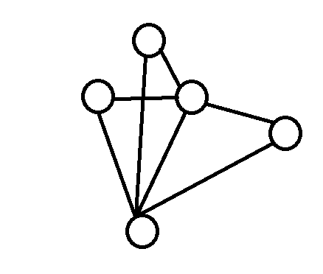

This graph contains some vertices and some edges connecting those vertices to each other.

Now, we must prove that if the degree of every vertex is at most d, then the graph is d+1 colorable.

Let’s make our graph a little easier to visualize so we can prove this:

