Mahitha Valluru

DS4100

Professor Schedlbauer

Assignment 9

To first do this assignment, there are several things that must be done. First, I will have to load any necessary libraries and set my working directory.

Here is a screenshot of the libraries I used:

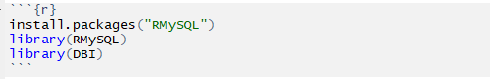

The two libraries are for loading the data frames into my MySQL database. Nothing much is needed for getting the data frames.

Now, I will have to set the working directory:

Screen Clipping

Nothing too hard so far. Now to load the csv file:

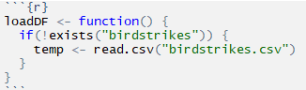

Notice that I labeled the data frame temp, because this has way too many columns that I will eventually will not need. This is also stated in the assignment, so I weeded out the unnecessary columns and created an actual data frame:

Screen Clipping

This will result in a data frame that looks like this:

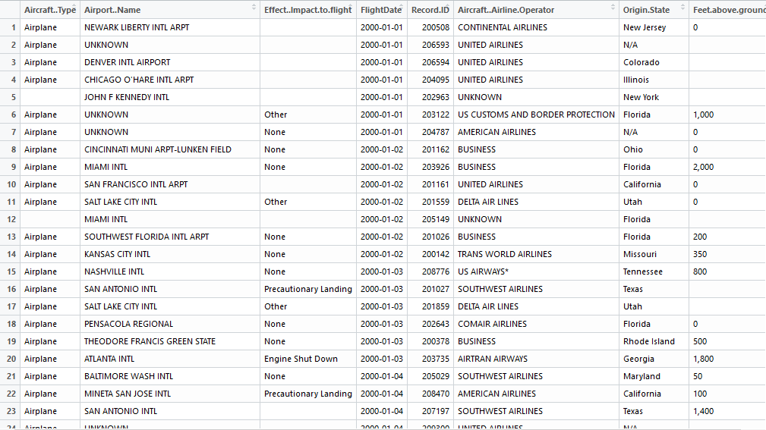

I also cleaned up the FlightDate column:

Screen Clipping

And now, the boring parts are over. I will now be creating tables. Here is a visual model/diagram that I have created in MySQL Workbench. Since I was going to be using MySQL, it made sense to me to use that to create a diagram. However, it was difficult for me to show primary and foreign keys as arrows, but there are yellow key signs right next to what should be primary and foreign keys. Hopefully they will be acceptable.

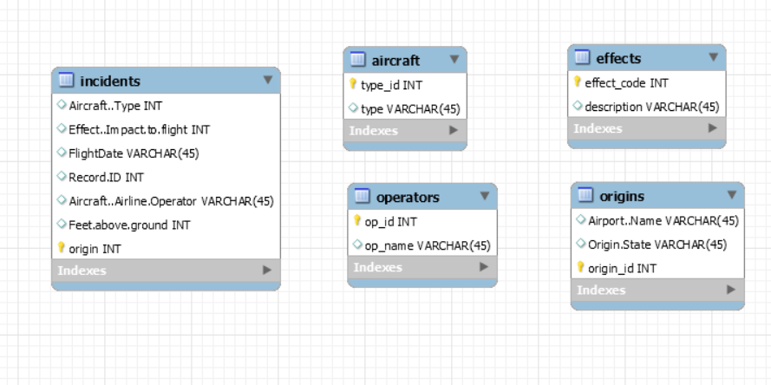

As you can see, there are 5 tables and the incidents table mirrors the birdstrikes table. The rest have some values but not all of them.

Now that I have an outline of how many tables I need and what I need for each table, I can now go on to create these tables.

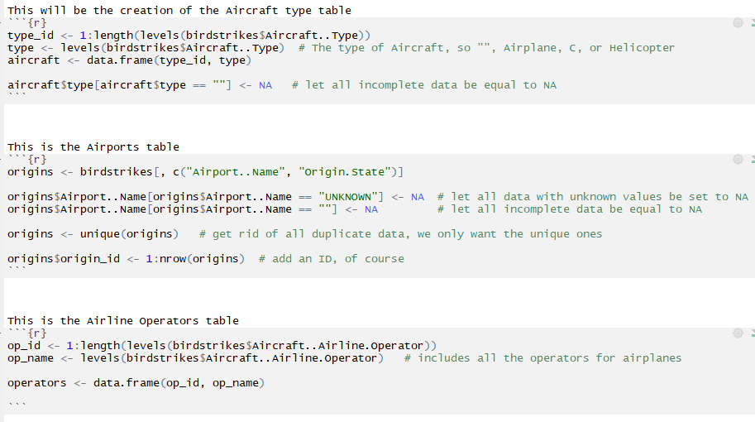

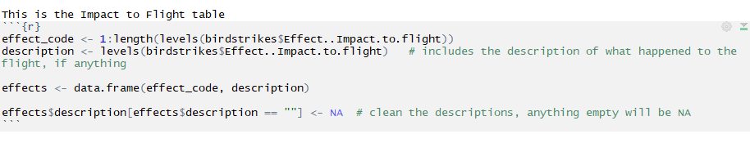

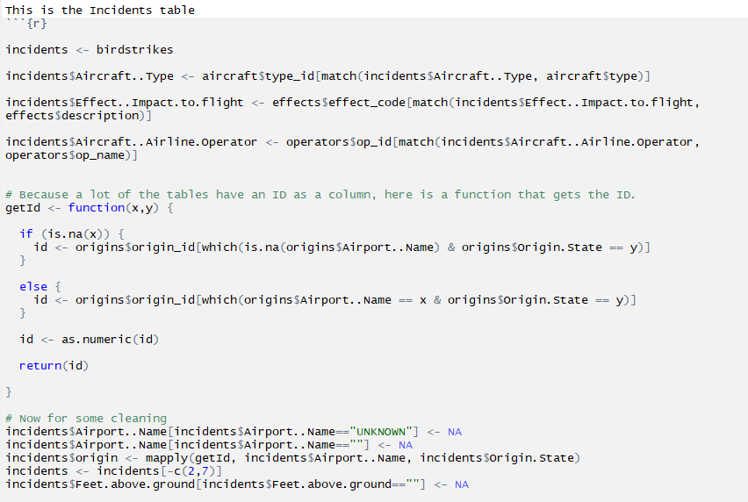

As you can see, the incidents table is quite extensive compared to the other ones mainly because I had to clean it so much, as it is a mirror of the birdstrikes table. I had to create a getID function to get the IDs of several variables and add them to the table.

On to the next part: implementing the tables into my database design and loading the data from the excel file. First, I had to write the tables:

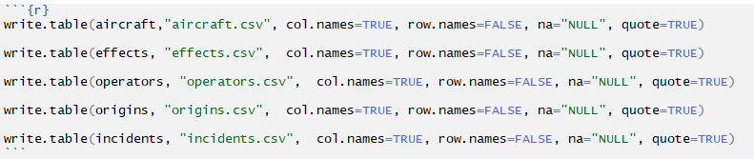

Once this was done, I had to connect to the database I had created in MySQL:

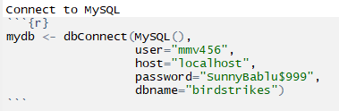

Now, I had to create my connection and write tables into the database:

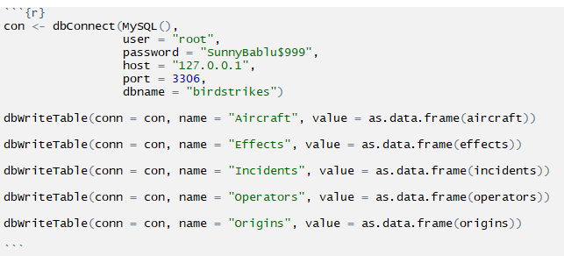

From here, I can go to MySQL and type in commands:

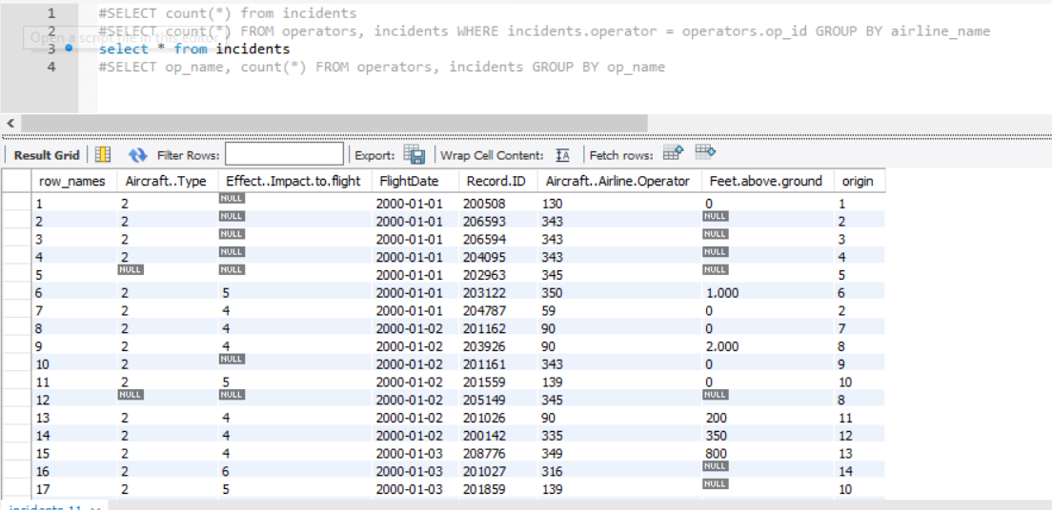

As you can see, I had other commands commented out, as I can only have one “Select” on screen at once. Once I run the command, it either prints out the value or a table with the command outputted. Here is a screenshot of a command that outputs a number:

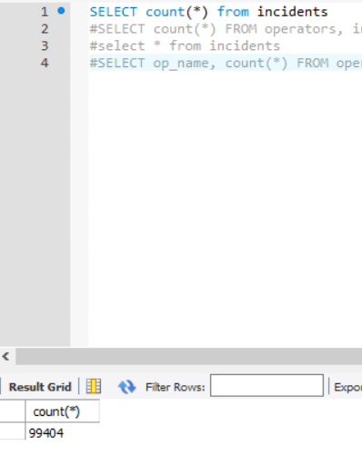

This is also the answer to the first problem of part 3, I just wanted to let you know that it works on MySQL.

I used many resources along with Professor Schedlbauer’s notes to get this to work with MySQL. The website links are:

* <http://www.jason-french.com/blog/2014/07/03/using-r-with-mysql-databases/>
* <https://www.r-bloggers.com/accessing-mysql-through-r/>
* <https://stackoverflow.com/questions/41466031/how-to-write-entire-dataframe-into-mysql-table-in-r>
* <https://stackoverflow.com/questions/41848862/how-to-check-if-the-connection-to-mysql-through-rmysql-persists-or-not>
* <https://www.siteground.com/kb/how_can_i_empty_out_an_sql_database/>
* <http://g2pc1.bu.edu/~qzpeng/manual/MySQL%20Commands.htm>
* <https://github.com/smartinsightsfromdata/rpostgresql/issues/43>
* <https://www.w3schools.com/sql/sql_select.asp>
* <https://technet.microsoft.com/en-us/library/ms190742(v=sql.105).aspx>
* <https://mkmanu.wordpress.com/2014/07/24/r-and-mysql-a-tutorial-for-beginners/>
* <https://www.connectionstrings.com/mysql/>

I had a lot of trouble connecting to the database from RStudio, but after much researching (obviously), I was able to do it.