

United Nations Development Programme

Handbook on Setting Remuneration
for Service Contract Personnel

Office of Human Resources

Bureau of Management

Table of Contents

A. Introduction 3
HQ support and monitoring mechanisms 3
No Link with UN National Salary Scales and Conditions of Service 4
Approaching the Market 4
Public Sector Focus 4
B. The Desired Market Position 5
C. Benchmark Terms of Reference 6
D. Data Collection and Analysis 6
Data Collection Methods 6
Quantification of Salaries and Benefits 7
Matching Terms of Reference 7
E. Designing the Remuneration System 8
Broadband Options 8
Setting the Remuneration Scale 9
F. Promulgation and Maintenance 10
Setting the Effective Date 10
Ageing Salary Data 10
Integration into Payroll 10
Managing Pay for Performance 11
Reporting back to Organizations 12
Updating Survey Data 12
Special Measures 13
G. Transitional Measures 13
Where the new SC remuneration scale is lower than current SC remuneration 14
Typical Integration from current to new Service Contract remuneration 14
Where the new SC remuneration scale is significantly higher than the existing SC remuneration 14

Annex 1: List of Sample Organizations that should be considered for SC Remuneration Surveys 15
Annex 2: Service Contract Survey Benchmark Thumbnail TORs 16
1. Development Project Management 16
2. Information Technology 17
3. General Administration 18
4. Human Resources – general norm is SC at support level in this service area 19
5. Finance and Accounting 20
6. Team Assistants/Secretaries 21
Annex 3: Sample Survey Questionnaire 22
Annex 4: Terms of Reference Summary Sheet 25
Annex 5: Sample Service Contract Remuneration Structure 27

Introduction

The Service Contract (SC) modality, as specified in the HR User Guide, is intended to support the engagement of personnel to service development projects and to provide non-core services where outsourcing is not a viable and/or feasible option. Individuals engaged under the SC modality are considered as local contractors. The basis for the establishment of conditions of service for SC holders is therefore found in the local labour market and must be consistent with prevailing levels of pay for similar services and comparable work in the local labour market.

SC holders are subject to all the provisions of local labour and tax law as applied to nationals generally. UNDP is not responsible for payment of tax on earnings or other taxes due on the remuneration of the SC, nor is UNDP responsible for reimbursement of taxes paid by SC holders in respect of earnings received under SC with UNDP. The payment of taxes is the sole responsibility of the individual under SC. In this regard, the remuneration package under the SC is set at the gross level and may include an additional lump sum for participation in national social insurance programmes that are mandatory in accordance with the UNDP User Guide. UNDP country offices should be cognizant of the fact that engagement under the SC modality, while not necessarily short term, is not intended to support extended employment. Individuals hired under Service Contracts are expected to return to the national market at the conclusion of the project or when the non-core function is no longer required by the office. Therefore, while Service Contract conditions should be broadly competitive, in no instance should conditions lead the market or impede the movement of individuals into and out of this contracting modality. Finally, and most importantly, the process for establishing Service Contract remuneration must be simple and transparent. The guidelines presented in this handbook have been designed to meet this objective. This handbook, is intended to provide structural guidance that will make the process straight forward and consistent across duty stations while preserving the flexibility needed to be effective at the local level. Furthermore, since SC holders will be integrated into the global payroll system, it is necessary to adopt a more consistent and structured approach in setting and maintaining SC remuneration.

The creation of Service Contract remuneration scales is a process and responsibility primarily managed by Country Offices. The Director of the UNDP Office of Human Resources (OHR) has therefore delegated to UNDP Resident Representatives full responsibility and accountability to collect and analyze data locally to create and update Service Contract remuneration scales in accordance with this Handbook. The Resident Representatives may delegate the responsibility for setting of SC remuneration to the “Responsible Officer”, who manages the planning and contracting of human resources necessary to meet the office goals, objectives and work plan. Country offices must report any significant engagement/retention issues regarding SCs which are linked to levels of remuneration.

HQ support and monitoring mechanisms

The OHR Headquarters unit responsible for compensation matters will provide technical advice and guidance to Country Offices in the setting of remuneration for SCs. The Regional Bureau will be responsible for ensuring the proper implementation of the guidelines for establishing SC remuneration. Mechanisms for reporting on the setting of SC remuneration will be established by HQ on a periodic basis to ensure conformity with this Handbook.

No Link with UN National Salary Scales and Conditions of Service
There is no direct linkage in approach or amounts between SC remuneration and the UN salary scales for the staff series of contracts. As mentioned above, the objectives of contracting SCs, as part of the UNDP workforce are consistent with overall efforts to increase national development and strengthen technical capacity and expertise under national execution. Therefore, the SC is distinct in nature, with finite functions and limited services that are directly related to the execution of development projects or service areas that can be outsourced. This approach is considered by UNDP as a means of greater involvement of the national partners in the development process.
To serve this purpose, the SC remuneration policy is distinct in the following areas:
- target market position (prevailing instead of best prevailing – 50th vs. 75th percentile)
- comparator sample (focusing on public instead of private sector employers)
- gross remuneration subject to national taxation
- enrolment in local social security schemes where available
- integrated remuneration system from junior support services through professional services organized in a broadband format
- no annual increments, all remuneration movement for individuals based only on revision of the remuneration scale.
- no retroactive adjustments in remuneration.

These primary differences should be kept in mind by Country Offices while managing SC remuneration. The essential non-career, non-core character of SC services justifies these differences. SC holders must be made aware at the outset of engagement that such differences exist and the rationale for these differences.

Approaching the Market

Service Contract remuneration is based upon prevailing conditions found in the local labour market. It is therefore necessary to gather information on local conditions of employment in a structured manner to support construction of SC remuneration scales. In keeping with the objective of simplicity, SC remuneration scales must be designed to be comprehensive, inclusive of the value of typical allowances and benefits that are found in the local labour market. The objective here is not to manage separate allowances and benefits for SC holders. Rather, the value of these should be included in the remuneration scales such that these scales are broadly competitive with the total remuneration values for the 50th percentile of the local labour market.

Public Sector Focus

To ensure competitive remuneration packages for similar services in the local labour market and to facilitate the collection and updating of remuneration information, the target market for the SC has been defined as primarily drawn from the bilateral and NGO community. These are the organizations that engage personnel with profiles most closely similar to services included in the SC. Further these organizations usually maintain clear remuneration policies and structures that ensure a reasonably accurate alignment of data.

Finally, UNDP seeks to base SC remuneration predominantly on prevailing conditions found amongst public sector and not for profit employers. While inclusion of private sector employers is anticipated to ensure coverage of the range of services included in the SC, private sector employers should constitute no more than one third of the employer sample. The inclusion of a private sector employer, as with other employers, is conditioned on the availability of clear and comprehensive information on remuneration packages offered. All employers from which data is sought should have established remuneration ranges which clearly distinguish pay for levels of responsibility.

The survey model for collecting local market information anticipates a standard sample of ten employers. In very limited labour markets, that sample may be reduced to as few as six employers. In all instances no less than two thirds of the sample must be drawn from public/not for profit employers. This means seven public-sector employers for a ten employer sample and four public sector employers for a six employer sample. A list of suggested employers for inclusion in the sample is provided in Annex 1.

Engaging organizations and employers to participate in SC surveys should be carried out on the basis of reciprocity; UNDP Country Offices must therefore emphasize the willingness to exchange information on remuneration and the commitment to confidentiality to encourage participation by outside organizations in the survey.

The Desired Market Position

In subsequent sections of the Handbook, guidelines are provided regarding benchmark terms of reference for services, data collection and analysis and the construction of the SC remuneration scale. It is recognized that within these procedures, Country Offices require flexibility in targeting a desired market position. While broadly the policy for establishing SC remuneration is to target the fiftieth percentile of the surveyed employers, Country Offices will have authority to adjust this market condition based upon the need to improve the performance of the SC remuneration system in the local market context.

Within the principle of providing competitive remuneration packages that reference predominantly a public sector sample, Country Offices will have the latitude to set remuneration to fall from the fortieth to the sixtieth percentile of the data range collected. This market position must be set broadly for the entire remuneration scale and not be set band by band.

The SC remuneration structure, addressed in Section F of this handbook, is designed again to provide great flexibility in setting the pay range to enable Country Offices to respond to changing market conditions. Where though the overall remuneration structure is not performing well, Country Offices should note these deficiencies and if necessary, seek additional guidance in collecting/analyzing local market information and adjusting the remuneration scale to improve its performance.

Benchmark Terms of Reference

A series of benchmark Terms of Reference (TOR) spanning the range of services from physical operations to substantive innovation in six occupations has been selected as the internal proxy for maintaining competitive SC remuneration. These TORs have been selected because they represent the services under SCs most frequently engaged by the UN system and because these TORs can be found and measured in most external labour markets. The benchmark TORs are by definition a representative sample and cannot reflect every possible service under SCs if a streamlined and cost-effective approach to setting SC remuneration is to be maintained. The six occupations represented by the benchmark TORs are:

- Development Programme Management
- Information Technology
- General Administration
- Human Resources
- Finance and Accounting
- Team Assistants/Secretaries

Please see Annex 2 for tables containing brief thumbnail descriptions of the SC benchmark TORs and their equivalent SC level.

Data Collection and Analysis

As described in previous sections of the Handbook, UNDP policy stipulates consistency with conditions for comparable services in the local labour market as the main basis for establishing SC remuneration. Therefore, data on local market rates must be accurately collected to ensure that remuneration levels are appropriate. This section outlines the basic approach that should be used by Country Offices.

Data Collection Methods

Approaches to data collection in remuneration surveys have evolved significantly in the last 10-15 years with the widespread adoption of new telecommunication and information technologies. HR professionals in the comparator market are typically asked to participate in several surveys each year and are becoming increasingly selective in the surveys they choose to participate in. Furthermore, with the implementation of corporate Enterprise Resource Platforms (ERPs) such as Peoplesoft, Oracle and SAP, many multinational corporations are consolidating their compensation expertise at the regional or global level. Therefore, while traditional methods of data collection involve face-to-face interviews with participating organizations at the local level, it may be necessary to adapt to more modern approaches aimed at reducing the burden on participating organizations while maintaining the accuracy of the data collected. These methods are described below:

- Pre-Interview Survey Questionnaire: A streamlined survey questionnaire may be sent to participating organizations to allow them to submit base data such as remuneraton scales and tables of benefits in advance of the survey interview. Even if organizations do not actually submit the data prior to the interview, this gives them an opportunity to prepare for the interview. A sample of this questionnaire is provided in Annex 3.

- Remote Survey Interviews: Survey interviews may be conducted by telephone. This can save a lot of time that would otherwise be spent traveling to and from organizations and completing increased security formalities adopted by many office buildings. Remote survey interviews may be necessitated by the fact that the compensation manager for a particular local market may actually be based at the organization’s regional or global service center located in another country.

- Application of Global TOR Matching Guidelines: Guidelines for establishing matches with SC benchmark TORs can be established for multinational organizations with classification systems implemented on a global or regional level.

- Preparation of Participant’s Reports: Providing good feedback to participating organizations is an integral part of securing the flow of data from year to year. The Country Office must ensure that reports sharing the results of the survey and allowing each employer to compare their data with the other participants in the survey are prepared and sent. It is of course critical that the reports be prepared to protect the confidential information of each participant. While each participant should be able to compare their data generally with that of the other participants, a participant should not be able to identify how much another particular participant is paying.

While the use of pre-interview survey questionnaires is recommended to collect data prior to the interview, this questionnaire should not be used as a substitute to the interview. The Country Office should normally conduct an interview, either by telephone or in person, to confirm the data reported and to validate the TOR matches. In order to ensure consistency and reliability of data, the TOR matches must always be established by the Country Office and not by each participating employer.

Quantification of Salaries and Benefits

In order to simplify data collection and analysis, the remuneration at the midpoint for each TOR will serve as the single reference for ensuring appropriate SC remuneration. The midpoint remuneration is the midpoint or average of the minimum remuneration and the maximum remuneration. The minimum remuneration represents an organization’s minimum hiring rate while the maximum remuneration is the highest normally attainable remuneration within each organization’s TOR. For organizations that don’t have a structured remuneration scale or defined minimum and maximum remuneration levels, the organization’s average actual remuneration or market reference point for that TOR may be used. Quantification of benefits and allowances should be consistent with general practices in the salary survey industry.

Matching Terms of Reference

The single most important component of a reliable remuneration survey is accurate matching of TORs. Without accurate matching a remuneration survey is of limited value. It is therefore important that the individual collecting the data has a solid understanding of the benchmark TORs and of the progressions of services that they represent. The following four factors should be evaluated in establishing SC TOR matches: A sheet for recording matches for the benchmark TORs is provided in Annex 4.

- Structure: Understanding the structure of the organization is critical to establishing accurate TOR matches as each TOR must be examined in the context of the other functions it interacts with. Examining the roles of all the TORs in a functional team enables a more accurate evaluation of each individual TOR. External TOR at levels above and below the benchmark TORs should also be examined to determine context.

- Content: Scope and depth of responsibilities should be examined in order to measure the substantive contribution of each TOR. Examine whether the functions of a TOR typically fall under well-established guidelines or whether origination of new perspectives or approaches is required. The complexity of analytical functions performed should also be examined.

- Progression: While the organization structure and TOR content provide most of the information necessary to establish accurate TOR matches, experience and training requirements at various levels should also be examined in order to understand movement between the levels.

- Qualifications: Finally, identify any educational requirements or the degree of specialization that may be required in a particular field for each TOR. While educational requirements alone can not be used to establish TOR matches, this information can be useful as the last piece of this four-step approach. The importance or weight given to the qualifications required may also vary across occupations with higher weights given in more technical occupations, but generally speaking this factor has the least weight in determining a TOR match.

Designing the Remuneration System

The SC is intended to provide great flexibility in engaging and recognition for high quality services. The design of the remuneration system is based upon broad bands in an integrated remuneration structure. While data is collected for specific benchmark TORs as detailed in the previous section, this remuneration data is integrated into the SC remuneration system to provide for wide remuneration ranges which support flexibility in engagement and movement through service quality evaluation measures.

Broadband Options

To ensure comprehensive data collection, remuneration data as described in the previous section has been collected for six service occupations across the eleven levels of responsibility typically found in a UNDP development project and Country Office setting. The SC remuneration structure though will integrate remuneration into five broadbands. These broadbands are aligned against the standard TOR levels as illustrated in the table below.

Contribution Value | SC Levels | Service Bands
Substantive Innovation | SC-11 | SB-5
Adaptive Delivery | SC-10 | SB-5
Analytical | SC-9 | SB-4
Basic Conceptual Comprehension | SC-8 | SB-4
Integrated Service Execution | SC-7 | SB-3
Comprehensive Process Support | SC-6 | SB-3
Specialized Process Support | SC-5 | SB-3
Basic Process Support | SC-4 | SB-2
Repetitive Support | SC-3 | SB-2
Mechanical Operations | SC-2 | SB-1
Physical Operations | SC-1 | SB-1

Setting the Remuneration Scale

This is essentially a three step process:

- aggregate individual TOR data to the band level,
- smooth the raw band data to provide for an internally consistent yet market influenced progression between bands;
- set the min/max span of remuneration for each band.

The midpoint raw TOR data may be used to set raw band market references. Following the smoothing of the SC pay scale, the raw band data should be retained for future reference as a measure of changes in the comparator organizations. The initial point of departure in constructing the remuneration scale is to use the raw TOR data for the surveyed organizations targeted to the fiftieth percentile of the market.

Since the SC remuneration system is broadbanded, it is not useful to provide global guidelines for the range of spans and differentials in levels which should guide construction. These ranges would need to be so wide as to provide little practical guidance.

Once the remuneration scale has been developed, the Country Office should examine the utility of the scale from a resource and competitive market position perspective. If necessary, the raw job data market extract should be adjusted to a higher or lower market position to improve either the competitiveness or budgetary aspects of the scale.

Finally, the SC remuneration scale should be established in local currency. Only when it is the practice of all of the surveyed organizations to denominate remuneration and make payments in a currency other than local currency should this be considered. However, to the extent possible, payment of remuneration should remain in local currency. If the remuneration scale is denominated in a currency other than the local currency and paid in local currency, the UN prevailing operational rate of exchange must be applied. Payments of remuneration to SC holders in currencies other than local currency should be based upon documented evidence of similar practice by all of the surveyed employers and confirmation of legality by the appropriate national authorities.

Promulgation and Maintenance

Setting the Effective Date

For effective management of project budgets, the promulgation and maintenance of SC remuneration scales are implemented prospectively. There is no retroactivity in setting the effective date of the SC remuneration scale, therefore in all cases the effective date of a revised SC remuneration scale can be no sooner than the first of the month following the completion of the data analysis and scale construction.

Ageing Salary Data

To ensure that SC remuneration scales are reflective of current market conditions, consideration should be given to “ageing” raw market data. The effective date of the comparator organization data will vary based upon organizational policies for adjusting remuneration. It is possible to examine trend information and estimate movement of a given market position from the date of the revision of an organization’s remuneration to the anticipated effective date of the SC revised remuneration scale.

Through data ageing there is a mechanism for ensuring both that SC remuneration is kept competitive and that the remuneration management process does not create difficulties for payrolling and budgeting. Country offices also have the flexibility to promulgate updates in SC remuneration without data ageing, bearing in mind that there is no retroactivity and all remuneration scales must be issued with prospective effect.

Integration into Payroll

Through the Atlas system, UNDP has progressively integrated all financial and human resource functions. The introduction of these guidelines to support setting SC remuneration supports the integration of SCs into the global payroll system. The SC remuneration scales must therefore, be prepared in conformity with the structures presented in Annex 2. These scales need to identify minima, maxima and midpoints by pay band and need to be electronically exportable into the Atlas system. The Global payroll unit will provide instructions for the electronic formats of Service Contract pay scales to support integration into the payroll system.

Managing Pay for Performance

The Performance Bonus for individual Service Contract holders is governed entirely through service quality assessment. The decision to grant a Performance Bonus is not automatic or granted as an entitlement.

During the Service Quality Evaluation process, the Supervisor of the SC holder: (i) makes a recommendation for a Performance Bonus, (ii) confirms that the individual has met all the contract objectives and (iii) confirms that the performance was more than satisfactory. In assessing the performance, Country Offices consider the quality of the individual’s services in comparison to the performance of other SC holders conducting similar services. The Resident Representative has sole discretion to approve recommendations for Performance Bonuses based on the Service Quality Evaluation and the availability of resources under the project.

The Performance Bonus is a one time payment granted to a SC Holder at the end of a twelve month contract after the service quality assessment. The Performance Bonus is calculated as a percentage of 1 to 3% of the gross remuneration rate that was in effect at the time of the evaluation taking into consideration the level of quality of service performance.

The following examples illustrate assessment of results and establishment of the appropriate percentage for a bonus :

Example 1: Tangible contribution:

Under the work plan, SC holder must design a MDG campaign in region X of the country, with the participation of NGOs X,Y,Z. As part of the TOR the SC holder must achieve an increased awareness in that region. The SC holder establishes an effective network in the region that results in the donor funding for the campaign, which was not foreseen in the plan, nor envisaged. This additional funding and donor presence increases visibility and contributes to the success of the campaign.
The supervisor could conclude that this SC holder performed more than satisfactory and could conclude to recommend 1 -3 % bonus.

Example 2: More than satisfactory contribution

The SC expands MDG partnership network, implements effective communication tools, and demonstrates programme relevance, which enhances UNDP's coordination role, resulting in securing additional resource streams from a critical donor.

The supervisor could easily render this achievement as more than satisfactory, and, subject to the funding situation of the particular project the SC holder is working, may consider a performance bonus of 1 - 3 %.

Example 3: Contribution Exceeding established ToR

UNDP has a project on building social facilities first level health services in a disaster area, with OCHA funding in one country as part of its post-crisis interventions. The office hires a SC holder to supervise construction work. The Plan of work is to complete the supervisor on 5 social facilities in region X and ensure completion of buildings for temporary acceptance.

The SC holder, who is a construction engineer by profession, identifies a flaw in the floor tile construction in three sites and reports this to the contractor. The architect agrees and explains in detail how the designs were made and the SC holder concludes that in fact the mistake in construction was not due to flawed designs but due to misinterpretation of those designs. Under normal circumstances, this could be overlooked since there's a nuanced difference in the way the designs should have been interpreted in construction and only a trained eye could understand this. While the responsibility of the SC holder was strictly supervision of the construction sites, in this example he/she went beyond his/her area of responsibility and intervened which created a significant saving.
The supervisor could conclude that this SC holder performed beyond expectations and could conclude to recommend 1 - 3 % bonus.

Reporting back to Organizations

Country offices should ensure that at the conclusion of a SC survey, participating organizations receive a summary report of findings. This report should include the following information:

- summary of data collected from the specific organization showing TOR matches and the valuation of their remuneration package;
- a table showing the average of all organizations by benchmark TOR and the fiftieth percentile remuneration;
- a summary table of organization practices on remuneration;
- the revised Service Contract remuneration scale.

Updating Survey Data

At the time of data collection for the SC remuneration survey, the periodicity of adjustment of surveyed organizations should be ascertained. SC remuneration scales should generally be updated annually. Data should be collected from comparator organizations at a time during the year following when a majority of these organizations revise remuneration packages. As noted above, this data should be aged to the anticipated prospective effective date.

Only in rare instances should SC remuneration scales be updated more frequently than once per year. Such updating should take place only if all of the surveyed organizations have implemented more frequent updating as well.

Again with each update of survey information, the Country Office should ensure that a report of the survey be provided to the participating organizations.

Special Measures

There are times where extreme economic or social events take place that disrupt the normal pattern of employer activity in a market. At these moments it may be necessary to take measures outside of the normal adjustment mechanisms in order to maintain an effective functioning remuneration system. Special measures are intended to provide short term partial relief during times of economic and social crisis. These measures are not intended to sustain fully purchasing power or to provide full economic insulation during periods of crisis. The measures are intended to be of short duration, typically no more than three months and in no instance longer than six months.

In acute emergency and/or economic/social upheaval which has impacted the security of a country profoundly, temporary special measures may be applied. Such measures may warrant an adjustment to SC remuneration. SC holders are eligible to receive an allowance for working under hazardous conditions only when the Chairman of the International Civil Service Commission has approved the implementation of hazard pay for UN staff. Hazard Pay is typically authorized:

- For duty stations where very hazardous conditions such as war or active hostilities prevail and where the evacuation of families and non-essential staff has taken place;
- For duty stations where no evacuation has taken place, but in which staff are required to work in hazardous conditions such as war or where active hostilities prevail, including situations where staff are required to work on cross-border missions in hazardous areas;
- Where the performance of functional medical requirements that directly expose staff to life-threatening diseases, such as severe acute respiratory syndrome (SARS) and the Ebola virus, in the course of the performance of their duties.

Hazard pay is authorized for a limited period, normally up to three months at a time, subject to ongoing review, and is lifted when hazardous conditions are deemed to have abated. SC holders are eligible to receive hazard pay only on days that they are required to work and actually do so. The daily rate is obtained by dividing the annual amount (i.e. 25 percent of the net mid-point of the SC Band) by 365 days. In some situations it may be appropriate to incorporate such a component in the form of a bonus when setting the remuneration for SCs. However, any revision to the individual SC remuneration is only made upon extension of a contract or for new contracts. The SC must include a clause stipulating that this component is short term and is reviewed on a continuous basis and may be withdrawn when the conditions improve.

Transitional Measures

Implementation of these guidelines and the introduction of a more uniform approach in establishing SC remuneration will in many duty stations require transitional measures. The introduction of these guidelines is not intended to create significant disruptions in current SC remuneration practices. Where application of these guidelines results in a SC remuneration package that is significantly different from current rates of remuneration, transitional measures should be considered.

Where the new SC remuneration scale is lower than current SC remuneration

In such instances, the current remuneration rates should be frozen. Existing SC holders will retain their individual remuneration for current contract duration. Upon conclusion of contracts, new contracts should be issued with appropriate adjustments to remuneration. Flexibility for placement of existing SC holders in the appropriate pay range should be practiced to minimize the negative impact of the change in remuneration. (i.e. placement may be at the third quartile in the range if necessary)

Where the gap between existing remuneration and the new SC remuneration scale is more than 10%, some consideration should be given to providing diminishing lumpsum differential payments for a period not to exceed 12 months into a new contract.

Typical Integration from current to new Service Contract remuneration

In most instances, integration from existing SC remuneration scales to the new remuneration scale should take place by integrating the individual SC holder at his/her current remuneration level in the point in the band closest to this amount. Placement in the band beyond its third quartile should be avoided if possible. Since all adjustment to remuneration for an individual SC holder is driven by results and separate from the movement of the remuneration scale, consideration of the movement of the new SC scale in comparison to the current scale should not be an issue.

Where the new SC remuneration scale is significantly higher than the existing SC remuneration

In cases where the new SC remuneration scale would result in increases in excess of twenty five percent or double the normal annual rate of movement in a country, whichever is lower, phasing in the new remuneration rates for existing staff should be considered. The new remuneration rates should be phased in over a period of not exceeding twenty four months. New SC holders should be placed for the most part in the lowest quartile of the appropriate band.

Annex 1: List of Sample Organizations that should be considered for SC Remuneration Surveys

Public/Not for Profit Sector |  |  |  | Private Sector
Bilaterals/ Embassies | International Organizations | NGOs | Other
USAID/US Embassy  DFID/UK Embassy  CIDA/Canadian Embassy  SMV/Dutch Embassy  GTZ/German Embassy  AUSAID/Australian Embassy | World Bank  Regional IFIs  European Union | Save the Children  ICRC  CRS  World Vision  MSF  Conservation Int’l  IUCN  Heifer Int’l  RTI | Ford Foundation  Wellcome Trust  Clinton Foundation | ABT Associates  Chemonics  Colgate/Palmolive  Proctor & Gamble  Unilever  Exxon/Mobil  Shell

Annex 2: Service Contract Survey Benchmark Thumbnail TORs

- Development Project Management

Contribution Value | SC Level | Sample Service area | Thumbnail TOR description
Substantive Innovation | SC-11 | Senior Project Officer | Innovate development programme in a major sector of activity. Design project portfolios and promote organization’s capacity as a reliable partner with national counterparts. Ensure coordination of sectoral activities with broader country programme. Advocate on behalf of organization’s goals.
Adaptive Delivery | SC-10 | Project Officer | Design sectoral programme initiatives to support broader country programme goals. Assess project proposals for relevance and coherence. Organize project execution consistent with programme objectives engaging national counterparts and building reputation for quality design and reliable delivery.
Analytical | SC-9 | Project Officer | Assess project proposals for quality and consistency. Identify project delivery issues and ensure effective coordination of project resources. Work closely with national counterparts to build cooperative relationships and establish the organization as an effective partner.
Basic Conceptual Comprehension | SC-8 | Assistant Project Officer | Review project components, develop project resource profiles and timelines. Assess delivery issues and works with national counterparts to build common understanding and coordination on project activities.
Integrated Service Execution | SC-7 | Sr. Programme Assistant | Oversee support activities in project implementation including procurement, recruitment and operations logistics. Assess support requirements against project objectives and operating environment.
Comprehensive Process Support | SC-6 | Programme Assistant | Prepare project financial statements and manage project budgets, monitoring expenditures against established allocations
Specialized Process Support | SC-5 | Sr. Programme Clerk | Organize statistical data on project implementation which supports transparent management of project resources. Support procurement and recruitment related project activities
Basic Process Support | SC-4
Repetitive Support | SC-3
Mechanical Operations | SC-2
Physical Operations | SC-1

- Information Technology

Contribution Value | SC Level | Sample Service area. | Thumbnail TOR description
Substantive Innovation | SC-11 | Chief, IT Services | Organize provision of integrated services covering system, hardware and software. Develop and sustain performance standards aligned with business cycles
Adaptive Delivery | SC-10 | IT Operations Specialist | Oversee system integrity and operation, ensuring continual secure and stable operating environment. Promote accessibility and utility to user community
Analytical | SC-9 | Systems Analyst/Developer | Advise on system configuration to promote optimal use by individual users. Review current operations identifying areas where improved performance is needed.
Basic Conceptual Comprehension | SC-8 | Systems/ Analyst - Programmer | Analyze basic system design requirements, Write programme code and validate system functionality from development through production stage. Assess system performance against design specifications
Integrated Service Execution | SC-7 | Webmaster | Oversee development and maintenance of web services and web platform. Advise on development of web portals for delivering information.
Comprehensive Process Support | SC-6 | OTC | Ensure operational services of network/hardware/ software and advise users on basic access issues.
Specialized Process Support | SC-5 | Help Desk Asst | Provide specific assistance with respect to network and software questions. Maintain overview of overall system performance
Basic Process Support | SC-4
Repetitive Support | SC-3
Mechanical Operations | SC-2
Physical Operations | SC-1

- General Administration

Contribution Value | SC Level | Sample Service area | Thumbnail TOR description
Substantive Innovation | SC-11 | Building Manager | Oversee management of premises including contracted services, office supplies and procurement, layout and maintenance
Adaptive Delivery | SC-10 | Admin. Services Specialist | Advise on delivery of specialized administrative support related to procurement and or supply including service contracting and insurance related to office operations
Analytical | SC-9 | Admin. Services Officer | Analyze administrative service needs to support specific business operations encompassing travel, transport, supply and/or communication
Basic Conceptual Comprehension | SC-8 | Admin. Services Officer | Compile/analyze data on admin services performance against organization need. Organize reporting systems on admin services delivery. Provide support in analysis of major service delivery programmes.
Integrated Service Execution | SC-7 | Sr. Admin. Assistant | Supervise provision of general administrative services. Oversee quality of service delivery related to timeliness and relevance to business needs. Advise management on service process adaptation and evolution
Comprehensive Process Support | SC-6 | Admin. Assistant | Provide specialized process delivery in a specific administrative service, ensuring consistency and timeliness of delivery
Specialized Process Support | SC-5 | Sr. Admin. Clerk | Review specific service needs against established procedures, process requests for servicing, anticipating timing and delivery issues
Basic Process Support | SC-4 | Admin. Clerk | Review service needs in a relatively simple operational or procedural environment. Ensure consistency in delivery against established service standards
Repetitive Support | SC-3 | Sr. Driver | Provide chauffeur services at the representational level including knowledge of travel, customs and protocol issues
Mechanical Operations | SC-2 | Driver | Provide chauffeur services
Physical Operations | SC-1 | Messenger | Support internal communications through movement and storage of documents, files and correspondence. Delivery hard copy documentation outside of the organization

- Human Resources

Contribution Value | SC Level | Sample Service Area | Thumbnail description
Substantive Innovation | SC-11 | HR Advisor | Manage service delivery platform or major policy component of HR Programme. Integration of use of technology with timely, appropriate service focus. Concentration on quality/responsiveness
Adaptive Delivery | SC-10 | HR Specialist | Provide refined HR advice/service in provision of substantive support to business process
Analytical | SC-9 | HR Services Analyst | Provide dedicated HR Services in the areas of recruitment, entitlement administration or learning and development
Basic Conceptual Comprehension | SC-8 | HR Services Analyst | Support provision of HR Services through managing ERP datasets, analyzing service requests against existing policies, organizing data on workforce trends and service delivery performance
Integrated Service Execution | SC-7 | Sr. HR Services Assistant | Organization of integrated process delivery, optimizing use of technology, ensuring relevance and optimal utility to user community
Comprehensive Process Support | SC-6 | HR Services Assistant | Provision of specialized process services in entitlement mgmt and contracting, promoting consistency and responsiveness to client community
Specialized Process Support | SC-5 | HR Clerk | Processing of entitlement/recruitment needs for client community with focus on timely response
Basic Process Support | SC-4
Repetitive Support | SC-3
Mechanical Operations | SC-2
Physical Operations | SC-1

- Finance and Accounting

Contribution Value | SC Level | Sample Service Area | Thumbnail TOR description
Substantive Innovation | SC-11 | Accounting /Financial Specialist | Advise on accounting systems and policies to promote optimal and soundest use of financial resources, advise business units on financial management and promote awareness of financial management dimensions to business activities
Adaptive Delivery | SC-10 | Sr. Accountant | Provide specific accounting services to support business development and execution. Ensure timely adaptive services in sync with business needs. Advise managers on specific issues related to sound accounting principles
Analytical | SC-9 | Accountant | Analyze specific accounting issues related to business development and execution. Propose accounting services and processes to support sound financial management and responsive servicing
Basic Conceptual Comprehension | SC-8 | Jr. Accountant | Organize information on performance of accounting systems, monitor performance of accounting functions and provide oversight on delivery of accounting services.
Integrated Service Execution | SC-7 | Sr. Accounts Assistant | Oversee management of accounting information systems, validate system integrity and ensure timely production of reports and accounting information.
Comprehensive Process Support | SC-6 | Accounts Asst | Prepare periodic financial reports, reconcile accounting information.
Specialized Process Support | SC-5 | Sr. Accounting Clerk | Validate complex accounting transactions, ensure timely provision of services consistent with accounting procedures.
Basic Process Support | SC-4 | Bookkeeper | Examine basic accounting transactions, ensure appropriate posting of accounting information.
Repetitive Support | SC-3
Mechanical Operations | SC-2
Physical Operations | SC-1

- Team Assistants/Secretaries

Contribution Value | SC Level | Sample Service area | Thumbnail TOR description
Substantive Innovation | SC-11
Adaptive Delivery | SC-10
Analytical | SC-9
Basic Conceptual Comprehension | SC-8
Integrated Service Execution | SC-7
Comprehensive Process Support | SC-6 | Executive Assistant | Provide confidential secretarial and administrative assistance at the representational and/or highest executive level. Communicate executive decisions and directions
Specialized Process Support | SC-5 | Sr. Secretary | Provide secretarial and communication support to a large business unit, facilitating integration of communication and business activity with other units of the organization
Basic Process Support | SC-4 | Secretary | Provide basic secretarial support to a small business service including text processing and information management
Repetitive Support | SC-3 | Clerk-Typist | Manage information in both hard copy and electronic format. Facilitate distribution and retrieval of business information
Mechanical Operations | SC-2
Physical Operations | SC-1

Annex 3: Sample Survey Questionnaire


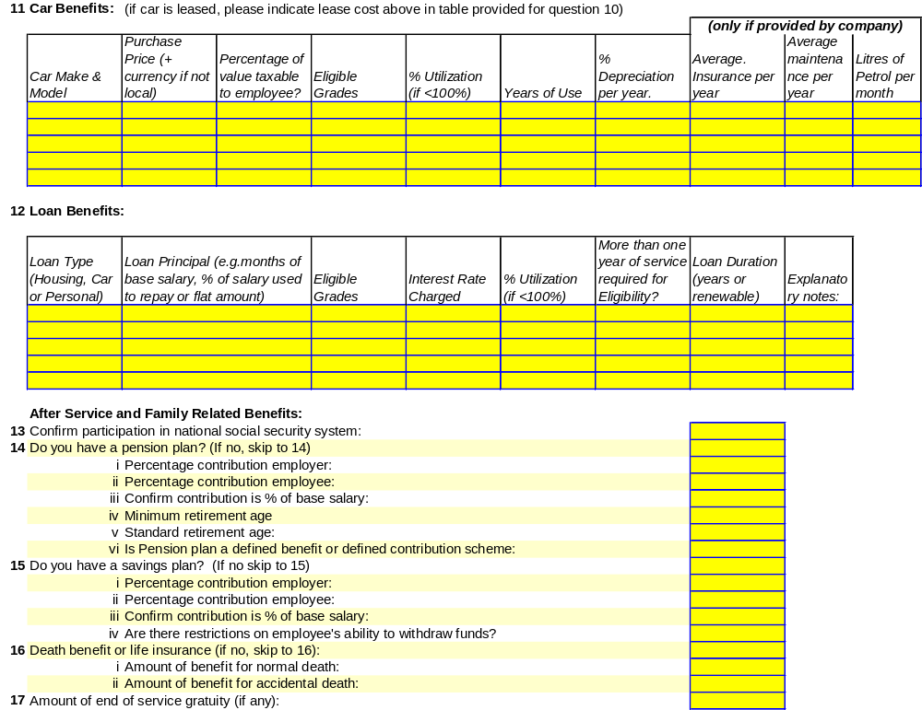
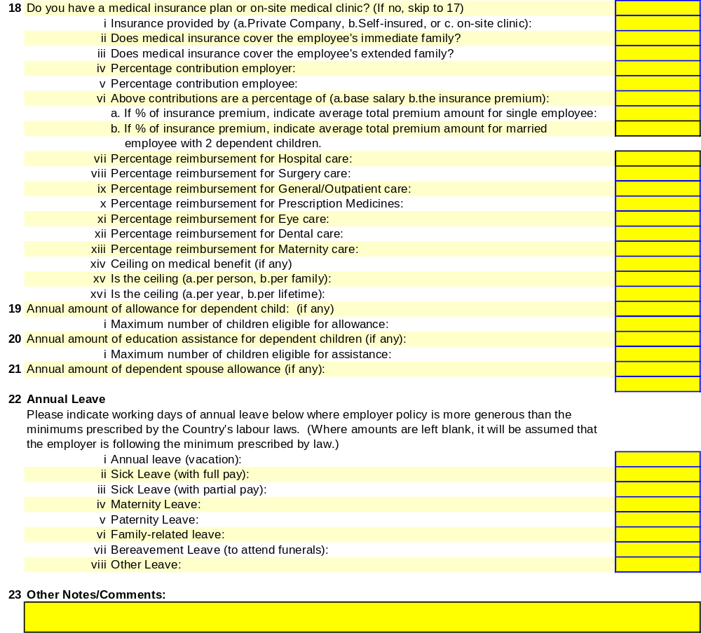

Annex 4: Terms of Reference Summary Sheet

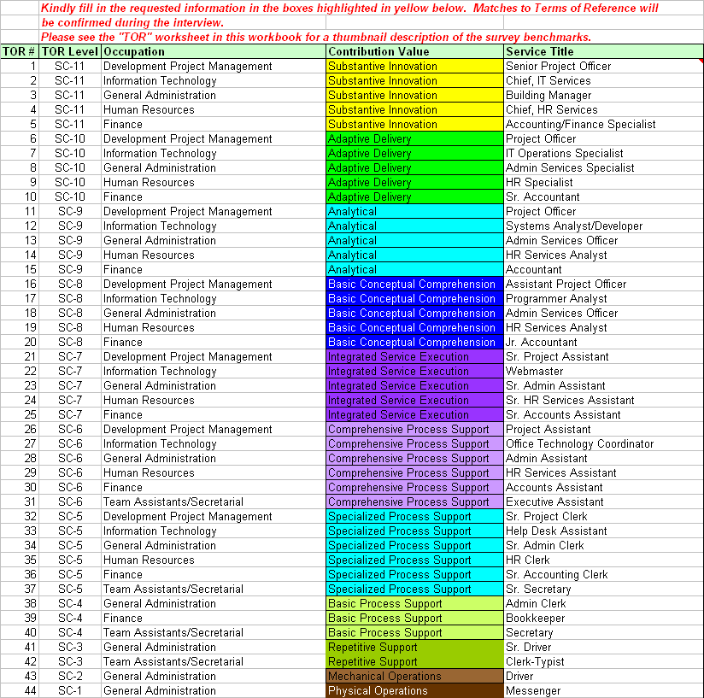


Annex 5: Sample Service Contract Remuneration Structure

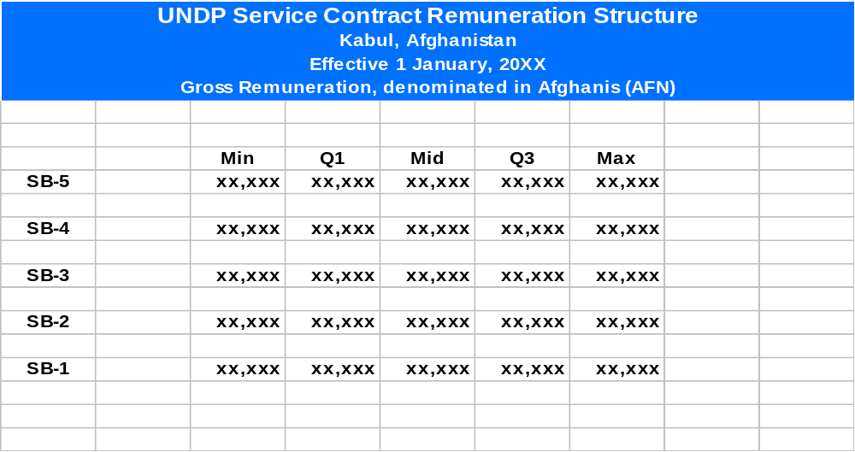

See UNDP Service Contract User Guide for guidelines regarding social insurance payments.
Please note that TORs below the SC5 level have been left blank intentionally as specialized functions in Development Project Management are not found at these levels.
Please note that TORs below the SC5 level have been left blank intentionally as specialized functions in Information Technology are not found at these levels.
Please note that while service contracts serving in the area of Human Resources in UNDP projects do not typically exceed the SC-9 level, TORs at the SC-10 and SC-11 levels are included to allow for matching to those levels of responsibility in the external labour market if they exist. This allows for additional external data points to inform the establishment and maintenance of the SB-5 pay ranges. TORs below the SC5 level have been left blank intentionally as specialized functions in Human Resources are not found at these levels.
Please note that TORs below the SC4 level have been left blank intentionally as specialized functions in Finance and Accounting are not found at these levels.
Please note that TORs above the SC6 level and below the SC3 level have been left blank intentionally as specialized functions for Team Assistants/Secretaries are not found at these levels.

