By: Quan Huie, Vanessa Montoya, Steven Rorabaugh, Melissa Salazar, Hein San

Table of Contents

[Problem Statement 3](bookmark://_Toc46239648#_Toc46239648)

[Summary 3](bookmark://_Toc46239649#_Toc46239649)

[Customer Profile 3](bookmark://_Toc46239650#_Toc46239650)

[Goals 4](bookmark://_Toc46239651#_Toc46239651)

[MVP Goals 4](bookmark://_Toc46239652#_Toc46239652)

[Stretch Goals (//Add one stretch goal for each of us) 4](bookmark://_Toc46239653#_Toc46239653)

[In scope Scenarios 5](bookmark://_Toc46239654#_Toc46239654)

[P0: 5](bookmark://_Toc46239655#_Toc46239655)

[Sign**-**in page**:** 5](bookmark://_Toc46239656#_Toc46239656)

[Quizpage**:** 5](bookmark://_Toc46239657#_Toc46239657)

[Electionspage (Matches)**:** 5](bookmark://_Toc46239658#_Toc46239658)

[Politician Profile page**:** 5](bookmark://_Toc46239659#_Toc46239659)

[Voting page: 5](bookmark://_Toc46239660#_Toc46239660)

[Misc: 5](bookmark://_Toc46239661#_Toc46239661)

[P1 5](bookmark://_Toc46239662#_Toc46239662)

[Self-match: 5](bookmark://_Toc46239663#_Toc46239663)

[Stats: 6](bookmark://_Toc46239664#_Toc46239664)

[Elections page (matches): 6](bookmark://_Toc46239665#_Toc46239665)

[Voting page: 6](bookmark://_Toc46239666#_Toc46239666)

[Out of scope 6](bookmark://_Toc46239667#_Toc46239667)

[P2: 6](bookmark://_Toc46239668#_Toc46239668)

[Sign-uppage**:** 6](bookmark://_Toc46239669#_Toc46239669)

[Quizpage**:** 6](bookmark://_Toc46239670#_Toc46239670)

[Politician ProfilePage**:** 6](bookmark://_Toc46239671#_Toc46239671)

[Explore politicians: 6](bookmark://_Toc46239672#_Toc46239672)

[Voting page**:** 6](bookmark://_Toc46239673#_Toc46239673)

[Newsscreenpage**:** 6](bookmark://_Toc46239674#_Toc46239674)

[Get involvedpage**:** 7](bookmark://_Toc46239675#_Toc46239675)

[Ballot Propositionspage**:** 7](bookmark://_Toc46239676#_Toc46239676)

[Anti-Matchpage**:** 7](bookmark://_Toc46239677#_Toc46239677)

[Misc: 7](bookmark://_Toc46239678#_Toc46239678)

[UX 7](bookmark://_Toc46239679#_Toc46239679)

[Breakdown of work 11](bookmark://_Toc46239680#_Toc46239680)

[Competitor Analysis 12](bookmark://_Toc46239681#_Toc46239681)

[Future Opportunities 13](bookmark://_Toc46239682#_Toc46239682)

[Politician Profile 13](bookmark://_Toc46239683#_Toc46239683)

[State and Federal Governments: 14](bookmark://_Toc46239684#_Toc46239684)

[Voting 14](bookmark://_Toc46239685#_Toc46239685)

[Legislation: 14](bookmark://_Toc46239686#_Toc46239686)

[Student Governments: 14](bookmark://_Toc46239687#_Toc46239687)

# Problem Statement

According to census.gov, in 2018, people aged 18-29 averaged 21.4% of the total votes in local elections; in areas such as Florida’s District 11 this number was even lower, at 12.7%. There is evidence that young voters can create positive change regarding issues that uniquely impact them, such as student debt, gun control, climate change, and affordable housing. Knowing the value of young voters, how might we increase their participation in local government by raising voter turnout for people between the ages of 18-29 so that they can advocate for themselves and instigate change?

# Summary

Have you ever felt like you had no idea who the people on your local ballot were? Have you skipped out on voting because you didn’t have the time to find unbiased news? Designed to make voting in local elections simple, Poliquick aims to personalize the user's need to get informed. You can customize our app every step of the way to fit your interests. This is your one stop-shop to find information on anything from upcoming county elections, poll locations, and candidate rankings based on the issues you care about. Skip the hassle of opening 12 different tabs just to compare candidates. Unlike our competitors, we are centralized and personalized to aid you in making your best and most informed decision.

# Customer Profile

Poliquick’s initial target market is people who are 18-29 years old, who are registered to vote but didn't vote in past year.

* Who – People aged 18-29 years old
* What – who are uninformed about their local government candidate, with little time to research
* Where – local, based on voting districts
* Why – According to census.gov, in 2018, people aged 18-29 averaged 21.4% of the total votes in local elections; in areas such as Florida’s District 11 this number was even lower, at 12.7%. stats to consider (based on our user surveys with people in our target age group):
  + Only 10% rated above a 5 out of 10 in local gov participation
  + 70% rated below a 5 out of 10 in local gov participation
  + Average 3.22 out of 10; Median 3 out of 10
  + Only 26.4% were not interested in becoming more involved
  + 53.4% voted locally
    - Of those who did not vote locally, only 22.6% were not interested in becoming more involved
* When – typically during peak election times
* How – by matching voters with local politicians through a quick and easy quiz, providing dates of elections and polling place locations

Our team received over 160 responses to our user survey and followed up with 10 users for interviews to learn about possible pain points. These were some common trends based on the feedback received:

* Not trusting the media
* News fatigue
* Wanting an unbiased source
* Feeling uneducated
* Annoyed at unwanted calls, visits, interaction with candidates
* Prefer to research on their own
* Being able to quickly compare politicians
* Voting process being fine, but not participating because of lack of education
* Want more transparency – especially on the local level
* Prefer to hear insights rather than just slogans or phrases
* Finding the right polling location was confusing, took hours to realize which place to go

# Goals

## MVP Goals

* Increasing voter turnout among the age group 18-29: In a study conducted by Portland State University on mayoral elections, the median age of voters in 29 out of 30 major cities was above 50. The following would be used as a measure of success for this goal:
  + The number of users that voted in a local election
* Make sure that voters feel confident enough to make an informed decision on voting in local elections: During our user interviews, our interviewees attributed their lack of voting to a lack of information; many lacked a resource for researching local candidates and their views.
  + Have surveys asking how informed they feel at certain points: before starting the app and after using the site for a prolonged period (2 weeks).
  + Increase the total amount of quizzes that are taken by all our users compared to the previous election cycle

## Stretch Goals (//Add one stretch goal for each of us)

* Creating a community: A pain point that was expressed by an interviewee was her family did not share the same political views that she had. Making the results of the quiz public will allow users to see other individuals in their area care about the same issues they do. We will measure the success of this goal by:
  + A survey question that asks the user if they are surprised by the data. Specifically, if they are surprised by the number of users that care about the same issues in their area (lower/higher than expected?)
* Make our matching process transparent: A fear that was expressed by interviewees was political bias that could come with this app.
  + To measure the success of this goal, we will include questions in the survey that ask users how reliable they think the matching process is
* Make the most out of the user’s time: During one of Georgia’s elections, voters waited approximately 4-7 hours to cast their vote. Since our user doesn’t have much time on their hands, we would like to present them with estimates on the waiting times for polls in their area
  + We would measure the success of this goal through a survey that asked users approximately how long they waited in line
* Ensure that users have a smooth process when registering and giving us the information that they want. The information that is given to us will be secured in the cloud.
  + To measure the success of this goal, we will decrease the amount of bugs and consider all the scenarios, such as the user not putting their city when registering
* Create more individual city-specific questions

# In scopeScenarios

## P0:

### Sign**-**in page**:**

* A user can sign up/in for a personalized experience or choose to be a guest with fewer privileges (no saved data, no politician matches, etc)
* A signed-in user will have their information saved for subsequent log-in

### Quizpage**:**

* A signed-in user can take a policy quiz personalized to their city to get matched with a candidate based on their results
* A signed-in user can view the match rate between them and the politician
* A user’s quiz choices will be connected to their registration info in order to persist responses and retrieve their results for future logins

### Electionspage (Matches)**:**

* A signed-in user will see politicians who are running in the upcoming local elections ordered by most compatible to least (highest match at the top)
* A user will be able to filter representatives by position
* A guest user will be shown politicians by order of when the representative’s election will be held
* A user can click on a politician to navigate to their profile and learn more about the candidate
* A user can navigate to different pages using the toolbar

### Politician Profile page**:**

* A user can view a politician’s photo, elected/running position, a short bio, and their stances on our quiz questions
* A user can navigate back to the main page or to the voting polls screen using toolbar

### Voting page:

* A user can see their city’s voting booths on a map and zoom in to find the closest/most convenient option
* A user can read over the required documentation that’s required to vote for a reminder

### Misc:

* Our app will be first optimized for a small screen experience
* To test our matching algorithm, we will create faux candidates and users
* We are scoping down and targeting five cities which have the lowest young voter turnout in the country

P1**:**

### Self-match:

* A user can select an issue and see what side politicians fall on to self-match themselves

### Stats:

* A user can view results of the quiz for their community as well as polling stats on local candidates

### Elections page (matches):

* A user can sort candidates using more filter options

### Voting page:

* A user can give us feedback on how long they waited in line at the booth where they voted so our app can give other users an estimated time at that location (security and privacy will come into play here)

# Out of scope

## P2:

### Sign-uppage**:**

* A user will have different sign-up options regular user or politician (see Future Opportunities)
* A politician will need to have their account verified

### Quizpage**:**

* A user can change their city and retake the quiz

### Politician ProfilePage**:**

* A user can view bills the politician has proposed/supported default orders by date from most recent to least
* A user can read through a candidate’s past votes (Like voting yes on a climate change reform bill)
* A politician can take the quiz and modify their profile which the public has access to
* A politician can view stats for app users in their city to better understand their community
* A user can follow a politician to easily find them and keep up with their recent

### Explore politicians:

* A user can use the search bar at the top to find specific representatives (not limited to local officials)

### Voting page**:**

* A user can schedule a time to visit a booth and the app will add a reminder to their calendar

### Newsscreenpage**:**

* A user can view personalized local news that targets their interests (top 5 articles which updates everyday)
* Using logging we can further customize suggestions by learning from what the user clicks on
* A user can choose to not receive news from specific outlets
* A user can see the source of every article for transparency

### Get involvedpage**:**

* A user can browse different ways to get involved in their community
* A user can filter by type of event such as: rallies, petitions to sign, volunteering, groups to join, etc
* A user can also filter by date of the events such as happening now or next week or next month, etc
* A user can click on an “Attend” button for an event to add it to their calendar
* A user can opt-in to receive a newsletter in their email that includes information about events, elections, and ballot proposals.

### Ballot Propositionspage**:**

* A user can view upcoming ballot propositions
* A user can click on a proposition to view more information
* A user can use tags on the propositions to find propositions specific to certain issues like taxes
* A user can set a reminder or notification to vote

### Anti-Matchpage**:**

* A user can click this button located on the News page to be shown a politician or news article or event they disagree with to inspire open mindedness and stepping outside of their bubble

### Misc:

* Logging to gain insight about value of our app derived from user behavior

# UX

To illustrate the above, meet our sample user, Polly, from Seattle.

Polly is a college transfer who is taking on extra classes to graduate early. On top of academics, she works part-time as a barista, so she doesn’t have much time to research politics. In her new city, she feels uninformed and detached from her local government. She understands the importance of voting but fears making an uninformed decision. She needs a way to quickly cross-reference accurate information on these candidates to her own political stances. Her friend recommends she use Poliquick, a site designed to take in a user’s preferences and match them to a local politician.

* 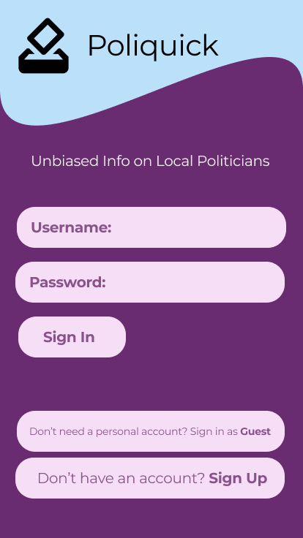Sign in page: On her phone, Polly enters the Poliquick website URL and the page loads. She doesn’t have a prior account but wants to customize her app experience so she signs up with a username, password, and her location (city) to keep her personal data saved. After she accepts the terms and conditions, she is registered and redirected to a Quiz page.

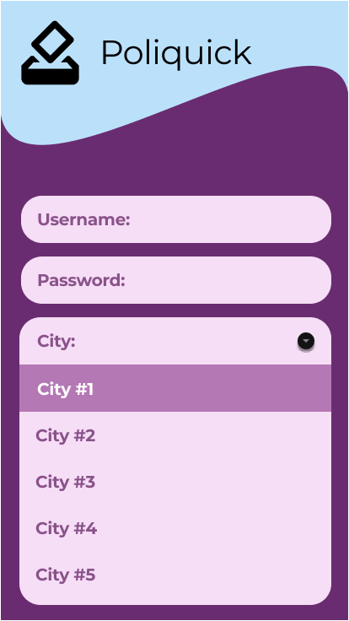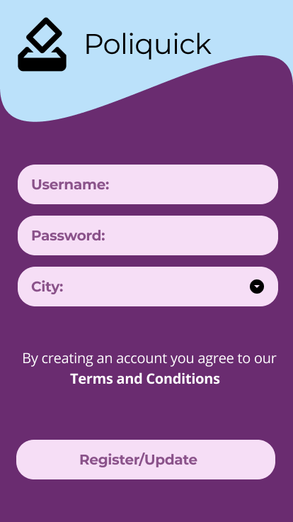

* 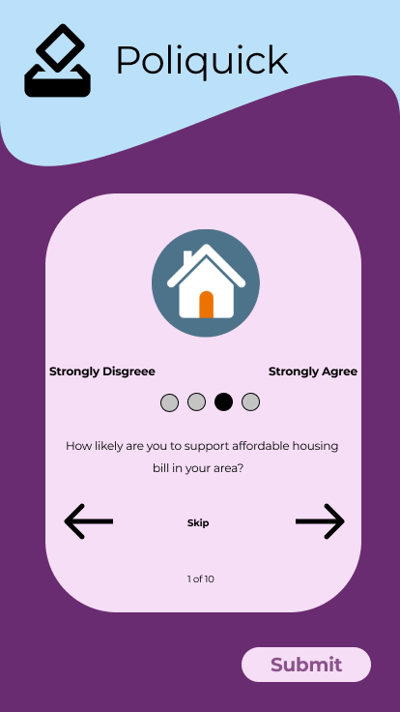Quiz: On the quiz page, Polly is presented with series of political statements that are personalized to her city. As she provides her input on each of these statements, the app is using this data to narrow down which local political candidates align with her views on policies.
* 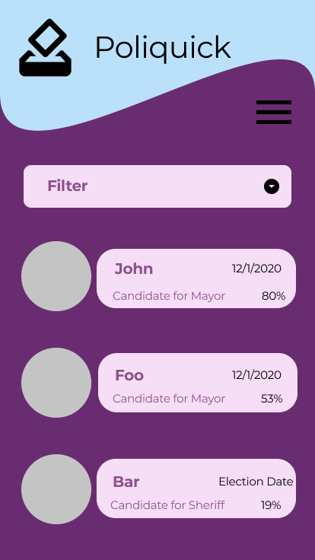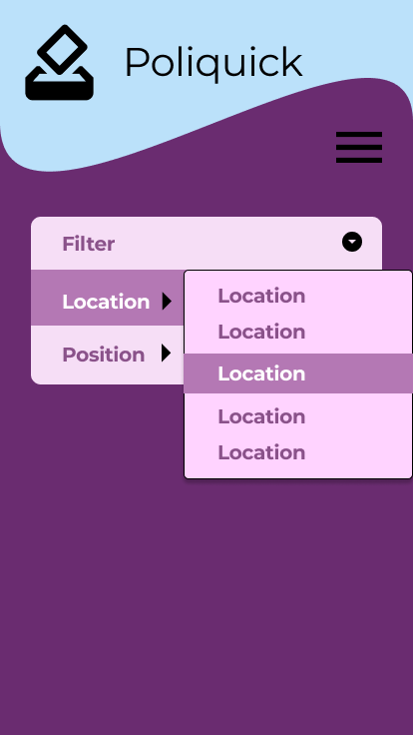Election/Match page: Once Polly is finished with her quiz; she is brought to the Match page. Here she can see all the candidates in her area that are currently running for a position. The candidates are ordered based on how well they align with Polly. Polly notices the drop-down menu. This allows her to select a specific position to show candidates from. Since the mayoral election is the soonest, she sticks with that. Now she wants to know more about the candidate that she most matched with, so she selects the person's name.

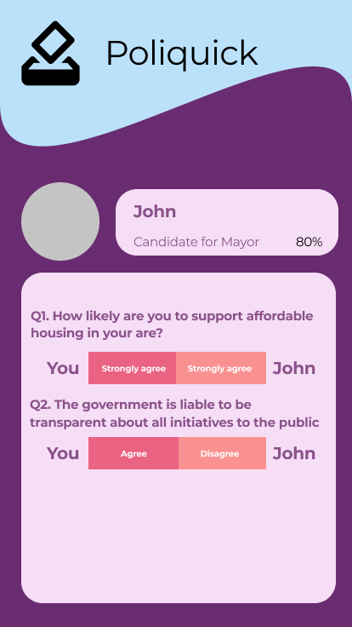

* Politician profile: Polly clicks on her highest match, politician X, to navigate to their profile where she can see their stances on important issues like crime, taxes, gun control, and others. Issues specific to her city are included as well. She looks at the corner and spots the compatibility percentage to that candidate, 92%. Next, she scrolls to view what recent actions politician X has taken. She reads through their proposed bill to combat homelessness.

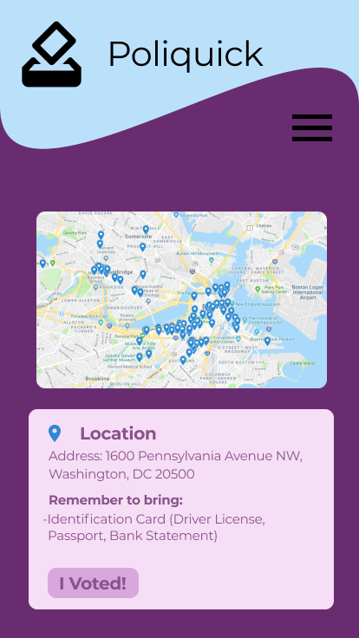

* Voting Locations: Now that Polly is well informed, she wants to cast her vote. Polly visits the Poll Locator tab and finds her nearest voting poll. She’s also really worried about the voting process since it’s her first time. However, on the same tab, she is notified about any documents/verification she needs to bring along with her. Feeling a lot more informed, Polly heads out to polls.

Polly is relieved to feel informed about her local government and make a difference through voting.

# Breakdown of work

* Whoever make changes need to be reviewed by the person assigned to a specific task

|  |  |  |  |
| --- | --- | --- | --- |
| **Main Reviewer** | | **Page Assigned** | |
| Hein | | Sign-In, Registration page | |
| Melissa | | Voting Polls | |
| Quan | | Politician Profile, Registration page | |
| Steven | | Quiz | |
| Vanessa | | Elections (main) | |
| Feature Name | Description | | Assigned to | |
| Sign-in CSS | Styling front-end for sign-in page which includes adding background colors, buttons, and headers | | Quan | |
| Terms and Conditions | Create a Terms and Conditions so that user knows that we’ll be using their data in the web-app | | Hein | |
| Back-end Sign-up | Storing user login credentials and linking them to the user’s quiz results and other account information so this data can persist through different pages | | Quan, Hein | |
| Creating Quiz Questions | Create a list of general questions as well as specific ones to a user’s city. | | Steven | |
| Styling and formatting questions | Styling front-end for the quiz, link actions and answers to backend  Stretch Goal: Add data about real politicians | | Quan | |
| Matching Algorithm | Create an algorithm to match users with politicians based on their quiz answers | | Steven | |
| Sample Politicians | Create a couple of sample politician profiles to test our matching code. (Start after finishing Quiz) | | Steven | |
| Sample User | Create a sample user who will be matched with our made-up politicians | | Melissa | |
| Display politician matches | Create politician components which use flexbox, style boxes to include their politician name, picture, match percentage  Stretch Goal: Anti-Match page: provides a link to the least percentage matched politician | | Vanessa | |
| Filter & page styling | Create a fluent UI dropdown menu for filtering by position, add background colors and clickable attributes to profiles | | Vanessa | |
| Back-end election page work | Grab info passed from the quiz page to make politician components and order them based on compatibility  Stretch goal: Give politicians extra props such as tags ex: student-loan-forgiveness-advocate to let the user sort by specific issues that politicians are | | Vanessa | |
| Microsoft Azure | Figure out how to store data to cloud and push the web app | | Hein | |
| Voting Booth back-end work | Figure out how to use Google Civic Information API to integrate in the project  Stretch goal: Implement estimates on the waiting time for the polls. | | Melissa | |
| Menu Bar + Navigation | Navigate from election page to Voting page | | Melissa, Quan | |

# Competitor Analysis

The following is information on Poliquick’s competitors:

* [https://justfacts.votesmart.org](https://justfacts.votesmart.org/)
  + - Vote Smart lets you search a politician or address. You can then select the official and look through categories that include their votes, positions on key issues, ratings, speeches, and funding
    - Strengths: Has key issue stances for well-known politicians. User can see other information like the funding, speeches and how they’ve voted in the past.
    - Weaknesses: Doesn’t match users with politicians. If user doesn’t know who they are looking for they might have a harder time and there is incomplete information especially on local politicians.
    - Opportunities: Our app can match users with local politicians
    - Threats: has lots of information on votes, positions, speeches, contact info
  + https://www.isidewith.com/political-quiz
    - Provides a quiz to match user to politicians. Other website features include users voting on issues and being able to search up candidates.
    - Strengths: Nice user interface, comprehensive quiz, and the users are able to submit different answers so it’s very interactive.
    - Weaknesses: Quiz is too lengthy. There is no info on issues just the percentage scale for what users chose. When searching politicians key parts of their platform are not easily digestible and just clumped in with masses of other info. This site is also not targeted to local politicians.
    - Opportunities: Our app can focus more on local elections, will be less lengthy.
    - Threats: Asks user detailed questions, with the ability to add exceptions to their answers
  + <https://www.congress.gov/state-legislature-websites>
    - Clickable map of the US. When you click somewhere it brings you to a state legislature site. From there you can look at representatives, bills passed, and the budget.
    - Strengths: Reliable and unbiased straight from the source.
    - Weaknesses: Excessive navigating to different sites. Information is not easily readable. Find my legislator just lists their names and provides no resource to find out more about them.
    - Opportunities: Our app will be easy to navigate, will have information about local legislators
    - Threats: Lots of information, map focused
  + <https://www.propublica.org/datastore/api/propublica-congress-api>
    - Voting records, explanations, Nominations, floor action, etc. for representatives and senators, updating in real time
    - Strengths: contains information on nearly everything about congress members
    - Weaknesses: overload on the information, difficult to use/navigate
    - Opportunities: Our app provides polling locations, as well as matches the politicans for the user instead of relying on them doing the research
    - Threats:very thorough information, a user can find nearly anything they want about a politician using this API

# Future Opportunities

## Politician Profile

* Possible Idea: Politicians will be able to log in through a separate process and take the same quiz
* Would give users **direct, transparent**, information on politician’s stances
* Steps:
  + Research pain points for politicians
  + Develop UI/UX for politicians
* Benefits for Politicians:
  + Information on their user base
  + View how their constituents feel about certain issues
  + Give them visibility to users within the app (ideal for less known/popular candidates)
  + Get instant polling on how they’re doing

## State and Federal Governments:

* Possible Idea: Users will be matched with the candidate they align with the most for state and federal elections.
* Steps:
  + Research reasons behind low voter turnouts for our demographic in these elections
  + Determine whether this feature is fulfilling the needs of a user
* Goal: Increase voter-turnout for these elections within the 18-29 age group. Data to assess the accomplishment of this goal will be gathered through Census.gov.

Voting:

* Possible Idea: Users will be able to vote for the politicians (local, state, and federal) they connect with through the comfort of their own home or on the go.
* Votes would be added to the blockchain to ensure security and transparency
* To this day there is no way to vote online, which would make Poliquick the first of its kind
* Steps:
  + Security: verify a person’s identity and eligibility to vote
  + Develop a system to keep track of users that have voted to prevent voter fraud
* Goal: One of the biggest pain points of our users is the lack of time. Through this feature, we save our users a trip to their local voting poll and the wasted time that comes with waiting in those long lines. The success of this feature will be measured by the number of votes that are submitted through our app

## Legislation:

* Users will be able to propose their own legislation on the app. These legislations will be posted on the home page of a politician
* Steps:
  + Incentivize politicians to create a political account; This would require doing research on the needs of this new user group
  + Provide a framework for users to easily create feasible proposals on any issue
* Goal: The number of legislations viewed/liked by users with a political account will be used as a measure of success.
  + With proper representation of these issues, college cities such as Berkeley are making strides in climate change reform. Berkeley was the first city in California to pass a law which made it illegal to create new buildings with natural-gas infrastructure in residential communities, leading other college cities such as San Jose to follow suit with similar laws. This example goes to show the power of young voices in local government.

## Student Governments:

* Establish private servers for schools to use.
* Students would be given the opportunity to:
  + Campaign on the platform
  + Submit their votes for student candidates
  + Provide feedback to the student government on issues in the school
* Steps:
  + Requires doing research on new user group (k-12 students)
  + Collaboration with schools
* Goal: Increase political engagement within children (17 and below). A big indicator of government involvement in the future, is a person’s involvement on the topic in school. We will use the number of students that create regular accounts, after having a school account, as a measure of success.

Signed off:

Sana Nagar

Khushboo Sharma