Class Diagrams for DSS – DHIS2 Data Exchange module
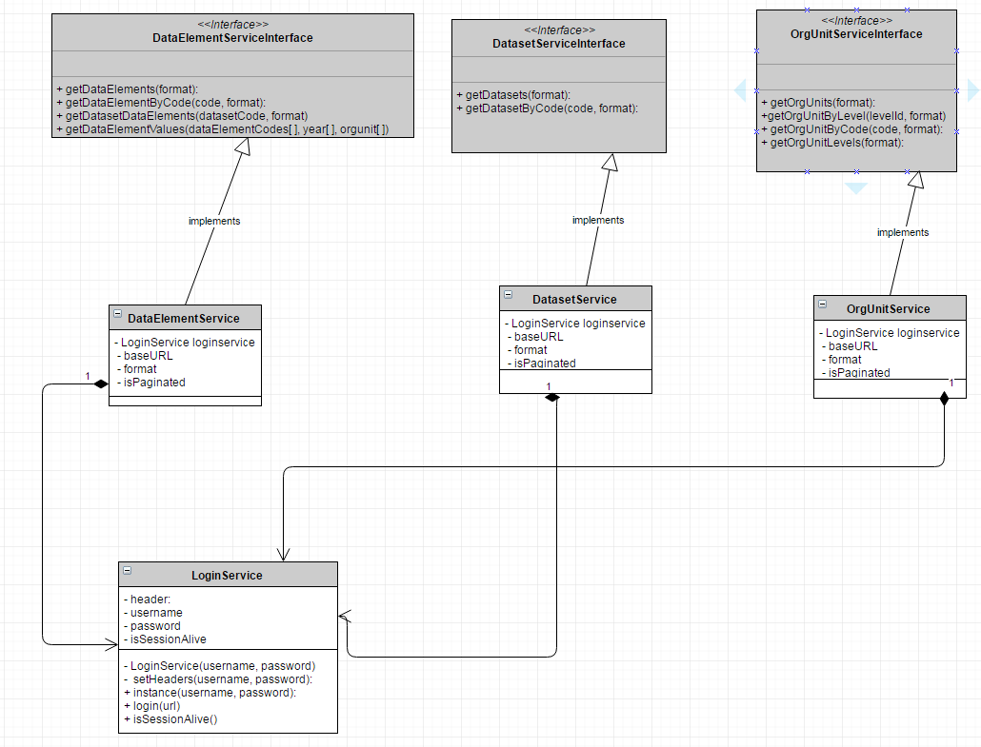
Variable ‘format’: Default value is TRUE
- If true, response will be in xml format otherwise it will be JSON
Variable ‘isPaginated: Default value is TRUE
- If true, responses will be paginated based on DHIS2 pagination default otherwise everything will be returned.

