..

МIНIСТЕРСТВО ОСВIТИ І НАУКИ УКРАЇНИ
НАЦІОНАЛЬНИЙ ТЕХНІЧНИЙ УНІВЕРСИТЕТ УКРАЇНИ
“КИЇВСЬКИЙ ПОЛІТЕХНІЧНИЙ ІНСТИТУТ
ІМЕНІ ІГОРЯ СІКОРСЬКОГО”

Факультет прикладної математики
Кафедра програмного забезпечення комп’ютерних систем

Лабораторна робота № 5
з дисципліни “Основи web-програмування”
тема “Знайомство з роботою зі запитами в мові JavaScript: HTTP\s, AJAX,
CORS, JSON”

Виконав  студент 2 курсу  групи КП-92  Мовчан Максим Олександрович  (прізвище, ім’я, по батькові)  варіант № - |  | Перевірив  “____” “____________” 20___ р.  викладач  Гадиняк Руслан Анатолійович  (прізвище, ім’я, по батькові)

Київ 2020

Мета роботи
Отримати навички роботи з отриманням данних.

Завдання
Завдання 1. Зробити запит за списком користувачів https://randomuser.me/api.
Повертаючи 50 користувачів.
Завдання 2. Замінити сортування, фільтрацію, валідацію та пошук на роботу з
данними із запиту. Оновити статистику на роботу з данними, що повертаються із
запиту. Якщо кількість користувачів змінюється (фільтрація, пошук, додали
нових), це відображається у статистиці.
Завдання 3. Додати до сторінки чекбокси, які будуть додаватись до запиту
як queryString (Країну, Стать, Вік). Відповідно до вибранного чекбоксу, додавати
до запиту параметр.
Завдання 4. Додати пагінацію: робити запит на наступні 10 користувачів при
натиску на кнопку «далі» (додані користувачівідображаються на сторінці).
Завдання 5. Додати до package.json як devDependency пакет json-server. Та
налаштувати так, щоб при сабміті форми, на нього відправлявся POST запит з
провалідованними данними з форми (опціонально).
App.js
require('../scss/style.scss');
require('../css/app.css');

const {
toFormatList, sortBy, findOne, validatePerson,
} = require('./data_helpers');

let teachCount = 10;
let reqParams = `results=${teachCount}`;

function createTopTeacherEntry(name, isFav, country, imURL, id, addStar = true) {
let filling = '';
if (!imURL) {
const fullnameArray = name.split(' ');
filling = `<p>${fullnameArray[0][0]}. ${fullnameArray[1] ? fullnameArray[1][0] : ''}.</p>`;
} else {
filling = `<img src="${imURL}" alt="Teacher pic" class="teach-pic"></img>`;
}

let star = '';
if (addStar) {
star = `<img class="star" src="./images/${isFav ? 'star.png' : 'star1.png'}" alt="favorite teacher">`;
}

const li = `
<li class="teach-elem" data-id="${id}">
${star}
<div class="comp-card">
${filling}
</div>
<a href="#popup-teach-info" onclick="blur_background()" class="name-link">
<p class="top-name-big">${name}</p>
</a>
<p>${country}</p>
</li>`;
return li;
}

function fillPopup(teach) {
if (!teach) {
return;
}
const email = teach.email ? teach.email : '';
const phone = teach.phone ? teach.phone : '';
const popupTeach = document.getElementById('popup-teach-info');
popupTeach.getElementsByClassName('card')[0].dataset.bgcolor = teach.bg_color;
popupTeach.getElementsByTagName('img')[0].src = teach.picture_large ? teach.picture_large : './images/special-teacher.jpg';
popupTeach.getElementsByClassName('personal-info')[0].innerHTML = `
<div class="name-star">
<p>${teach.full_name}</p>
<img src="./images/${teach.favorite ? 'star.png' : 'star1.png'}" alt="favorite" class="star">
</div>
<p>${teach.city}, ${teach.country}</p>
<p>${teach.age}, ${teach.gender[0].toUpperCase()}</p>
<a href="mailto:${email}"><p>${email}</p></a>
<a href="tel:${phone}"><p>${phone}</p></a>
`;
const otherInfo = popupTeach.getElementsByClassName('other-info')[0];
otherInfo.getElementsByTagName('p')[0].innerText = teach.note ? teach.note : 'No comments';
}

function loadTopTeachers(teachers) {
let html = '';
teachers.forEach((teach) => {
const li = createTopTeacherEntry(teach.full_name,
teach.favorite,
teach.country,
teach.picture_large,
teach.id);
html += li;
});

const topList = document.getElementById('top-list');
topList.innerHTML = html;
return topList;
}

function applyFilters(teachers) {
let filteredTeachers = teachers;
if (document.getElementById('photo-filter').checked) {
filteredTeachers = filteredTeachers.filter((p) => p.picture_large != null);
}

if (document.getElementById('fav-filter').checked) {
filteredTeachers = filteredTeachers.filter((p) => p.favorite === true);
}

const country = document.getElementById('country-filter').selectedOptions[0].text;
if (country !== 'All') {
filteredTeachers = filteredTeachers.filter((p) => p.country === country);
}

if (document.getElementById('age-check-filter').checked) {
filteredTeachers = filteredTeachers.filter((p) => p.age === parseInt(document.getElementById('age-filter').value, 10));
}

return filteredTeachers;
}

function fillStatTable(teachers) {
const tableBody = document.getElementById('stat-table-body');
tableBody.innerHTML = '';
teachers.forEach((teach) => {
const entry = document.createElement('tr');
let child = {};
['full_name', 'age', 'gender', 'country'].forEach((key) => {
child = document.createElement('td');
child.innerText = teach[key];
entry.appendChild(child);
});
tableBody.appendChild(entry);
});
}

async function render() {
try {
const res = await fetch(`https://randomuser.me/api/?seed=oleg&${reqParams}`);
const teachers = (await res.json()).results;
const formatted = toFormatList(teachers);

const teachersFiltered = applyFilters(formatted);
const topList = loadTopTeachers(teachersFiltered);

const favs = document.getElementById('fav-carousel');
favs.innerHTML = '';

const updateFavorites = function f() {
favs.innerHTML = '';
teachersFiltered.filter((teach) => teach.favorite).slice(0, 5).forEach(
(fav) => {
const li = document.createElement('li');
li.innerHTML = createTopTeacherEntry(fav.full_name,
fav.favorite,
fav.country,
fav.picture_large,
fav.id,
false);
favs.appendChild(li);
},
);
};
if (topList.getAttribute('listener') !== 'true') {
topList.addEventListener('click', (e) => {
topList.setAttribute('listener', 'true');
if (e.originalTarget.className === 'top-name-big') {
fillPopup(
formatted.find((p) => p.id === e.target.parentElement.parentElement.dataset.id),
);
}

if (e.originalTarget.className === 'star' && e.target) {
const person = formatted.find((p) => p.id === e.target.parentElement.dataset.id);
if (person) {
person.favorite = !person.favorite;
e.originalTarget.src = `./images/${person.favorite ? 'star.png' : 'star1.png'}`;
updateFavorites();
}
}
});
}

if (document.getElementById('searchbar').getAttribute('listener') !== 'true') {
document.getElementById('searchbar').addEventListener('submit', (e) => {
e.preventDefault();
document.getElementById('searchbar').setAttribute('listener', 'true');
const searchData = e.target[0].value.split(':');
let chosenOne;
if (searchData[0] === 'note') {
chosenOne = formatted
.find((person) => person.note && person.note.includes(searchData[1]));
} else {
chosenOne = findOne(formatted, searchData[0], searchData[1]);
}

if (chosenOne) {
fillPopup(chosenOne);
window.location.replace('/#popup-teach-info');
} else {
window.alert('No teachers');
}
});
}

if (document.getElementById('nextBtn').getAttribute('listener') !== 'true') {
document.getElementById('nextBtn').addEventListener('click', () => {
document.getElementById('nextBtn').setAttribute('listener', 'true');
teachCount += 10;
reqParams = `results=${teachCount}`;
render();
});
}

if (document.getElementById('filters').getAttribute('listener') !== 'true') {
document.getElementById('filters').addEventListener('change', () => {
document.getElementById('filters').setAttribute('listener', 'true');
reqParams = `results=${teachCount}`;
if (document.getElementById('gender-check-filter').checked) {
reqParams += `&gender=${document.getElementById('gender-filter').value}`;
}
render();
});
}
if (document.getElementById('stat').getAttribute('listener') !== 'true') {
document.getElementById('stat').addEventListener('click', (e) => {
document.getElementById('stat').setAttribute('listener', 'true');
if (e.target.nodeName === 'TH') {
const sorted = sortBy(formatted, e.target.id.split('-')[1], 1);
fillStatTable(sorted.slice(0, 5));
}
});
}
if (document.getElementsByClassName('fav-with-arrows')[0].getAttribute('listener') !== 'true') {
document.getElementsByClassName('fav-with-arrows')[0]
.addEventListener('click', (e) => {
document.getElementsByClassName('fav-with-arrows')[0].setAttribute('listener', 'true');
fillPopup(
formatted.find((p) => p.id === e.originalTarget.parentElement.parentElement.dataset.id),
);
});
}

fillStatTable(formatted.slice(0, 5));
const form = document.getElementById('teacherform');
if (form.getAttribute('listener') !== 'true') {
form.addEventListener('submit', (e) => {
e.preventDefault();
document.getElementById('teacherform').setAttribute('listener', 'true');
const newTeach = {
id: Math.random().toString(36).substring(),
favorite: false,
course: '',
bg_color: form.elements[8].value,
gender: document.getElementById('teacherform').elements[6].checked ? 'Male' : 'Female',
title: null,
full_name: form.elements[0].value,
city: form.elements[2].value,
state: null,
country: form.elements[1].selectedOptions[0].text,
postcode: null,
coordinates: null,
timezone: null,
email: form.elements[4].value,
b_date: null,
age: null,
phone: form.elements[3].value,
picture_large: null,
picture_thumbnail: null,
note: null,
};
if (validatePerson(newTeach)) {
formatted.push(newTeach);
loadTopTeachers(formatted);
fetch('http://localhost:3000/teachers', {
method: 'POST',
headers: {
'Content-Type': 'application/json',
},
body: JSON.stringify(newTeach, null, 4),
}).catch((err) => { console.log(err.message); });
} else {
alert('Bad data');
}
});
}
} catch (e) {
console.log(`Pain: ${e.message}`);
}
}

render();

data_helpers.js
const phoneCodes = require('./json/codes.json');

function capitalizeFirstLetter(string) {
return string.charAt(0).toUpperCase() + string.slice(1);
}

export function toFormatList(userList) {
const formattedUserList = userList.map((person) => ({
id: person.id.value || `${person.name.first}${person.name.last}`,
favorite: false,
course: null,
bg_color: '#FF0000',
gender: capitalizeFirstLetter(person.gender),
title: person.name.title,
full_name: `${person.name.first} ${person.name.last}`,
city: person.location.city,
state: person.location.state,
country: person.location.country,
postcode: person.location.postcode,
coordinates: person.location.coordinates,
timezone: person.location.timezone,
email: person.email,
b_date: person.dob.date,
age: parseInt(person.dob.age, 10),
phone: person.phone,
picture_large: person.picture.large,
picture_thumbnail: person.picture.thumbnail,
note: null,
}));

return formattedUserList;
}

export function upCaseCheck(str) {
if (typeof str === 'string' || str instanceof String) {
return str.charAt(0).toUpperCase() === str.charAt(0);
}
return false;
}

export function validatePerson(person) {
if (!(upCaseCheck(person.gender)
&& upCaseCheck(person.full_name)
&& (person.state ? upCaseCheck(person.state) : true)
&& upCaseCheck(person.city)
&& upCaseCheck(person.country)
)) {
return false;
}
/*
if (typeof person.age !== 'number') {
return false;
} */

const phone = person.phone.replace(/[.,/\s#!$%^&*;:{}=\-_`~()]/g, '');
const { country } = person;
const codeInfo = phoneCodes.country.find((code) => code.eng === country);
if (!codeInfo) {
return false;
}
if (!(phone.startsWith(codeInfo.code.replace(0, 0, '')) && parseInt(phone.replace('+', '', '').length, 10) === parseInt(codeInfo.length, 10))) {
return false;
}
return /\S+@\S+\.\S+/.test(person.email);
}

export function filterBy(userList, param, val) {
if (!(userList && param && userList[0][param])) {
return [];
}
return userList.filter((user) => user[param] === val);
}

export function strComp(str1, str2) {
const s1 = str1.toLowerCase();
const s2 = str2.toLowerCase();
if (s1 < s2) {
return 1;
}
if (s1 > s2) {
return -1;
}
return 0;
}

export function sortBy(userList, param, ord) {
if (!(userList && param && ord)) {
return [];
}
if (typeof userList[0][param] === 'number') {
return userList.sort((per1, per2) => ord * (per2[param] - per1[param]));
}
if (typeof userList[0][param] === 'string' || userList[0][param] instanceof String) {
return userList.sort((per1, per2) => ord * strComp(per2[param], per1[param]));
}
return userList.sort();
}

export function findOne(userList, param, val) {
if (!(userList && param && val)) {
return null;
}
if (/^\d+$/.test(val)) {
return userList.find((per) => per[param] === parseInt(val, 10));
}
return userList.find((per) => per[param] === val);
}

export function getPercentage(userList, pred) {
if (!userList) {
return 0;
}
const filtered = userList.filter((per) => pred(per));

return 100 * (filtered ? filtered.length / userList.length : 0);
}

Index.html
<!DOCTYPE html>
<html lang="en">

<head itemscope itemtype="http://schema.org/WebSite">

<meta charset="utf-8">
<meta http-equiv="x-ua-compatible" content="ie=edge">
<meta name="msapplication-tap-highlight" content="no">
<meta name="viewport" content="width=device-width, initial-scale=1">

<title>Teachinder</title>

<link rel="stylesheet" href="./css/app.css">
<script src="https://kit.fontawesome.com/42f1ad770e.js" crossorigin="anonymous"></script>
</head>

<body itemscope itemtype="http://schema.org/WebPage">
<header>
<div class="header-top">
<h1>Teachinder</h1>
<form id="searchbar" class="searchbar">
<label for="search"></label>
<input type="text" id="search" name="search" placeholder="Enter name to search" >
<input type="submit" value="Search" aria-label="search" />
</form>
</div>
<div class="navbar">
<nav class="nav-header">
<a href="#teach">Teachers</a>
<a href="#stat">Statistics</a>
<a href="#fav">Favorites</a>
<a href="#about">About</a>
</nav>
<a class="add-button" href="#popup-add-teach" onclick="blur_background()">Add teacher</a>
</div>
</header>
<main>
<div id="popup-add-teach" class="overlay">
<section class="add-card popup">
<div class="popup-header">
<h2>Add Teacher</h2>
<a href="#" onclick="unblur_background()">&times;</a>
</div>
<form id="teacherform">
<label for="fullname">Full name:</label><br>
<input type="text" id="fullname" name="fullname" placeholder="John Smith" required><br>

<label for="country">Country:</label><br>
<select id="country" name="country" required>
<option value="ua" aria-selected="true">Ukraine</option>
<option value="ger">Germany</option>
<option value="by">Finland</option>
<option value="uk">UK</option>
<option value="as">Austria</option>
<option value="tk">Turkey</option>
<option value="ir">Iran</option>
<option value="nl">Netherlands</option>
<option value="ie">Ireland</option>
<option value="au">Australia</option>
<option value="us">United States</option>
<option value="in">India</option>
<option value="fr">France</option>
<option value="cn">Canada</option>
<option value="sp">Spain</option>
<option value="dn">Denmark</option>
<option value="nz">New Zealand</option>
<option value="sz">Switzerland</option>
<option value="nw">Norway</option>
<option value="sz">Switzerland</option>
</select><br>

<label for="city">City:</label><br>
<input id="city" type="text" name="city"><br>

<label for="phonenum">Phone number:</label><br>
<input id="phonenum" type="tel" name="phonenum" placeholder="+380123456789" required><br>

<label for="email">Email:</label><br>
<input id="email" type="email" name="email" placeholder="johnsmith@gmail.com" required><br>

<fieldset class="choice">
<legend>
Sex:
</legend>
<div class="gender-container">
<label for="male-radio">Male</label>
<input type="radio" id="male-radio" name="gender" value="male" checked>
<label for="female-radio">Female</label>
<input type="radio" id="female-radio" name="gender" value="female">
</div>

</fieldset>
<div class="color">
<label for="backcol">Background color:</label>
<div>
<img src="images/circle.svg">
<input id="backcol" type="color" name="backcol">
</div>

</div>

<!--
<label for="birthdate">Date of birth:</label><br>
<input id="birthdate" type="date" name="birthdate"><br>

<label for="comment">Comment:</label><br>
<textarea id="comment" name="comment" form="teacherform">Enter comment here...</textarea><br>
-->

<input type="submit" value="Add" aria-label="submit">
</form>
</div>
</section>

<div id="popup-teach-info" class="overlay">
<section class="teacher-info-card popup">
<div class="popup-header">
<h2>Teacher Info</h2>
<a href="#" onclick="unblur_background()">&times;</a>
</div>
<article data-bgcolor="#999999" class="card">
<img class="pic" src="./images/teacher.jpg" alt="teacher's picture">

<section class="personal-info">
<div class="name-star">
<p>John Smith</p>
<img src="images/star.png" alt="favorite" class="star">
</div>
<p>Some Place, USA</p>
<p>30, M</p>
<a href="mailto:johnsmith@gmail.com"><p>johnsmith@gmail.com</p></a>
<a href="tel:+380-12-345-67-89"><p>+380-12-345-67-89</p></a>
</section>
<section class="other-info">
<p>
Lorem ipsum dolor sit amet, consectetur adipiscing elit,
sed do eiusmod tempor incididunt ut labore et dolore magna aliqua.
Ut enim ad minim veniam, quis nostrud exercitation ullamco laboris
nisi ut aliquip ex ea commodo consequat. Duis aute irure dolor in
reprehenderit in voluptate velit esse cillum dolore eu fugiat nulla
pariatur. Excepteur sint occaecat cupidatat non proident, sunt in
culpa qui officia deserunt mollit anim id est laborum
</p>
<a>toggle map</a>

</section>
</article>
</section>
</div>

<section id="top">
<h2 class="main-page-header">
Top Teachers
</h2>
<div class="filter" id="filters">
<span>Filter by:</span>
<div>
<input name="photo-filter" id="photo-filter" type="checkbox" class="photo-filter">
<label for="photo-filter">Show only with photo</label>
</div>
<div>
<input name="fav-filter" id="fav-filter" type="checkbox" class="fav-filter">
<label for="fav-filter">Show only favorites</label>
</div>

<div>
<label for="country">
Country:
</label>
<select id="country-filter" name="country" required>
<option value='all' aria-selected="true">All</option>
<option value="ua">Ukraine</option>
<option value="ger">Germany</option>
<option value="by">Finland</option>
<option value="uk">UK</option>
<option value="as">Austria</option>
<option value="tk">Turkey</option>
<option value="ir">Iran</option>
<option value="nl">Netherlands</option>
<option value="ie">Ireland</option>
<option value="au">Australia</option>
<option value="us">United States</option>
<option value="in">India</option>
<option value="fr">France</option>
<option value="cn">Canada</option>
<option value="sp">Spain</option>
<option value="dn">Denmark</option>
<option value="nz">New Zealand</option>
<option value="sz">Switzerland</option>
<option value="nw">Norway</option>
<option value="sz">Switzerland</option>
</select>
</div>
<div>
<input name="age-filter-check" id="age-check-filter" type="checkbox">
<label for="age-filter">Age:</label>
<input name="age-filter" id="age-filter" type="number" min=0 max=110 value=25>
</div>
<div>
<input name="gender-filter-check" id="gender-check-filter" type="checkbox">
<label for="gender-filter">Gender:</label>
<select id="gender-filter" name="gender" required>
<option value="male" aria-selected="true" selected>Male</option>
<option value="female">Female</option>
</select>
</div>
</div>
<ul class="top" id="top-list">
<li class="teach-elem">
<img class="star" src="./images/star.png" alt="favorite teacher">
<div class="comp-card">
<img src="./images/teacher.jpg" alt="Teacher pic" class="teach-pic">
</div>
<a href="#popup-teach-info" onclick="blur_background()" class="name-link"><p class="top-name-big">John Smith</p></a>
<p>US</p>
</li>
<li class="teach-elem">
<img class="star" src="./images/star.png" alt="favorite teacher">
<div class="comp-card">
<img src="./images/teacher.jpg" alt="Teacher pic" class="teach-pic">
</div>
<a href="#popup-teach-info" onclick="blur_background()" class="name-link"><p class="top-name-big">John Smith</p></a>
<p>US</p>
</li>
<li class="teach-elem">
<img class="star" src="./images/star.png" alt="favorite teacher">
<div class="comp-card">
<img src="./images/teacher.jpg" alt="Teacher pic" class="teach-pic">
</div>
<a href="#popup-teach-info" onclick="blur_background()" class="name-link"><p class="top-name-big">John Smith</p></a>
<p>US</p>
</li>
<li class="teach-elem">
<img class="star" src="./images/star.png" alt="favorite teacher">
<div class="comp-card">
<img src="./images/teacher.jpg" alt="Teacher pic" class="teach-pic">
</div>
<a href="#popup-teach-info" onclick="blur_background()" class="name-link"><p class="top-name-big">John Smith</p></a>
<p>US</p>
</li>
<li class="teach-elem">
<img class="star" src="./images/star.png" alt="favorite teacher">
<div class="comp-card">
<img src="./images/teacher.jpg" alt="Teacher pic" class="teach-pic">
</div>
<a href="#popup-teach-info" onclick="blur_background()" class="name-link"><p class="top-name-big">John Smith</p></a>
<p>US</p>
</li>
<li class="teach-elem">
<img class="star" src="./images/star.png" alt="favorite teacher">
<div class="comp-card">
<img src="./images/teacher.jpg" alt="Teacher pic" class="teach-pic">
</div>
<a href="#popup-teach-info" onclick="blur_background()" class="name-link"><p class="top-name-big">John Smith</p></a>
<p>US</p>
</li>
<li class="teach-elem">
<img class="star" src="./images/star.png" alt="favorite teacher">
<div class="comp-card">
<img src="./images/teacher.jpg" alt="Teacher pic" class="teach-pic">
</div>
<a href="#popup-teach-info" onclick="blur_background()" class="name-link"><p class="top-name-big">John Smith</p></a>
<p>US</p>

</li>

<li class="teach-elem">
<img class="star" src="./images/star.png" alt="favorite teacher">
<div class="comp-card">
<p>
J.S.
</p>
</div>
<a href="#popup-teach-info" onclick="blur_background()" class="name-link"><p class="top-name-big">John Smith</p></a>
<p>US</p>
</li>
</ul>
<button class="add-button" id="nextBtn">Next</button>
</section>

<section id="table-stats">
<h2 class="main-page-header">Statistics</h2>
<table class="tb-stat" id="stat" frame="border" rules="all" cellpadding="4">
<thead>
<tr>
<th id="stat-full_name">Name</th>
<th id="stat-age">Age</th>
<th id="stat-gender">Gender</th>
<th id="stat-country">Nationality</th>
</tr>
</thead>
<tbody id="stat-table-body">
<tr>
<td>John Smith</td>
<td>30</td>
<td>Male</td>
<td>Some country</td>
</tr>
<tr>
<td>John Smith</td>
<td>30</td>
<td>Male</td>
<td>Some country</td>
</tr>
<tr>
<td>John Smith</td>
<td>30</td>
<td>Male</td>
<td>Some country</td>
</tr>
<tr>
<td>John Smith</td>
<td>30</td>
<td>Male</td>
<td>Some country</td>
</tr>
<tr>
<td>John Smith</td>
<td>30</td>
<td>Male</td>
<td>Some country</td>
</tr>
</tbody>

</table>
<div class="table-stat-pages">
<a class="selected-page">1</a>
<a>2</a>
<a>3</a>
<span>...</span>
<a>Last</a>
</div>
</section>

<section class="fav-section">
<h2 class="main-page-header">
Favorites
</h2>
<div class="fav-with-arrows">
<a><i class="fas fa-arrow-left arrow"></i></a>
<ul class="fav" id='fav-carousel'>
<li class="teach-elem">
<div class="comp-card">
<img src="./images/teacher.jpg" alt="Teacher pic">
</div>
<p class="top-name-big">John Smith</p>
<p>US</p>
</li>
<li class="teach-elem">
<div class="comp-card">
<img src="./images/teacher.jpg" alt="Teacher pic">
</div>
<p class="top-name-big">John Smith</p>
<p>US</p>
</li>
<li class="teach-elem fav-selected">
<div class="comp-card">
<img src="./images/teacher.jpg" alt="Teacher pic">
</div>
<p class="top-name-big">John Smith</p>
<p>US</p>
</li>
<li class="teach-elem">
<div class="comp-card">
<img src="./images/teacher.jpg" alt="Teacher pic">
</div>
<p class="top-name-big">John Smith</p>
<p>US</p>
</li>
<li class="teach-elem">
<div class="comp-card">
<img src="./images/teacher.jpg" alt="Teacher pic">
</div>
<p class="top-name-big">John Smith</p>
<p>US</p>
</li>

</ul>
<a><i class="fas fa-arrow-right arrow"></i></a>
</div>

</section>

</main>
<footer>
<hr>
<p>
Lorem ipsum dolor sit amet, consectetur adipiscing elit. Suspendisse nec urna a elit vulputate pharetra feugiat eu diam.
Donec nec convallis nibh, vitae finibus sapien. Sed malesuada elit nec ante auctor, id rhoncus sapien dictum.
Vestibulum vulputate urna diam, nec pharetra purus efficitur vel.
</p>
<p>
Lorem ipsum dolor sit amet, consectetur adipiscing elit. Suspendisse nec urna a elit vulputate pharetra feugiat eu diam.
</p>
<p>
Lorem ipsum dolor sit amet, consectetur adipiscing elit.
</p>
<div class="navbar">
<nav class="nav-footer">
<a href="#teach">Teachers</a>
<a href="#stat">Statistics</a>
<a href="#fav">Favorites</a>
<a href="#about">About</a>
</nav>
<a class="add-button" href="#popup-add-teach" onclick="blur_background()">Add teacher</a>
</div>
</footer>
<script type="text/javascript" src="../build/app.js"></script>
</body>
<script>
function blur_background() {
const blurme = document.querySelectorAll("header, footer, #top, #table-stats, .fav-section");
blurme.forEach(elem => {
elem.style.filter = "blur(4px)";
elem.style.pointerEvents = "none";
})
const body = document.getElementsByTagName("body")[0];
body.style.boxShadow = "none";
body.style.overflow = "hidden";
}

function unblur_background() {
const blurred = document.querySelectorAll("header, footer, #top, #table-stats, .fav-section")
blurred.forEach(elem => {
elem.style.filter = "none"
elem.style.pointerEvents = "all"
})
const body = document.getElementsByTagName("body")[0];
body.style.boxShadow = "10px 0 5px -2px #dfdfdf, -10px 0 5px -2px #dfdfdf";
body.style.overflow = "auto";
}

</script>
</html>
Скриншоти
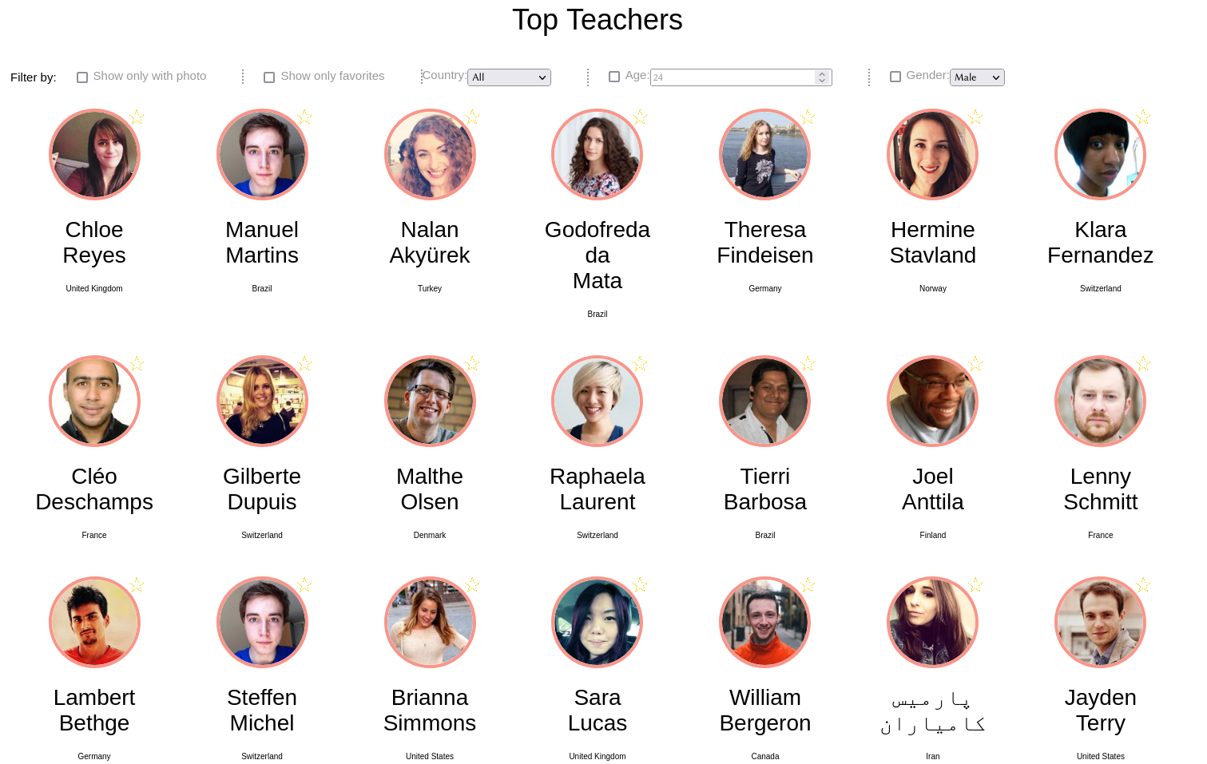

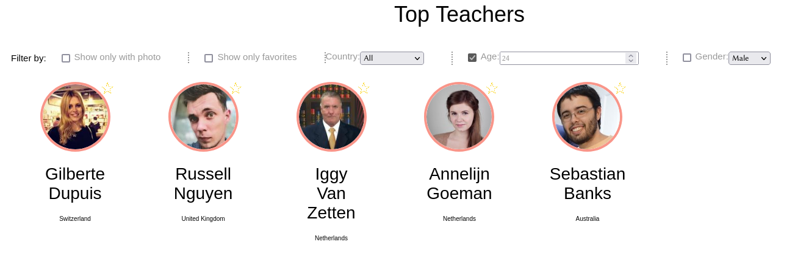
Висновок
У даній лабораторнії роботі було інтегровано JS функції для фільтрації з існуючої сторінки з апі, що повертає випадкових людей

