STRUCTURE OF DATASET FOR EXERCISES

File “ES.zip” contains a csv file with tick data for CME E-mini S&P 500 futures.
The structure of the data is as follows:
- Column 0 is the contract name
- Column 1 is the date, in YYYYMMDD format
- Column 2 is the time, in HHMMSSsss format
- Column 3 is the price
- Column 4 is the volume (0 in the early days, when the CME did not collect volume information)
- Column 5 is a special flag for trades. You may ignore it

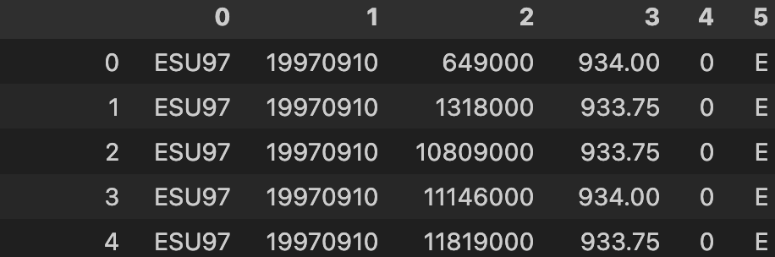
You can find the roll date by the changes in value in column 0.

