UNIVERSITY OF AGRICULTURE FAISALABAD


Course: mobile app development (CS-512)
Degree: BSCS(M2)
Developed by:
MUAMMAD MUNEEB (23-AG-9627)
MUAMMAD Ahtisham javad (23-AG-9603)

Semester: 6th
Submitted to:
Miss wajeeha azmat

PROJECT:
Resume building application

RESUME BUILDER ANDROID APPLICATION

Project Report
The Resume Builder Application is a mobile application developed using Android Studio to help users create professional resumes directly from their smartphones. The application provides an easy-to-use interface where users can enter their personal information, educational background, work experience, and skills. After entering the required information, users can preview their resume, select a preferred template, generate a PDF version, and share it with others.
The primary objective of this project is to simplify the resume creation process and eliminate the need for complex desktop software. The application is especially useful for students, fresh graduates, and job seekers who need to create professional resumes quickly and efficiently.

Problem Statement:
Many individuals face difficulties while creating professional resumes because traditional resume creation methods require technical skills, expensive software, or access to a computer. There is a need for a simple, mobile-based solution that allows users to create, edit, save, and share resumes anytime and anywhere.
This project addresses this problem by providing a user-friendly Android application that automates resume creation and formatting.

Android Components:
- Activities
- Intents
- RecyclerView
- CardView
- SQLiteOpenHelper
- PDF Document APi
- File Provider

Adding dependencies in gradle :
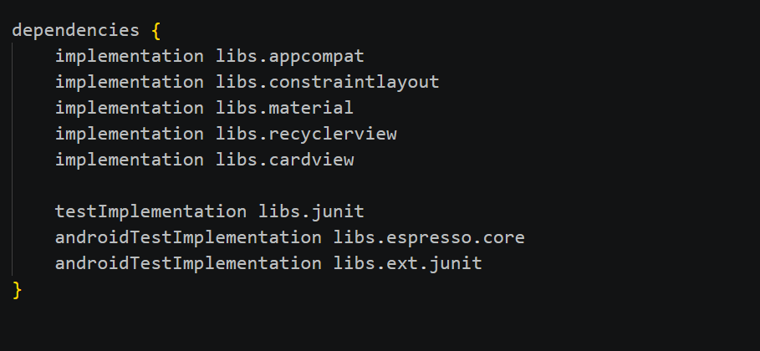
Activitiy creation of system in Xml file :
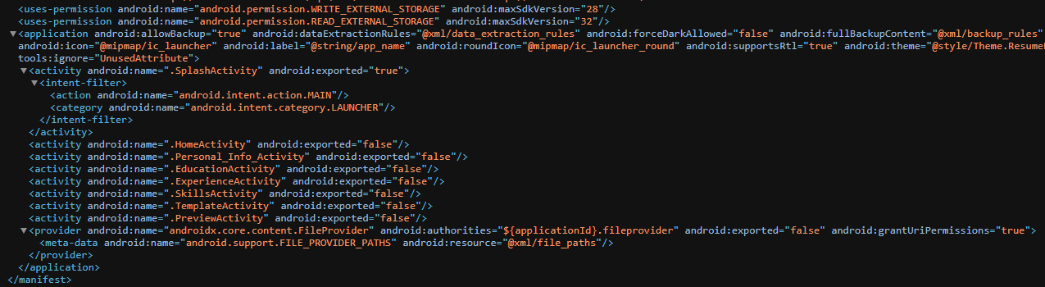
System Features
- Splash Screen
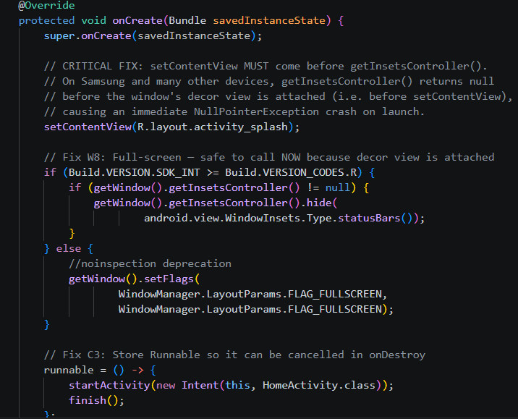

- Home Screen

Functions:
Create New Resume , View Existing Resume , Edit Resume, Generate PDF , Share Resume

- Personal Information Module

Information Collected
Full Name ,Email Address , Phone Number ,Address , Professional Summary
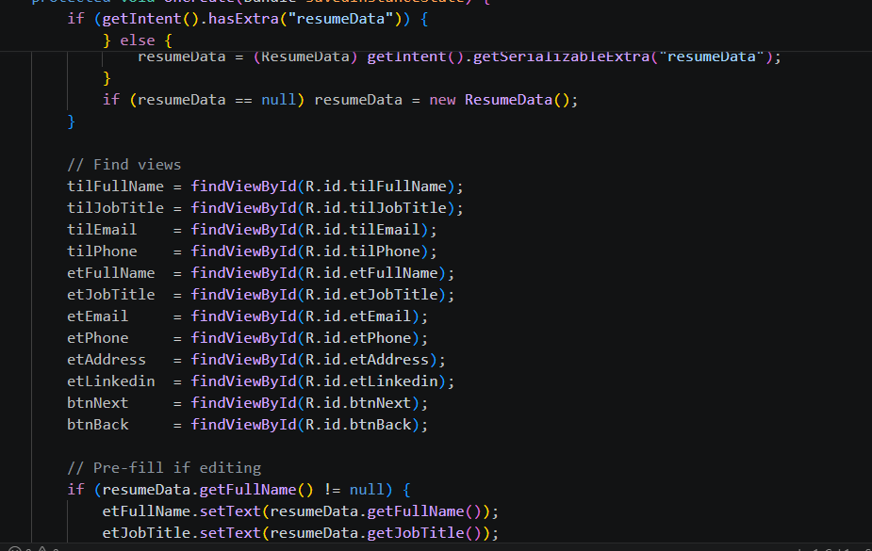

- Education Module

Information Stored:
Degree Name , Institution Name , Passing Year ,CGPA/Percentage
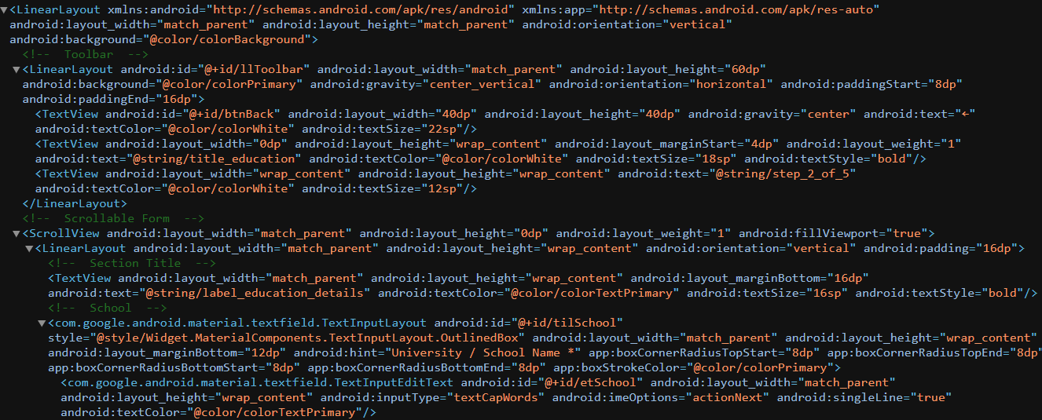

- Experience Module

Information Stored
Job Title , Company Name , Duration , Responsibilities
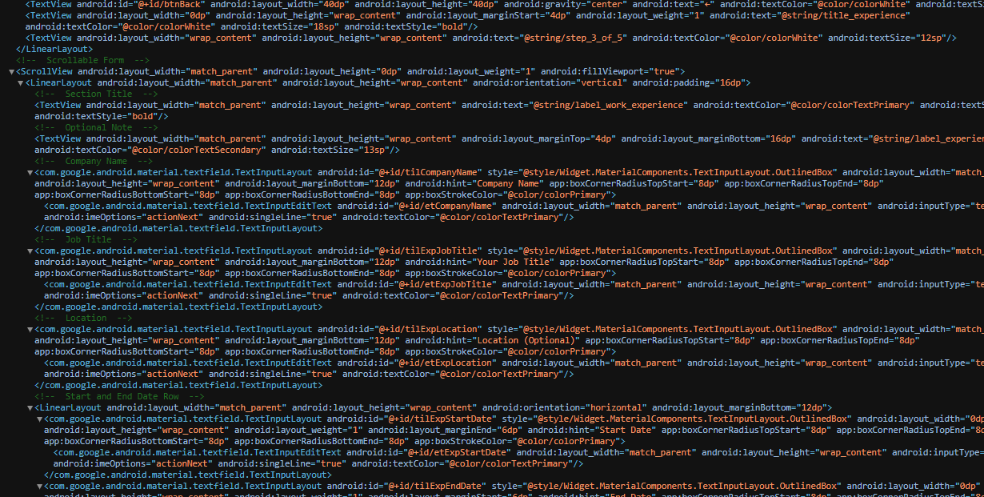
- Skills Module
Users can add technical and soft skills.

Examples:Java Programming , Android Development , Communication Skill , Problem Solving , Teamwork
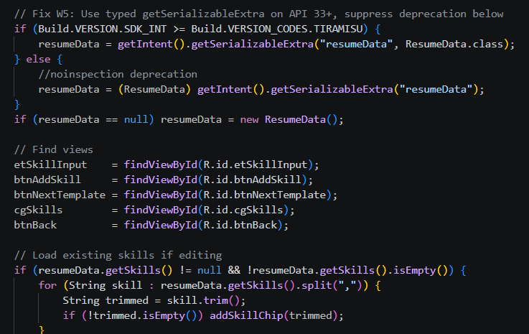

Template Selection
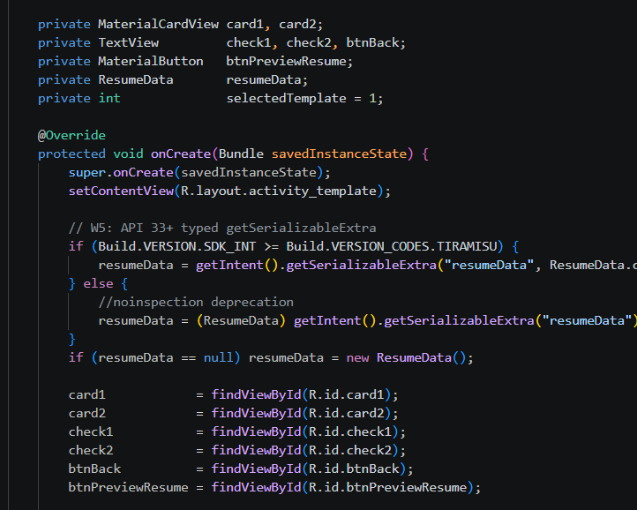

- Resume Preview
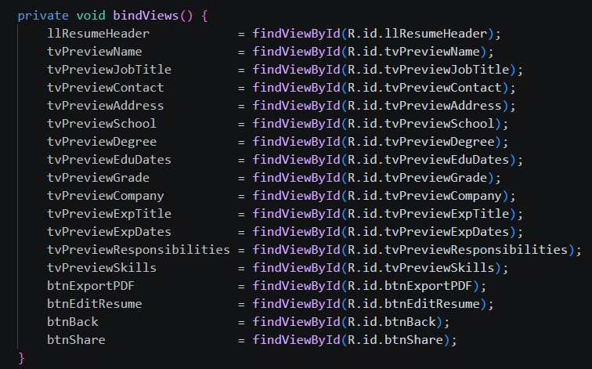

SQLite Database Storage

- PDF Generation
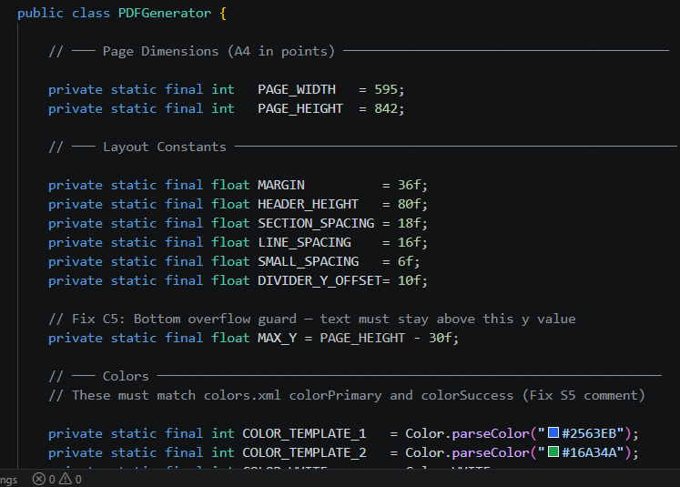

Process:
- Collect user information.
- Format data into selected template.
- Generate PDF document.
- Save file in device storage.
- Resume Sharing
Users can share generated resumes through different applications.

Sharing Options
Email, WhatsApp , Google Drive , Bluetooth , Other Android applications
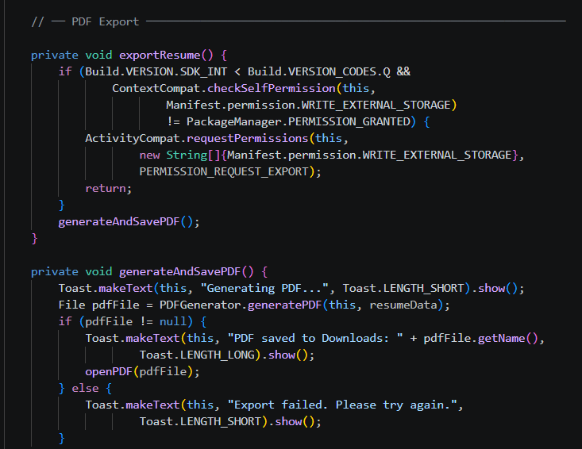
Database Design

Table: Resume
Field Name | Data Type
ID | Integer
Name | Text
Email | Text
Phone | Text
Address | Text
Education | Text
Experience | Text
Skills | Text
Template | Text
Working Procedure:
The Images of these procedure are attached in folder

Step 1:User launches the application.

Step 2:Splash screen appears.

Step 3:Home screen is displayed.

Step 4:User enters personal information.

Step 5:User adds education details.

Step 6:User adds work experience.

Step 7:User enters skills.

Step 8:User selects a resume template.

Step 9:Application displays resume preview.

Step 10: PDF resume is generated.

Step 11:User saves or shares the generated resume.

