# Context

3000 tuples per node

Summarization occurs at the beginning of the recursive call

Parallelization achieved by spawning a thread per child of the root node

Test file: sample2.mzml, 5155894 points

Client has rendering limited to first 5000 points (doesn’t affect detail level 0)

Environment: Lenovo Ideapad. Intel i7 with 8GB RAM, 1TB HDD

Ran from NetBeans 8.1, no debugging/profiling

# Results

|  |  |  |  |  |  |  |
| --- | --- | --- | --- | --- | --- | --- |
| **Strategy** | **Sorting?** | **Random?** | **Aggregate Summarization Time (ms)** | **Aggregate Tree Build Time (ms)** | **Tree Build Real Time (ms)** | **# points returned (top level)** |
| Intensity Cutoff | Yes | No | 3260 | 18282 | 6715 | 3000 |
| Uniform Striding | No | No | 824 | 14402 | 4082 | 3000 |
| Uniform Sampling | No (shuffle) | Yes | 2884 | 24209 | 8777 | 3000 |
| Weighted Sampling | No | Yes | 3240 | 19985 | 5459 | 3000 |
| Weighted Striding (w/o sorting) | No | No | 1270 | 14344 | 4219 | 3000 |
| Weighted Striding (w/ sorting) | Yes | no | 4512 | 20243 | 7423 | 3000 |

# Notes

Strided selection frequently encountered summarization times of 0ms, Java’s system time is prone to losing accuracy on measurements below 15 ms. Multiple times Uniform Striding presented Aggregate Summarization Times of around 20ms, implying that accuracy was lost. These numbers were ignored.

Uniform Sampling does not perform sorting on the dataset, rather performs shuffling. This produces a lessened summarization time compared to strategies that emply sorting (sorting is NlogN, shuffle N). The shuffle increases the time to sort when constructing new nodes, however. This effect creates the heightened Aggregate Tree Build Time and Tree Build Real Time.

## Pictures!

### Intensity Cutoff Level 0

## 

## Intensity Cutoff Level 0

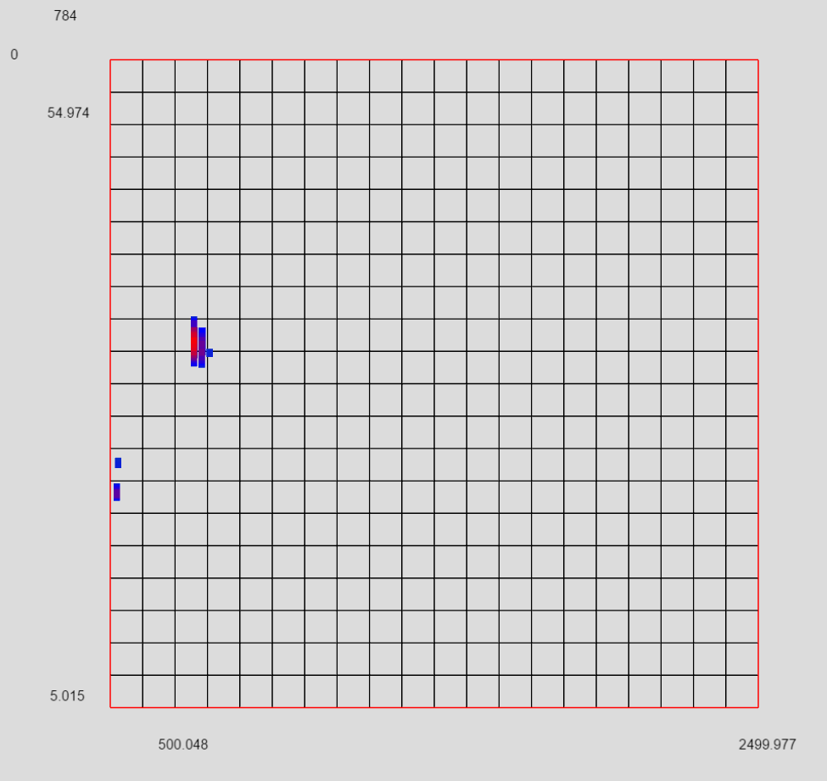

## Uniform Striding Level 0

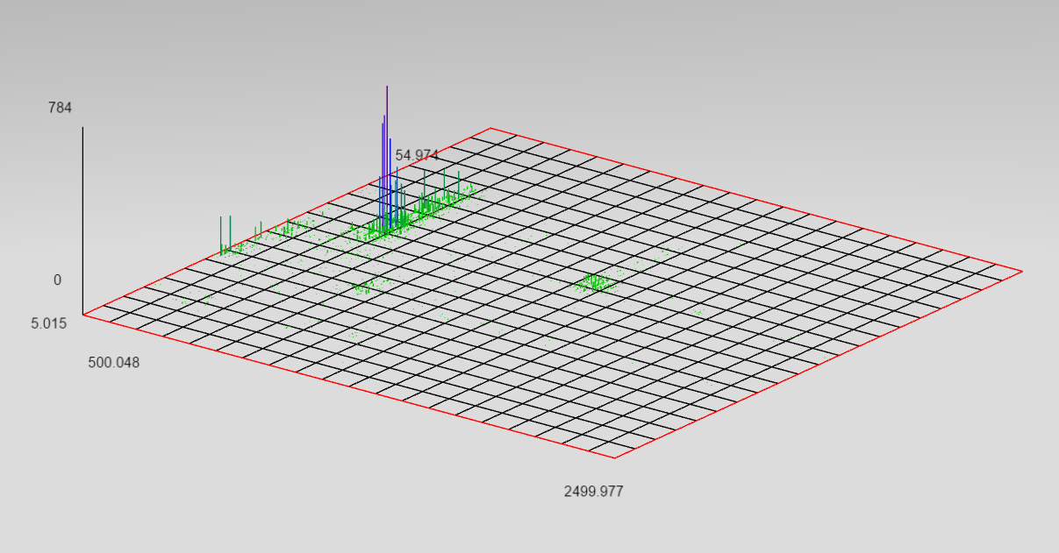

## Uniform Striding Level 0

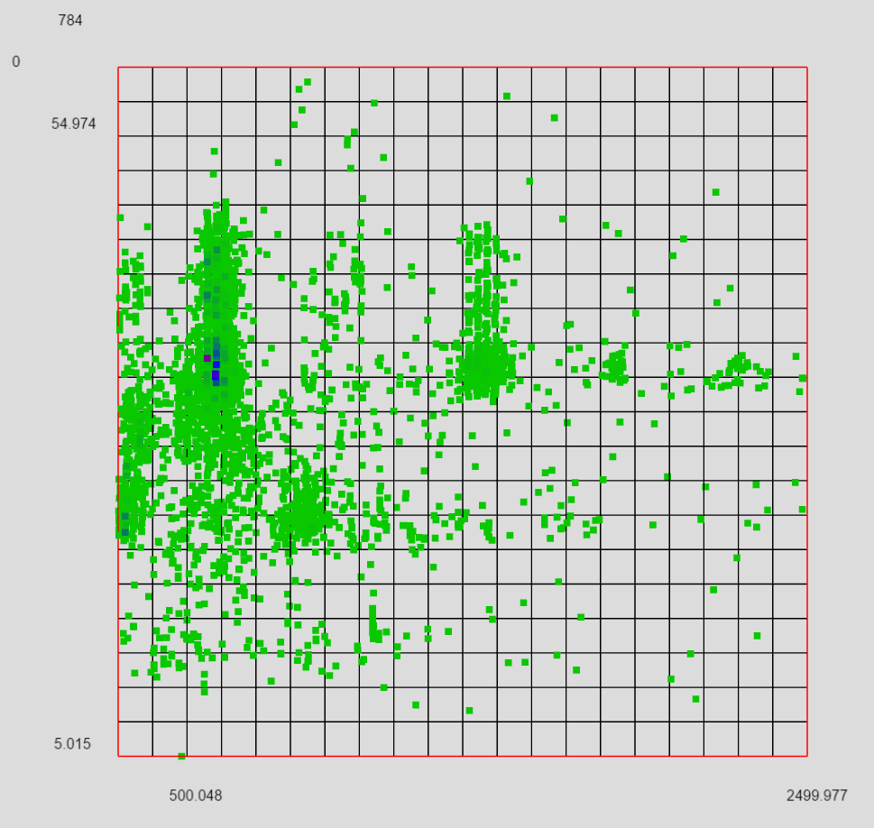

## Uniform Sampling Level 0

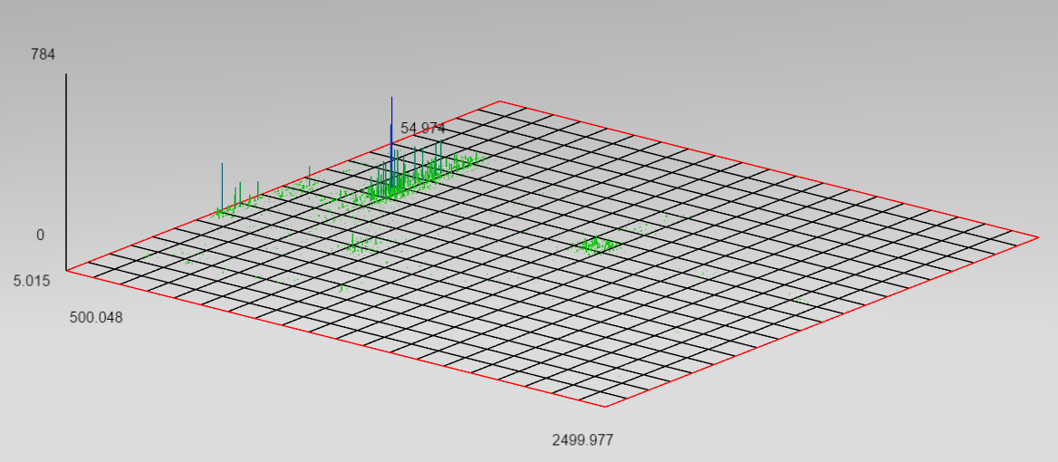

## Uniform Sampling Level 0

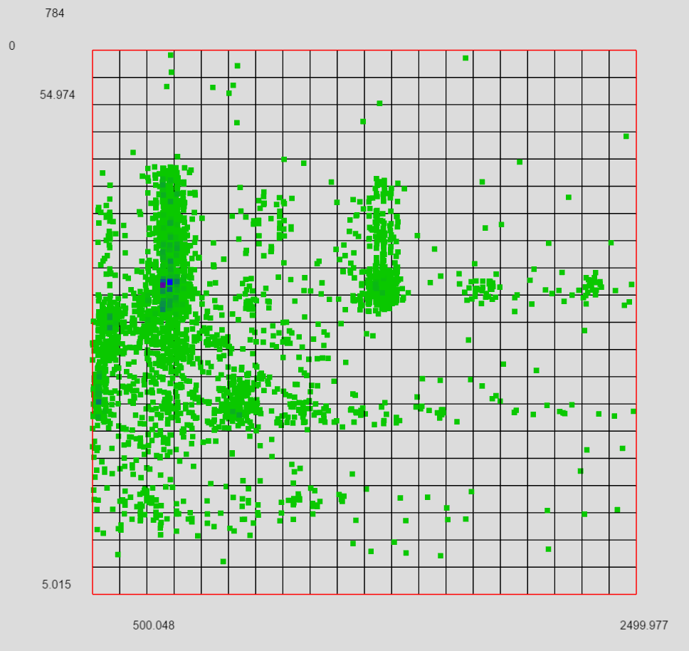

## Weighting Sampling Level 0

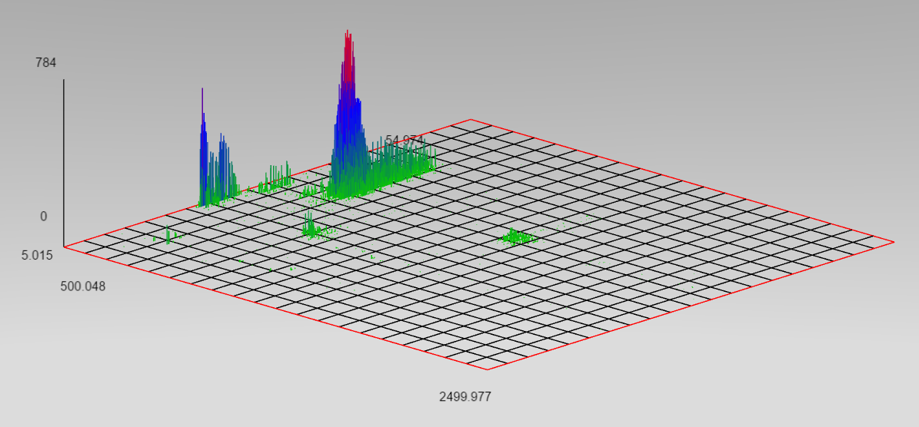

## Weighting Sampling Level 0

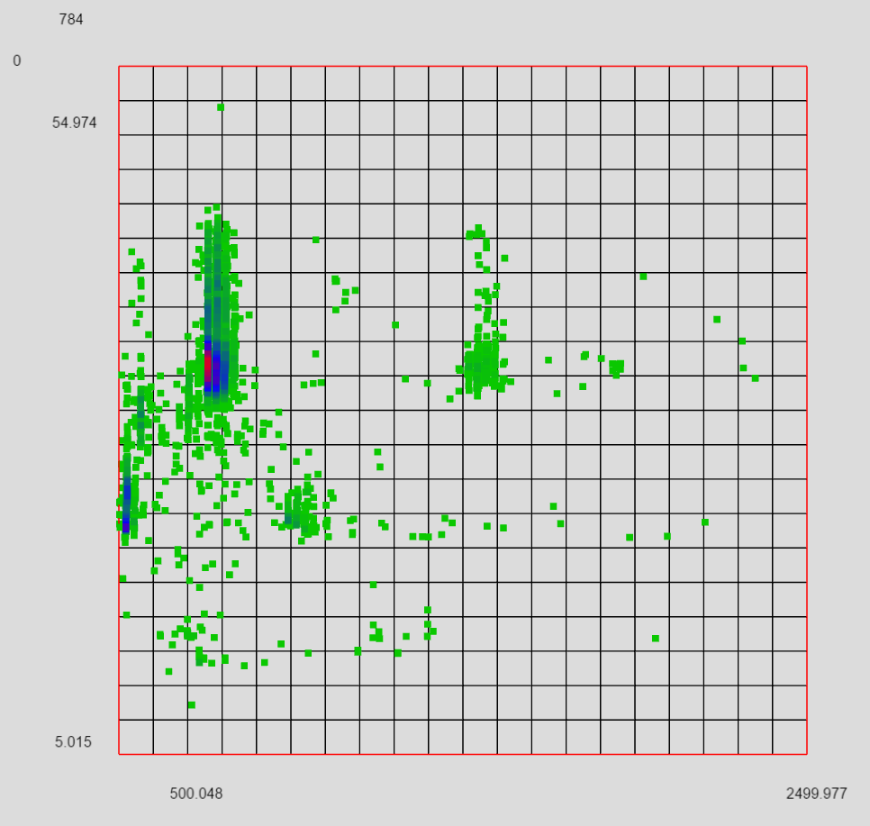

## Weighted Striding (w/o sorting) Level 0

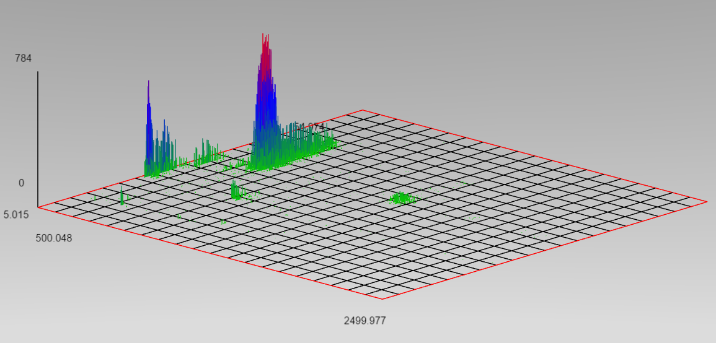

## Weighted Striding (w/o sorting) Level 0

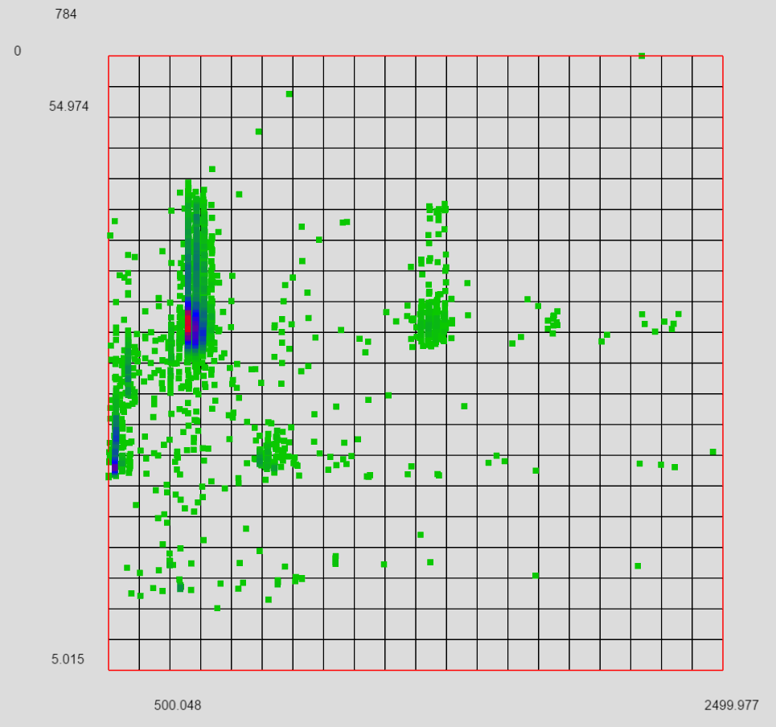

## Weighted Striding (w/ sorting) Level 0

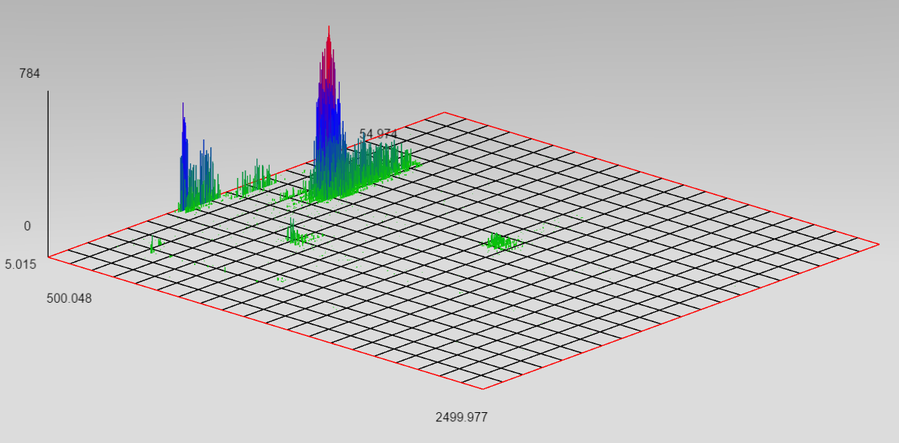

## Weighted Striding (w/ sorting) Level 0

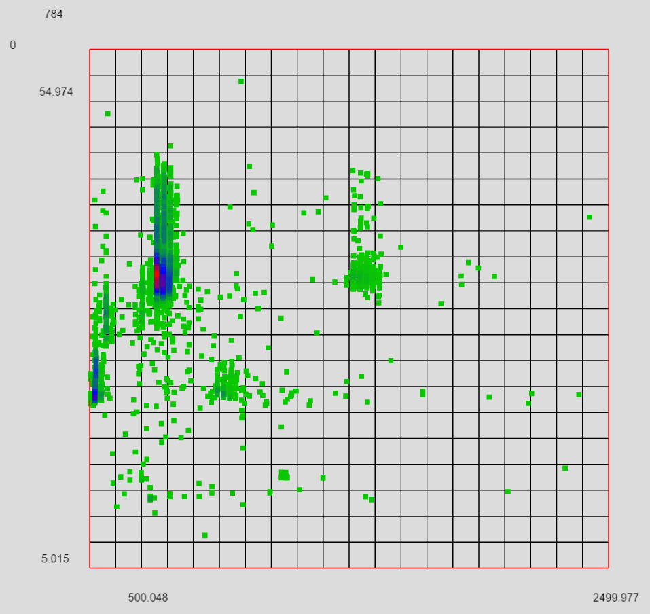

Level 0 2D