


ReOwn
Give your items a new home



Students name :
- Mennat-Allah Ashraf Elsayed (Team leader)
- Hana Elsayed Hassan
- Somaya medhat Mahdy
- Mariam Mohamed Mohamed
- Ahmed Elsayed Ahmed
- Amgad Ahmed Salah

Table of Contents
- Project Summary .................................................................................4
- System Analysis ...................................................................................4
2.1 Problem Statement .............................................................................4
2.2 Solution ...............................................................................................4
2.3 Design Thinking ...................................................................................5
- System Features ...................................................................................7
3.1 User Features ......................................................................................7
3.2 Admin Features ...................................................................................9
- Figma ………………………………………………………………………………………………10
4.1 UI for User .........................................................................................10
4.2 Ui for Admin ......................................................................................11
- System Design ....................................................................................12
5.1 Use Case Diagram .............................................................................12
5.2 Database Design (ERD) ......................................................................12
- Code Snippets ………………………………………………………………………………….13
- Conclusion .........................................................................................13

- Project Summary
ReOwn is a web-based marketplace designed to simplify the process of buying and selling used items within local communities. The platform allows users to upload product images, add clear descriptions, specify pricing, and share their exact location, helping nearby buyers find suitable items quickly and efficiently.
ReOwn encourages sustainable consumption by giving second life to items that are still in good condition but no longer needed by their owners. Through this platform, users can save money, reduce waste, and participate in an eco-friendly system that promotes reuse and responsible consumer behavior.

2- Analysis
2.1- Problem Statement :
In recent years, the rising cost of new products has made it increasingly difficult for individuals to afford essential items such as electronics, furniture, and household tools. Meanwhile, millions of usable items remain stored in homes, unused and forgotten, contributing to significant resource waste.
This situation highlights two major issues:
- Economic difficulty — people need affordable alternatives to expensive new goods.
- Environmental impact — unused items lead to increased production, higher consumption of raw materials, and more waste ending up in landfills.
There is a clear gap between people searching for affordable products and the large number of items that are available but not being re-circulated. ReOwn aims to bridge this gap.

2.2- Solution :
ReOwn offers a secure, user-friendly platform that enables individuals to sell items they no longer need and purchase second-hand products at reasonable prices. The platform facilitates smooth communication between buyers and sellers, provides accurate item details, and uses location-based browsing to help users find nearby products easily.
By promoting reuse and simplifying local exchange, ReOwn helps users save money, reduces environmental waste, and supports a sustainable community-driven marketplace.

2.3 - Design Thinking :
The design thinking methodology was applied throughout the development of ReOwn to ensure that the platform meets real user needs and delivers a smooth, efficient, and intuitive experience. The process followed five main stages:
1. Understanding User Needs (Empathize)
The first step was analyzing the needs, frustrations, and desired experience for the two main types of users:
Buyers need:
- Access to affordable second-hand products
- Ability to find items available near their location
- A clear and trustworthy product description
- Simple and fast communication with sellers
- Avoiding shipping delays or extra shipping costs
Sellers need:
- A quick and simple way to list items
- Ability to upload multiple photos
- Clear fields for price, description, and location
- An interface that allows easy editing or deleting ads
- Reaching a large number of nearby buyers
Understanding these needs shaped the features and UI flow of the entire platform.

2. Define — Identifying the Core Problem
Based on research, the main problems defined were:
- Difficulty finding affordable used items nearby
- Complicated or slow listing processes on existing platforms
- Lack of location-based search focused on local exchange
- Slow or unclear communication between buyers and sellers
These pain points guided the next step: ideation.

3. Ideation & Wireframing
After defining the problem, multiple UI ideas and user journeys were sketched to explore the best solutions.
Key ideas generated:
- Clean Home Page with categories and recommended products
- Location-based filtering system
- Very simple “Add Ad” interface requiring minimal effort
- A dedicated Messages system for buyer–seller communication
- Clear “Product Details” page with price, description, photos, and seller info
Wireframes were created for:
- Home Page
- Product Details Page
- Add Ad Page
- Edit Ad Page
- Messages Page
- User Profile Page
These wireframes served as the blueprint for the final UI design.

4. Evaluating User Flows
Each flow was analyzed to ensure the platform is simple and fast to use:
Buyer Flow:
Home → Browse/Search → View Product → Contact Seller / Add to Favorites
Seller Flow:
Profile → Add Ad → Upload Photos → Publish → Manage Ads
During evaluation, unnecessary steps were removed and form fields were minimized to reduce friction.

5. Prototyping (Figma)
A high-fidelity prototype was designed in Figma, including:
- Final layouts for all main pages
- Colors, typography, iconography
- Interactive components
- Mobile and desktop responsive designs
- Admin dashboard interface
The prototype allowed visualizing user interactions before development began.

  - System Features

3.1 User Features
1. User Authentication
- Create a new account (Sign Up)
- Login with email and password
- Reset or recover password
2. Home Page
- Browse the latest ads
- Search for products
- Filter items by category, price range, and location
- View featured or recommended products
3. Categories Page
- Browse all available categories
- View products within each category
4. Product Details Page
- View product images, price, condition, and description
- View seller information
- Check seller’s location for nearby purchases
- Contact seller through in-app chat or phone number
- Add the item to Favorites
5. Add Ad
- Upload multiple product images
- Enter product name, price, and description
- Select a category
- Add location
- Publish the ad instantly
6. Edit / Delete Ads
- Update product information
- Replace images
- Delete unwanted ads
7. Favorites
- Save products for later
- Remove items from the favorites list
8. Messaging System
- Real-time chat between buyer and seller
- Send and receive messages
- Get notifications when a new message arrives
9. User Profile
- View personal information
- Edit name, phone number, and location
- View all listed ads

3.2 Admin Features
1. Admin Dashboard
- Central control panel for monitoring and managing platform activity
2. Manage Users
- View list of all users
- Delete or block inappropriate accounts
- Activate or deactivate accounts
3. Manage Products
- Review all posted products
- Approve or remove inappropriate ads
- Update or reassign categories
4. Categories Management
- Add new categories
- Edit category names
- Delete unused categories
5. System Statistics
- Display total number of users
- Display total number of ads
- Track most popular categories
- View platform activity insights

  - Figma

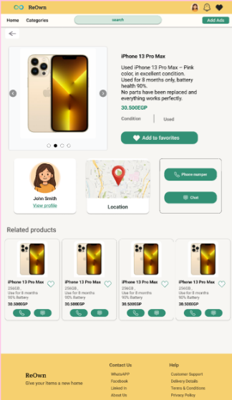
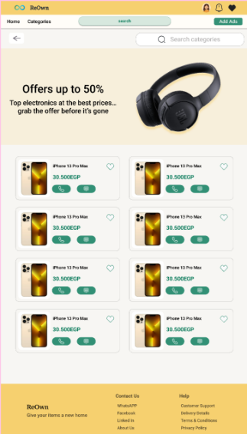
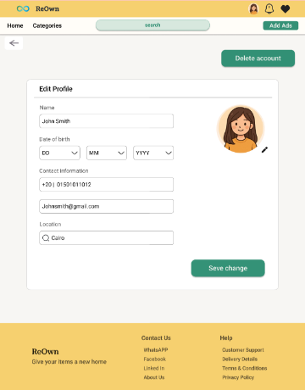
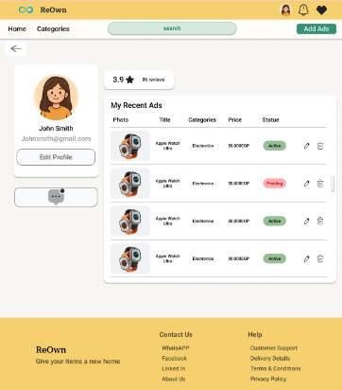
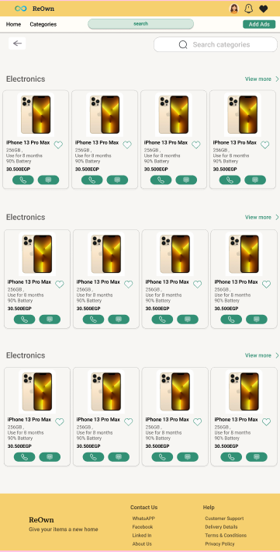
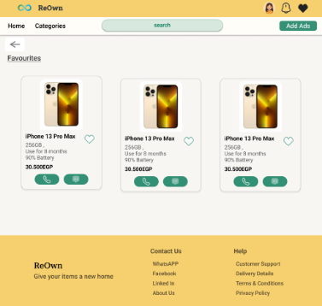
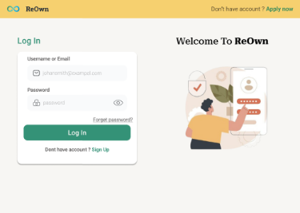
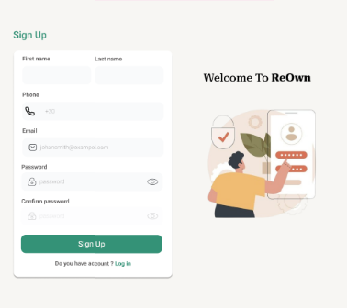
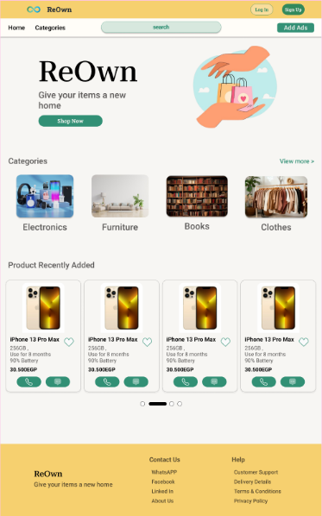
4.1 UI for User :
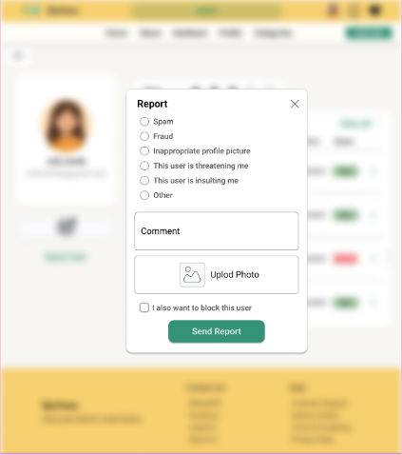
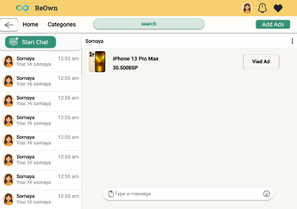
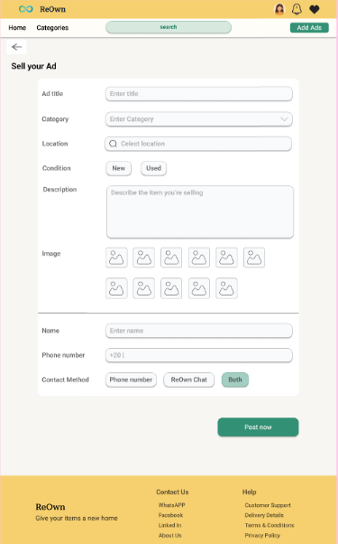
4.2 UI for Admin :
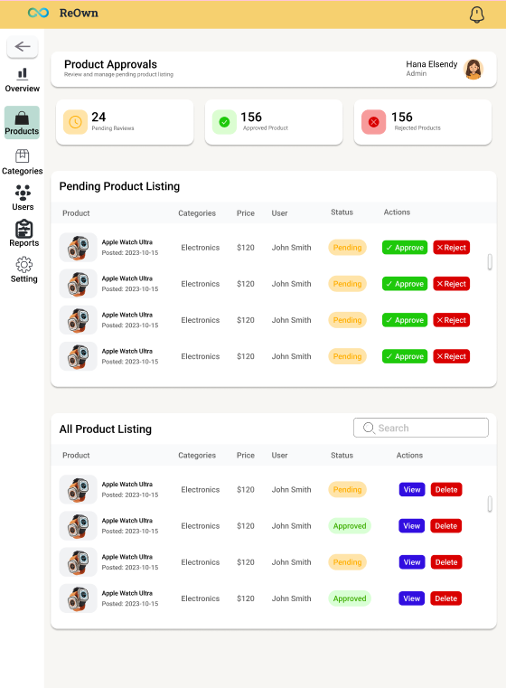
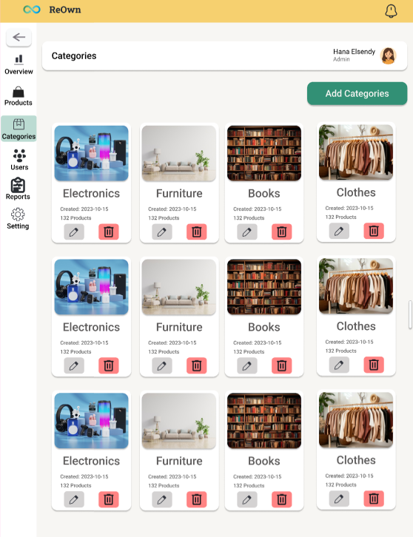
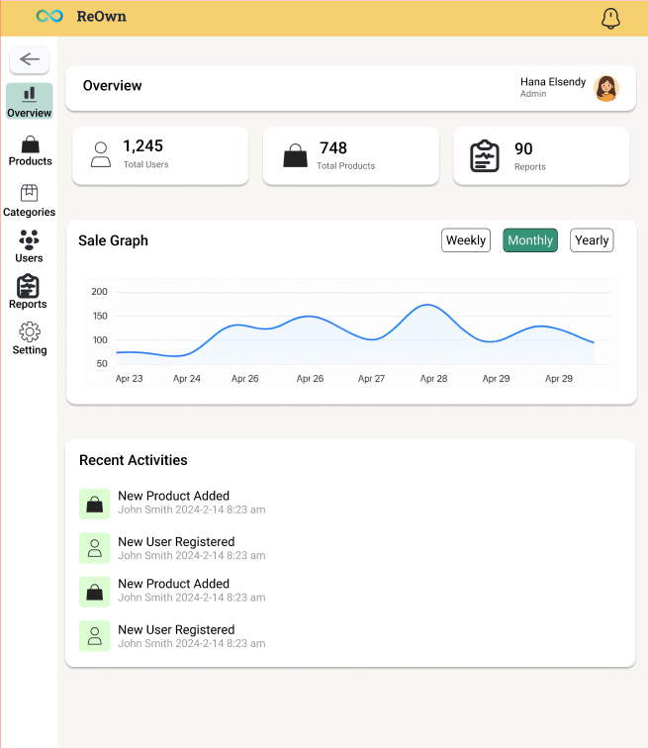

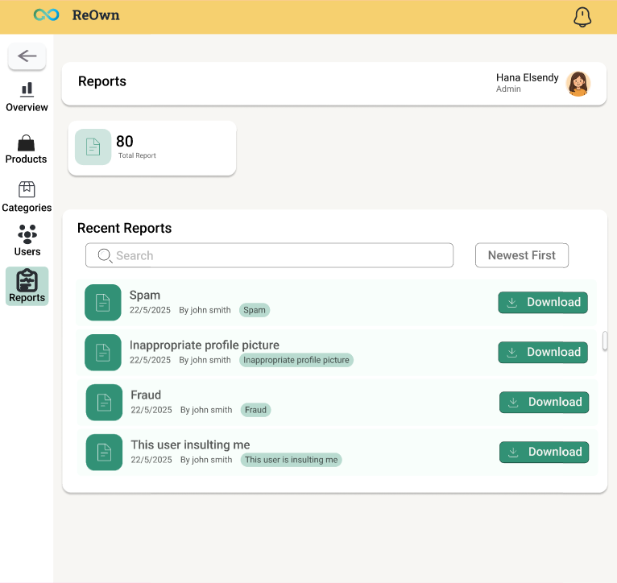
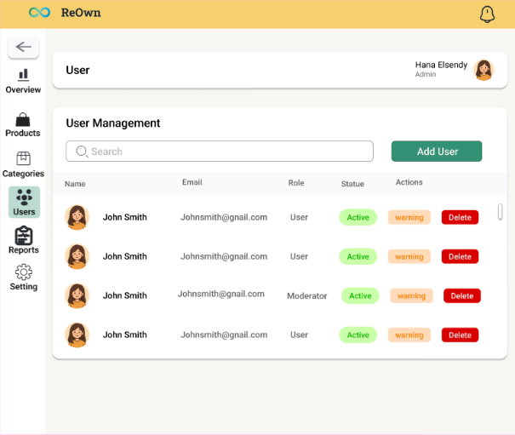
  - System Diagrams

5.1 Use Case Diagram :
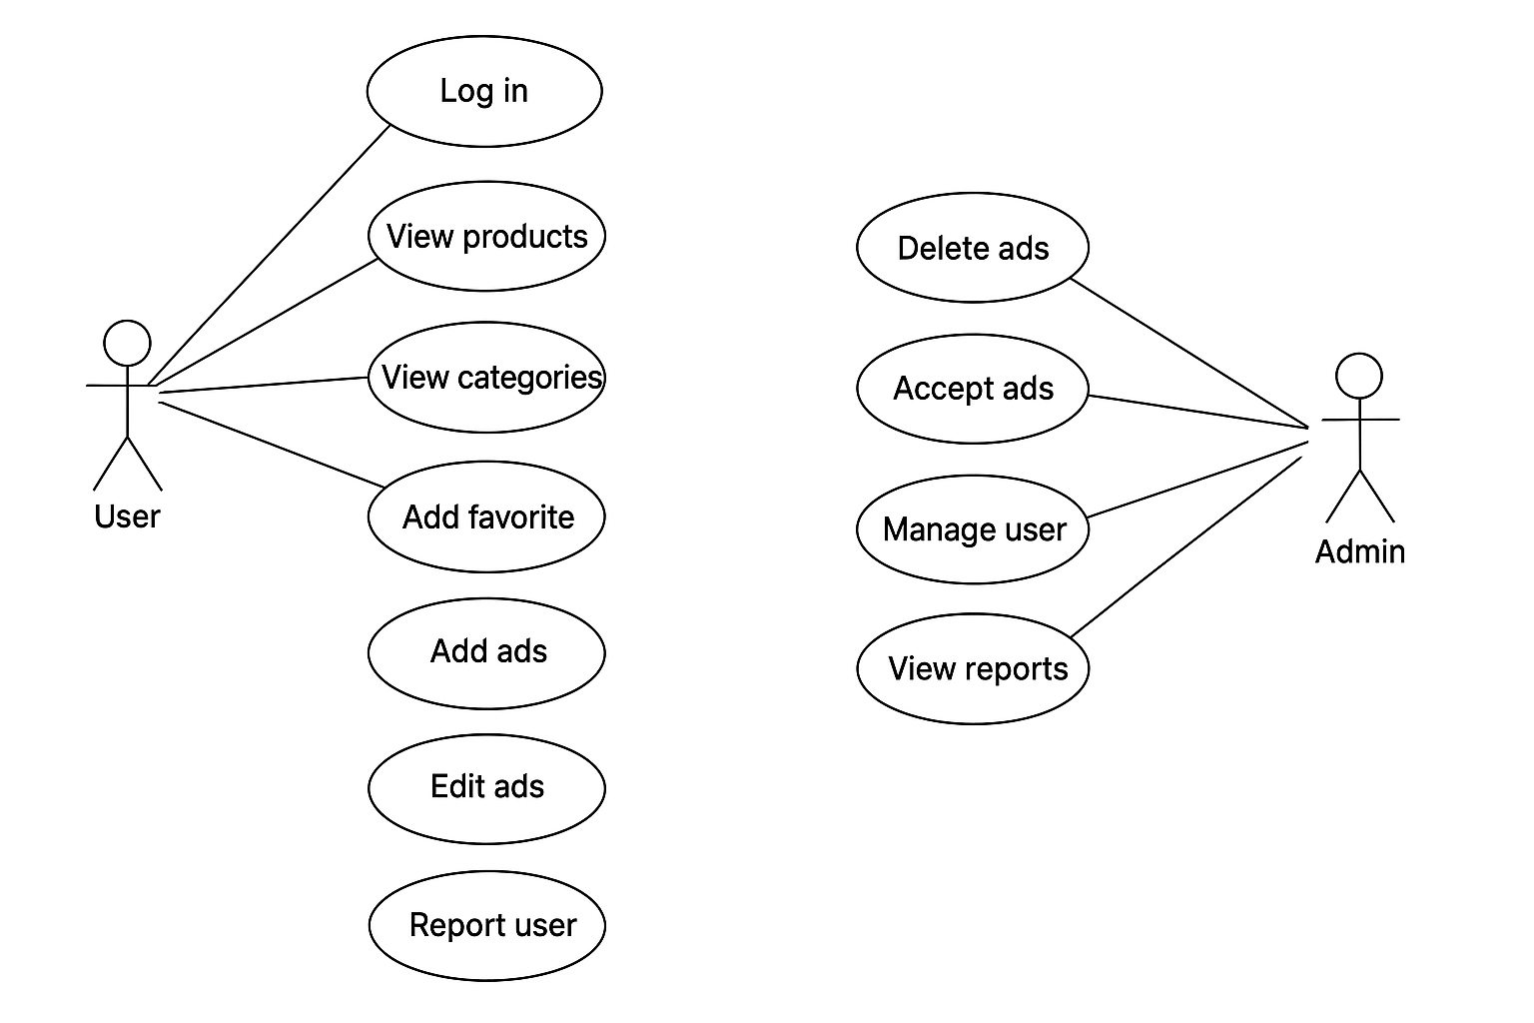

5.2 Database :

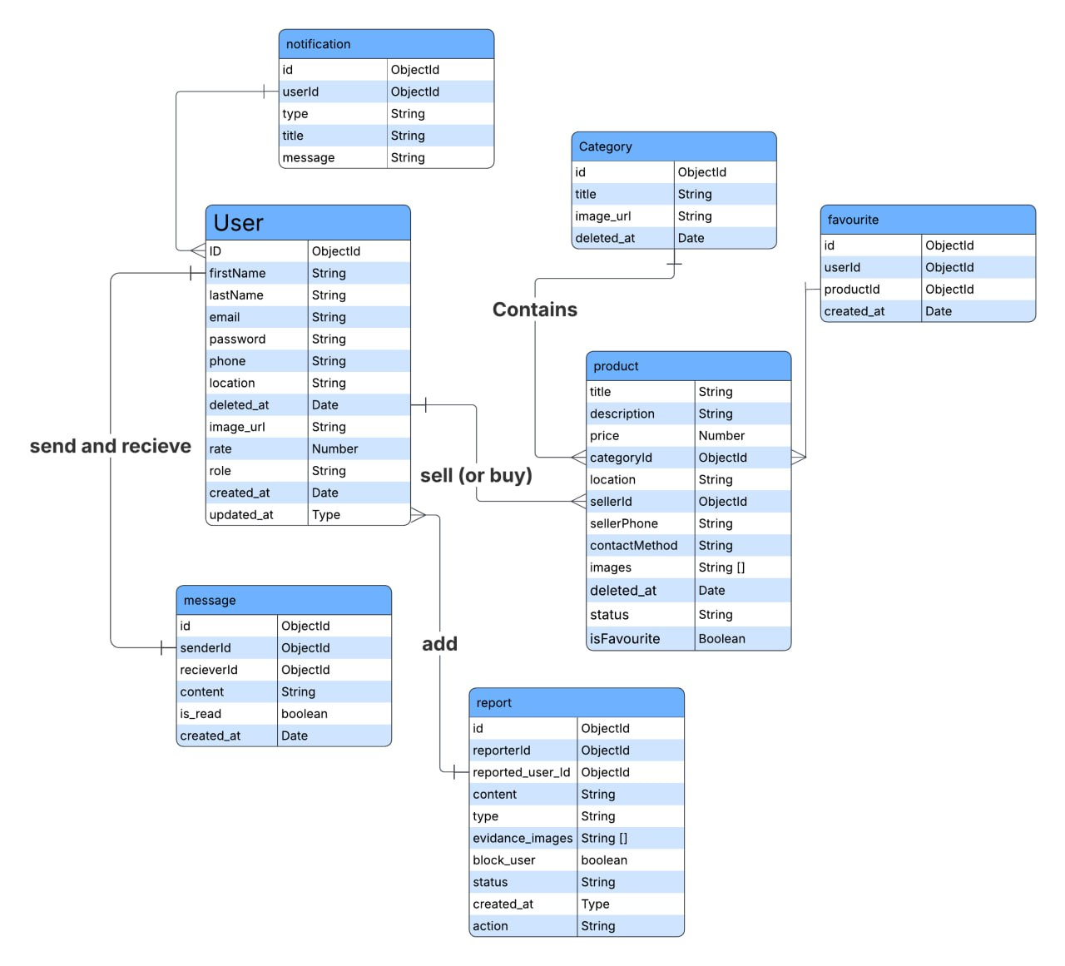

  - Code Snippets

https://github.com/mna712/DEPI-Graduation-Project

  - Conclusion

In conclusion, ReOwn is more than just a platform for buying and selling used items — it reflects a shift toward smarter, more sustainable consumer habits. By offering a simple and intuitive experience, the system successfully connects people looking for affordable products with others who have items they no longer need, giving those items a second life instead of letting them go to waste.

Throughout the stages of analysis, design, and development, we focused on addressing real challenges such as the difficulty of finding nearby second-hand products and the complexity of listing items on other platforms. The result is a user-friendly, efficient marketplace that encourages direct communication, supports local exchange, and promotes reuse within the community.

ReOwn marks the beginning of a project with strong potential to grow and create even greater value, paving the way for more eco-friendly, community-driven digital solutions in the future.

