**Liudmyla Kaskevych**

**Personal information**

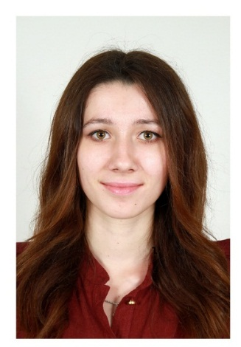

Date of birth: 22.03.1994

Location: Czech Republic, Federova 1700/7 Praha

e-mail: liudmyla.kaskevych@gmail.com

Mobile: +420774070673

Nationality: Ukrainian

Driving license: Yes

Marital status: married

Pernicious habits: No

**Academic qualification**

2012-2016 – BA in Philology of English Language and Literature (translation included)

2016-2017 – Master Degree in Philology and Linguistics, Interpretation and Translation (Eng.-Germ-French). Cross-Cultural Communication.

2016 – Diploma of WIPO (World Intellectual Property Organization)

**Areas of expertise**

* Translation Studies
* Interpretation and Translation from the English Language, French and German
* Customer Service

**Work experience**

1.07-30.10.2018 –Buyer specialist (R.F. Profi, Turnov)

*Responsibilities:* communication with a customers; development of sources for supply ;processing the material specifications and prices, delivery dates, etc.; evaluation of the costs, managing delivery schedules; processing of standard terms and conditions of delivery; communication with other departments; processing of inquires; monitoring of supplier performance, preparation of reports and other records; problem-solving.

01.03.2019 – 2020 – GV Application Service Consultant (ADP)

*Responsibilities:* provide technical support for clients within SAP HR Modules;  
deliver World Class Service in accordance with Company Service Level Agreements; contribute to testing of version upgrades and providing relevant training to user; resolving client application questions or problems in the area of system set up, product functionality and product enhancements in addition to other services issues in the complex area of payroll, time management and HR; understanding the clients systems and processes and their relationship to company's products and services to troubleshoot and solve issues.

**Experience and key competencies**

Language skills:

* English (C1)
* German (B1)
* French (A2)
* Czech (B2)
* Russian (C2)
* MS Office (Word, Excel, PowerPoint)
* Windows – user
* Share Point – advance user
* Siebel – active user
* CRM – advance user
* Use of basic knowledge of marketing and economics.
* SAP HR Module (Payroll, Time Management), SAP GUI Module – advanced user

Personal attributes:

* Ability to analyze and resolve problems through effective communication
* Self-motivation;
* Organization skills and single-mindedness;
* Strong team player and work independency;
* Focus on results;
* Ability to prioritize and stick to deadlines
* Good communication skills and presentation ability;
* Very strong organizational skills with excellent attention to detail;
* Strong ability to work with clients in virtual environment.

Interests:

Sport, travelling and reading. Interest in IT.