**Student Management Module**

**User Guide**

**Version 1.0**

Table of Content

1. Introduction
2. Add or register new students
3. Editing existing students
4. Deleting existing students
5. Searching existing students

**1. Introduction**

Welcome to Student Management Module. This module will enable you to do common tasks for searching, editing, deleting, and adding new students any time you want. This module basically provides two main features. They are Student List and Student Registration as you can see in the following figure with red border surrounded.

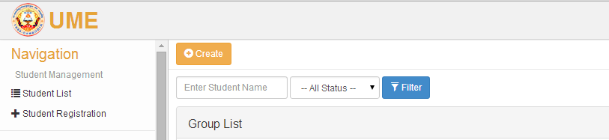

* **Student List:** displays all students that do exist in the system. From this list, you can do some other tasks like deleting students, editing students, searching or filtering students and even registering new students. In the following picture, you can see a list of students with some other options for processing student information.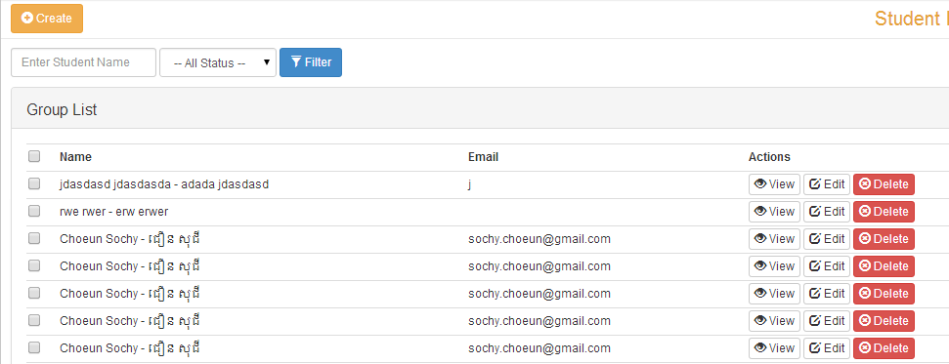
* **Student Registration:** allows you to register or add new students. This page will give you all the options you need to store a student information. For the detail on how to fill in information correctly for registering new students, you will in the section. Take a look at the figure below. In the figure, you will see many fields and options that allow you to fill student information efficiently.   
  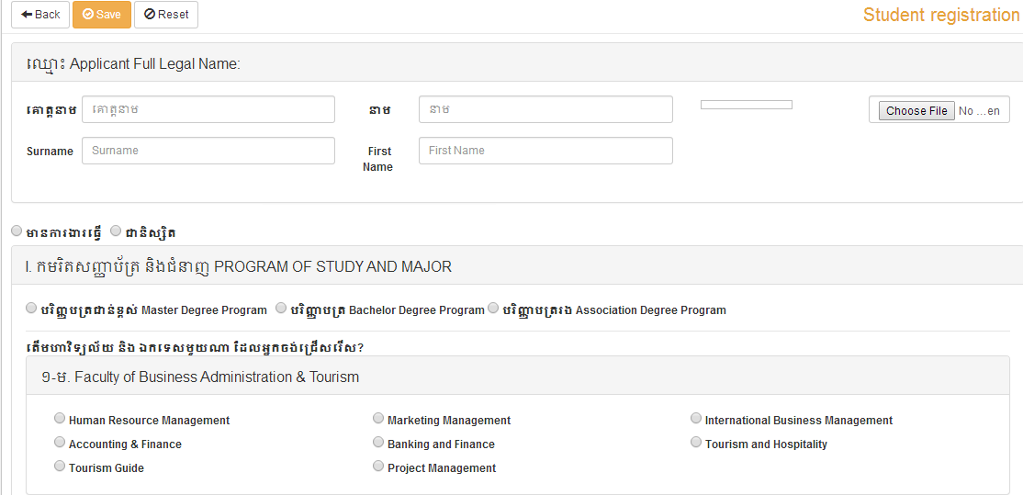

**2. Add or Register New Students**

To add or register a new student, follow these steps.

**Step #1:** On the left panel of the software, click on Student Registration menu or you can click on the Create button as you can see in the following illustration.

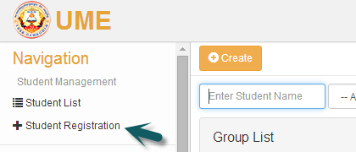

**Step #2:** After you follow the first step, you will be able to see student registration form the same the picture below. This registration is divided into different sections. Each section contains a group of information that you need to select or fill.

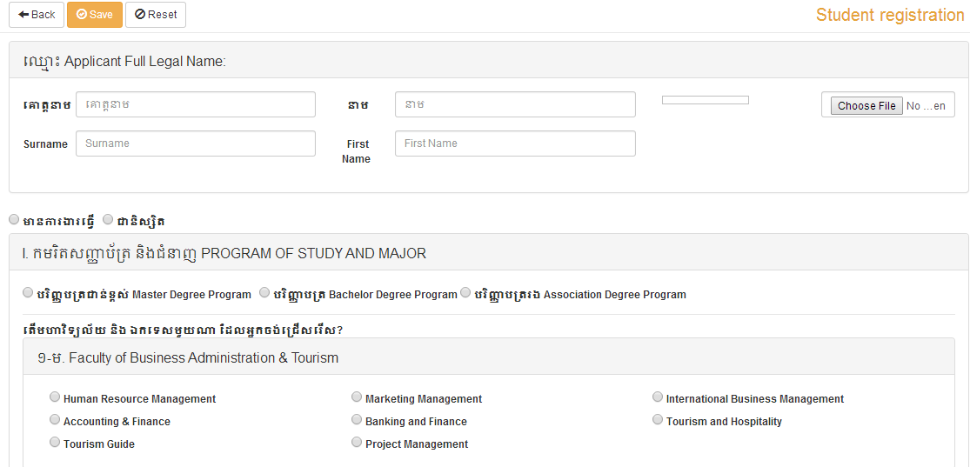

**Step #3:** After you complete all information that you need, you must click on the Save button to save your information, otherwise you will lose it.

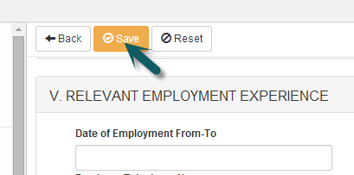

If you want to cancel the registration, click on the Reset button as the following figure.

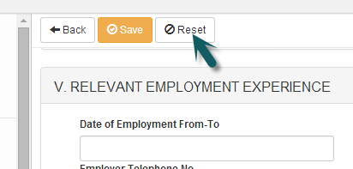

To go back to student list, you just click on the Back button as in the below illustration.

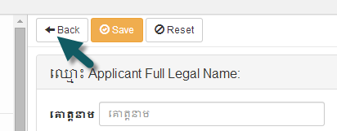

**3. Edit Existing Students**

To change or editing any existing student information, follow these steps.

**Step #1:** Go to Student List page by navigating from the menu in the left panel. From the list, select a student that you want to change or update information and then click on Edit icon. Let see an example below.

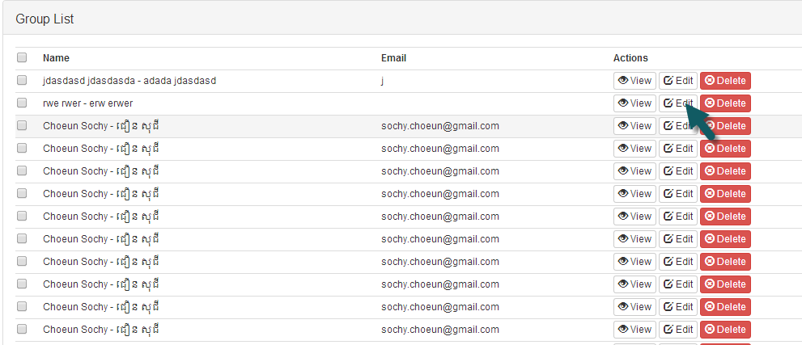

If you have many students and you can find the wanted student, you can navigate from one page to another page by click the pagination at the button.

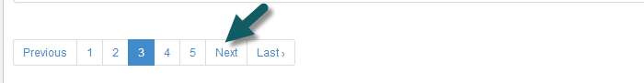

After you click Edit, you will see a form for changing student information. Just update the information and then click Save to permanently save your changes to the system.

Wait for Software Testing To Be Complete!