**Room Management Module**

**User Guide**

**Version 1.0**

Table of Content

1. Introduction
2. Adding room type
3. Editing, deleting and view room type
4. Adding new room
5. Editing, deleting and viewing room

**1. Introduction**

Welcome to Room Management Module. This module will enable you to do common tasks for searching, editing, deleting, and adding new room and room type any time you want. This module basically provides the following features.

- Managing and adding room type

- Managing and adding room

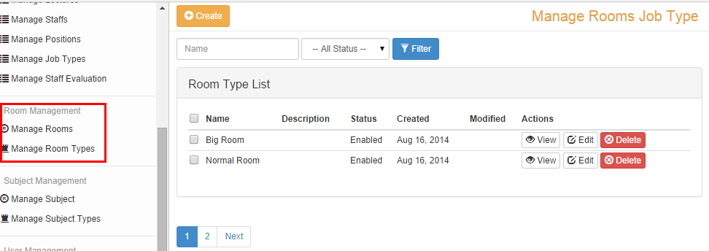

**2. Adding Room Type**

Generally, before adding a new room, the first thing that we have to do is to create a room type.

To create a new room type, do the following steps.

**Step #1**

Go to Room Management module and then click on Manage Room Type menu in the left panel and you will see a list as the following.

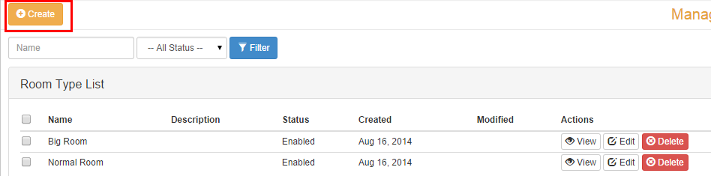

**Step #2**

Click on the Create button on the top of the page then fill the information and click Save button to save your added data.

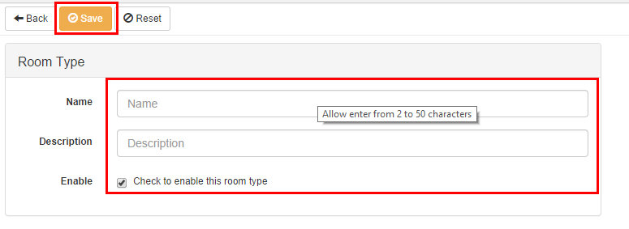

**3. Editing, Deleting and Viewing Room Type**

After adding new room type, you also can edit it as well. In some situations, make something wrong when you add new record, so you need to update or edit it. To edit a record, first you have determine which one you want to change. Second, click on the Edit button in the list as in the figure below.

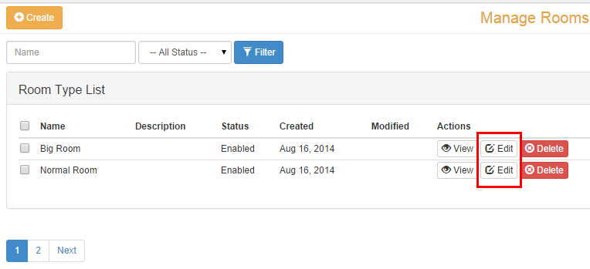

Third, fill in the form with appropriate data and click Update button to save changes.

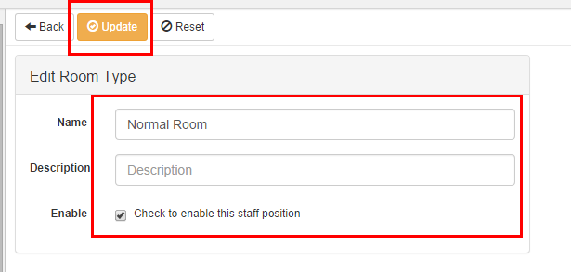

Yes, this is the simple and easy way to update your room type. Besides that, if you want to delete it from your database, just click on the Delete button and confirm the dialog box, that’s all.

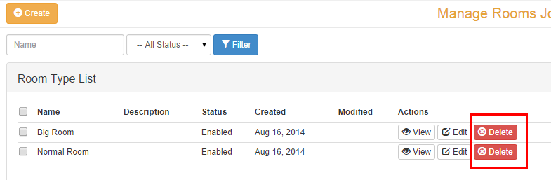

If you want to view detail information of each room type, you click on the View button to see its info. Let see the following example.

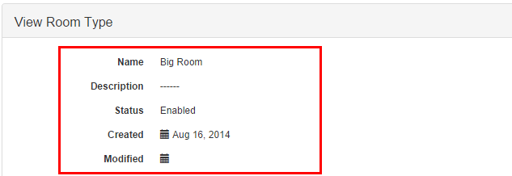

**4. Adding New Room**

When you already have some of room types, now you can create or add new rooms for your classes. To add a new room, follow these procedures.

**Step #1**

Go to Room Management Module and then click on the Manage Rooms menu. From there you will see a list of all rooms that you created previously for your class.

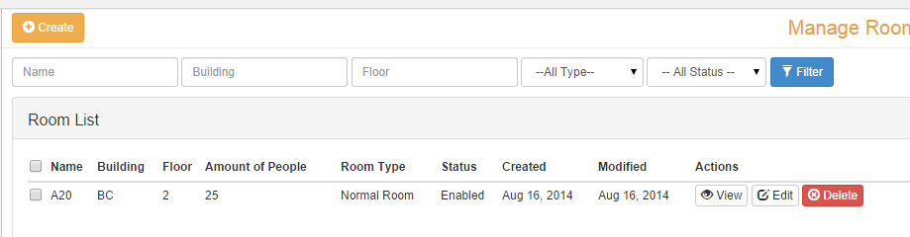

**Step #2**

Click on the Create button on the top of your list and fill in the required information. After that, click on the Save button to add or save your new room, that’s all.

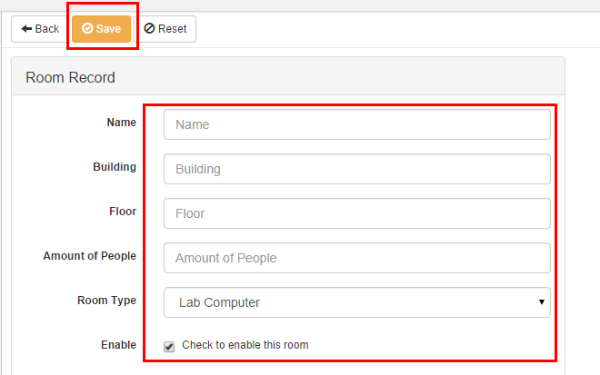

**5. Editing, Deleting and Viewing a Room**

To edit or update an existing room from your system, follow these procedure.

First, find the room that you want to make change or edit. Then click on the Edit button as the following figure.

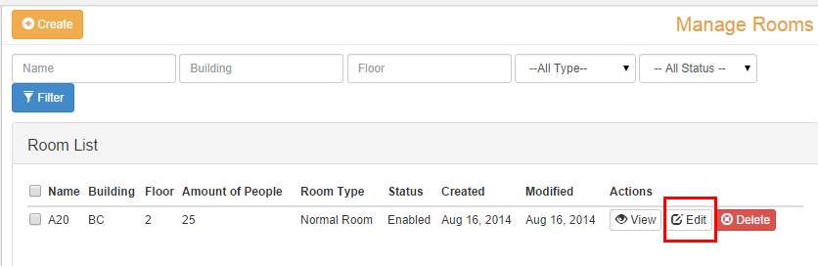

Second, fill in the correct data and then click button Update to save your changes.

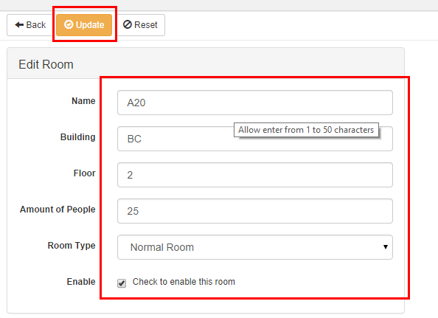

That is what the procedure you use to update rooms. If you want to remove it from your system, it’s really easy. You just click in the Delete button and confirm the dialog box, that’s all.

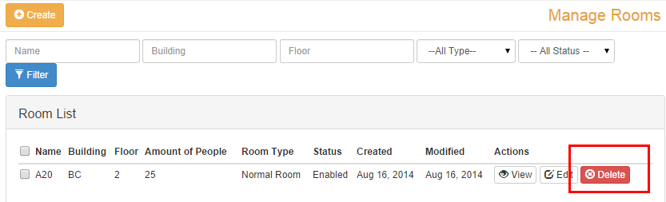

You also can view detail information of any room as you want. To see its information, you click on the View button that you can see from the room list and you will be able to see all details information of the selected room.

