**Staff Management Module**

**User Guide**

**Version 1.0**

Table of Content

1. Introduction
2. Managing Lectures
3. Managing Staffs
4. Managing Positions
5. Managing Job Types
6. Managing Staff Evaluation

**1. Introduction**

Staff Management Module is one of the main modules of the system. It will be a module that you may work a lot for common tasks that are related to staffs. This module provides the following features:

* Lecture management: allows you to control all lectures such as editing, adding and deleting a lecture.
* Staff management: allows you to control all staffs. You can add new staff, update existing staff information such as email and phone number.
* Position management: allows you to manage all positions available in the system. You can add new position, edit existing position and so on.
* Job type management: provides you full control on job type. You can modify, view detail, update or delete any job type.
* Staff evaluation management: allows you to do and control staff evaluation. You evaluate by ability, by attendant or by course idea.

All of these features are the expressed as menu links. In the following figure, it does exist in the left panel, just below Education Management Module.

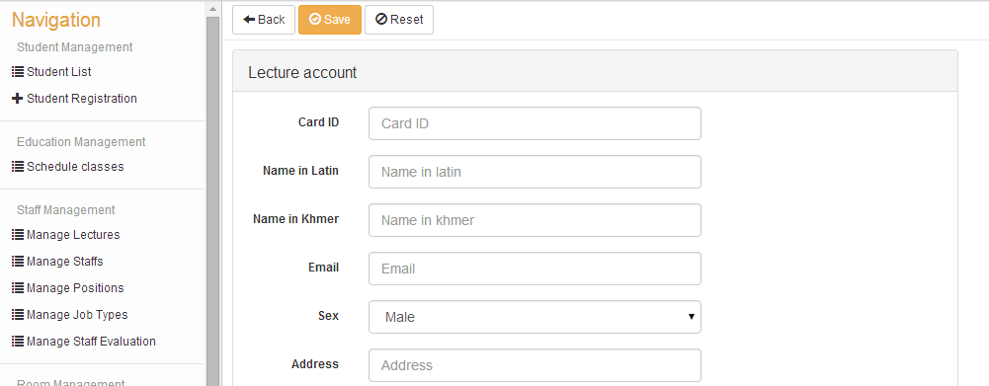

In the next several sections, you will see how to do specific tasks on each feature.

**2. Managing Lectures**

To add a new lecture, follow these steps:

**Step #1:** Go to Staff Management Module and then click on Manage Lectures menu as the following figure.

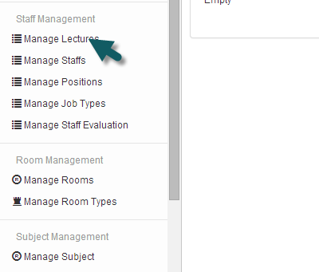

**Step #2:** After you click the above link menu, you will be referenced to Manage Lectures page. In that page, click on the Create button on the top as the following figure. Once you click the button, you will see the form for adding new lecture.

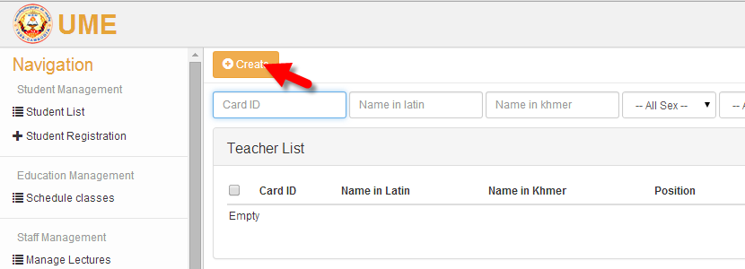

**Step #3:** In the Lecture Account form, fill in all required information, once already, click on the Save button to add new lecture.

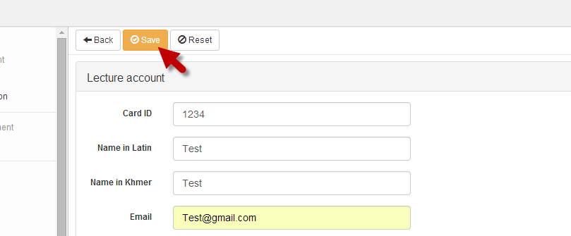

To delete a lecture, you just go to Manage Lectures page and then find the wanted lecture for deleting. Once you found it, just clicking the Delete icon and that is all.

To edit any lecture, go to Manage Lectures page and then find the one that you want to change. After that just click the Edit icon, you will see the form for changing data as the following figure.

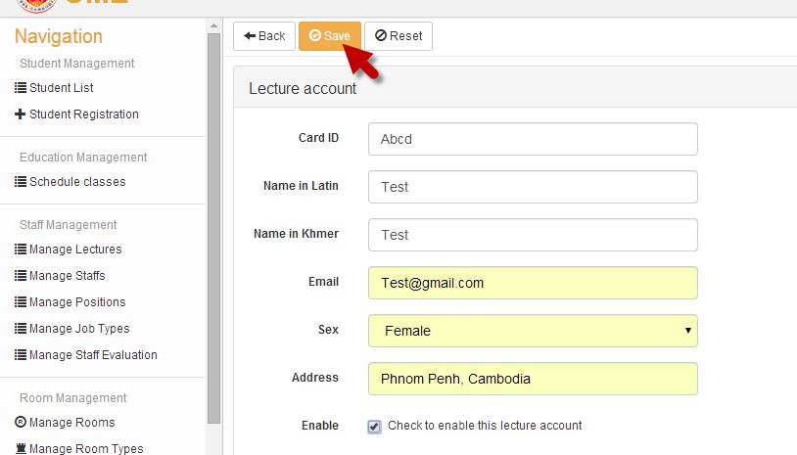

After you make changes to your data already, don’t forget to click on the Save button to make changes permanently. If you forget, your changes will not take effect. Anyway, if you want cancel or reset your changes, just click on the Reset button next to the Save button and that’s all.

**3. Managing Staffs**

To add a new staff, do the following steps.

**Step #1:** Go to Manage Staffs page and then click on the Create button on the top of the page.

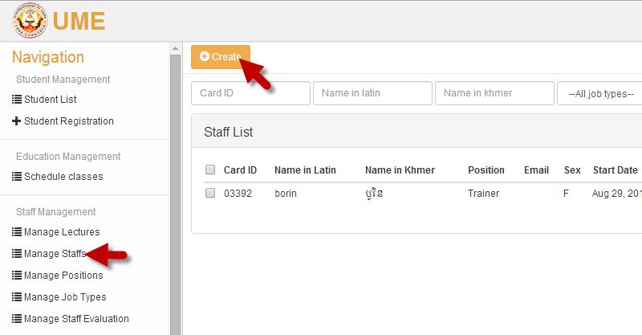

**Step #2:** After you click on the Create button, you will see a form for adding new a new staff. Then you just fill in all required information and click Save button to add.

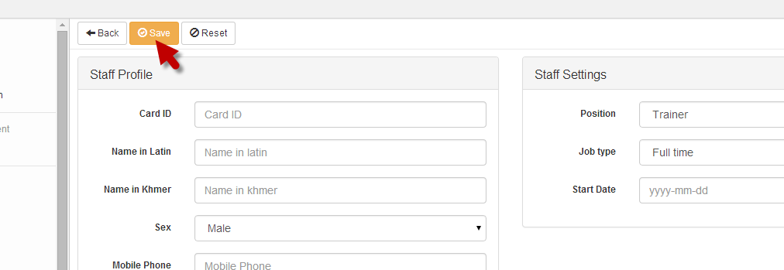

To delete a staff, go to the Manage Staffs page. There, you will see the list of all staffs with pagination. If you cannot find wanted staffs in the current page, you can use pagination to move to other pages. In this list just find the staff that you want to delete and click on the Delete button as you can see in the following figure.

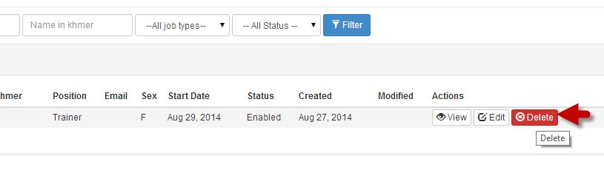

v

To view detail information of a staff, go to Manage Staffs page and then find the wanted staff that you want to view information. When you found, just click on the View button that stays next to Edit button in the page. Let see the following image as the example.

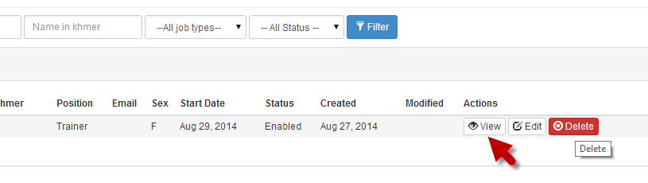

Detail information may be shown like this.

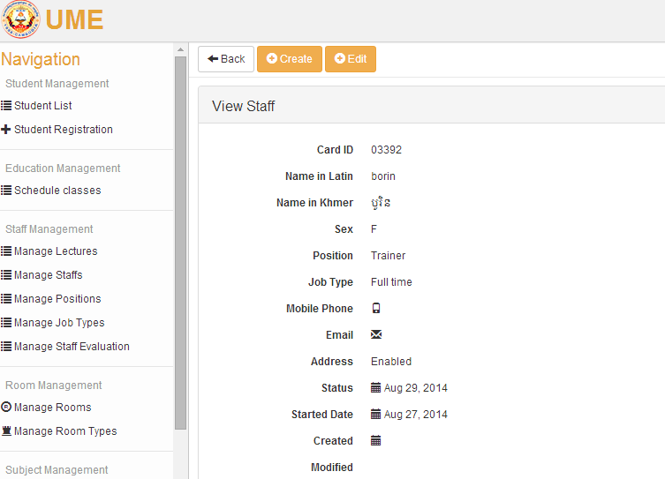

To edit or update a staff, you just follow similar procedure as deleting or viewing. Go to Manage Staffs page and then find the staff that you want to update his/her information. When you found, just click on the Edit button that stands next to the Delete button.

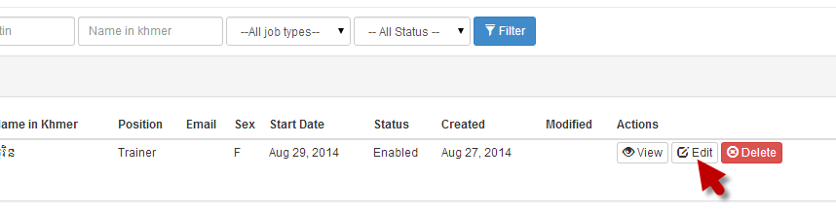

Once you click the Edit button, the update form will appear as the following picture.

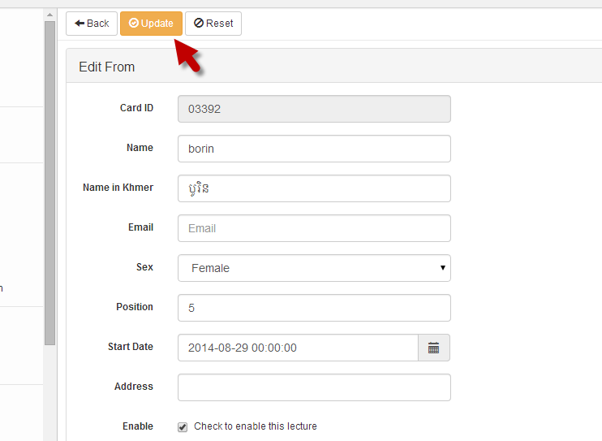

Once you make changes all required information, just click the Update button on the top of the form to save data permanently. If you don’t click this button, your update will not take effect. Anyway, if you want to cancel your update, just click on the Reset button that stands next to the Update button as you can see in the figure above.

**4. Managing Positions**

This feature provides you the full control for managing positions of your staffs. To add a new position for your staff, go to the Manage Positions page and then click on the Create button on the top of the page.

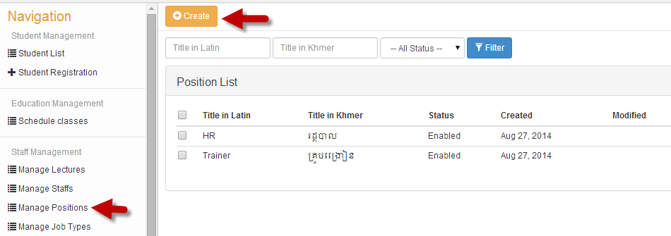

After that, a form will appear for you to fill in data. Fill in the required data correctly and then click Save button to add new position. If you want cancel the entry, just click on the Reset button near the Save button and that’s all.

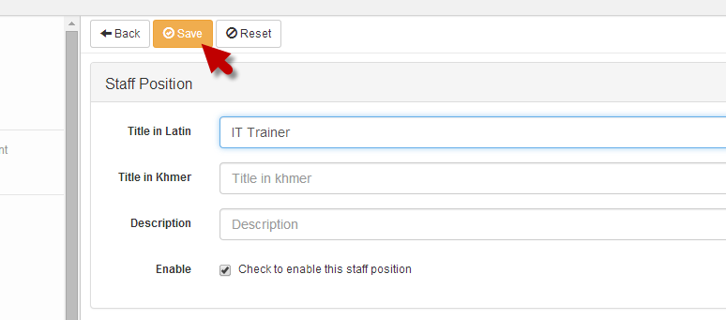

To delete a position, just go to the Manage Positions page. In that page, you will see a list of all positions. Just choose the one you want to delete and the click on the Delete button. Let see the figure below.

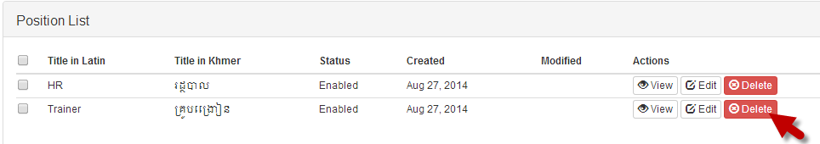

Similarly, if you want to update the existing position, you can go to the Manage Positions page and then find the position that you want to change and click on the Edition button. After that a form appears for you to update information. Once you make change to the information, click on the Update button to save changes.

