CS 1033
Multimedia and Communications

Lab 02: Introduction to Photoshop
(Graphics part 1 of 2)

REMEMBER TO BRING YOUR MEMORY STICK TO EVERY LAB!

Photoshop Layout – Reference Sheet

Use this picture as a Photoshop layout reference sheet as you work through labs 2 and 3.
If you are reading this on a paper printout, be sure to open the original PDF file for this tutorial so you can see the different colors!

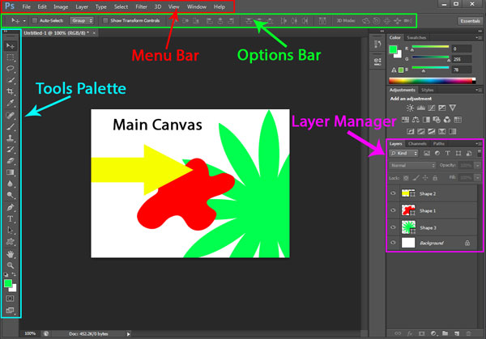

LAB #2 - Exercise 1
Objectives:
- Becoming familiar with the Photoshop layout
- Adjusting Image Properties: Brightness and Contrast, Hue/Saturation/Lightness
- Working with Text: creating, editing color, editing the text, moving the text
- Drawing a straight line
- Saving the image - .psd and .jpg

Before starting this lab, make sure to copy the folder “lab02” from http://www.csd.uwo.ca/~lreid/cs1033labs/lab02 to your memory stick. Remember from Lab 1 that your memory stick is most likely labelled as the F: drive on the computer. After you do this, the folder “cs1033” on your memory stick should contain two folders: lab01 and lab02.

- Start Photoshop CS6.
From the Menu Bar at the top, click File > Open, then navigate to F:\cs1033\lab02. From the Dialog box that pops up, select “house.jpg”. This opens an Image window in which you can start editing. Press the Tab button: this hides the toolbars so you can view just the image. Press Tab again to enable toolbars.
- From the Menu Bar, select File>Save As. Save the file in the folder called “lab02” on your memory stick, so it will be saved in the folder F:\cs1033\lab02. Name the file “exercise1_complete.psd”, and make sure the format is set to Photoshop. This saves the file in Photoshop’s native format so that layering is retained, allowing you to modify it easily later on. During our tutorials, we will always first save the file that we are working to a different name than the source file, so we don’t overwrite the original!
  - NOTE: if you get the following message, just hit OK: 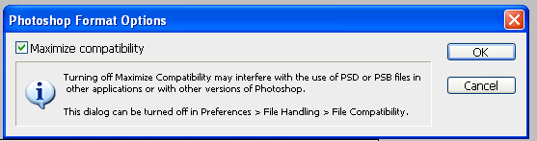
- Photoshop Layout and Magnifying
- The Tools Palette is the vertical bar on the left of the screen. From it, click the magnifying glass
- Some options for the magnifying glass tool will appear at the top of the screen, just below the Menu Bar. This is the Options Bar, and will always show the options available for the selected tool. Try clicking on different tools from the Tools Palette, and watch the Options Bar change.
- Click back on the magnifying glass. Move your mouse over the image, and left-click to zoom in. Each time you click, it zooms in a bit more. To zoom back out, right click, then select “Zoom Out”
- Make sure you return back to a normal view (not zoomed in too much). A quick shortcut to zoom back to 100% is to hold Ctrl + 1.

- Experiment with “Brightness and Contrast”
- From the Menu Bar, select Image >Adjustments >Brightness/Contrast.
- With the “Preview” box checked, use the slider to move Brightness and Contrast and see how the image changes. Once you’re done, CANCEL OUT OF IT so that the picture remains unchanged. If you have already pressed “OK”, undo your operation by selecting from the Menu Bar Edit>Undo
Pixel: one screen “dot”
Brightness: changes the intensity of ALL pixels uniformly.
Contrast: changes the difference between the darkest and lightest pixel for ALL pixels

- Work with “Hue/Saturation/Lightness”
- From the Menu Bar, select Image >Adjustments > Hue/Saturation
  - Use slider and move Hue slider to the right and left of middle and see how it affects the picture. Also play with the Saturation level and Lightness to see the effects of changing the overall appearance of the image. Once you’ve finished exploring, press Cancel.
Hue: the base color
Saturation: the “purity” of the color (less “pure” = more grey)
Lightness: the brightness of the color

- Add Text to the Image
- From the Tools Palette, click the Text Button . Left-click the mouse near the middle of the image.
- In the Options Bar, set the font to Arial, size=30, and type in the words “Country Living”. Once you’re done, click the checkmark in the text Options Bar (top right) to save your changes.
- Notice in the Layer Manager (bottom right of the screen) that a new layer has been added to the background with the title “Country Living”.

- Changing the Text Color of the text “Country Living”
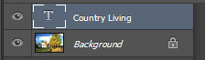
- In the Layer Manager …. Click on the “Country Living” layer, and then double-click on the letter “T”. This will select your text.
- Now from the text toolbar at the top of the screen, click on the colour option 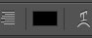. This will bring up a dialog box that will let you change the color.
- From the narrow rainbow-coloured box, click on a red color (this box let you choose the general color that you want). Then choose the exact shade of red using the “circle” inside the square. Press “OK”.

- Moving the Text selection
- Click on the layer labelled “Country Living”. Otherwise, if you are on “Background” you will be moving the entire picture. Then select the Move tool and place pointer over the text “Country Living” and drag the text to the top left corner in the sky portion.

- Next, under the “Country Living” string, add the text string “Family Living at its Best!” Set the text properties to “Times New Roman, size= 24pt, Bold Italic, and white color”.
Note that you will not be able to proceed until you click the Options Bar checkmark (as in step 5)!

- Next, to the bottom right part of the screen, add the text string “Fiddlers Real Estate (press enter) (519) 670-1443” with text font=Times New Roman, size=24, color=”red” and bold and italicize. You may have to drag into the right spot. It won’t look right, so you will now adjust the text to
  - “text font=Arial, size=24, bold, no italics, and color=black”, and right-align it

- Adding a straight line above the text “Fiddlers Real Estate”
- At the bottom of the Layer Manager Tab, click on the to create a new layer. By default, it will be called “Layer 1”, or some other number. Double click this text and change the layer name to “Straight Line”. Make sure you click on the layer in the Layer Manger.
- In the Tools Palette, right click the Rectangle Tool and select the Line Tool (as shown below).
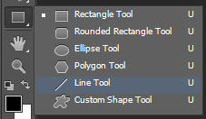
- In the Fill Color box in the Options Bar, change the color to red.
- Place your mouse just above the text “Fiddlers Real Estate” and draw a line that is as long as the text “Fiddlers Real Estate”.
- To get a thicker line, Undo the last operation, and in the Options Bar, set the Weight to 5 px. Then draw the line over the image. If you find it difficult to draw a straight line, try turning on Grid lines (from the Menu Bar, click View > Show > Grid) OR try holding down the shift key while aligning. This will limit the range of angles the line can take.
- If you need to move the line, select the Move tool and drag it to the right spot. Since there is only one straight line on this layer, the line is the only thing that would move. If you had drawn two lines on this layer, then both lines would have moved at the same time.

- Save the File in both .psd and .jpg formats
- Save the file again as “exercise1_complete.psd”, as in step 2 above.
- Next, save the file as a .jpg file by changing the format to JPEG. This is a universal file format, so it can be viewed on any computer, even if Photoshop is not installed on that computer. However, the layering will be lost in this format, making it hard to change later on (e.g. you can’t change the text).
  - NOTE: You may see this window every time you try to save as a jpg, just click on OK
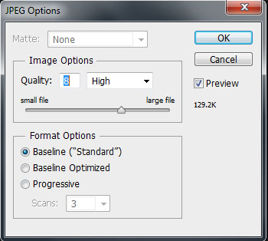
- Save the file in lab02 folder as exercise1_complete.psd and exercise1_complete.jpg
LAB #2 - Exercise 2

Objectives:
- Text – Special Effects: Drop Shadow, Bevel
- Line – Drop Effects

- Close all files, and open the file exercise2.psd. This ensures that you are starting at the correct starting point. Now save the file as exercise2_complete.psd.

- Text – Special Effects – Drop Shadow
- From the Layer Manager, click on layer labelled “Country Living”.
- From menu, select Layer > Layer Style > Drop Shadow
- In the dialog box, as you adjust the settings, you will momentarily see the changes. You may want to play a bit with each setting before setting it to the following values (check the box “Drop Shadow”):
Opacity = 53, Angle = -45 (or turn arrow), Distance = 15, Spread = 0, Size = 5, color should be black

  - To edit the effect later, use Layer > Layer Style > Drop Shadow (leave as is for now)
  - To cancel the effect, select Layer > Layer Style > Drop Shadow and uncheck the box “Drop Shadow” (please do this now)

- In Layer Manager, click on layer “Family Living at its Best” and add a drop shadow effect to it with the settings
Opacity= 75, Angle = -45 (or turn arrow), Distance = 10, Spread = 0, Size = 3, color=black

- Text – Special Effects – Bevel
- From the Layer Manager, click on layer labelled “Country Living”. (Drop shadow effect should have been turned off in step 2 above).
- From menu, select Layer > Layer Style > Bevel and Emboss
- In the dialog box, as you adjust the settings, you will momentarily see the changes. You may want to play a bit with each setting before setting it to the following values :
Style= Outer Bevel, Technique=smooth, Depth=100, Direction=down, Size=5, Soften=0,
Angle=-45, Highlight Mode color=White, Shadow Mode color=Black (leave the other settings at their default)
*Note: You can play around with these settings if you would like, but then reset them to this

- Straight Line – Special Effects – Drop Shadow
- From the Layer Manager, click on layer labelled “Straight Line”.
- From menu, select Layers > Layer Style > Drop Shadow
- Set the drop shadow values to the following:
Opacity=92, Angle=-90, Distance=5, Spread=15, Size=5, Blend mode color=Yellow

- Save the file in the lab02 folder as exercise2_complete.psd and exercise2_complete.jpg

LAB #2 - Exercise 3

Objectives:
- Inserting a layer, Deleting Layers
- Shapes – Drawing Shapes
- Using the Slider on shapes to change look
- Deleting Layers
- Adding Drop Shadow to Shapes
- Using the Deform tool – Change the orientation of Text

- Close all files then open the file exercise3.psd. Save it as exercise3_complete.psd.

- Insert Layer
- Click on the layer “Fiddlers Real Estate”, and then create a new layer using the button. Change the layer name to “Rectangle”. Notice it enters the layer above the item that initiated the command.

- Add a rectangle box for Real Estate Text
- Make sure that you are on the layer “Rectangle” you just created.
- From the Tools Palette, select the Rounded Rectangle Tool. This tool is like the Line Tool and the Rectangle Tool, and can be selected by right clicking where the Rectangle Tool or Line Tool is.
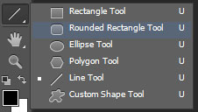
- Before drawing anything, change the Fill Color to blue in the Options Bar.
- Position cursor in the lower right part of the image, so that you can place the rectangle over the “Fiddlers Real Estate” text. To draw the rectangle, Click, hold down and drag to cover the text string and the red line. Then release the mouse. If it is not blue, then undo the last operation, change the color to blue, and then redo step 4.

- Move layers around so that the blue rectangle appears under the Layer “Fiddlers Real Estate”.
- Click on the layer “Rectangle” .Then drag it to the layer below “Fiddlers Real Estate”. This will cause the text and line to appear over the blue box.

- Adjusting Drop Shadow Effects
- The yellow highlighting over the red line may no longer appear yellow. To fix this, double-click on “Drop Shadow” layer that is below the “Straight Line” layer. From the dialog box, change the Blend Mode to “Normal”.
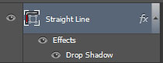

- Add a Pre-Formatted Style to an Object
- Select the “Rectangle” Layer
- Select the Styles tab (indicated by the White arrow in the image below)
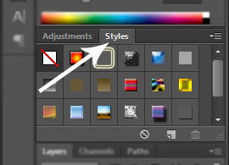
- Change the Layer Style from None () to Color Target (). The “Style” box allows you to quickly experiment with different colors and textures on the objects you create.

- Changing orientation of Text
- Add another layer and call it “Thorndale”.
- Select the Text Tool , and add the text “Thorndale” under the text “Family Living at its Best” with text attributes:
Times New Roman, 48 pt, bold italics, red color
- To change the orientation of the text “Thorndale”, from the Option Bar click the Orientation tool … this will change the orientation to vertical. Press it again to change it back to horizontal.
- To rotate the text string, first ensure the “Thorndale” layer is selected. From the Menu Bar, click Edit > Transform > Rotate. Now either rotate the text by hand so it’s standing on its side, or type in -90 in the angle field on the Options Bar . Once you are done, click the checkmark in the Options Bar.
- Use the Move Tool from the Tools Palette to move the “Thorndale” text to the bottom left of the image, ensuring it does not touch any other text.

- Add a drop shadow to the text “Thorndale”.
- Add a Drop Shadow (Layers > Layer Style >Drop Shadow). Modify it to something you like.

- Add a Custom Bird Shape.
- Select the Rectangle Tool from the Tools Palette
- From the Options Bar, select the Custom Shape Tool. This will be in the same list at the Rectangle Tool and the Line Tool. Right Click on this list, as shown below.
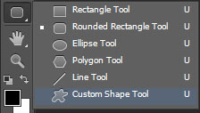
- In the Options Bar select the down arrow next to the Shape: option. From there select the options menu, as indicated below.
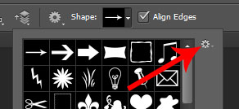
- From the dropdown menu, select “All” and OK. This will load additional shapes into the toolset.
- From the new shapes, select a bird shape , ensure the color is black, and draw a bird in the sky, to the right of the “Family Living at its Best!” text
- This will create another layer called “Shape 1” (or some other number). Double click “Shape 1”, and change the text to “Bird”. It is good practice to ensure all of your layers are named appropriately, so you can easily track down a shape!

- Save the file in Lab 2 folder as exercise3_complete.psd and exercise3_complete.jpg

LAB #2 - Exercise 4

Objectives:
- Testing you on creating:
- Entering Text, Creating Shapes
- Drop Shadows, Bevels,
- Distort (to change orientation, and lengthen shape)
- Inserting Layers

- Start up Photoshop, and select “Open”
From your folder “lab02”, open the file pizza.jpg. Save it as exercise4_complete.psd.

- Create the look below using the tips indicated below. Note that if you’re using a black-and-white printout of this tutorial, you won’t be able to see all the colors in the image below!! Hint: the Styles Effect: Double Ring Glow is in the Color Menu, if it is not showing, select Window>Color, then select Styles and the third one is Double Ring Glow, remember to put it back to the white circle with the red line through it (Default Style (none) when you are done or you will have problems with coloring your other text!

- Save the file in Lab 2 folder as exercise4_complete.psd and exercise4_complete.jpg

- REMEMBER TO REMOVE YOUR MEMORY STICK FROM YOUR MACHINE AND PUT IT IN YOUR BACKPACK! (don’t forget it in our lab machines)! J

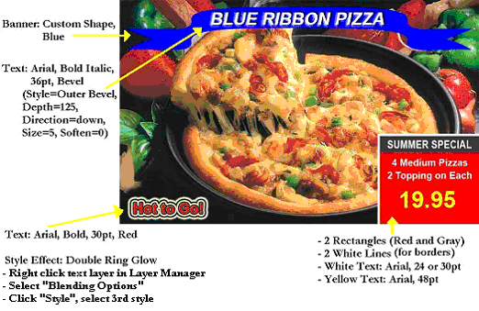

Exercise 1 Image: (Completed)
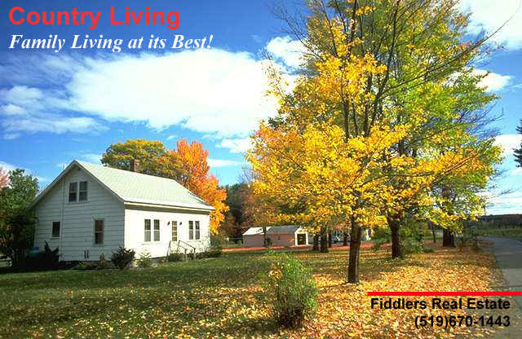

Exercise 2 Image: (Completed)
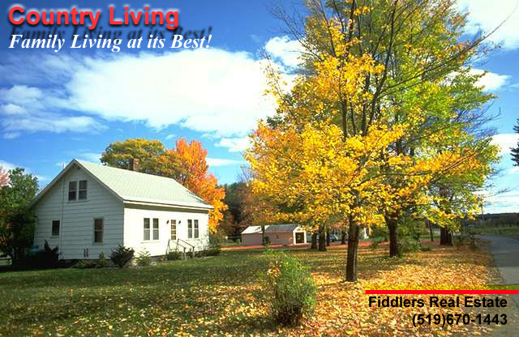

Exercise 3 Image: (Completed)
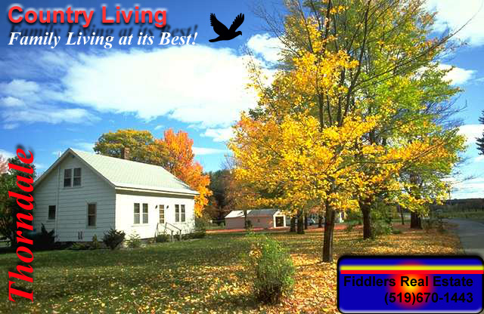

Exercise 4 Image: (Completed)
