CS 1033
Multimedia and Communications

Lab 03: Photoshop Techniques
(Graphics part 2 of 2)
REMEMBER TO BRING YOUR MEMORY STICK TO EVERY LAB!

Photoshop Layout – Reference Sheet

Use this picture as a Photoshop layout reference sheet as you work through labs 2 and 3.
If you are reading this on a paper printout, be sure to open the original PDF file for this tutorial so you can see the different colors!

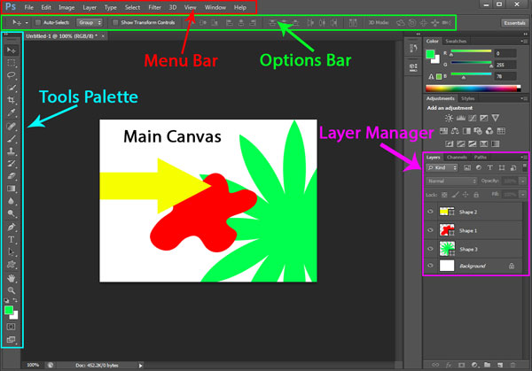

LAB #3 - Exercise 1

Objectives:
- Starting up a Blank or Colored Canvas
- Adding, Resizing, Cropping Images to the Canvas
- Flipping and Rotating Layers and the Canvas
- Adding Text, Shapes

Before starting this lab, make sure to save the files and folders from: http://www.csd.uwo.ca/~lreid/cs1033labs/lab03 to your memory stick in a folder names Lab03.

You will start with a blank canvas and add elements to it to create effects as in Exercise 1 completed.

- Set a Background Color
- Start up Photoshop CS6. If any files are open in Photoshop, close them.
- In the Tools Palette, you will see two overlapping boxes 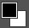 (your colors will be different).
- The box on top indicates Foreground Color, and the box on bottom indicates Background Color
(So in the icon above, foreground=black and background=white)
- Click on the Foreground Color box, and from the dialog box that appears select black. For the Background Color, select a dark blue.
- The result should look like this:
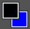

- Create an Empty Colored Canvas
- From the Menu Bar, select File > New
- In the Dialog Box, set:
Width=900 pixels
Height=600 pixels
Resolution=96 pixels/inch
Color Mode=RGB 8-Bit
Background Contents=Background Color
Once you have set all these options, hit OK.
- This will create a new canvas, with a background color of whatever you set up in step 1 (dark blue).
- Change the background color to red, so it appears as 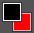 (do not change the foreground color).
- Save the file as exercise1_complete.psd on your memory stick in folder “lab03”.
- Add Text to Canvas
- Click on the Text Tool and enter the text: “Ontario Getaways!” with attributes:
Font Type: Book Antiqua
Size: 72 pt
Bold Italics
Color= Very Light Blue (almost blue-white)
- Use the Move Tool to center the text in the middle of the canvas
- Add a Drop Shadow to the text (make sure have the text layer selected).
From the Menu Bar select Layer > Layer Style > Drop Shadow. Set it as:
Color=black, Opacity=75%, Angle=135, Distance=5px, Spread=5, Size=2

- Add an Oval Shape
- Right click on the Shape Tool in the Tools Palette, and select the Ellipse Tool.
- In the Options Bar, select a lilac (very light purple) color.
- Left click on the canvas. Fill in the dialogue as shown below and select OK.
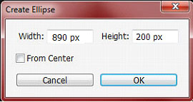
- Using the Move Tool move the oval to be covering the text.
- In the Layer Manager, name the layer with the oval as “Oval”, and position it between the “Background” and “Ontario Getaways” layers. The oval is now a background for the text.
- With the oval layer still selected, add a Bevel. From the Menu Bar: Layer > Layer Style > Bevel and Emboss. Set it as:
  - Structure Box: Style=Outer Bevel, Depth=120%, Direction=down, Size=15px, Soften=5px
  - Shading Box: Highlight Mode=Normal, Highlight Color should be white, Shadow Mode=Normal, Shadow Mode Color= black (leave all other options as-is)
- Save the file again as exercise1_complete.psd (just in case you make a mistake later!)

- Open another Image
- To add another image to the canvas, you must open the file that contains the image. From the Menu Bar, click File >Open, and from the “lab3/images/ folder” click on “shores.jpg”.
- The image will open, but our previous work may be hidden. To show both, from the Menu Bar, click Window > Arrange > Float All in Windows. Now every image has its own window.

(We are going to leave the images in separate floating windows, but to return to the original view you could click Window > Arrange > Consolidate All to Tabs. For now leave the “Float All in Windows” option.)

- Resize and Add an Image
- Now we must resize the shores.jpg image. With the shores.jpg window selected, on the Menu Bar, click Image > Image Size, and in the Dialog Box, change the Height to 200 pixels (the Width will adjust automatically), and press OK.
- To ADD THIS image to the blue canvas: In the Layer Manager, click and hold down the left mouse button over the “Background” layer. Now drag it to the blue canvas, and release the mouse button. This will copy the image into the blue canvas, as a new layer. Rename this new layer as “Shores”, and make sure the layer is above the other layers in the Layer Manager.
  - You can use the Move Tool to put the image in its proper place but don’t worry about rotating it yet (see the picture at the end of this document).
  - You may now close the shores.jpg window (don’t save).
- Next open the image “niagarafalls.jpg”. Resize with Height=200 pixels and add it to the blue canvas into position as before. Rename the layer to “Niagara”. Close the niagarafalls.jpg file and don’t save.

- Cropping an Image
- Open the image “toronto.jpg”.
- Crop the image to eliminate the text “Ontario”: Click on the “Crop” tool and move your mouse to the lower left hand corner of the image and drag to outline everything except for the lower text “Ontario”. To complete the crop operation hit enter.
- Resize with Height=200 pixels and then copy this image to the canvas.
- Rename layer to “Toronto”.
- Close toronto.jpg and don’t save.

- Flipping the Canvas or Layer
- To flip the “shores” image in the canvas, you must first select the image by clicking on the “shores” layer in the Layer Manager.
- From the Menu Bar select Image > Image Rotation > Flip Canvas Horizontal. Notice how the entire canvas flips. Undo this last operation.
- From the Menu Bar select Edit > Transform > Flip Horizontal. Note only the layer has flipped.
- There will be times when you will want to flip the picture because of which way you may want someone to face, or the flipped version is more suitable for the effect you want to achieve.
- Try flipping vertically: Edit > Transform > Flip Vertical (and then re-flip upright again)

- Rotating the Canvas or Layer
- Click on the “Shores” layer. From the Menu Bar select Image > Image Rotation > Arbitrary
- When dialog box pops up, set the field: 90°CW (“ClockWise”). Undo the operation, and change it to 15° CCW (“Counter-ClockWise”). See how the entire canvas is rotated and the empty sides of the canvas take on the background color – this is due to the fact that you selected an angle other than 90°/180°/270°. Undo this.
- This time try Edit > Transform > Rotate. Left-click outside of the Shores image and hold down the mouse button, then move the mouse around. Rotate the layer into position (see result at the end of this document).
- Click on the Toronto layer, and rotate it into position as in the diagram.

- Add Drop Shadow to Each Image (Shores, Toronto, Niagara)
- Click on the “Shores” layer, and add a Drop Shadow with the following attributes:
Blend Mode = Normal, Color=Black, Opacity=75%, Angle=-45, Distance=5px, Spread=5, Size=5
- Repeat for the “Toronto” and “Niagara” layers.
- Save the file in Lab 3 folder as exercise1_complete.psd and exercise1_complete.jpg

LAB #3 - Exercise 2

Objectives:
- Superimposing images
- Air Brush, Eraser, Brush Tips

In this exercise you will be adding a flower vendor stand to a street scene in France. Both images are separate .jpg files, and you will bring them together onto one canvas using the Eraser tool to blend them together seamlessly! Enjoy!

- Resize Image
  - Close all open files, and open the file “france.jpg”
  - From the Menu Bar, set image size (using Image > Image Size) to a width of 800 pixels
  - Save the file as exerise2_complete.psd (make sure do to Save As!!)

- Open image file “flowervendor.jpg” and flip image (i.e. canvas) horizontally.

- Superimpose the two images
- You will copy the flowervendor.jpg image and paste it into the france.jpg file.
  - From Menu Bar, click Window > Arrange > Float All in Windows
  - Drag the “Background” Layer (in Layer Manager) from flowervendor.jpg to france.jpg
  - Close the flowervendor.jpg file (do not save)
  - In Layer Manager, re-label “Layer1” as “Vendor”
- Now you will be working off the canvas with the two images. Drag the “Vendor” image to the lower half and half of the image has disappeared. Drop the vendor image in the center of the canvas.

- Deleting a Layer, “Undo” using History
- Click on the layer “Vendor”. Delete the layer to erase the flowers from the scene, by clicking the small Garbage Can icon in the Layer Manager.
- To restore the layer, you can use Edit > Undo from the Menu Bar, but this can only undo the last action (but DON’T undo just yet!)
- To open the History Box, from the Menu Bar click Window > History. This will open a list of all previous actions.
- Scroll to the bottom, and right click the action called “Delete Layer”, then choose “Delete”. This will restore the Vendor layer, by deleting your delete action. In other words, this erases something that you did, NOT something that you made!
- Hide the History by pressing the History Button (white arrow in the image below)
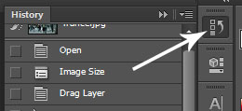

- Using the Eraser Tool
- Select the “Vendor” layer from the Layer Manager.
- On the Tools Palette, click on the Eraser tool .
The Eraser tool allows you to erase part of a layer, so the layer beneath it can peek through.
- First you need to make the Eraser brush bigger. In the Options Bar at the top of the screen, change the brush size by clicking on the down arrow of the brush size option
- In the Dialog Box that appears change the Size to 31px and the Hardness to 100%.

- Slowly start erasing by clicking the left mouse button and dragging. Erase away as much of the vendor scene so that the perimeter of the tent/flowers blends into the scene as shown in the example at the end of this document.
- If you need to get in really close: zoom into the image, select a smaller brush, and keep erasing. Remember though, the point is to just try out this tool, it doesn’t have to be perfect for the lab!
- Zoom out once you are done and happy. Remember to use Undo if you erased too much!

- Using the Magic Eraser Tool
- In the Tools Palette, right click on the Eraser Tool, and select the Magic Eraser tool
The Magic Eraser makes erasing easier by erasing similar “chunks” at once.
- Select the “Background” Layer from the Layer Manager.
- Left click anywhere in the sky. The sky will be replaced with alternating grey and white squares, which indicate transparency (in other words, there is nothing there, not even white color). Repeat to replace the rest of the sky (you may have to zoom in to get the sky between the trees).
- In the Layer Manager, you will notice this layer is no longer named “Background”; this is because the layer was edited. Change the layer name to “Street”.

- Creating and Setting a New Background
- Open the file “moon.jpg”, resize it to width=800, and copy the background layer to the main canvas. Close the file.
- Position this new layer so that the moon is just peeking over the skyline.
- In the Layer Manager, move the new layer to the very bottom of the stack. To set this as the new background layer, from the Menu Bar select Layer > New > Background from Layer.

- Add some text to the image: “C’est la vie!” – Book Antiqua, 36pt. Ensure this layer is above any other ones. It will automatically name itself as the text you added. Put this text near the top and in the middle (horizontally) of the image.

- Blurring Edges
- The edges between the trees and the night sky are very sharp, making the image look “fake”. To fix this, we will blur the tree edges a bit.
- In the Layer Manager, click the Eyeball icon beside the “C’est la Vie!” layer. This will “hide” the layer until the next time you click the Eyeball icon.
- Select the “Street” layer in the Layer Manager.
- From the Tools Palette, click the Blur Tool. From the Options Bar, ensure a small brush is selected (13pt), Mode=Normal, and Strength=50% (the “strength” indicates how much blur you’re going to add).
- While holding down the left mouse button, carefully blur the edges of the tree so it is not as sharp.
- Finally, click the Eyeball icon beside the “C’est la Vie!” layer to re-display the text.

- Save the files in Lab3 folder as exercise2_complete.psd and exercise2_complete.jpg

LAB #3 - Exercise 3

Objectives:
- Using Selections to isolate images
- Adjustment Layers and Clipping Masks
- Effects: Black & White, Feathering

- Ensure the file exercise2_complete.psd is still open.
Save the file as “exercise3.psd” in your “lab3” folder.

- Selecting part of an image, modifying opacity, and paste into picture
- Open the “eiffel_tower.jpg”
- Right-click on the Rectangular Marquee Tool and select the Elliptical Marquee Tool.
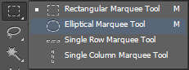
- The Elliptical Marquee tool generally draws an ellipse, but to constrain the selection to a circle we must also hold down the Shift key.
- While holding down the Shift key, click on the top left corner of the image, and drag the circle over the top part of the Eiffel tower with the diameter spanning the width of the image.
- A marquee will appear. If you need to reposition the marquee circle just click and drag inside the circle. If you had selected the Move tool it would have cut out the selection and moved it as well.
- Copy the marquee selection by using Edit > Copy. Move to the exercise3.psd canvas and paste using Edit > Paste. Using the Move Tool Move it to the top left corner, and name the layer “Eiffel”.
- Opacity Effect: To modify the opacity of the Eiffel selection, right click the layer in the Layer Manager, select “Blending Options”, then set Opacity=50%. Note this was the same menu that had appeared previously for Drop Shadow and Bevel. Add bevel by clicking the “Bevel and Emboss” text, and press OK.
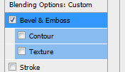

- Adding a Black & White “Mask” Layer
- To create an effect on just the Eiffel Layer, you must create a layer mask.
- Make sure the “Eiffel” layer is selected from the Layer Manager. From the Menu Bar, click
Layer > New Adjustment Layer > Black & White. Make sure there is a check beside
“Use Previous Layer to Create Clipping Mask”. Click OK
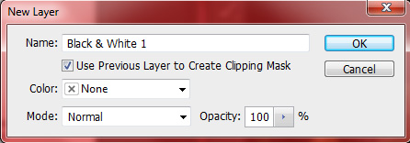

- In the Properties Panel that pops out set the Preset drop down box to “Maximum White”.
- Hide the panel.
- Try moving the new “Black & White” layer up and down in the Layer Manager. Notice it disables the clipping mask that had locked it to the Eiffel Layer, and now affects all layers below it in the Layer Manager.
- Return the layer above the Eiffel layer, and re-enable the clipping mask by right clicking the black and white layer and selecting “Create Clipping Mask”.
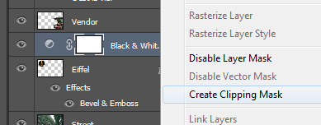

- Feather Effect on Champs.jpg.
- Open the file “champs.jpg”, and create a Circle marquee (as above, but do not copy yet).
- From Menu Bar click Select > Modify > Contract and select 10 pixels-- this moves the marquee in by 10 pixels.
- Next set the Feather effect: Select > Modify > Feather and select 10 pixels -- this makes the edges less sharp.
- Copy this selection from champs.jpg to the main canvas image, and label the layer “Champs”.

- Save the file in the lab3 folder as exercise3_complete.psd and exercise3_complete.jpg

LAB #3 - Exercise 4

Objectives:
- Entering Text, Creating Shapes
- Resizing images
- Adding Text , Shapes
- Selections and Marques
- Eraser to merge images
- Opacity, Feathering

- Start up Photoshop, and select “Open”.

From your folder “Lab3”, you will be working with the files:
  - bridge.jpg - Use it as your canvas (background). You will be adding the other files to this “main” file as new layers.
  - france.jpg - Extract the couple from france and add to canvas on hilltop (use the eraser tool)
  - cablecar.jpg Resized W=250, oval selection, feathered
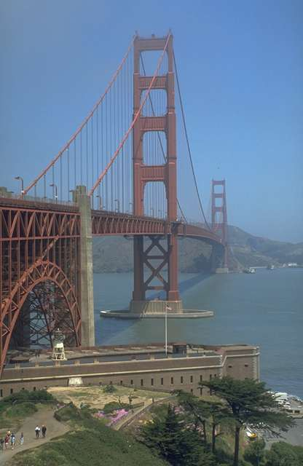
  - fishermans.jpg - Resized W=250, oval selection, feathered
  - Add text “San Francisco” – Book Antiqua – Drop Shadow, play around
font size and use one that you think looks appropriate.
  - Save the file in the lab03 folder as exercise4_complete.psd
and exercise4_complete.jpg.
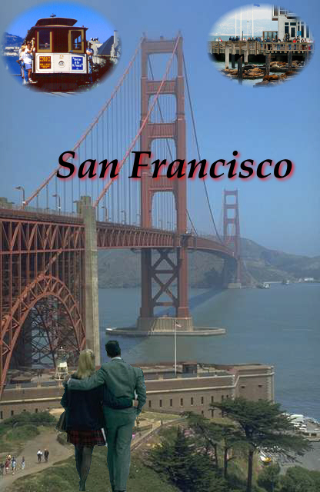
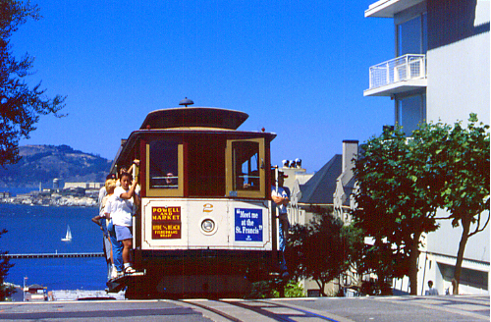

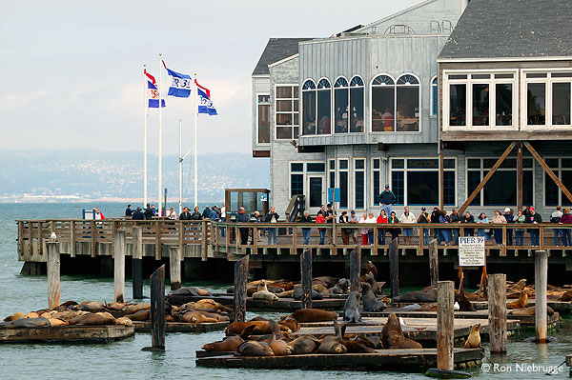
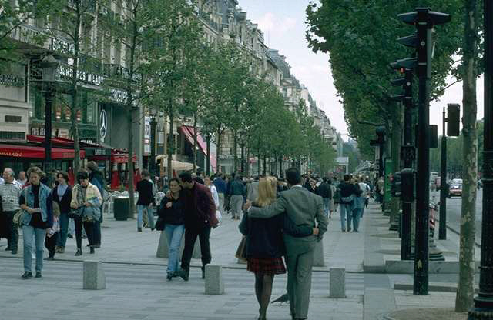
Exercise 1 Image: (Completed)

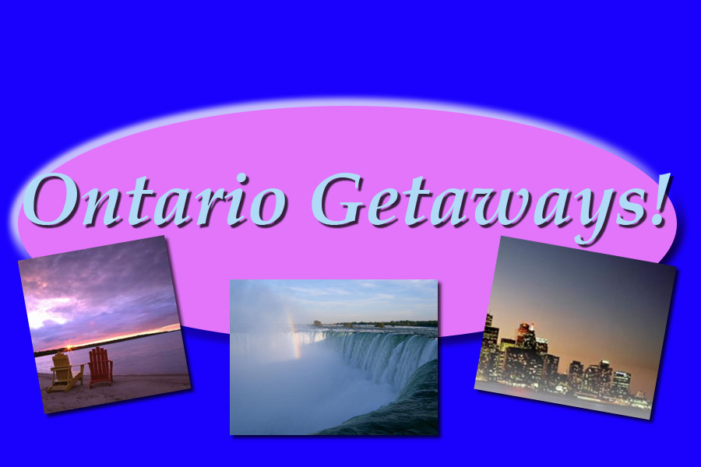

Exercise 2 Image: (Completed)

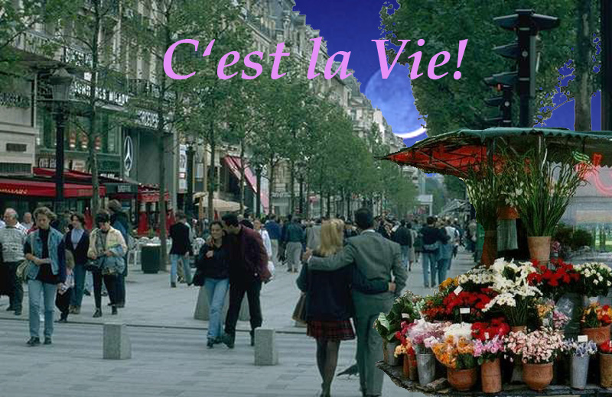

Exercise 3 Image: (Completed)

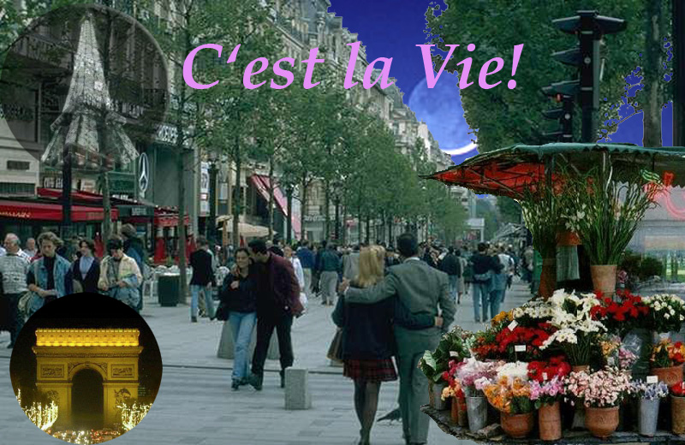

Exercise 4 Image: (Completed)

