CS 1033
Multimedia and Communications

Lab 04: Introduction to Dreamweaver
(Website Design part 1 of 3)
REMEMBER TO BRING YOUR MEMORY STICK TO EVERY LAB!
Dreamweaver Layout – Reference Sheet

Use this picture as a Dreamweaver layout reference sheet as you work through labs 4-6.
If you are reading this on a paper printout be sure to open the original PDF file on your computer so you can see the different colours!

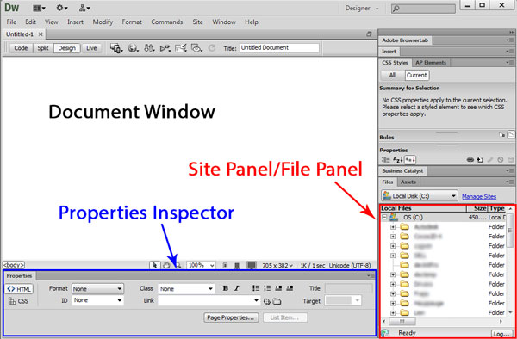

Document window
- The working environment where you are entering text and images to build your web pages.

Site Panel – also known as File Panel (right side of screen)
- Shows the folder that you are currently working in
- Gives a way to access the files on the computer

Property Inspector Panel (bottom of screen)
- Shows characteristics of objects/text that you have inserted i.e. size, colour, text font etc.

LAB #4 - Tutorial 1

Objectives:
- Creating a “New Site” where files do not exist.
- Creating a “New Site” where files exist.
- Removing a Site.

Note: Do NOT copy any files from the website until you are prompted to do so.

- Before you start Dreamweaver, browse to your Memory Stick folder, and create a new subfolder within cs1033 called lab04. Then inside the lab04 folder, create 4 new subfolders called “session1”, “session2”, “session3”, and “pictures”. You should now have the following folders:
  - F:\cs1033\lab04\session1
  - F:\cs1033\lab04\session2
  - F:\cs1033\lab04\session3
  - F:\cs1033\lab04\pictures
**Remember F: just represents your Memory Stick Drive**

Go to http://www.csd.uwo.ca/~lreid/cs1033labs/lab04 and save the files from the “images” folder into the “pictures” folder on your memory stick.
- Start up Dreamweaver CS6 if you are asked to make Dreamweaver the default program for certain file types, just click “OK”

- Creating a New Site:
- A website consists of one or more webpages. Webpages are files that are written in a file format called HTML (Hypertext Markup Language). When you create a website, you will save all of its associated webpages in the same folder on your Memory Stick. A different website should have all of its webpages in a different folder.
- In Dreamweaver, a website is simply called a Site. A Dreamweaver Site is linked to a folder on your hard disk (i.e. to a specific subfolder in your F: drive)
- In the next few steps, you will create a new Dreamweaver Site called “OP library”, (which does NOT currently exist and has no files associated with it). You will also instruct Dreamweaver to automatically create a folder in your Memory Stick drive to store all the webpages for that site (F:\cs1033\lab04\oplibrary\).
- From the main window, under the heading “Create New”, click on “Dreamweaver Site…” (or in the Menu Bar, click Site > Manage Sites, then select New Site).

Enter the following information:
  - Site name: Type “OP library” (no quotes around it and it can be upper/lower case). This is the Site name that will appear inside Dreamweaver, i.e. the website name.

  - Local Site folder: This is where you instruct Dreamweaver which folder on your Memory Stick to associate with the Site you’re creating. Click on the folder icon, and locate the path directory that you created earlier as follows:
“F:\cs1033\lab04\”
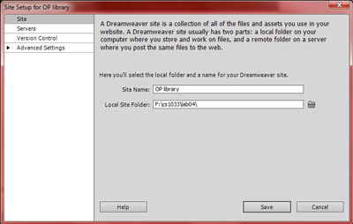

- Right now there is no oplibrary folder within lab04, so therefore we want Dreamweaver to create one for us. To do this, we type “oplibrary” next to the Local Site Folder (lowercase and all one text string with no spaces because it is a folder name that will likely be moved to a live web server and often times web servers are Unix machines which do not like spaces in folder names or file names).
- Now the Local Site Folder should be “F:\cs1033\lab04\oplibrary”
- Now click “Save”. The folder oplibrary will be created in your lab04 folder.
You can check that your lab04 folder now contains: oplibrary, session1, session2, session3, and pictures folders.
- You will be returned to the main Dreamweaver page
- Now within Dreamweaver you have a “Site” that points to your F:\cs1033\lab04\oplibrary folder. Dreamweaver treats your oplibrary folder as the root to a website. You will not have to do this step again for the OP Library site. In fact, every time you start up Dreamweaver it will be pointing to the last site you were working on. If you want to work on another website instead, use the dropdown box in the “File panel” to select any of the websites that you have defined.
Note: You can only work on ONE SITE at a time, but you can have more than one file (webpage) from the current website open at the same time.

- Creating a New Site For An Existing Folder (with or without files)

Now you will create three new Sites and associate them with the folders you created at the beginning of this lab. Look at the chart below to see what new Sites you will be creating and the folders you will be associating them with. Instructions on how to do this are provided AFTER THE CHART.

Site Name | Local Root
Session 1 | F:\cs1033\lab04\session1
Session 2 | F:\cs1033\lab04\session2
Session 3 | F:\cs1033\lab04\session3

- From the Menu Bar at the top of the screen, select Site >Manage Sites (or in the File Panel on the right side of the screen, click on the dropdown box and select “Manage Sites”).
- A Site box dialog box appears.
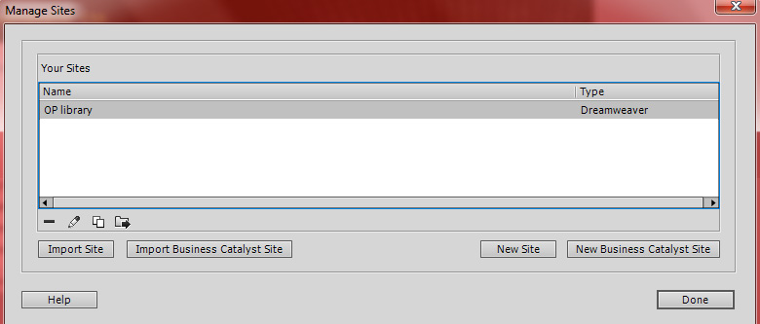
- Click on the “New Site” button. This will launch another dialog box.
- Enter the following information:
  - Site Name: Session 1
  - Local Site folder: Click the folder icon, and locate the path directory “F:\cs1033\lab04\session1”.
    - You DON’T have to add “session1” to the end of the string this time because the folder already exists.

  - Then click “OK”
5. Repeat the above steps to create the site names for “Session 2” and “Session 3”.

- Removing a Site Name (Dissociating a Site from Dreamweaver)

There may be times when you will decide that you will no longer want to work on this site. This may be because the site is old, or you may not be responsible for maintaining this site, or you created a new site that is more current. To disassociate the Site name from Dreamweaver so that the Site no longer appears in the dropdown list (in the File Panel on the right of the screen):

- From the Menu Bar, select Site > Manage Sites. At the next pop up box, select ‘OP Library’ and then click the Remove Site Button and Yes. Remember this disassociates the site name but DOES NOT delete the files in that folder. The folder with all the files will remain on your hard disk.
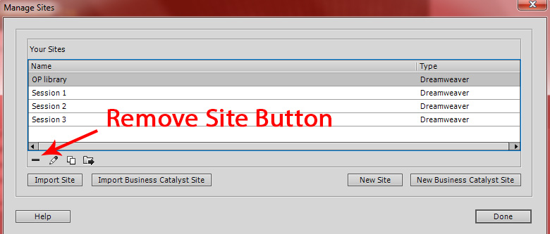
- Select Done
LAB #4 - Tutorial 2

Objectives:
- Opening an existing Site
- Creating and saving webpages
- Entering text into a webpage
- Formatting text, setting headers, color, size, alignment
- Using the view modes: code view, design view and split view
- Opening a page in a browser
- Setting the page title property

- Re-creating the Site “OP library”
- Since you removed the site “OP Library” in the last exercise, you must first re-create it.
- Since the folder “oplibrary” exists on your Memory Stick, follow step 4 from Tutorial #1 to create a new Site called “OP library” and associate it with this folder.
- From the File Panel drop-down list, make sure “OP library” is selected. Note that it will initially be empty.
- Creating a Webpage for the Website “OP library”
- From the Menu Bar, select File > New. A dialog box appears.
Select Blank Page → HTML → <none>. Click on the “Create” button.
- Notice that the Document window opens with a blank file labelled “Untitled-1” which appears in a tab directly above the white space of the document window.

- Saving an HTML (Webpage) File
It is best to immediately save your file with the filename you plan to give it.
- From the Menu Bar, select File >Save As. Provide the name index.html. Always make sure that you are saving index.html in the correct directory/subdirectory, the root folder, because when you move around subdirectories, Dreamweaver may remember the last place you saved, which may have been to another subdirectory, so be careful and always check.

Note: The first webpage of your website that kick starts your website is the file called “index.html” (or “index.htm”). Internet browsers (such as Internet Explorer, Firefox, and Safari) are programmed to look for this file first within any website, so it is important that you always name your opening webpage: index.html

Note: Dreamweaver CS6 saves files with extension “.html” whereas older versions of Dreamweaver saved webpages with the extension “.htm”. You can work with both types since they are both HTML files and can be opened with any version of Dreamweaver.

Note: When you save a file, it will appear in the File panel on the right hand side of your screen to indicate that it is now part of the Site (website). Every time you create a file and save it, it will show up in the File Panel.

- Entering Text into a Webpage
Look at the column labelled: Text to Enter, type that text into the document window, while referring to the “Notes” column on the right. “<Enter>” means to press the “Enter” key, and <Shift>+<Enter> means to hold down the Shift key while pressing “Enter”.

Text To Enter | Notes
Roll Woods Park Public School - Our Library<Enter> | - When you press “Enter” it will insert a paragraph break (it leaves a blank line in between the text Roll Woods … Our Library and the text you are about to type: Welcome to our Library!)
Welcome to our Library! <Enter>

Take a tour of our Library where your children have access to books, computer labs, and a quiet work space area for reading, research and group work. <Enter> | - Keep typing and allow the line breaks to occur as the text runs out of space on the line on the right side of the document window.
Welcome to our library <Shift-Enter>  Where children, learning and fun <Shift>+<Enter>  are brought together <Enter> | - <Shift-Enter> forces cursor to the next line. You may not see the cursor flashing because it is a bug in Dreamweaver... but as you start typing you will see the text on the new line.
Through books, computers and technology<Shift>+<Enter>
Open your child’s mind <Shift>+<Enter>
to learning and the future!<Enter >

- Save the Webpage
From the menu, File > Save As and then type in the name “index.html”, making sure it is pointing to the same directory as in step (1) above. Always use File>Save As when saving instead of “Save” because with the latter option it may save it in the wrong directory and you may be wondering where the saved version is.

- Closing the Webpage
From the Menu Bar, File > Close or it is faster to click on the “X” icon in the top right hand corner of the document window. If you close the file before saving the file, Dreamweaver will prompt you to see you want to save the file before quitting.

- Create another Webpage
Create a new webpage called “teachers.html” and add the following information: Once you finished entering the information, save and close the file.
Text To Enter | Notes
Roll Wood Staff Directory<Enter>  Principal: Mr. Hardwood<Shift>+<Enter>  (519) 656-2141<Shift>+<Enter>  hardwood@rollwood.ca<Enter>  Grade 1: Mrs. Smith<Shift>+<Enter>  (519) 433-3167<Shift>+<Enter>  smith@rollwood.ca<Enter>  Grade 2: Mr. Jordan<Shift>+<Enter>  (519) 471-2525<Shift>+<Enter>  jordan@rollwood.ca | Between the text “Principal:” and “Mr.”, leave three spaces. You will notice that as you are trying to press on the Space Bar, Dreamweaver will only put one space and that’s it. To override this, so that you can add more spaces hold down the <Shift> key AND the hold down the <Ctrl> key and press the Space Bar. This is called a non-breaking space command in HTML.  Remember, if you want a blank line, for example between paragraphs, hit the <Enter> key and if you just want a line break, hold down the <Shift> key and hit the <Enter> key, otherwise don’t hit enter and just let the window decide where to break the lines.

- Open two Webpages at the same time
- From the File panel, open the file named index.html by double clicking on the filename index.html.
- Now open the file teachers.html. Notice now that the top of the Document window has two tabs, one tab named “index.html” and one tab named “teachers.html”.
- Try clicking on each of the two tabs. Notice this allows you to switch between the two files. This allows you to easily select the file you wish to edit.
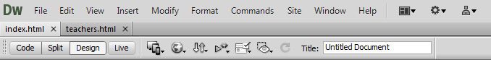

Note: Right now, the Dreamweaver Site “OP library” contains two webpages: index.html and teachers.html.

- Copying between two webpages
- From the index.html file, highlight the text “Roll Woods Park Public School - Our Library”, copy it by going to menu bar and selecting Edit >Copy, and then click on the “teachers.html” tab, and paste the text at the top of this file , again use the menu bar to do this, select Edit > Paste.

- Save and close the webpage teachers.html (keep index.html open).

- Viewing the HTML Code - other modes
In the top of the document window, you will notice the three buttons: Code, Split and Design. Press each one of these modes in succession and you will see the document window change.
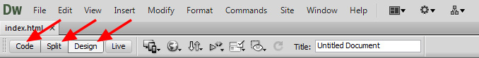

Explanation of Modes
  - Design: This is the mode we will normally be using. It displays the webpage almost exactly like the webpage will look in a real browser. This is called a WYSIWYG editor (“What You See Is What You Get”). However, Dreamweaver is actually creating the webpage using HTML code “under the covers”.
  - Code: Clicking on this mode shows the actual HTML code being built in the background.
  - Split: Splits the screen horizontally with the upper showing Code, and the lower the Design view. If you place your pointer on the separation line between the two windows, you can drag the windows larger or smaller to better suit you. Also if you highlight some text in the lower portion of your screen, you will see it highlights the HTML code in the top part of the screen for easy debugging at times when you need it.

- Previewing Your Webpage

Webpages are stored as HTML code, and it is the job of Internet Browsers to interpret this code and display it in a format that humans can understand. To ensure that what you are creating will appear properly in browsers, you need to preview it to see how it would behave in an Internet browser.
- Select the Icon as shown below, and select a browser to view your webpage in. Note: when Dreamweaver was installed, any web browsers that existed on your system were detected and are now shown in this list.
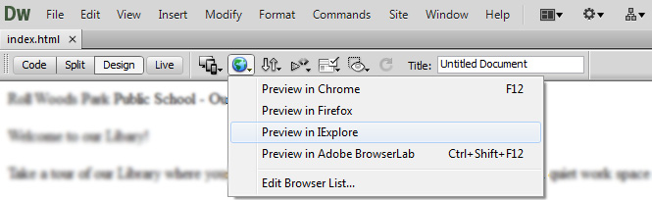
- Notice that because the webpage is not built inside of a table (which you will be learning later) the first paragraph may look longer, but play around with the “middle” button in the top of your screen, and then drag one of the browser window corners to see the window get smaller and larger, and watch how the first paragraph in the webpage changes in length. This occurs because the text is not stored inside of a table cell. We’ll talk more about this later in the section with tables.

- Setting a Page Title Property

Notice: In the web browser, the title bar (top line in the window) says:

This line is controlled by the “Page Title Property” and needs to be changed to show a title that is more descriptive of what the webpage is about. For example, a better title might be: Roll Wood Public School – Library. Assigning a title is important because when this page is printed, by selecting “File>Print” from the browser, the top line of the printed webpage will contain the property title text and this will help the reader remember why he/she printed the webpage and what the page is all about. You do not want it left as “Untitled Document”.

Change the Page Title Property of the index.html file by typing the text: Roll Wood Public School – Library.

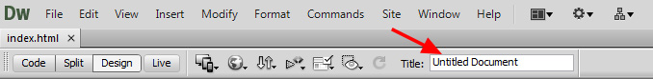

Now preview the webpage again in IE to see if your webpage property title was set.

- Setting Text Attributes: Formatting Text

Text formatting options are controlled through the Properties Panel which is usually located at the bottom of the screen, see the images below. Some of the properties you can control are:
    - Headers - Heading 1, Heading 2, Heading 3, Heading 4, Heading 5, Heading 6 (predefined sizes and bolds text)
    - Text color - Click on square and select from palette; or enter the hexadecimal value
    - Text size – Select the size and box beside it has “pixels” or “points”
    - Font type - New Times, Verdana etc.
    - Special effects - Bold, Italics (menu Text >Style for additional options) (never use underlining for emphasis since it is reserved for links)

There are two different tabs within the Properties Panel: HTML and CSS. You can change between these two by selecting the buttons on the left of the Properties Panel. Both are shown below.
HTML Properties
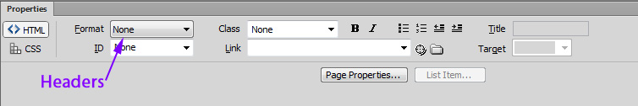

CSS Properties
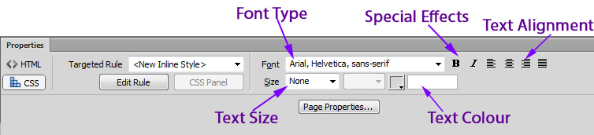

Changing Text Formatting Attributes using Styles

To change text within Dreamweaver, you can create ‘rules’ or styles which will determine the different attributes of the text (colour, size, alignment, etc.). Once you define a style, you can apply it to any text and that text will take on the style’s colour, size, alignment, etc.

We want to change some of the Text Attributes on our page

- Highlight the text “Roll Wood Park Public School - Our Library”
- In the Property Inspector, click on the CSS button, and your Property Inspector will now change to this:
- Set the Targeted Rule box to <New CSS Rule>.
- Change the colour to Red by clicking on the square box next to the Text Colour field and choosing a red, or by typing #FF0000 in the Text Colour field.
- A dialogue box should pop up with the title New CSS Rule. Fill in the information like the image below, and read what each option is for: 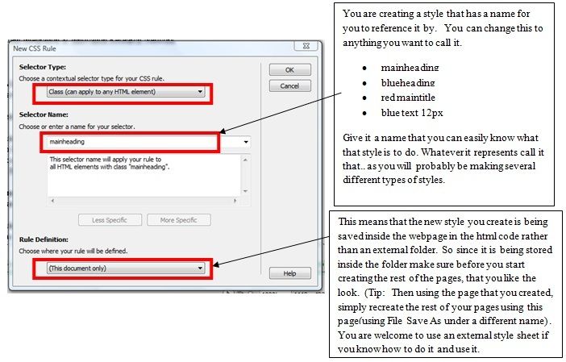
- Click OK. Now all the changes you make to the selected text are going to be assigned to the style “mainheading”. You will see how the highlighted text in the window will change as you change your text attributes.
- Change the font to Arial and centre the text using the text alignment.
- Once you have finished assigning the text attributes (font color, size etc.) in the Property Inspector, click on the <>HTML button to go back to the HTML mode.
- Set the Format dropdown to Heading 2.

- Now with your text still selected, and all the changes made your Class field should look like the image below:
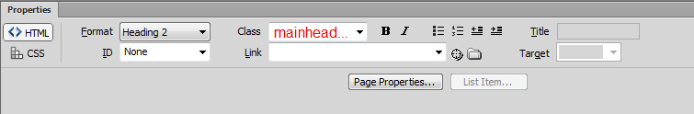

The style “mainheading” is now saved within your webpage. You can also apply this style to another part of your webpage. If for example you wanted another title on your webpage, you could simply highlight the new text and change the Class dropdown to “mainheading.”

Format Your Webpage
Edit the file index.html and set the text formatting attributes as indicated in the chart below. When asked to fill in the style name, use the name given in the middle column. You have already completed the first row.

Text To Enter | CSS Style Name | Attributes to Apply
Roll Wood Park Public School - Our Library | mainheading | - Heading 2; font type=Arial;  - color=red (point to any red or #FF0000);  - Center heading
Welcome to our Library! | subheading | - Heading 3; Font type=Verdana; color=blue (or #3333FF)  - center heading
Take a tour of our Library where your children have access to books, computer lab, and a quiet work space area for reading, research and group work. | intro | - Font type= Times New Roman;  - Font size=16 px  - Color=black
Welcome to our library  ... Where children, learning and fun  ....... are brought together | blueLeft | - Font type=Comic Sans MS Note: you may need to add this font by selecting “Edit Font List”, choosing the font in “Available Fonts”, then using the “<<” button to move the font into “Chosen Fonts”;  - Font size=14 px; Color=blue  - Align text left
Through books, computers and technology  Open your child’s mind  to learning and the future! | blueRight | - Font type=Comic Sans MS;  - Font size=14 px; Color=blue  - Align text right

- Save the file index.html.

- Preview it in Internet Explorer: It should look like something as the illustration below the chart when previewed. But because of your monitor resolution it will spread all the way across the width of your screen. Click on the middle button and drag the corners of the browser window and watch how the document looks different.
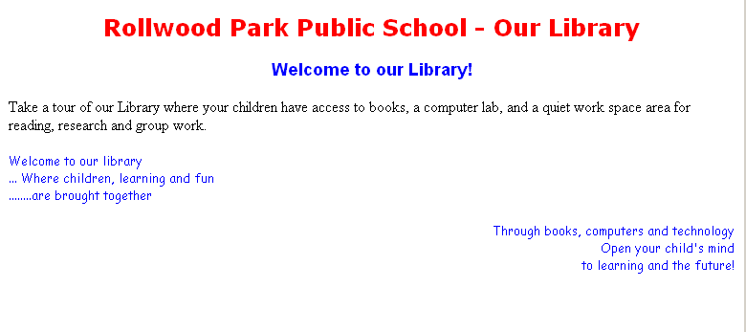

LAB #4 - Tutorial 3

Objectives:
- Setting the page properties
- Previewing the webpage to view the page properties

Setting Page Properties:
Rather than typing your content into your webpage and then assigning the text color, background color or background image to your document, it is better to assign these properties before you begin to enter text into the webpage.

To set page properties on the index.html file:
- From the menu, select Modify > Page Properties or from the Property Panel click the “Page Properties” button (see button outlined in red below)
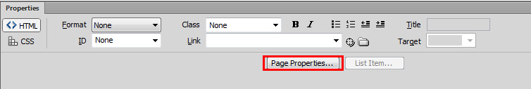

- You will then see the following dialog box which allows you to set some defaults for the webpage:
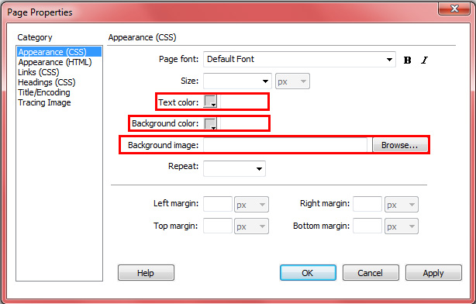

- In each of the cases below, make the change and click “Apply” (not “OK”):
    - Background Color: Select some sort of soft yellow color and then select “Apply”. Notice the background of the webpage changes.
    - Background: Assume now that you liked the page before you set the background to yellow, try setting it back to the default color by clicking on the little yellow box next to the “Background” label, and then set it back to null by selecting the square with the diagonal line.
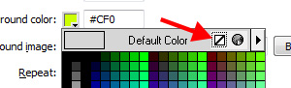

    - Background Image: This time let’s assume you want to see if an image would look good as the background of the page. Click on the “Browse” button and point to F:\cs1033\lab04\pictures\backyellow.gif. Click on the “Apply” button. When asked if copying the file to your root folder, click Yes, and Save.
    - Text: Select some sort of red color. This only changes text that has not been changed directly through the Property Panel. In other words, as you type now it should display text in red. If your cursor does not display red, your cursor is in the HTML code tab that is controlling another attribute for your webpage. Click on the “OK” button and check to see if your text is red. If not, ask your TA to double check your font codes in “Code” Mode

  - Save your file “index.html”.

LAB #4 - Tutorial 4

Objectives:
- Inserting an image (from local hard disk)
- Resizing an image (dragging, picture properties)
- Using text alignment with an image
- Observing alternative text rendering differences between Internet Explorer and Firefox

Image Attributes – Reference Sheet

You can modify the attributes of an image through the Property Inspector panel at the bottom of the screen. Use this picture as a reference sheet for Image Attributes as you work through the rest of lab 4.
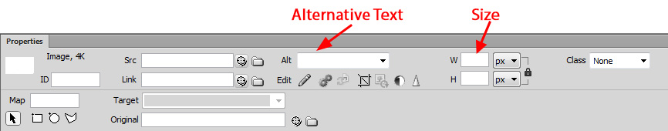

1. Copying the Updated Material from the Instructor’s Area:
- Make sure Dreamweaver is NOT open!
- In the F:\cs1033\lab04\session1 folder on your Memory Stick create a new folder called images.
- Go to http://www.csd.uwo.ca/~lreid/cs1033labs/lab04/session1 and save the file session1.html into the session1 folder on your memory stick.
- Rename the file session1.html to index.html.
- Save the pictures from the images folder into your newly created images folder.

Now your session1 folder should include an index.html file and an images folder with two jpeg images in it.

2. Opening the site in Dreamweaver:
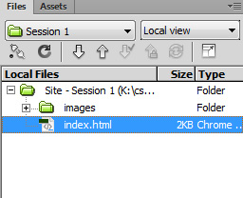
- Start Dreamweaver CS6
- To open the “Session 1” Site:
  - Open the “Session 1” Site: from the Menu Bar, click Site > Manage Sites. In the dialog box, highlight “Session1” and click “Done”
  - Check to ensure the Site was updated correctly: The File Panel (right side of the screen) should now list and images folder and index.html. Note: You may have to click the “+” beside the Site- Session1 to show these files.

In the File Panel on the right, open the file “index.html”.
Inserting a Graphic Image

- Place insertion point at the beginning of the paragraph (NOT the title) with the text “Welcome to our library”.

- To insert the image, select from the menu Insert > Image. When dialog box pops up, use the drop down box in the “Look in” field to make sure the folder is F:\cs1033\lab04\session1. From there double-click into the images folder. As you single-click any of the images, the right side of the screen previews the image, its dimensions in pixels, size in KB, and download time.

- Double-click the image “boyreading.gif”.

- Another dialog box opens: In the “Alternative text:” field enter the descriptive text string “Boy Reading”. This descriptive text string can be a combination of upper, lower and mixed case characters. The purpose of this field is to accommodate those individuals who are blind and rely on specialized equipment/software to describe an image on your webpage, this independent of its alternate text.

- After assigning an alternative text string, if you preview the file using Internet Explorer, and move your pointer over that image and stabilize it, a small caption appears for a few seconds with the alternative descriptive text string.

Note: In Google Chrome and Firefox, this caption does not appear when your mouse hovers over the image. This is one of the differences between previewing in Chrome/Firefox and Internet Explorer. To enable text captions in Firefox:
  - Click on the “Split” tab at the top of your document window.
  - Click on the image. Notice in the left portion (HTML code), the tag gets highlighted and contains alternative text description (alt=”Boy Reading”)
  - In the left portion, right before the text alt=”Boy Reading”, add the following text:
Title=”Boy Reading” and save the file.
  - Switch back to “Design” mode, and preview webpage in Firefox to confirm that it works right (File>Preview in Browser> Firefox).

- To modify the “Alternative text” field to another string, click on the image, and in the Property panel (bottom of screen), overwrite the Alt field value with “Boy Reads”. You would also have to change the Title parameter in the HTML code so that Firefox also reflects this change. Preview in both browsers (IE and Firefox) to confirm this modification was done.
Resizing a Graphic Image

- Two methods are available for resizing: dragging or resizing through Property Inspector.
- Dragging:
    - Click on image and handles (black boxes) appear around image.
    - Position mouse over the lower right corner handle, click, and drag in different directions… This will not ensure aspect ratio.
    - To keep Aspect ratio: Hold the “Shift” key down and drag the bottom right corner to a smaller size. Notice how the image is resized proportionately.
    - Undo your last resize operation, and return the image to what it was before

- Property Inspector
- Set width=150 and height=84
- Note: when you resize an image in Dreamweaver, it creates a “note” inside the HTML code to tell web browsers what size the image should be displayed as. In other words, it is NOT altering the image saved on your hard disk. When the HTML page gets displayed in a web browser, the browser reads this “note” and displays the image in the different size.

Wrapping Text around a Graphic Image

- To wrap text around the image
- Select the image, and in the Menu Bar near the top, select Format > Align > Left
      - Notice how text wraps around the image.
      - Change it to Right
      - Change it to Top, Middle, and Bottom. These options, unlike Left and Right, force one line of text from the paragraph into that position, forcing the remainder of the remaining paragraph underneath the image.
      - Set the alignment back to Left.

- Add another image to the webpage:

- Just to the left of the paragraph “Through books, computers and technology”
insert the image “books.gif” from the images folder.
- Set the Alternative Text: Reading books
- Resize the image to width=150 height=131
- Right-align the text around the image
- Add the Title parameter to the HTML code with the text Title=”Reading books”
- Save the file as “index.html”
- Preview the file in both browsers

- Save and Close index.html.

NOTE ON SAVING IMAGES: You will notice that each website you are working with contains a subfolder called “images”. This is where all the images for that website are located. This helps ensure all images for a website are organized in a single place, making it easier to transfer websites to other computers. Be sure to use “images” subfolders to store the images for every website you create as we WILL be looking for this when we grade your assignments!!
LAB #4 - Exercise

Objectives:
- Building and working with a Site
- Formatting text
- Previewing a webpage
- Adding a Horizontal Rule separator
- Setting page properties

You have been asked to set up a website for the “Travel Land” travel agency. You are to:

- Create a new Dreamweaver Site called “Travel Land”, and associate it with a new folder on your hard disk called “travel”.
- Create an index.html page for the website “Travel Land” and enter the text as outlined below. Be careful with the paragraph breaks and Line breaks as shown below:

Vacation Land Getaways <Enter> | mainheading | - Set to Red (#CC3300)  - Arial, Center  - Heading 1 ; Size: None
Great Trips! Incredible Prices! <Enter> | subheading | - Set to Blue (#0033CC)  - Arial, ; Center  - Heading 3; Size: None
When was the last time you took a vacation?  Picture yourself relaxing by a beach under the hot sun, or snorkelling amongst the beautiful coral reefs of Cozumel, or taking a cruise amongst the Mediterranean islands!  It's time to escape! <Enter> | paragaraph1 | - Default will be black text color  - Left align  - Arial; 14 px
Let Vacation Land plan your next vacation. We offer air, cruises, package holidays, and much much more. We are a one stop Travel Center to meet all your needs. <Enter> | paragraph2 | - Try center align; Left-align;  - Georgia Times; 16 px;  - Bold italics  - Red text (#CC3300)
Call us today or contact us to assist you in planning your vacation getaway! <Enter> | callustoday | - Left align;  - Arial; 14 px
Travel Land Getaways <Shift><Enter>  1296 Richmond Street <Shift><Enter>  London, Ontario Canada N6G 3Y5<Shift><Enter>  E: travelland@execulink.com T: (519) 667-1841<Shift><Enter> | contactinfo | - Center  - Arial; 14 px; Bold

- Adding a Horizontal Rule
- You will be adding a horizontal rule (horizontal line) above the company’s address information. Begin by placing cursor above the information, select Insert > HTML > Horizontal Rule.
- Change attributes of line by clicking on the line and modifying the attribute values in the Property Panel (see below). Set to 80% Width, Height=4, Align Center, and put a check beside Shading. (For horizontal ruler to be filled in, uncheck Shading box)
- Ignore the empty white box under “Horizontal Rule”; this is the “ID” field, which is something we wont be looking at in this course.

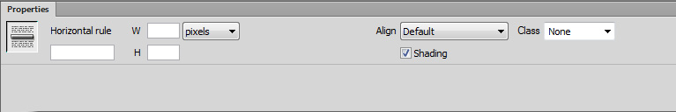

- Preview your webpage in Internet Explorer and Firefox if available on your system. Notice the line above the company’s address.
- Set the “Property Title” to Travel Land Tourism Agency – Best prices in town!
Preview the webpage again in IE to see whether the property title was set.
- Set the webpage background to the following file: F:\cs1033\lab04\pictures\backyellow.gif. Copy the file to your root folder when prompted.
Important Note: when Dreamweaver copies the file to your root folder, it is copying the file from your cs1033\lab04\images folder to the folder of the current site you are working on. Whenever you work with webpages, it is important that ALL of your website files (HTML webpages, images, sounds, video, etc.) are located in your website root folder or in one of its subfolders. In later labs, you will work on transferring your website to a remote server; if some files are not in your website folder, they will not get transferred properly and you will have broken links and/or missing images!

- Save the file “index.html”.

- Preview your webpage in Internet Explorer.

Once you are satisfied with your webpage, show your TA to earn the mark for this lab.

