CS 1033
Multimedia and Communications

Lab 05: Webpage Graphics and Effects
(Website Design part 2 of 3)
REMEMBER TO BRING YOUR MEMORY STICK TO EVERY LAB!
Image Attributes – Reference Sheet

You can modify the attributes of an image through the Property Inspector panel at the bottom of the screen. Use this picture as a reference sheet for Image Attributes as you work through lab 5.
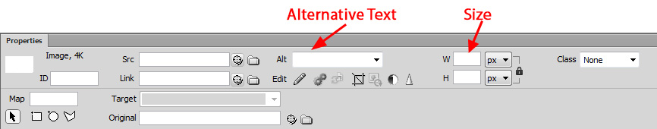

BEFORE YOU START THE TUTORIAL:

In Lab 4, you created the Dreamweaver Sites “Session 1”, “Session 2”, “Session 3”, and “Travel Land”. This week you will update these Sites with new content, which is provided at http://www.csd.uwo.ca/~lreid/cs1033labs/.

1. Copying the Updated Material from the Instructor’s Area:
- Make sure Dreamweaver is NOT open!
- Create a folder called lab05 on your memory stick in the cs1033 folder.
- Download the file lab05.zip from the website (http://www.csd.uwo.ca/~lreid/cs1033labs/lab05) to your memory stick (to F:\cs1033\lab05).
- Right click on the lab05.zip file and select Extract all...
- On the window that appears, make sure the Destination folder is your lab05 folder
  - (ex. F:\cs1033\lab05)
- Select Extract
  - The lab05 folder should now contain four subfolders: session1, session2, session3, and travel, as well as the lab05.zip file.

2. Remapping Sites in Dreamweaver:
- Start Dreamweaver CS6
- To remap the “Session 1” Site (which will only work if you completed last week’s lab) do:
  - Open the “Session 1” Site: from the Menu Bar, click Site > Manage Sites. In the dialog box, highlight “Session1” and click “Site Edit Button”
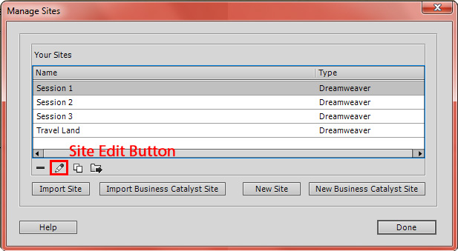
  - The “Session 1” website is currently associated with the folder “F:\cs1033\lab04\session1”, which you created during last week’s lab

  - To associate it with the updated material, click the folder icon beside “Local Site Folder”, and change the folder to “F:\cs1033\lab05\session1”. Press “Save” to associate it with the new folder, then “OK”. When it says “The cache will be recreated…”, press “OK”. Upon returning to the “Manage Sites” dialog box, press “Done”.
  - Check to ensure the Site was updated correctly: The File Panel (right side of the screen) should now list two new files: ex3.html and index.html, as well as an images folder. Note: You may have to click the “+” beside the Site Session1 to show these files.

LAB #5 - Tutorial 1

Objectives:
- Inserting images, and reviewing resizing
- Adding horizontal and vertical spacing around image
- Using text alignment
- Setting borders
- Adding a background to a web page

Inserting Images and Resizing - review

- Open the site “Session 1”. Open the file “ex3.html”.

- Place insertion point in front of title text “Computer Lab”.
- Insert the image “computerlab1.jpg” from the “Images” folder.
    - (Insert > Image)
- Set Alternative Text to “Computer Lab”
- Resize it to width=150 height=112
    - You will notice that when you change the width, the height will automatically change. This is because Dreamweaver automatically keeps the aspect ratio of an image. To change this, select the Lock button beside the size textboxes.
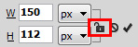
- Wrap text around image-left aligned (Notice how the bullets are hidden by the picture. This will be corrected later)
    - (Format > Align > Left)

- Place insertion point at beginning of title text “Work Space”.
- Insert the image “research1.jpg” from the “Images” folder.
- Set Alternative Text to “Research”
- Resize it to width=150 height=112
- Left aligned the image. Notice how the bullets are hidden by the picture. The next step will correct this.

Adding spacing around image – Horizontal, Vertical

- Around the paragraph “Computer Lab.”, notice, how there is no padding between the right edge of the image and the text. To add horizontal padding around the image:
- Click on image “computerlab1”
- Right Click on the image and select Edit Tag <img>...
- In the window that pops up, set the Horizontal space value to 40. This value is the number of pixels and is always a whole number larger than 0.
- Notice that the Width and Height values are now set back to the original size of the image. Fix these numbers back to width=150 and height=112 before pressing ok. You will need to do this every time you wish to adjust any settings in this window.
- The padding is on both sides of the image. You cannot add it to only one side. Also notice how the bullets have reappeared.
- Set the Vertical Space value to 40. Notice how the title beside the image “Computer Lab” has now moved up. Once you learn about tables, you will have better control.
- Undo this last operation of Vertical spacing (i.e. set Vertical Space to 0).
- Repeat the above steps to the paragraph “Work Space”.

Adding a Border around Image

- Click on the first image with the girl. Right click on the image and select Edit Tag <img>... Set the Border value to 4. (Remember to set the image size again)
  - A black outline is produced around the image. What you see is not always necessarily what you get. Preview it in IE and see how the border thickness only appears around the image.

- Assign a border of size=4 around the other two images.

- Notice in the last image because the header is red, you would think that the image will have a red border, however if you preview it in IE, you will see that it is black. This box appears as red in the document window because of the HTML controlling the heading text.

- But if you preview it in Firefox or Netscape, the border may show up with red. If it does, to correct it you must go into the HTML code. Click on the image, and in the code, take the entire highlighted text and move it before the text “<span class="style3">” (some people may have “<p class=”style2”>” instead or some minor variation of this, that’s fine too). Now if you preview it in IE or Firefox, you should see the border is now black.

- Save the web page as “ourlibrary.html”.

Note: When you right click on an image and select Edit Tag <img>... will notice that you also have the option to resize the image, set the alternate text, and set the alignment. This is a useful window for changing all of these options at once.

Adding a background to the Web Page

- Now add a background image to act as a background of the webpage:
  - In the Property panel, click “Page Properties” and click on the Browse button next to the “Background Image” field.
  - Locate the file “backyellow.gif” from the Images folder. Click “OK”, then “OK” again to exit the dialog box.
  - Notice how the screen fills with the background image. Save the webpage as “ourlibrary.html”

Modifying Brightness, Contrast, Cropping

- Whenever you click on an image, in the Property panel you will find the following icons:

By placing the mouse over any of these buttons, you will get a description of the feature. From left to right, these descriptions are:
- Edit: edit the image with your system’s default image editor
- Edit Image Settings: allows you to edit the type of image and the quality
- Update from Original
- Crop: show only a part of the image
- Resample: Resamples a resized image, improving its picture quality at its new size and shape.
- Brightness and Contrast: brightens or darkens the image
- Sharpen: makes the image crisper

Be careful with these operations as they affect the actual image saved on your hard disk, altering the image, according to the features you apply (unlike the resize operation in Tutorial 1 which did not modify the actual file). For now you can experiment with these transformations but DO NOT apply them (cancel out of it).

LAB #5 - Tutorial 2

Objectives:
- Creating unordered and ordered (numbered) lists
- Changing the numbering style of an ordered list (e.g. a.b.c., i.ii.iii. etc.)
- Re-numbering list items
- Creating sublists using indent/outdent
- Double spacing lists

Creating a Structured List

- Open the site “session2”. Open the file “bluespruce.html”.
Notice there are two book entries.

- Add the following four book entries, given below, after the two books that are already there. Bold the main title (as in the previous example) and pay attention to the end of line entries (Press <Enter> or Press <Shift><Enter>) as it will affect the structured list later.
- Omas’ Quilt: by Bourgeois, Paulette, Kids Can Press $15.95 <Enter>
- Stella, Queen of the Snow: by Gay, Marie-Louise. Groundwood $18.95 <Shift><Enter>
- Two So Small: by Hutchins, Hazel, Annick Press $8.95 <Enter>
- It’s Raining It’s Pouring: by Spalding, Andrea, Orca $19.95 <Enter>

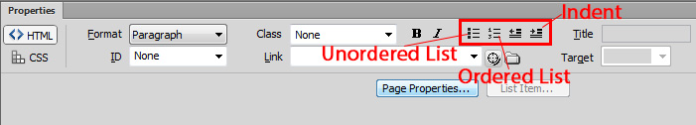

- To make the book list into an Unordered list (bullet structured list) do:
- Highlight the text from “The Frog Princess” to “It’s Raining It’s Pouring”.
- Click on the Unordered list icon in the Property panel. (see figure above)
- Notice how the items become bulleted except for the entry “Two So Small”. This is because the book above it “Stella, Queen of the Snow” had a line break at the end of the line. Line breaks are considered to be part of a paragraph, and thus not treated as a separate entry. To fix this, delete the line break, and add a paragraph break.

- Next, highlight the text from “The Frog Princess” to “It’s Raining It’s Pouring”.
- Select the Ordered (“Numbered”) list icon in the Property Inspector.
- Notice how the values change to “1, 2, 3,”

Changing the format – “a,b,c”; “i,ii,iii”; etc.

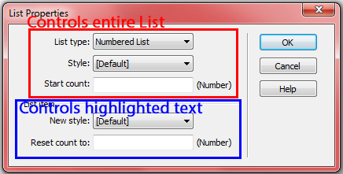
- Change the structured list to “ordered” list with numbering “a,b,c…”. Do this by:
- Placing the cursor in the beginning of the text “The Frog Princess”
- In the Properties Panel press the List Items button
- For the “List type” field, select “Numbered list”
- For the “Style” field, select “Alphabet Small (a,b,c…)”, then press “OK”
- Repeat the above steps again, but change List Type to “Bulleted List” and Style to “Square”

Changing the numbering sequence (to start from 3,4,5)

- Change the list back to “Numbered” with labelling “a,b,c…”
- To change the numbering sequence to begin with the letter “d”, enter “Start Count”=4 since “d” is the fourth letter in the alphabet. This letter positioning applies to any other numbering system you use.
- Change the list back to normal numbering (“Start count”=1) and “1,2,3…” format.

Creating sub-lists:

Using the Indent and Outdent icons provides you with control over creating sublists
- Highlight books (2) and (3) and then click on the Indent button in the property panel. Notice the two move over and now change this sub-list to an unordered bullet list. You can change the bullet type by modifying the options as done in step 5 above.

- To add another entry to this sublist, simply click at the end of the last entry in the sublist and press <Enter>. This creates another entry at that same level. Enter the book:
Drop of Gold: by Van Klampen, Vlasta, Annick Press $18.95

- Change the line spacing of this structured list from single to double spacing:

- At the end of each line add a Line Break <Shift><Enter> You may have to do this twice to create the double spacing effect.

- Preview it to see what it looks like, (because you may have either entered too many or too few line breaks) but two normally does it. Don’t worry what the appearance looks like in the document window, but preview it in the browser to see the final product.
- Save the file as bluespruce.html and preview the webpage. Once you are satisfied with your results, close the file.
LAB #5 - Tutorial 3

Objectives:
- Creating Links
- To another webpage within the site
- To a website on the Internet
- To an email link
- Copying links from one webpage to another

Entering Text that will later become links:

- Open the site “session3”. Open the file “index.html”.

- After the first two heading lines, insert a horizontal ruler (Insert>HTML>Horizontal Ruler).
Set the ruler width=80% (look in property panel).

- Following the horizontal ruler, enter the following text on one line with two spaces before and after each vertical bar. This text will be used to create links to different webpages.
Our Library | Red Maple | Blue Spruce | Thames Valley Board | UWO Home
- Note the vertical bar is created by entering <Shift> <\ >key
- The extra spaces can be added by entering <Ctrl><Shift><spacebar> (non-breaking space)

- Highlight the line containing the text and
  - set alignment to center (Give it a new CSS Rule name navigation)
  - make sure that text color is black
  - bold the line and set font size to 14 px

- Save the web page as “index.html”.

Creating a Link to webpage within the site:

- You are about to create links that link to webpages within the SAME website, for the following text that you just entered:
- Our Library - link to ourlibrary.html:
  - Highlight the text “Our Library”.
  - In the Property Panel, make sure the HTML page is selected. Beside the Link field, click on the folder icon. When the dialog box appears, select the file “ourlibrary.html” and press “OK”.
  - Notice the link has been created as the text is now underlined and the property panel holds the location of the link.
  - Preview the webpage and test if the link works.

- Next link:
  - Red Maple to link to redmaple.html
  - Blue Spruce to link to bluespruce.html

Creating a Link to another website on the Internet:

- You are about to create a link to a website on the Internet for the Thames Valley School Board
  - Highlight the text “Thames Valley Board”.
  - In the Property panel, beside the Link field, enter the URL website address which is “www.tvdsb.on.ca”
  - Notice the link has been created and the property panel holds that value.
  - Preview the webpage and test if the link works (it shouldn’t!)
  - To correct this, ALWAYS begin an Internet website with “http://” so that the complete url address (in this case is: http://www.tvdsb.on.ca) is given.
  - Now preview and see if it works
- Next link the UWO Home page with the url address: www.uwo.ca and preview and test your link (Did you remember the http ☺?)

Setting Linked webpage in a New Window:

- Note: Any time you create a link and test the link from the browser, the link always opens within the same browser window. To open a “linked” webpage in a new window, set the “Target” field in the property panel to “_blank”. Preview it and test it out. Try this out with the “Thames Valley Board” and the “UWO Home” text links.
To clear this target field, simply delete the word “_blank” and leave the field empty.

Creating an E-mail Link:

- Now set an e-mail link on the text Send us an e-mail to the e-mail of library@rollwood.ca (this address is a fake address, but it should start up Outlook Express when someone clicks the link)
- Highlight the text “Send us an e-mail”
- From the menu, select Insert > E-mail Link. A dialog box appears with the highlighted text in the Text field. In the E-mail field, type library@rollwood.ca. Notice the property panel enters the value “mailto:library@rollwood.ca” into the link field.
- A shortcut: go directly to the “Link” field, and type the “mailto” string directly.
- Preview and test out the link.

Copying Links from One Webpage to Another:

Now that you have established all the Text links in the index.html webpage, you need to copy this set of links (navigational links structure) to the remaining webpages in order to have a two-way linking structure.

To accomplish this, copy the navigational links from the index.html webpage to the webpages “ourlibrary.htm”, “redmaple.htm” and “bluespruce.htm”

- Using the “index.html” file, highlight the horizontal line and the navigational link, and perform a Copy operation: Edit>Copy (or <Ctrl><C>). :
- Open the file “ourlibrary.html” (no need to close the other files). Position pointer after the headers and from the menu select Edit > Paste (or <Ctrl><V>). Now save the file.
- Repeat the above steps to copy the navigational links into the remaining webpages (redmaple.htm and bluespreuce.htm)

- Save all the webpages under the same name as you opened them.
- Open index.html. Preview it in both browsers to ensure that the links all work.
LAB #5 - Tutorial 4

Objectives:
- Creating Bookmarks (also called “Named Anchors” or “Targets”)
- Setting default bookmarks (top of page)
- Linking to a bookmark in an external webpage

Named anchors let you set markers in a document, which are often placed at a specific topic or at the top of a document. You can then create links to these named anchors, which quickly take your visitor to the specified position.

Creating a link to a named anchor is a two-step process.
    - Create a named anchor;
    - Create a link to the named anchor.

In this tutorial, you will edit the document “redmaple.html” which contains an unordered list of book descriptions. In this tutorial you will turn each list item into a link pointing to the section of where the book begins in this webpage. When someone clicks on any item in the unordered list, it will jump directly to that specific section.

To create a bookmark (named anchor) for the first book “A Bushel of Light”

- Open the site “session3”. Open the file “redmaple.html”.

- Step 1: create the anchor
  - Find the section where the book description of “A Bushel of Light” begins (NOT the list that contains “A Bushel of Light”). Click at the beginning of the line of the header text “A Bushel of Light”.
  - From the menu select Insert>Named Anchor and a popup window appears.
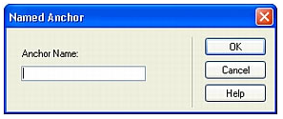

  - In the “Anchor Name” field, type “bushel” (Note: the text string cannot have spaces and must be in lower case), then press OK.
  - Notice the anchor item that is inserted at that point. This indicates that an anchor has been set at this point. The anchor icon is not displayed when you preview the webpage.
  - If you ever see anchors in a document (also called “Bookmarks” or “targets”) and would like to identify the anchor name, click on the anchor icon and look in the Property Panel.

- Step 2: create a link to the named anchor
- In the unordered list, highlight the name of the book “A Bushel of Light”.
- In the Property panel, (in the Link field), type “#bushel”. (It is very important that it begins with a # because it tells a browser that it will jump to that section of the anchor named “bushel”)
- Preview the webpage, and click on the link “A Bushel of Light”. If done properly it should take you to the beginning of that book description.
- Save the file “redmaple.htm”

- Create bookmarks for the book titles given below and test them:
- Across the Steel River (call bookmark “steelriver”)
- Bed of Badlands (call bookmark “badlands”)
- Last entry: “Whose Side are you On?” (call anchor “side”)

Note: When in the browser, a bookmark which links near the bottom of a webpage behaves differently. The browser is unable to bring the bookmark to the top of the window because there is nothing to display underneath. This is not a bug but the behaviour of the browser. A browser makes sure that the monitor is always filled with a full page of content information.

- Save the web page as “redmaple.htm”.

To set up a bookmark to take you to the Top of the Webpage

When setting up bookmarks in a document, you need to provide the user with the option to be able to return back to the top of the document.
- To create a bookmark labelled “Back to Top”, which will take you to the top of the page:
- Go to the beginning of the webpage, and create an anchor called “top”
- Go to the end of the “Bushel of Light” paragraph
- Type the text “Back to Top”
- Highlight the text “Back to Top”
- Go to the Property panel, and in the Link field enter “#top”
- Test it by previewing your webpage, and clicking on the Bushel of Light link. It should take you to that section. Click the “Back to Top” link. It should take you to the top of the page.
- If the link works, copy this link and paste it to the end of each section where the anchors were set up in the previous section. Test them out to make sure that they work.

- Next, replace the “Back to Top” link located at the end of the “Bone Beds of Badlands” section, with the graphics image “toparrow.gif” .
- Erase the text “Back to Top”
- Insert the image “images/toparrow.gif” from the images folder. Set the alternate text to “Back to Top”.
- Click on the arrow image, and set the Link field to “#top”.
- Preview it and test it out.

Linking to a bookmark located in an external webpage.

In this exercise, you will be setting up a link in the file “ourlibary.html” to point to the anchor “badlands” which is in the redmaple.html file.

- Open the file “ourlibrary.html”, and under the “Reading Material” section, the last line says:
Check out the Reading Program book "Bone Beds of the Badland"

  - Highlight the text “Bone Beds of the Badland”.
  - In the Property Panel in the Link field, click on the folder icon and point to redmaple.html.
  - Then you must append to the end of the Link field entry “#badlands” so that the Link field is: “redmaple.html#badlands”
  - Preview the file ourlibrary.html and test if the external anchor works.

Next save the file “ourlibrary.html” and preview to see if this link will jump you to the proper location.

- Save all files and close them.
LAB #5 - Exercise

Objectives:
- Inserting, resizing, aligning and setting padding around images
- Building a navigational link structure:
- Setting up links, setting up bookmarks

From the Travel Site, open the webpage “index.html” and perform the following operations to achieve the look as in the diagram. Note that your paragraphs will probably be wider than they appear below, but don’t worry about this.

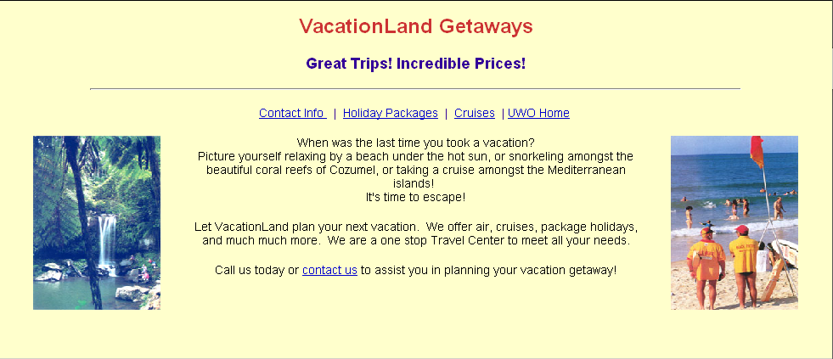

Add images to the webpage
- Flank the left side of the document with the image: “images\picwaterfall.jpg”
- Set the Alternative Text to “Jamaica Waterfalls”
- Resize the image to width=150 and Height=205 (remember to unlock)
- Set the Title text to Title=”Jamaica Waterfalls” in the HTML code
- Add horizontal padding of 30

- Flank the right side of the document with the image: “images\piconbeach.jpg”
- Set the Alternative Text to “Men on Beach”
- Resize the image to width=150 and Height=205
- Set the Title text to Title=“Men on Beach” in the HTML code
- Add horizontal padding of 30
- Save the file as index.html

Add links to top of Webpage after the Headings:
- Insert a horizontal line of 80% width
- Type the text links (make sure it’s centered, and name the CSS Rule navigation):

Vacation Land | Holiday Packages | Cruises | Contact Us | UWO Home
- Set the text links as follow:
- Vacation Land – index.html
- Contact Info - contactus.html
- Holiday Packages – holidaypkgs.html
- Cruises – cruises.html
- UWO Home: http://www.uwo.ca
Save the webpage “index.html”

- In each of the other webpages, overwrite the text “Place navigational links here” with the navigational structure above.

- In the index.html file, set the text “contact us” at the bottom of the webpage (last line) to an e-mail link pointing to info@traveland.com

- Save the webpage as index.html.

Add an ordered list and set bookmarks:

- Open the file holidaypkgs.html and add the following list:
- Palace Resorts, Cancun, Mexico
- Sunquest Resorts, Hawaii
- Jack Tar Village Resorts, Puerto Vallarta, Mexico
- Aloha Resorts, Hawaii
- Cruises

- Now set the first four items in the ordered list (everything except “Cruises”) as bookmark links so that when you select an item from the ordered list, it jumps to that section. You may call the bookmarks anything you want.

- Add a “Back to the Top” link to for each section. You can use the text “Back to the Top”, but in addition, set at least one using the image: “images\toparrow.gif”

- Put a link on the “Cruises” item in the ordered list (in step 18 above, item 5. Cruises), to the bookmark (named anchor) “TransAtlantic Cruises” in the cruises.html webpage. To do this you will need to open the cruises.html page and create an anchor (Insert>Named Anchor) right at the location where the green writing says TransAtlantic Cruises. Then go back to the holidaypkgs.html page and insert the link from item 5. Cruises to the bookmark (named anchor) you just created.

- Save the file as holidaypkgs.html.

