CS 1033
Multimedia and Communications

Lab 06: Webpage Tables and Image Links
(Website Design part 3 of 3)

REMEMBER TO BRING YOUR MEMORY STICK TO EVERY LAB!
Table Properties Reference Guide
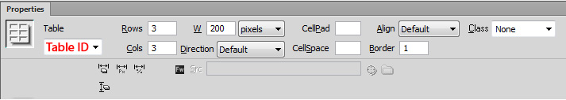The Property panel allows you to set properties for the currently selected table. Read this section to become acquainted with the table properties. Later in this tutorial you will build a website using the following adjustments:
Table Id | An optional name for the table
Rows and Cols | The number of rows and columns in the table
W | The width of the table in pixels, or as a percentage of the browser window’s width. You do not need to set the height of a table as it is controlled by the amount of content in that cell.
CellPad | The number of pixels between a cell’s content and the cell boundaries. 0 means that the text will touch the edges of the cell boundaries. A number larger than 0 will leave space in all four directions in the cell.
CellSpace | The number of pixels between the double lines of a table grid. If you don’t explicitly assign values for cell spacing and cell padding, most browsers display the table as if cell padding were set to 1 and cell spacing were set to ensure that browsers display the table with no padding or spacing, set Cell Padding and Cell Spacing to 0.adjacent table cells.
Align | Determines where the table appears, relative to other elements in the same paragraph, such as text or images.  Left aligns the table to the left of other elements (so that text in the same paragraph wraps around the table to the right); Right aligns the table to the right of other elements (with text wrapping around it to the left); Center centers the table (with text appearing above and/or below the table); and Default indicates that the browser should use its default alignment  When alignment is set to Default, other content is not displayed next to the table. To display a table next to other content, use Left or Right alignment.
Border | If you don’t explicitly assign a value for the border, most browsers display the table as if the border were set to 1. To ensure that browsers display the table with no border, set Border to 0. To view cell and table boundaries when the border is set to 0, select View > Visual Aids > Table Borders.
Clear Column Widths and Clear Row Heights | Deletes all explicitly specified row height or column width values from the table
Convert Table Widths to Pixels and Convert Table Heights to Pixels | Set the width or height of each column in the table to its current width in pixels (also sets the width of the whole table to its current width in pixels).
Bg Image | The table’s background image
Cell Properties Reference Guide
This Property inspector allows you to set properties for table elements (cells, row, and columns).
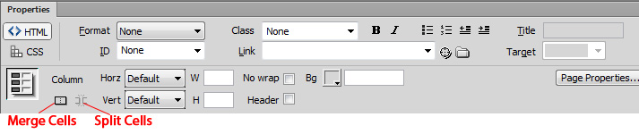
Horz | Specifies the horizontal alignment for the contents of a cell, row, or column. You can align the contents to the left, right, or center of the cells, or you can indicate that the browser should use its default alignment (usually left for regular cells and center for header cells).
Vert | Specifies the vertical alignment for the contents of a cell, row, or column. You can align the contents to the top, middle, bottom, or baseline of the cells, or indicate that the browser should use its default alignment (usually middle).
W and H | The width and height of selected cells in pixels, or as a percentage of the entire table’s width or height. To specify a percentage, follow the value with a percent symbol (%). To let the browser determine the proper width or height based on the contents of the cell and the widths and heights of the other columns and rows, leave the field blank (the default).  By default, a browser chooses a column width to accommodate the widest image or the longest line in a column. This is why a column sometimes becomes much wider than the other columns in the table when you add content to it.
Bg | Is the background color for a cell, column, or row, chosen with the color picker.
Merge Cells | Combines selected cells, rows, or columns into one cell. You can merge cells only if they form a rectangular block.
Split Cell | Divides a cell, creating two or more cells. You can split only one cell at a time; this button is disabled if more than one cell is selected.
No Wrap | Prevents line wrapping, keeping all the text in a given cell on a single line. If No Wrap is enabled, cells widen to accommodate all data as you type or paste into a cell. (Normally, cells expand horizontally to accommodate the longest word or widest image in the cell, and then expand vertically as necessary to accommodate other contents.)
Header | Formats the selected cells as table header cells. The contents of table header cells are bold and centered by default.
LAB #6 - Tutorial 1

Objectives:
- Working with Tables and their properties
- Working with Cell properties
- Opening a Word Document and using Paste or Paste Special

Copying the Updated Material from the Instructor’s Area:
- Make sure Dreamweaver is NOT open!
- Download the file lab06.zip from the website (http://www.csd.uwo.ca/~lreid/cs1033labs/lab06) to your memory stick in your cs1033 folder (to F:\cs1033).
- Right click on the lab06.zip file and select Extract all...
- On the window that appears, make sure the Destination folder is your lab06 folder
  - (ex. F:\cs1033\lab06)
- Select Extract
  - There should now be a lab06 folder in your cs1033 folder, and the lab06 folder should now contain a folder named cross_company.

- Start Dreamweaver CS6

- Create a Site called “Cross Company”, and point it to the folder F:\cs1033\lab06\cross_company\

- Create a new file called “index.html”. This will be the homepage of the website you are about to create.

Create a Table

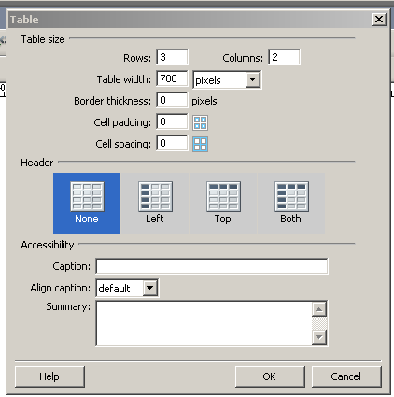
- At the beginning of your document, press the “Enter” key a couple of times, simply to make some space in the beginning of your file.

- To insert a table, from the menu select Insert >Table. In the dialog box, enter the following values into the appropriate fields:
- Rows: 3
- Columns: 2
- Table Width: 780 pixels
- Border thickness: 0 pixels
- Cell padding: 0
- Cell spacing: 0
- Header: None
- Press OK

- A table is created that looks like:
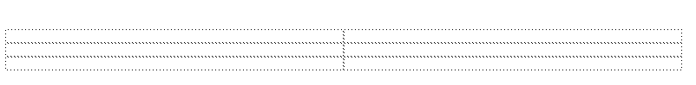
The lines are dotted because the parameter “Border Thickness” is set to 0, so there is no visible border.

Select a Table

To change the properties of a table you must always:
- First select the table
- And then Edit the Property Panel values for the table (bottom of the screen):

- To select the table, click anywhere on a row or column’s grid line, or the upper-left corner of the table. By doing so, the table that the cell is part of will become outlined in red, selection handles will appear along its edges, and the property panel will say “Table”.
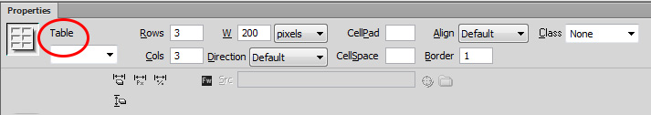
- When selecting a table, the Property Panel reflects the characteristics of that table, so that you can modify it if you choose.
- Other methods of selecting a table are possible: experiment and see if you can get each of the methods below to work. There will be times when one method is easier to use than others.
  - Click in a table cell, and then select the <table> tag in the tag selector at the lower-left corner of the Document window. There may be more than one table tag.
  - Click in a table cell, then select Modify > Table > Select Table.
  - Click in a table cell, then the green number that appears above the table (table header menu), and then select “Select Table”.
Editing a Table – Table Properties
Be sure you have read the “Table Properties Reference Guide” and “Cell Properties Reference Guide” before continuing.
- Merge the two cells in the first row combining the two columns to form one cell. To do this, highlight the two cells in the first row, and select the Merge button in the property panel.

Into this cell, insert the image banner_top.jpg and set the alternative text to “H. Cross Company”. Insert the text title=”H. Cross Company” into the HTML code so that Firefox displays the alternative text information as well.

- Delete the last two rows in the table
Highlight all the cells in the last two rows of the table, and right-click with your mouse. From the pop-up box, select Table > Delete Row. The two rows should be eliminated.

- Add another table below this banner
Make sure you have left an empty line between these two tables so that you can work with the separate tables more easily. (You will eliminate the space later)
From the menu, select Insert > Table, and create a table with width=780, border=0 and 2 Rows and 2 Columns.

- Add an image that represents the side navigation links. You will later add the links as hotspots.

- You are now working on the second table.
- In the first row first column, insert the image side_bar.jpg and set the Alternative text field to: “H. Cross Company Links”.
- Make sure that the first column of your table is just as wide as the sidebar image. To move it, simply place your mouse on the divider line between the first and second column, click down and drag it as far to the left as you possibly can, then release your mouse. You can adjust any column width by using this dragging method, or by clicking in the cell and modifying the W (width) value in the property panel.

- Create an image map (also known as setting hotspots) that links the side_bar buttons to the appropriate webpages.

These hotspots can link to another webpage, document (i.e. .pdf, .doc, .ppt, etc), or image
- To Set the first hotspot on the side_bar text “ Refractory Metals & Alloys”
  - Click on the side_bar image. The Property panel reflects the attributes of the image.
  - Select the Rectangle Hotspot Tool (as in the diagram below):
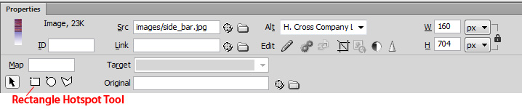
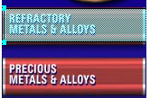
- Next, move your mouse over the text “Refractory Metals and Alloys” and click down to draw the rectangle so that it encompasses the entire red square (as in the picture on the left). It will show as a blue-green transparent color. Once you are done drawing the hotspot, release the mouse. You may be prompted for an ALT tag, if so insert the text “Alloys” in the Alt field of the Properties Panel.
- Link this to the file “refractory.html”: in the Link field, by selecting the folder icon and browsing to the file
- Test to see if this is working by first saving the file, then previewing it in IE. When you click on the “button”, the refractory.html page should open.

- Now repeat this entire process to set up the following hotspots to the linked files:
Side bar:
- Precious Metals & Alloys: Link to → preciousmetals.html
Top Banner Links:
- Company History: Link to → company_history.html
  - News: Link to → news.html
  - Purchasing Policy: Link to → purchasing.html
  - Catalog: Link to → catalog.html
  - Contact Us: Link to → contactus.html

Save the file as index.html.

Bring the two tables together

Up until now you had two separate tables separated by whitespace. To remove this space, position your mouse between the two tables and using the Delete or Backspace keys, delete the spacing until the tables come together. Note that they remain two separate tables.

Add the content to the webpage – Paste vs. Paste Special

In the cell to the right of the side navigational links, you will add paragraphs. In order to avoid typing a lot of text, the text is saved in a Word document you copy it from and paste it into the webpage.

  - Your Dreamweaver session is still active with the index.html webpage.
  - Open the Word document: “content for cross company.doc”
  - Highlight the text, and copy it.
  - Switch over to Dreamweaver. Click in the cell to the right of the side navigation bar, and paste into the cell by Right-clicking on your mouse, and selecting Paste.
  - Notice how the text was inserted into the cell. Note the content is right up against the edges, making it look “cluttered” (we’ll fix this later)
  - Undo this operation
Now use the option “Paste Special”. Notice that with this option it gives you more formatting control.
- Choose the option “Text with Structure plus basic formatting (bold, italics)”. Notice in the Property Panel that the font is “Default Font” with size “None”. Save the file and preview the webpage. Remember that the Paste function only copied over the bold and italics and links.
- Undo the last operation, and this time, use the Paste Special function but using
“Text with Structure plus full formatting (bold, italics, styles)”
Notice in this example, the two paragraphs keep their formatting styles.
- Undo the last operation, and then do a “Paste” operation (not “Paste Special”).
- Notice in the Property panel, that the Font is set to “Default Font”. Preview it.
- Next, to set the body of text automatically to “Arial” size 12 pixels, in the Property panel, click on Page Properties, and set font and size. Preview the page and see how the font takes on Arial 12 pixels because using the “Paste” function sets the font to a default which allows you to set the Page Properties font attributes.

Change the vertical/horizontal alignment of the text within the cell.

You probably have noticed that the content does not start at the top of the cell, and even you try to delete the space before it, you’ve discovered that there are no empty lines to delete. This happens because the text is centered by default within that cell because one of the other cells on that same row has more height. (in this case it is the side bar image that occupies more lines than the text you just copied).

To force the text to the top of that cell (vertical alignment)

        - Click in the cell, and in the Property Panel, set the field “Vert” to “Top”. (notice that there are other options as well, you can play these options now, but return it to “Top”)

To change the horizontal alignment of the text within the cell.

- Click in the cell, and in the Property Panel, set the field “Horz” to “Right” (which aligns to the right of that cell), then “Center” and then back to “Left”.
- There is still a problem: the text is against the edges of the cell. So, you need to add some padding.

Save the file as index.html.

Change the Cell Padding

Since the text runs into the edges of the cell, you need to add some padding in that cell. But the problem is that you cannot adjust the padding in only one cell. Cell padding is controlled by the table property and it affects every single cell in that table rather than only one. Try it anyways to see what happens to the appearance and how it affects other adjoining cells.

- Select the table (see earlier notes on how to select the table)
- In the Property Panel, set the cell padding to 10 (padding takes a number from 0 and up)

Problem: The cell now has padding in it, and the text no longer runs into the edges. But since each cell is affected, the side bar has padding as well, and so the image no longer lines up with the top banner (a separate table).
So this method will not work, you will now try the solutions outlined next

- Undo the cell padding operation so that the side bar lines up properly.

Solution 1: Split the cell into two columns:
      - Click in the cell which contains the text, and in the Property panel, click on the “Split” button. Split it into 2 columns. Notice how ONLY this cell is divided into two cells. Cut and paste the text from the middle column to the right column.
      - Drag the column divider to the left until there is reasonable spacing from the side bar.
      - Now undo until you eliminate solution 1 (where you started with two columns).

Solution 2: Add a nested table in this cell
      - Click in the same cell but click after the last paragraph “…radar systems and many more” add a couple of “Enter”s. Now insert a nested table in this cell by selecting from the menu Insert > Table with width=90% and 2 rows by 1 column (you can add as many rows and columns as you may need).
      - Center the table: Select the table and set Alignment to “Center”. You should now see how on either side of the table there is spacing. You can change the table width to 95% by modifying the table property “W” to 95% --- Try it.
      - Now drag the two paragraphs from above into the first row of the nested table. Notice how the spacing has been achieved. You will have to set the vertical alignment as well.

Add another image inside this nested table

- Place your mouse at the beginning of the first paragraph.
- From the images folder, insert the image “uncle_charlie_ad”.
- Wrap the text around so that the image is right-aligned. (RightClick>Align>Right)
- Add 20 units of horizontal spacing around the image. (RightClick>Edit Tag<img>...)

Turning an Image into a Link to another webpage
    - Click on the image of “uncle_charlie_ad.jpg”
    - In the Property Panel, set the link field to “history.html”
    - Notice that in this example you did not use hotspots. If you are linking an entire image, then simply use the process as above. If you want to set several different links from “one” image, then you must use hotspots.

Save the file as index.html.
Setting the Table Border

You will now experiment with table border.
- Select the table.

- In the Property Panel, set “Border=10”. Notice how the table has a thicker outer line. But this option does not work well with this set of images, since the side navigation bar is now misaligned with the top banner.
- The border can be assigned any value greater than 0. For now set the border to 0 because this allows the images (top banner, and side banner) to blend together seamlessly.

Changing the table background color, cell background color and page background

To change the Entire Table Background:
      - Select the right column of the lower table. You can do this by selecting a cell in the table, then clicking on the Size Value of the column. In this case, the number should be around 620. Then choose Select Column.
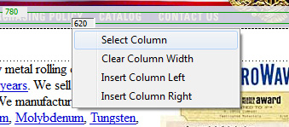
      - In the Property Panel, set “Bg Color= #16018A”. Notice how the entire column takes on the blue color.

To change the Cell(s) Background color of the Inner table (you can use the steps as outlined above, or follow the next steps):
- Highlight the cells containing “uncle_charlie_ad” and the cell below it.
- In the Property Panel, set “Bg Color” to “#FCE49C”. Notice how the entire inner table takes on the light creme color.
- Since the webpage doesn’t quite look balanced with the top navigational links, you can set the entire right hand side of the webpage (i.e. the cell containing the “nested” table of the company description) to white. Use the Cell Properties/Table properties of the inner table and cells to make the right hand portion white.

To change the Page Properties background
- Click anywhere on the webpage, and in the Property panel, select “Page Properties”.
- Set the Background color to “#E3C096”. Watch the webpage jump out at you because the entire page background sets the webpage apart.

Save the file as index.html and close it.

LAB #6 - Tutorial 2

Objectives:
- Setting image links
- Setting rollover links

- From the “Cross Company” site, open the file “tutorial_2.html”.

In the last tutorial, you added one image “side_bar.jpg” and used hotspots to link the webpages. In this tutorial, you will be adding individual images down the left column and linking them individually.

- Click in the cell directly below the banner in the first column (right above “Lamp Seal Products”).
- Insert the image: images\but_refractory.jpg (Alternative text: Refractory metals)
- Your image is highlighted with the handles so before inserting the next image, use the right arrow key on the keyboard to get past the image. The cursor will still be on the same line.
- Now you have a choice of either pressing <Enter> to leave a blank line before you insert the next image, or a <Shift-Enter> to force the next image on the next with no paragraph breaks. Select the <Enter> for now.
- Insert the image: images\but_precious.jpg (Alternative text: Precious metals)

Setting image links

    - Click on the image “Refractory Metals and Alloys”. In the Property Panel, set the Link field to the webpage “refractory.html”.
    - Preview the webpage. When you place your mouse over the button “Refractory Metals and Alloys” notice how the mouse turns into a “hand” indicating there is a link on that image. If you hover your mouse over the other images, they do not have a link associated with it.
    - Click on the first button to see if it links to the right webpage.
    - Set the link for the button “Precious Metals and Alloys” to the webpage
“preciousmetals.html”. Preview and test that it was done properly.

To create a rollover effect on links:

In this section, you will be shown how to create a rollover link. It assumes that you have two images of a button with a difference in color perhaps.

For Example: In the case below, the buttons are identical in shape and size but not in color. They are labelled but_processing.jpg, and but_processing_mo.jpg where “mo” stands for “mouse over version”. However, you can call your images anything you want.



    - First left-click your mouse in the area below the buttons you inserted previously.

    - To Create the effect, from the menu select:

    - Insert > Image Objects > Rollover Image and set the parameters as indicated below by clicking on Browse and pointing to the file.

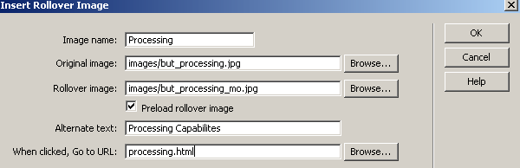

    - Notice that the image is inserted into the position, and look at the field values in the property panel.

    - Preview the webpage and notice the rollover effect when your mouse goes over the button. Make sure the link connects you to the correct file.

Next set the rollover effect for another button that you will insert:

- but_testing.jpg and but_testing_mo.jpg

- link it to: testing.html

- If the “testing” button is touching the button above it, use your arrow keys so that the cursor is at the start of the “testing” button, and press <Shift-Enter>. Do the same for any other buttons that are touching, so all the buttons have the same “space” between them.

Save the file as “tutorial2_done.html.

BRING YOUR OWN HEADPHONES TO THE REMAINING 7 LABS!!

