CS 1033
Multimedia and Communications

Lab 07: Introduction to Animation
(Adobe Flash part 1 of 2)
Flash Layout – Reference Sheet

You have encountered some of these panels before (in Photoshop), such as the Tools Panel (“Palette”) and the Property Inspector. The Stage is the term that Flash uses for the main canvas. Note the Layer Manager is no longer in the bottom right, but is integrated with the Timeline Panel at the top.
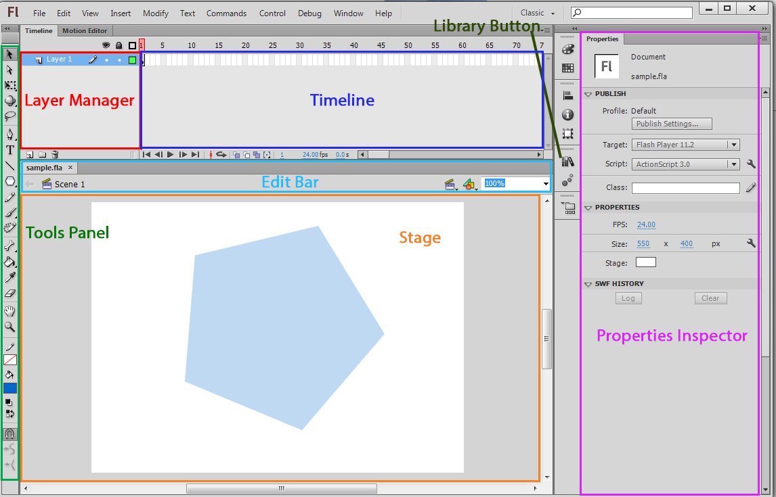

The Timeline Panel at the top of the screen is new to you, and is used to create animations. Any image you create on the Stage will be saved as a single frame on the Timeline, with all of its layers intact. During this lab, you will be creating multiple frames then by having Flash display them very quickly, one after another, it will give the illusion of “animation”. The Timeline Panel also acts as the Layer Manager, as shown below:
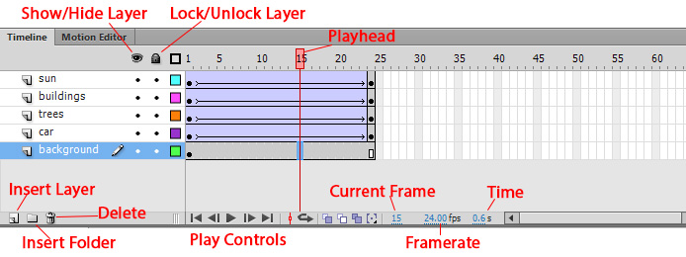
LAB #7 - Tutorial 1

Objectives:
- Creating and Saving Flash Files
- Creating Shapes on the Stage
- Saving Shapes as Symbols in the Library
- Adding Objects (Shapes and Symbols) to Layers and the Timeline
- Animating: Motion and Shape Tweens

Before you Start: Create a folder in your cs1033 folder called lab07. (F:\cs1033\lab07)
Go to www.csd.uwo.ca/~lreid/cs1033labs/lab07, and save all the files to your lab07 folder.

In this tutorial, you will be creating an animated face.
- Start Adobe Flash CS6 Professional. From the Menu Bar, select File > New, then from the dialog box select Actionscript 3.0, and then select OK.

- Immediately save your new file by selecting File > Save As, then save the file in your F:\cs1033\lab07 folder as face.fla, with “Save as type” set to Flash CS6 Document. Make sure you have examined the reference sheet above to get accustomed with the terminology for this lab!

- By default, the Workspace will look different than the reference sheet provided earlier in the lab. To change this, from the Menu Bar select Window>Workspace>Classic.
- In the Tool Panel, change the Stroke Colour . Make it any colour you want but don’t leave it as the Square with the Red line through it (no stroke).
- In the Tool Panel click and hold down the left mouse button on the Rectangle Tool (if you see an Oval Tool , click it instead.) By holding down the mouse button over the tool in the Tools Panel, you will see all the available shapes that can be drawn. Select the Oval Tool before continuing.
- Draw a small circle on the Stage to represent the right eye of a face. Don’t worry about its colors (you will be changing them). In the Timeline Panel, double click “Layer 1”, and change the layer name to “Right Eye”.
- Select the Selection Tool and double-click the circle’s center to select it. You should see both its outline (stroke) and center (fill) selected.

- To change the outline color of the eye, click the Stroke Color box in the Property Inspector (right side of the screen) and select black. Change the center of the eye by changing the Fill Color box to red.
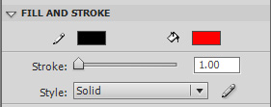
- Next you will create another eye, but instead of simply copying the right eye, you will first save it as a Library symbol. By doing so, you will be able to use the symbol over and over:
  - With the Selection Tool, double-click the right eye to select it
  - From the Menu Bar select Modify > Convert to Symbol.
  - In the dialog box, name the symbol “eye”, change its Type to “Graphic”, and press OK.
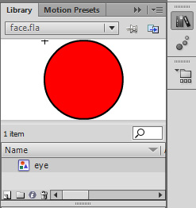
  - Select the Library Button. A popout menu will appear and the eye symbol you just created will be listed there, as well as a preview of the symbol. You can close the library by pressing the button again.
Note: the “eye” symbol appearing in the Library is the master copy of the eye, and the eyes on the stage are called instances of this symbol. Any changes you make to the Master Copy will change all the eye instances on the stage.
Note: in Flash, a shape is an object that you draw, while a symbol is a shape that is stored in the Library. Symbols on the stage are easily recognizable as they are surrounded by a blue box when you select them. The distinction between shape and symbol will be important when working with animations.
- Click the Insert Layer button (see below) in the lower left corner of the Layer Manager and change the new layer’s name to “Left Eye”. Ensure the “Left Eye” layer is selected before continuing.
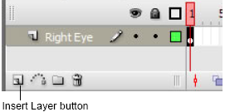
- Drag the “eye” symbol from the Library onto the Stage, and place it to the left of the right eye. You now have two instances of the eye symbol on the stage.

- Click on the “eye” symbol in the Library, then double-click its picture right above it. The red eye symbol will appear by itself on the screen, with a “+” symbol on its top left corner. This indicates that you are currently editing the Master Copy of the “eye” symbol. To get out of this mode, click the blue arrow in the Edit Bar (located below the Timeline) to “Move Up A Level” back to “Scene 1” (see next image):
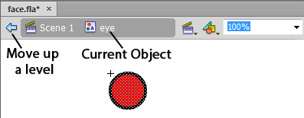

- Double-click on any of the eye instances on the Stage; this will again allow you to edit the Master Copy (denoted by “+” again), except you will do it with the entire stage still visible (although the other objects will appear faded).
- Change the fill color to green, then move back up a level using the blue arrow.
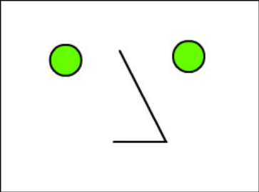
- Insert a new layer and name it “Nose”. Select the new Nose layer. Then use the Line Tool to draw two lines to form an angle that looks like a nose (see right). If you need to adjust angle or placement after you’ve drawn the lines:
→ use the Subselection tool to drag the end of a line
→ use the Selection tool to move a line
  - Now select both parts of the nose. An easy way of selecting both lines is by selecting frame 1 of the Nose layer.
  - Convert the nose to a symbol called Nosey by performing the following:
    - Select Modify>Convert To Symbol.
    - Call the new symbol Nosey and make sure you select the type to be Graphic.

Adding Animation
A Flash movie typically plays at 12 frames per second. To keep the face on the stage for 3 seconds, you would need to insert 36 additional frames after frame 1 (frame 1 currently holds the face you drew). In other words, starting at frame 1, it will take the movie 3 seconds to reach frame 37 (1 + 36 = 37).

- To change the frame rate to 12 frames per second, click on the Timeline Panel where it says 24.00 fps. Change this to 12.

- Select the Nose layer, then click on frame 37 from the Timeline:
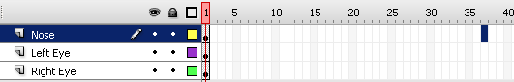
From the Menu Bar select Insert > Timeline > Frame (F5). Flash copies frame 1 to frames 2- 37:
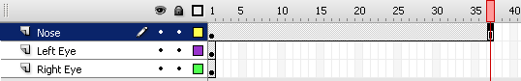
Notice that the Playhead (the red rectangle above) is on frame 37, and on the stage only the nose is visible (the eyes have disappeared). At the bottom of the timeline (see graphic below), you can see the movie is 37 frames long, is set to play at 12 frames per second (“fps”), and will play for 3 seconds:
Drag the playhead to various frames. Notice only frame 1 has eyes, while frames 1 to 37 have the nose.
- To watch your movie play, drag the playhead to frame 1, then click Play in the timeline.
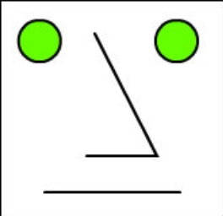
- Insert a new layer and name it “Mouth”. Select the layer and frame 1, and draw a straight line for the mouth using the Line Tool (see image below).
Note: In the Timeline, the Mouth layer already has frames up to frame 37 (like the Nose layer), even though you didn’t ask Flash to add the frames. When you create a new layer, Flash automatically generates frames for it based on the current movie length. Since the Right Eye and Left Eye layers were made when the movie was only 1 frame long, they remain only 1 frame long!
- Select the Selection Tool, and click on a blank part of the Stage to make sure nothing is selected. Move your mouse towards the middle of the mouth, and watch a curve appear next to the pointer. Now click and drag the bottom of the mouth to create a smile. This is represented by the images below:
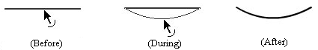

- On the Right Eye layer, select frame 37 and select Insert > Timeline > Keyframe (F6). A “keyframe” signals Flash that some animation action begins or ends at that frame, and is depicted on the Timeline by a black circle in the middle of a frame. Note that frame 1 is, by default, also set as a keyframe.

- With frame 37 and the Right Eye layer still selected, use the Selection Tool to drag the right eye on the stage to the right a short distance.
- Then right click any frame between 1 and 36 on the Right Eye layer, and select Create Classic Tween. The Right Eye layer in the Layer Manager will now appear blue and contain a solid arrow, as shown below:
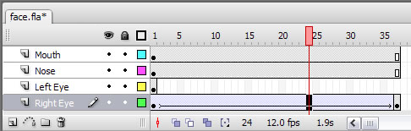

- Position the playhead on frame 1 and press Play. The movie will now show the right eye slowly move over the 37 frames. Note: To change the ending position of the eye, move only the symbol in the ending keyframe (the last frame, frame 37). Similarly, to adjust the starting position, move only the symbol in the starting keyframe (first frame). No other adjustments to the tween settings are needed.
Note: The word tween is derived from the word “between”, and refers to how Flash automatically creates all the frames “in between” the first keyframe and the last keyframe. Three types of tweens exist:
• Classic Tweens animate movement of symbols, but do not work for simple shapes.
• Shape Tweens animate shapes, changing shape or properties, but do not work for symbols.
• Motion Tweens can be used to animate symbols, but without the use of keyframes (harder to edit).
- Animate the left eye: Select frame 37 in the Left Eye layer and insert a keyframe. Then move the left eye to the left the same distance that you did for the right eye, and create a classic tween as you did before.
- Animate the mouth: Select frame 37 in the Mouth layer and insert a keyframe. Using the Selection tool, click on an empty part of the stage to de-select the mouth object, then use the tool to change the smile back to a straight line.

- Next, right click any frame between 1 to 36 in the Mouth layer, and select Create Shape Tween. The Mouth layer in the Layer Manager will now appear green and contain a solid arrow, as shown below:
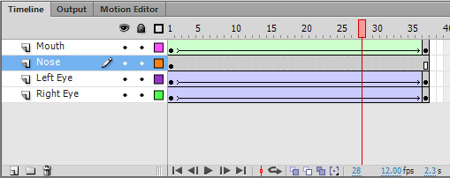

Note: In the timeline, the white squares (e.g. in Nose layer at frame 37) indicate the last frame for which objects in that layer are shown. If the last layer is a keyframe (e.g. Right Eye layer), only a black circle will be shown (no white rectangle). When you create a new layer that is empty, a white circle is shown to indicate an empty keyframe.
- Position the playhead on frame 1 and play the movie. The mouth animates as its shape changes.
- Save your file again as face.fla
LAB #7 - Tutorial 2

Objectives:
- Creating Motion and Shape Tweens
- Working with Tween Properties
- Working with Text

Classic Tweens: are used to animate changing colors, transparency, size, and position. However, they can only be used on layers with symbols, grouped objects, and text blocks (NOT shapes). Furthermore, they can only work on layers with no more than one symbol or group.
Note: After each of these steps, press Play to see the results.
- Save your file as face2.fla (File>Save As)
- Changing Color:
  - Set the playhead to frame 37 (the last frame), and select the right eye symbol instance.
  - In the Property Inspector, select Color Effect > Style = Tint.
  - In the color selector box beside it, you can change the color to blue. However, to make sure everyone is using the same shade of blue, fill in the RGB boxes to 0, 0, 255 (see below).
  - Next, change the Tint Amount from 50% (which is a mix of the original green color and the blue tint) to 100% (entirely blue), as shown below:
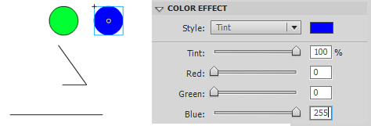
- Changing Transparency:
  - With the right eye still selected at frame 37, change Color style from “Tint” to “Alpha”.
  - Set the Alpha Amount to 0% (if its not already set) to make the eye completely transparent.
- Changing Color and Transparency Simultaneously: When you changed the Color style to “Alpha”, you lost the “Tint” effect. To correct this and have the right eye change colors while becoming transparent
  - Change the Color style to “Advanced”.
  - Change the values to those below:
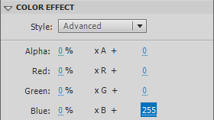
Note: Photoshop uses the RGB color scheme, where every color is created by setting the amount of Red, Green, and Blue only. Each of these colors has a possible range from 0 (none) to 255 (maximum). By setting blue to 255 and the rest to 0, you get pure blue. If all 3 colors are set to 255, you get white. If all 3 are set to 0, you get black.

- Save your program again. (File>Save)

- Changing Size:
  - Set the playhead to frame 37, and select the left eye symbol instance.
  - From the Menu Bar, select Modify > Transform > Free Transform.
  - Hold down Shift, and drag one of the corner handles to increase the size of the eye to twice its original size.
- Working with Motion Tween Properties: When you select an object that has a motion tween applied, the Property Inspector allows you to modify the tween behaviour even further. After each of these steps, preview using the Play button to see the result.
  - Select frame 1 in the Left Eye layer, and in the Property Inspector, change the Ease to -100.
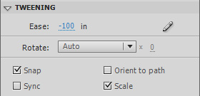
The Ease controls how fast the object starts or ends the tween. Setting a negative value causes it to start slow then speed up, while a high value does the opposite. Hit Play to watch .
  - Select the Nose Layer, then select Frame 37 and insert a Keyframe(F6).
  - Then right-click a frame between 1 and 37 and in the drop-down menu select create classic tween.
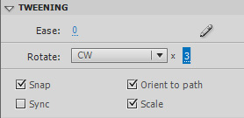
  - Then select frame 1 in the Nose layer, and in the Property Inspector, put a check beside Orient to Path. This causes an object to be linked to the path drawn in its guide layer (motion guides only).
  - Select frame 1 in the Nose layer, and in the Property Inspector, set Rotate to “CW” (clockwise) and its count to “3” times. This will cause the nose shape to rotate 3 times.

Shape Tweens: Can be used to animate changing shapes (i.e. morphing), colors, transparency, and position. However, they can only be used on layers with shapes and individual letters (NOT symbols, grouped objects, or text blocks).

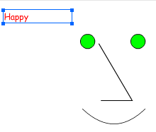
  - Create a new Layer, rename it to “Status”, and ensure the playhead is at frame 1.
  - Then select the Text Tool and in the upper left corner of the Stage, type in the word “Happy”.
  - In the Property Inspector, change its font to Comic Sans MS, size=24, color=red.

  - Select frame 37 of the Status layer, and insert a new keyframe (Insert > Timeline > Keyframe)(F6).
  - Using the Selection Tool , double click on the “Happy” text to select it, change the font color to blue, and change the text to “Sad”.
- Flash thinks text is similar to Symbols. In other words, only Classic Tweens work on lines of text, not Shape tweens. To use Shape Tweens instead, you must first convert the text to Shapes:
  - In frame 1, select the “Happy” text with the Selection Tool .
  - From the Menu Bar select Modify > Break Apart. This will split the word into individual letters (which is still text).
  - Select Modify > Break Apart again, to convert the letters into individual lines (in other words, into Shapes).
  - Repeat this with the “Sad” text in frame 37 (remember to use Modify > Break Apart twice!)
- With the Status layer still selected, Right Click on any frame between 1 and 36, and select Create Shape Tween. Preview the movie to watch the morphing animation. Morphing can be done with any Shape, such as Shape-to-Shape and Text-to-Shape morphs.
- In frame 37 of the Status Layer, use the Selection Tool to move the “Sad” text to the lower left corner of the Stage. Preview to watch the movie, and note the morphing shape also changes position.
This highlights an important point: Shape Tweens can also depict motion. Don’t make the mistake of thinking that Classic Tweens are used only for motion, and Shape tweens only for changing shape. The distinction between Classic and Shape Tweens is based on the type of object that they work on. The chart below highlights when to use Classic Tweens, and when to use Shape Tweens:
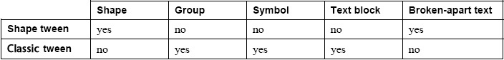
- Save your file as face2.fla. Then do a Save As and save your file as face3.fla (File>Save As)

LAB #7 - Tutorial 3

Objectives:
- Importing Image and Sound Files
- Working with Timeline Effects
- Exporting: SWF Format, Animated GIF, as a Webpage

- Set Background Color: With face3.fla still open, select Modify > Document. This brings up the overall Document Properties page, where you can change the Stage size, frame rate (frames per second), and background color. Make the following change:
  - Set background color to: yellow. Press OK
- Set Document Info: From the Menu Bar select File > File Info.... This brings up a window where you can fill in a lot of information about the document. Make the following changes.
  - Set Document Title to: “Animated Face”
  - Set Description to: “My first animated face!”
  - Press OK.
- Set Background Image:
  - Create a new layer, and change its name to “Background”. Move the layer so that it is below all the other layers in the Layer Manager.
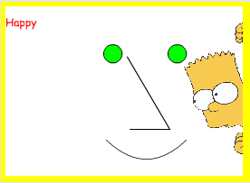
  - To import an image into this layer:
Select File > Import > Import to Stage, then browse to your lab07 folder and select the file “simpsons_2.jpg”. The file will automatically be placed in the Background layer. When an image is imported like this, it is automatically placed in the Library as a Bitmap Symbol. If the imported image was a Photoshop file, the layers would be imported as well, giving greater flexibility for animation (not covered during this lab).
  - Resize the image to fit the Stage:
    - Select the Free Transform Tool , and drag one of the corners to make it smaller. You can also click the center of the image and drag it to a different position. Adjust the image so it leaves a slim yellow border at its edge.
Note: the imported image is currently stored as a Symbol. If you ever need to apply Shape Tweens to it, you can convert the image to a Shape by selecting Modify > Break Apart (as you did with the text in the last exercise). Do NOT do this right now, however.

- Importing Sound: You can import sound clips the same way as image files.
  - Select File > Import > Import to Library and select the file bad.wav. The file will automatically be placed in the Library as a Sound Symbol.
  - Create a new layer in the Layer Manager, and call it “Sound”.
  - Select the Sound Layer. Press the Library Button to open the library, and drag the bad.wav symbol from the Library to anywhere on the Stage. You will notice a sound wave appear in the Sound Layer, as it is now embedded in the movie.
  - Select the Sound layer. In the Property Inspector, the Effect drop down allows you to set fade in and out effects, while the controls in the Sync drop down let you control looping. In the Sync drop-down, select the “Stream” option. Descriptions for each option are below:
    - Event: the clip keeps playing, even if the animation has stopped. If looping is enabled, the sound may start again even if the previous sound hasn’t finished (causing overlap).
    - Start: same as Event, but the sound is not allowed to overlap itself.
    - Stop: silences the sound.
    - Stream: Forces movie to keep pace with the sound. If Flash can’t show frames fast enough, some frames will be skipped, but the movie and sound will remain in sync.
Saving and Exporting

- You have been saving your work in FLA format, which is Flash’s native format for source files and requires Flash CS6 to open. To publish on the Web, you must convert the file to SWF format (“Small Web Format”): a compressed movie format played with Flash Player (installed on most computers). This format is used to play many online video games and is even used in the YouTube video player. To see how SWF compares to other formats, you will also be exporting to GIF and JPEG formats:
  - Save your file, then select File > Publish Settings.
  - Place checkmarks beside Flash, HTML, GIF Image, and JPEG image only (de-select any others).
  - Select GIF, and set playback to “Animated”.
  - Press Publish and then OK to save all the settings.
  - Close all files, and quit out of the Flash CS6 program.

- Browse to your lab07 folder, where you have been saving your files. You will see a number of files:
  - Open the file face3.jpg. The JPEG format is great for saving high quality images, but cannot play back animations. Hence, you will only see a still screenshot from your Flash file.
  - Open the file face3.gif by right clicking it, and selecting “Open with >Internet Explorer (NOTE: if Internet Explorer is not in the list, then select Chosose Program and select Internet Explorer from the list)”. The GIF format is lower resolution than the JPEG format, but can play simple animations in web browsers. However, it cannot play sounds.
  - Open the file face3.swf. The SWF format is designed to be played by Adobe Flash Player, which will open automatically and show your animation perfectly.
  - Open the file face.html. This empty, Flash-generated webpage is linked to the SWF file already. It relies on the face3.swf file in order to run. When moving this webpage to your publish area, you must include the .swf file as well. However, you will often be embedding an SWF file into an existing webpage, instead of creating one using Flash.
  - DELETE the face.html from your memory stick before continuing.
- Start up Dreamweaver CS6.
  - Create a new Site called “Animation”, and map it to your lab07 folder.
  - Create a new HTML file using File > New > HTML (for Layout, select “None”). Save your file immediately as index.html.
  - Insert the Flash file using Insert > Media > SWF. From the Dialog Box, select the face3.swf file.
In the next screen, label the Title field as “face” and press OK.
  - In the Properties Panel click Parameters. For the swfversion change the value to 10.0.0.0. Press OK.
  - Save and preview your webpage. Sometimes the web browser will ask if want to run the content. Click Allow Blocked Content.
- Upload the files to your publish.uwo.ca account
  - Open WinSCP
  - Click New and fill in the information as you did in lab01.
    - Host Name: panther.uwo.ca
    - User name: your school username
    - Password: your school password
  - Press Login.
- In the public_html folder, create a folder called lab07.
- Upload the following files to your lab07 folder: index.html, face3.swf, and the Scripts folder.

Note: remember to set the permissions properly for every file and folder. Files should have permission 0644, while folders should have permission 0755.

To view your work, go to publish.uwo.ca/~YOURUSERNAME/lab07.

LAB #7 - Tutorial 4

Objectives:
- Importing Video Files: Embedded, Progressive, Streaming
- Exporting Flash with Video

Note on Terminology: the animations you created so far are called Flash movies, and are first stored in the Flash source format (FLA) and then converted to movie format (SWF). In this tutorial you will import video clips (such as clips from TV shows), which are commonly stored in AVI, MOV, MPEG, or WMV formats.

Flash has 3 basic options when importing and playing video clips:
- Embedded Video: Inserts the video directly into the SWF file. Unfortunately, Flash has problems synchronizing audio with video after 4 seconds (if playing at 30 frames per second). Use this method only when the video clip is 4 seconds long (or less).
- External FLV with “Progressive Download”: Flash first converts the video clip to Flash Video format (FLV). The Flash SWF file then gets “linked” to the FLV file. In other words, the video file is stored externally to the SWF file.
When stored on the Internet, the download method is progressive: the video can start playing even before it is fully downloaded (i.e. similar to YouTube). Someone watching the video can fast-forward to any point that has been downloaded so far, but not to a part that has not yet been downloaded.
This is the recommended method to use, but due to time constraints will not be taught in this course.
- External FLV with “Streaming”: This method also creates an FLV file, but the download method is streaming: only the part that is playing gets downloaded, instead of the entire file. Someone watching the video can fast-forward to any point and it will play right away. This method produces the best performance, but requires a special server, hence will not be used in this course.
Tip: Regardless of the method you use, Flash will always compress the original video clip first. Hence, it is important to start with a high quality video clip, as its quality will be degraded when converted to Flash!
Embedding a Video Clip
- Start up Flash CS6, and create a new Flash file. Rename the first layer as Clip, then save this file as embedded.fla.
- To embed the video clip: Select File > Import > Import Video...

  - Browse to your lab07 folder, and select the file ostrich.avi. An error should show up saying the file type is not supported. To use video files such as .avi or .mov we need to convert it first. Press ok.
  - Press the button that says Launch Adobe Media Encoder. Press OK. This will launch another program. If you don’t see the new program, look at the taskbar at the bottom of your screen for this symbol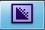.It takes a few minutes to open.
  - The program will look similar to this: 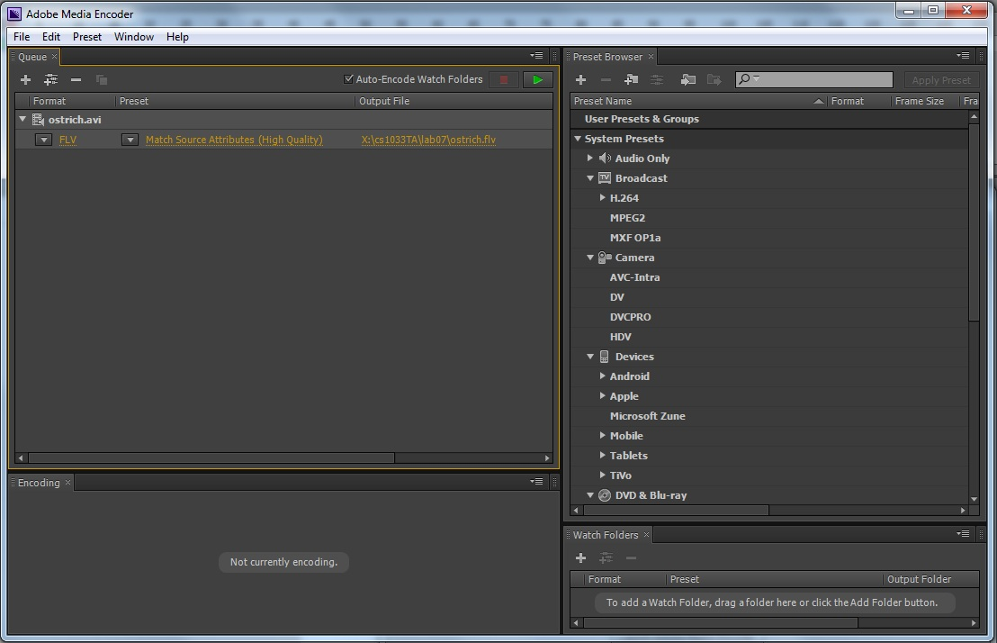
  - The right side of the screen is a list of preset conversion profiles. You don’t need to worry about these.
  - The top left side is the Queue. A queue is a lineup of things that need to be done, and currently you should only have one item in your queue: ostrich.avi.
  - To edit the settings for a particular conversion, press one of the yellow words under the queue item (on the above image that would be FLV, Match Source Attributes, etc.). A new screen will pop up showing settings which can be adjusted for the video.
  - You will see that under the Video Preview there is a timeline, which looks like the image below. You can use this timeline to preview your clip, and trim some footage off the ends.
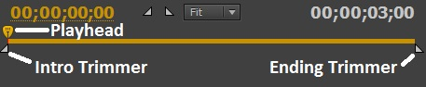
    - Drag the Playhead to move through the video.
    - Drag the Intro Trimmer to trim some footage off of the beginning of the video.
    - Drag the Ending Trimmer to trim some footage off the end of the video.
    - Set the Intro Trimmer and Ending Trimmer back to the ends of the timeline.

  - To crop the video, select the Source tab at the top left of the screen. You will notice now that there is the option to crop the video.
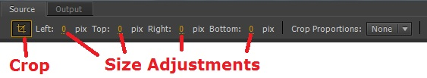
  - Select the Crop button. Set the values to the following:
    - Left: 46
    - Top: 19
    - Right: 166
    - Bottom: 0
Note: These numbers determine how many pixels to cut from each side. You will notice that there is a white box around the ostrich in the clip preview now.
  - Click the Output tab at the top left corner of the window. Notice that the preview window changed to include black bars around the cropped image. This is because the size of the video is still too large.
  - You will notice on the bottom right section of this screen there are a number of tabs, as is displayed below:
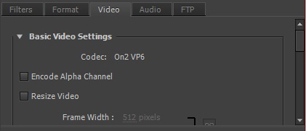
  - Select the Video tab. Check the Resize Video option. Click the Aspect Ratio Lock button to allow the aspect ratio to change while resizing (see image below).
  - Set the values to match the image below:
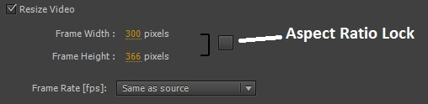
  - With these options you can change the size of your video. The numbers you changed the Frame Width and Frame Height to were chosen to fit the video with the Crop settings you applied in step i). However, there is an automatic way to do this. Uncheck the Resize Video checkbox and notice the black bars appear beside the preview image again.
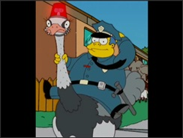
  - If you were to convert the video with these settings, the video would have black bars like this:
What we need to do now is change it so the video is converted to fit our new cropped settings that we set in step i).
  - Click the Output tab at the top left corner of the window. Set the Source Scaling value to different values to see their effects.
  - Finally, set the Source Scaling value to Change Output Size To Match Source. Notice that under the Video tab the Resize Video option is checked and the values in Frame Width and Frame Height are filled in with the same values we input before.
  - The Export Settings box on the top right portion of the window allows you to set more settings. Make sure that settings match those of the image below:
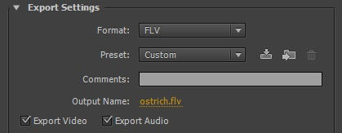
  - Everything is set up now, so press OK.
  - To convert all the videos in the queue, press the Start Queue button. You will see the video convert in the lower left portion of the window.
  - Go back to Adobe Flash CS6. You should still be on the Import Video
  - Select Browse and browse to your lab07 folder. Select the newly converted ostrich.flv file. Check Embed FLV in SWF and play in timeline. Click Next.
  - Make sure Symbol Type: is set to Embedded Video. Keep all three options checked. Click Next and then Finish. Flash will now take a few seconds to compress the video and embed it in the Library.
- Use Control > Play to preview the movie. Note that sound doesn’t work in this mode. So use Control > Test Scene to see how the finished product will appear… note this version has sound!
- Save the file again as embedded.fla, and close it.

