CS 1033
Multimedia and Communications

Lab 10: Sound Editing with Audacity and Incorporating Sound, Animation and Video into a Webpage with Dreamweaver

NOTE: you will need headphones for this lab to plug into the computer. In the labs, try doing the following if the front headphone jacks are not working:
Start>Control Panel>Sound Effects Manager>Front Panel>Headphone for the jack you want to plug your headphones into
BEFORE YOU START – Configuring your headphones

Since you will be working with audio this week, you will be bringing in a pair of headphones to plug into the front of your computer in the lab. Unfortunately, the lab computers don’t automatically “know” that your headphones were plugged in, so you will have to set the audio output to your headphones first!

- After you login to your computer, look to the bottom right of your screen for the System Tray.
In it, you will see a blue icon with yellow lines (if you leave your mouse overtop of it, it will say “Sound Effect”). Double click it to open the speaker settings (see image below).
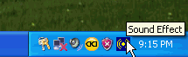
- The “Realtek Control Panel” will appear. Click on the tab marked “Speaker Configuration” at the top of the window (if it is not open already), which will switch to the window below:
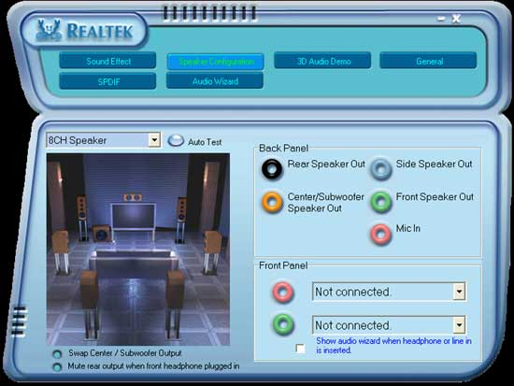
- Near the in the bottom right corner, there is an area marked “Front Panel”.
  - The red circle on your screen matches the red audio jack on the front of your computer, and is where a microphone would be plugged in.
  - The green circle on your screen matches the green audio jack on the front of your computer, and is where you plug your headphones in. Plug in your headphones here.
- Finally, in the dropdown beside the green circle on your screen, change the setting from “Not connected” to “Headphones”. Click the “X” at the top of the screen to save your settings and exit. Your headphones are now properly configured!
Reference Sheet – Audacity Layout
Audacity is a free, powerful, and easy to use audio editor and recorder for Windows, Mac OS X, Gnu Linux, and other operating systems. The screenshot below highlights its layout - use it as a reference during this lab.
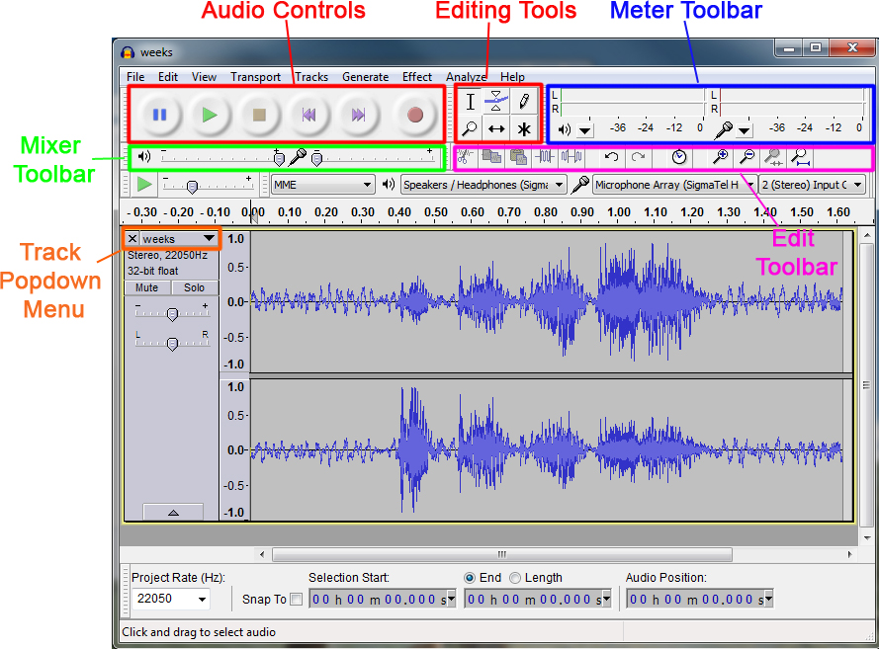
Although Audacity is a very powerful audio editor that works with an unlimited number of tracks of virtually any size, it cannot do everything. It cannot:
- record more than two channels at once on many systems,
- edit MIDI files, although it can open them.
LAB #10 - Tutorial 1

Objectives:
- Becoming familiar with the Audacity interface
- Opening, saving and working with WAV, MP3, and AUP (Audacity Project) files
- Editing a sound clip: cutting, amplifying, fading

Copying the Updated Material from the Instructor’s Area:
- Download the file lab10.zip from the website (http://www.csd.uwo.ca/~lreid/cs1033labs/lab10) to your memory stick in your cs1033 folder (to F:\cs1033).
- Right click on the lab10.zip file and select Extract all...
- On the window that appears, make sure the Destination folder is your lab10 folder
  - (ex. F:\cs1033\lab10)
- Select Extract
  - There should now be a lab10 folder in your cs1033 folder, and the lab10 folder should contain files and folders.

- Start the program by selecting the Audacity shortcut from the Desktop.

- You will notice that the SELECTION TOOL is highlighted by default (see screenshot below). This tool is often called an "I Beam" because it looks like a capital letter I.
Next you will notice a series of round buttons which have controls similar to a CD Player. We will be using the PLAY and STOP buttons. Other controls will be mentioned as needed.

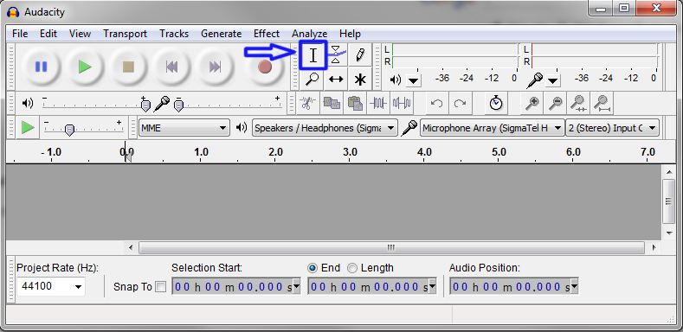
- From the Menu Bar, select File > Import > Audio. Browse to the lab10 folder you copied to your memory stick and open the file bart.wav. If a screen pops up, select Make a copy of the files before editing (safer) and press OK.
- Save the file as an Audacity Project: from the Menu Bar, select File > Save Project As, and save the file in your lab10 folder as bart.aup.
- Press the Play button 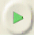to play the sound file.
- To play the sound file starting at different spots on the sound wave, select the I-Beam and click on any spot in the wave, then press the Play button again. Notice how it begins to play starting from that point on. To return to the beginning, move the I-Beam to the beginning of the track.


Replay the sound file again and try out the Audio buttons: Stop, Pause, Skip to Start, and Skip to End.

- Find the “door closing” sound: Play the sound a few times until you "See" where the door sound is in the wave pattern. The door sound is indicated by the red outline indicated in the diagram below:
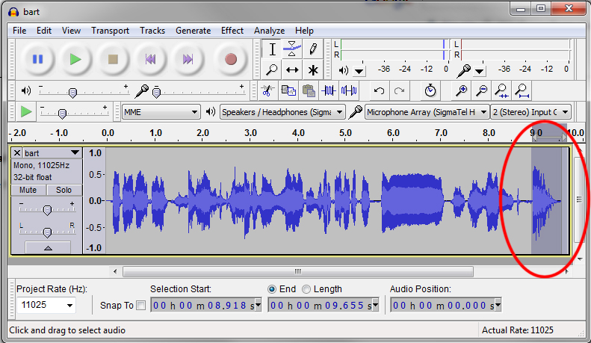
- Removing the “door closing” sound: Select the I-Beam tool , and click down at the beginning of the section outlined in red above, and highlight to the end of the wave. Now from the Menu Bar, select Edit > Remove Audio >Delete to delete the section.

- Amplify Bart's excuse for missing the makeup test, "Ohhhhh my ovaries":
  - To AMPLIFY we first find and select the section using the Selection tool.
  - Then to change the amplification, use the menu item Effect > Amplify. Use the default amplify settings (4.3 dB).
  - And Play from that spot on.
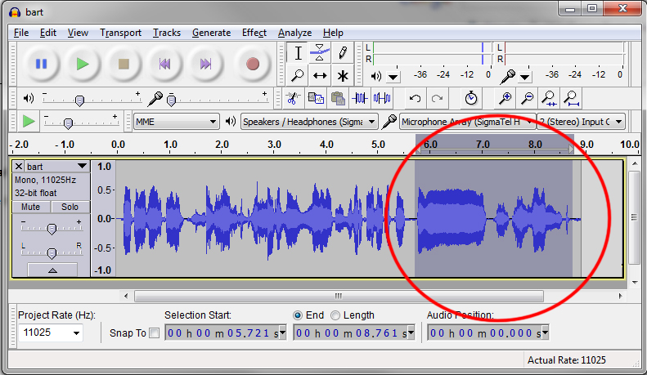
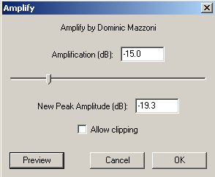
- Change the amplification to -15.0 and press the Preview button to hear the sound. The higher the amplification, the louder the sound. The lower the amplification, the fainter it becomes. Press OK.

- Fade Out the last half of Bart's "Ohhh" exclamation:

  - To do this, simply select the right-most half of the “OHHHHhhhhhh”.
  - Use the menu command Effect > Fade Out. Once completed, this should make this section of the wave pattern have a “bullet”-like appearance (see below). Try playing the full clip and watch the fading effect take place as it travels across the sound wave.
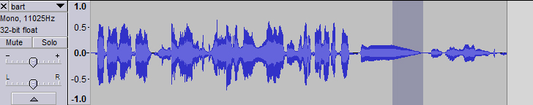

- Saving to WAV Format:
  - First, save your project file again (as bart.aup).
  - To save in the universal WAV format, from the menu bar select File > Export.
  - Make sure Save as type: is set to WAV and save it as bart-edited.wav in your lab10 folder.
  - Press SAVE.
- Saving to MP3 Format:
  - MP3 is another universal audio format that many of you may be familiar with.
  - To save in MP3 format, from the menu bar select File > Export
  - Make sure Save as type: is set to MP3 and save it as bart-edited.mp3 in your lab10 folder.
  - On the next screen select OK.
  - Audacity does not come with MP3 support by default, and you will see a message asking to Locate Lame. Click Browse and you should find the file lame_enc.dll in you lab10 folder on your memory stick.
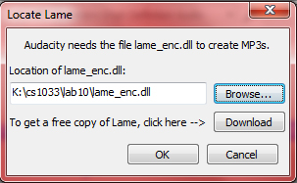
Note: If you plan to install Audacity at home, you must download the lame_enc.dll file. You can download it by clicking the Download button on this screen.
- Close Audacity, browse to your lab10 folder, and test to see if your WAV and MP3 files play in Windows Media Player. If Media Player asks to install an additional codec, click Install.

LAB #10 - Tutorial 2

Objectives:
- Mixing a Multi-Track Project

Audacity makes it easy to mix different sounds together. In this tutorial, you will be mixing background music (memento.mp3) with voiceovers (various Star Trek .wav files).
- Opening two tracks at once:
Start up Audacity. Instead of using File > Open (which opens up only one file), you can open two files by doing the following:
  - select File > Import > Audio..., and point to the file beam1.mp3 (human voice)
  - select File > Import > Audio..., and point to the file memento.mp3 (song)
  - Save the Project as mixing.aup. Your screen should now look like the image below:
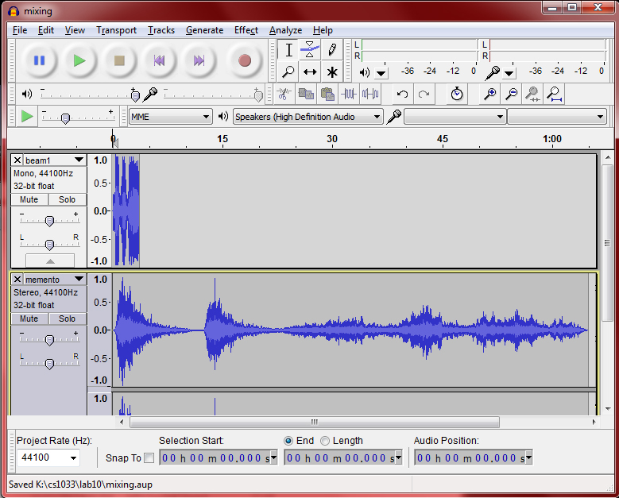
- Press Play and listen to the first 20 seconds (both tracks will play simultaneously). The first clip is 4 seconds long, while the second is over a minute. Note the beam1.mp3 file is in mono with only one sound wave, while memento.mp3 is in stereo with two (separate sound wave for left and right speakers).
- To listen to each track separately, use the “Mute” button to temporarily de-activate one track from playing. Experiment by setting the “Mute” for the first track and playing, then with the second. When you’re done, make sure “Mute” is off for both tracks.

- Zooming In/Out on Tracks: The first track is much shorter than the second track.
  - In order to work on the first track at a closer level, simply click on the track, and click the Zoom In (+) or Zoom Out (-) buttons. . Zoom until the top track occupies a bit more of the screen horizontally, as shown below:
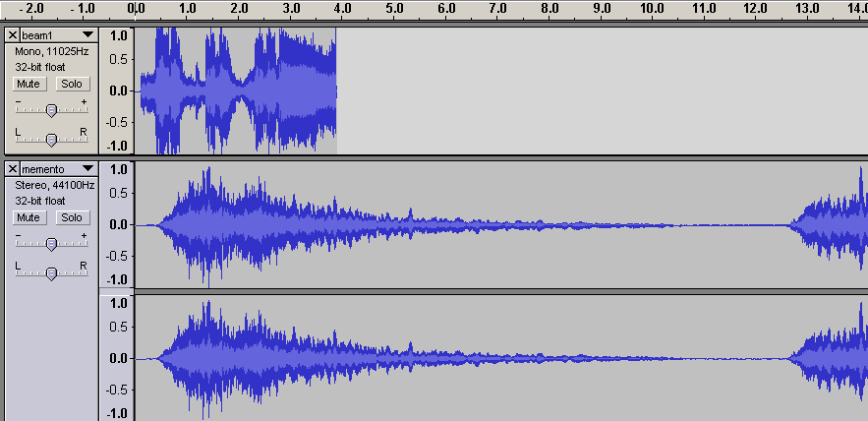
- Using the Time Shift Tool: First, zoom out until you can see at least the 30 seconds timeline in the screen. Click the Time Shift Tool. This tool allows you to change the relative positioning of tracks relative to one another in time. To use this tool, you simply click in a track and drag it to the left or right.
- With the Time Shift Tool selected, drag the top frame so it starts at the 6 second mark, as shown below. Once you’re done, listen to the first 15 seconds again to see the result.
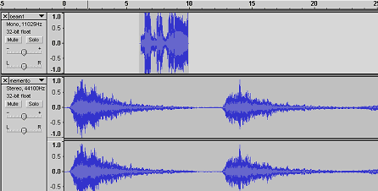

- Fading In/Out with the Effects Menu:
  - Now you will modify the beam1 track so that awful sound at the end of the track fades out so that it is easier on the ears.
  - First zoom in on the track so that you can work with it easier (zoom so the top track almost fills the screen):
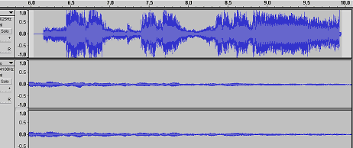
  - Next highlight the section as shown below. To fade the select from the menu, Effects > Fade Out and watch the highlighted section taper off. Now play the piece at that point.
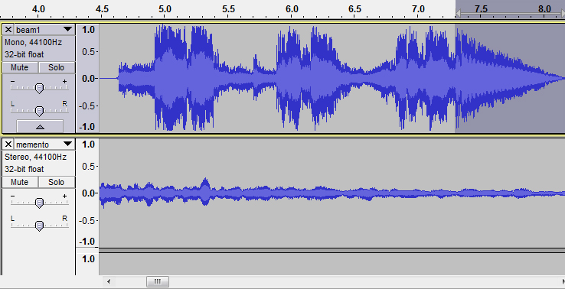
- Next, you will be adding additional tracks. Import the following files in the order listed below, using File > Import > Audio...:
  - beam2.wav (stereo)
  - best.mp3 (mono)
  - weeks.wav (stereo)
  - dah_duh_duh.mp3 (mono)
- To help get all the tracks on the same screen, you can adjust each track window just like in Windows.
  - First, zoom out until you can only see about 30 seconds worth of audio.
  - Then click on the dark grey area between two tracks and hold down your mouse button, and drag the window up to make it smaller. Repeat to make each track window smaller.

- Use the Time Shift tool to move each track so it is placed as in the picture below. Note you are moving each of the tracks to the 18 to 27 second range, with each track playing right after another (no overlaps). The 18 to 27 second range is filled with an area of “silence” in the background music, which will get filled by these tracks.
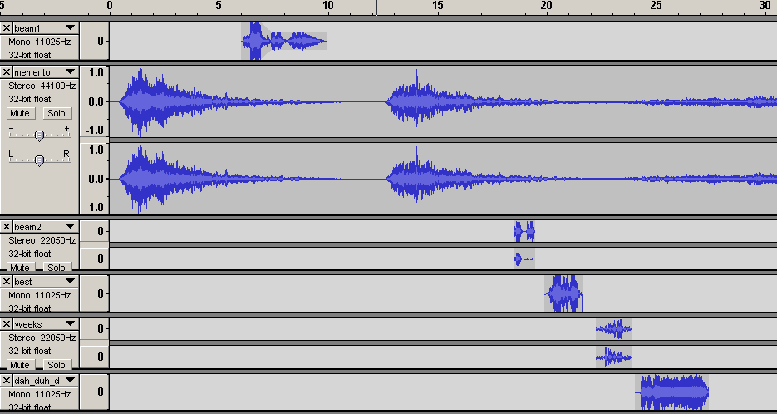
- Exporting as MP3 with attributes:
  - First save the Project as mixing.aup once again.
  - Then export to mp3 format as you did before (to mixing.mp3), but when you get to the Edit Metadata screen, put in the following information (but with your own name as the Artist and Album)… This information will be shown in Windows Media Player, Realplayer:, and your browser later in this tutorial! 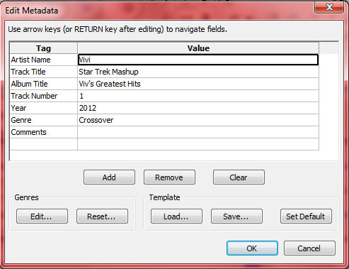
- Exit Audacity. Open the mixing.mp3 file in Windows Media Player to preview your track.
LAB #10 - Tutorial 3

Objectives:
- Adding Sound to a Webpage: Linking
- Adding Sound to a Webpage: Embedding

There are several different types of sound files and formats that can be put in Webpages, including .wav, .midi, and .mp3.. Some factors to consider before deciding on a format and method for adding sound are its purpose, your audience, file size, and sound quality.
NOTE |  | Sound files are handled very differently and inconsistently by different browsers. You may want to put a sound file in a Flash SWF file then embed the SWF to improve consistency.

Linking to an Audio File:
Linking to an audio file is a simple and effective way to add sound to a web page. This method of incorporating sound files lets visitors choose whether they want to listen to the file, and makes the file available to the widest audience.

- Open up Dreamweaver and open the webpage “memento_star_trek.html”.
- Save this file immediately as “music_link.html” so you don’t overwrite the original webpage.
- To create a link to an audio file:
- Highlight the text “Play the Song”. This will be the link to the audio file.
- In the Property Inspector, in the Link field, click on the folder icon to browse for the
audio file “mixing.mp3”

- Save your file, Preview the webpage and try it out. The default audio player for your computer (QuickTime, RealPlayer, or Windows Media Player) should begin playing the song. Alternatively, a website visitor could right-click and save the file to their computer.

Notice how the download time (bottom right corner in Dreamweaver) is only about 4-5 seconds using this method.

Embedding an Audio File
Embedding audio incorporates the sound directly into the page, but the sound only plays if visitors to your site have the plug-in for the chosen file type. Embed files if you want to use the sound as background music, if you want to control the volume, the way the player looks on the page, or the starting point of the file.
TIP |  | When embedding sound files, carefully consider their appropriate use in your web site, and how visitors to your site use these media resources. Always provide a control to either enable or disable the playing of the sound, in the event that visitors don’t want to listen to the audio.

- To embed a audio file:
- In the Design view, place the insertion point where you want to embed the file. For this exercise, place it in the middle of the yellow panel to the right of the pictures.
- From the Menu Bar, click Insert > Media > Plugin.
- In the pop up box, point to the audio file mixing.mp3. A plug in icon will appear.
- Save your file and Preview the webpage again. Notice how the music starts playing automatically.

Notice how the download time has increased significantly using this method. This method is not a good way of embedding a file since it is so large.

- Click on the Plug in Icon, then in the Property Inspector change the Width and Height values to 300 and 100 respectively. These values determine the size at which the audio controls are displayed in the browser.

- Next, click the “Parameters” button, and add the following to disable the autostart:
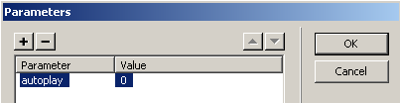
NOTE: The autoplay feature can’t be disabled in all browsers. Changing this Parameter will work in some browsers, but in order to have more control we will learn another method for converting to a more universal format!
- Save your file and Preview your webpage again to ensure the audio controls display properly
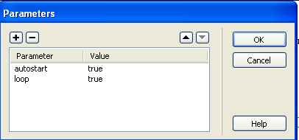
You can also use other “parameters” to control other aspects of the sound plugin. Adding the loop parameter and setting its value to true will cause the sound to repeat. Similarly, the hidden parameter can be used to hide the plugin from the user.

LAB #10 - Tutorial 4

Objectives:
- Inserting animation into a page

- Open Dreamweaver and create a new site called Snow. Point this site to the folder called F:\cs1033\lab10\snow. Open the file called home.html.
- Adding flash video to the webpage:
  - Make sure you are in design mode with the file you opened. Click before the word Welcome to place your cursor there.
  - This is where we will place our Flash animation. Then select Insert>Media>SWF.
  - You will be asked which file to insert. Browse the musicvideo folder and select the file called snowmananimation.swf and click on OK.
  - Give it the title Snowman Melting. Leave the Access Key and Tab Index fields empty and hit OK.
  - You should see a large gray square where the animation will be displayed.
  - Save your file and preview it. If you are asked to copy any files, press OK. Notice the animation is very large and it repeats.

- Let’s change the size of the animation. Go back into design mode and click on the gray box where the animation is to be displayed. Then in properties window change the width to be 110 and the height to be 80. Save the file and preview it again.

- Now let’s make it play only once. Go back into design mode and click on the gray box where the animation is to be displayed. Then look at the properties window. On the left hand side of the screen deselect the Loop checkbox. Save the file and preview it again. Now the animation only plays once.

- Finally, let’s make a splash screen.

  - Create a new page, immediately save this page with the name index.html.
  - Click on the Page Properties button at the bottom of the screen.
  - Set the background colour to be #FFFF99, then hit OK
  - Add the text “Welcome to the CS1033 Snow Web Page”, then hit enter 4 times and then add the text: “Click here to enter the site”.
  - Give the page the title: “Let It Snow!.” Your page should look like this:

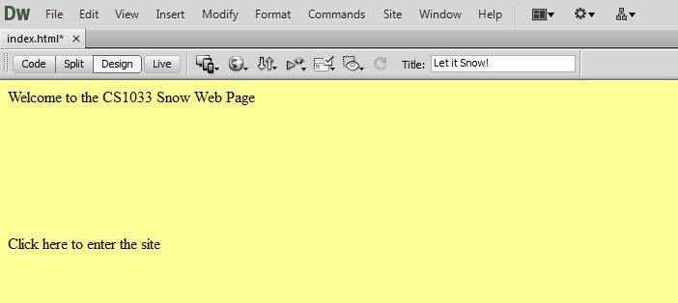

- Now we will format the text:
  - Highlight the top line of text.
  - From the Properties Pane, select the Format drop down box and then select Heading 1.
  - Highlight the second line of text
  - In the Properties Pane beside the link box, put the name of your home page: home.html and hit enter.
  - Now put your cursor between the two lines and insert the animation. Select Insert>Media>SWF and find the snowmananimation.swf again in the musicvideo folder, then hit OK.
  - When you are prompted for a title, put “Snowman Melting”. Leave the access key and tab index empty, then hit OK. Now you should see a big gray box where your snowman will be displayed.
  - Finally, center everything on the page by putting your cursor at the top left of the screen (just before the Welcome) and highlighting EVERYTHING on the page to the bottom right corner, (make sure the bottom line is highlighted) and then in the Properties Pane, click on the center alignment icon.
  - Save your page. Your page should now look like this:
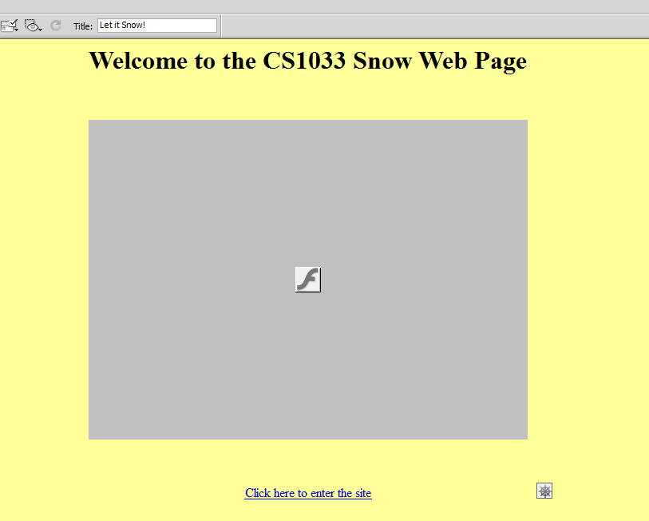

- Now preview your page and make sure that the link works to the home page.
LAB #10 - Tutorial 5

Objectives:
- Convert video to the flv format
- Add some video to a webpage

- We are going to convert a regular video format into a smaller more universal format:
  - Got to Start Menu, and open Adobe Media Encoder CS6. It may be in the Adobe folder in the Start Menu.
  - We have worked with this program when we were converting videos in the Flash tutorials.
  - Press the symbol in the top left corner.
  - Find the folder f:\cs1033\lab10\snow\musicvideo and select the file called :weather.wmv
  - The queue should now look like this:
  - If the left section does not say FLV like it does above, click on it and change the Format to FLV.
  - Press the Start Queue button to convert the video.
  - The output file will be saved in the same location as the original.
- Now quit out of the Flash Video Encoder and open Dreamweaver again.
- Open the fileweather.html.
  - Put your cursor under the line: “The Weather Report”
  - Select Insert>Media>FLV.
  - Beside the URL box, select the Browse button, go into the musicvideo folder and select weather.flv and hit OK.
  - Set the Width to 320, and Height to 240.
  - On the Insert Flash Video screen, press the Detect Size button. From the Skin dropdown box, select Corona Skin 3 (min width: 258). Your screen should look like this →:
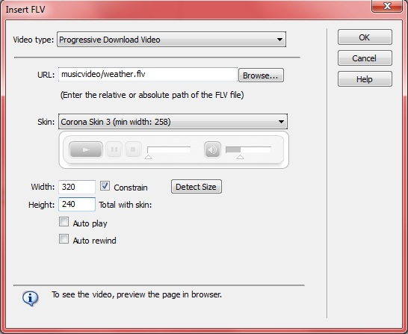
  - Hit OK, save your file and preview it in IE. Make sure your video works.

- Finally, let’s tie up some lose ends.
  - Close the weather.html page. Open the home.html.
  - Make a hotspot on the button image on the left of the page that just covers the word Home.
  - Make this hotspot link to the file home.html.
  - Now, make a hotspot over the words: Weather Report, and make this hotspot link to the file weather.html.
  - Make a hotspot over the word Video, make this hotspot link to the file weather.html. Save your home.html page and close it.
- Open the page index.html, preview it and click on the link at the bottom of this page, then make sure that all the links you just put in your home page work.
- Say good bye to your teaching assistant as you have now officially finished all the CS1033 labs ☺.

