ASSIGNMENT 1

180919

SOUND 20190306

* **Try to build, run, and understand the app**

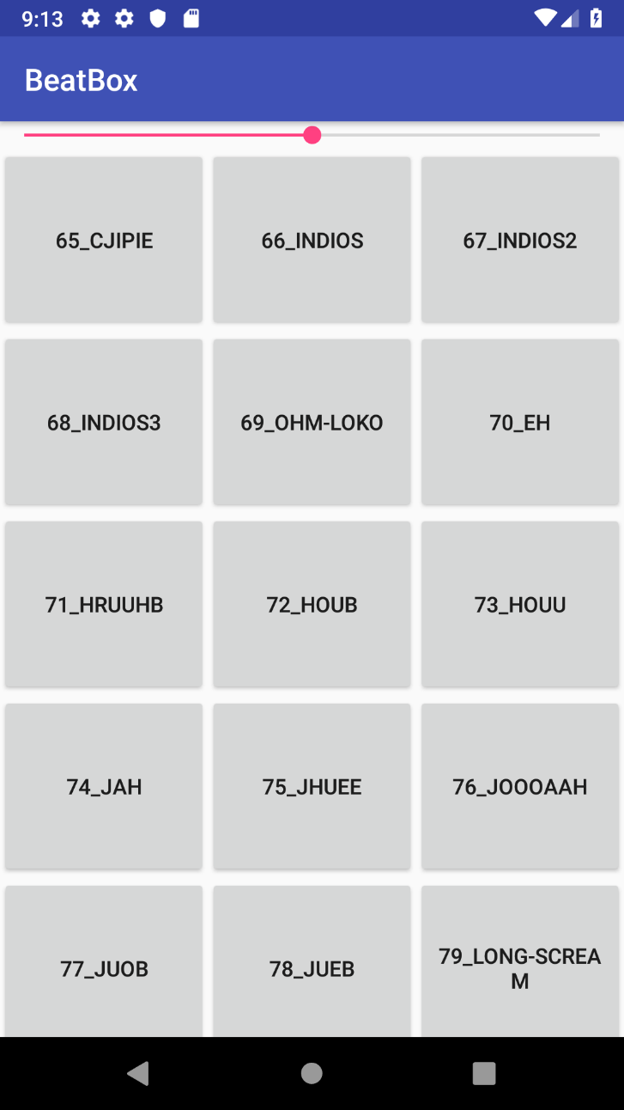

SoundPool is an Application that allow users to play different sounds.

* **Add a playback speed control to the app, e.g. a SeekBar or TextBox, ref.play(…) function.**

After building and understanding the sound application, I was able to add a playback speed control to the application using a seekbar. This was done by adding a seekbar to the activity_fragment.xml then initialize it in the SingleFragmentActivity.java class.

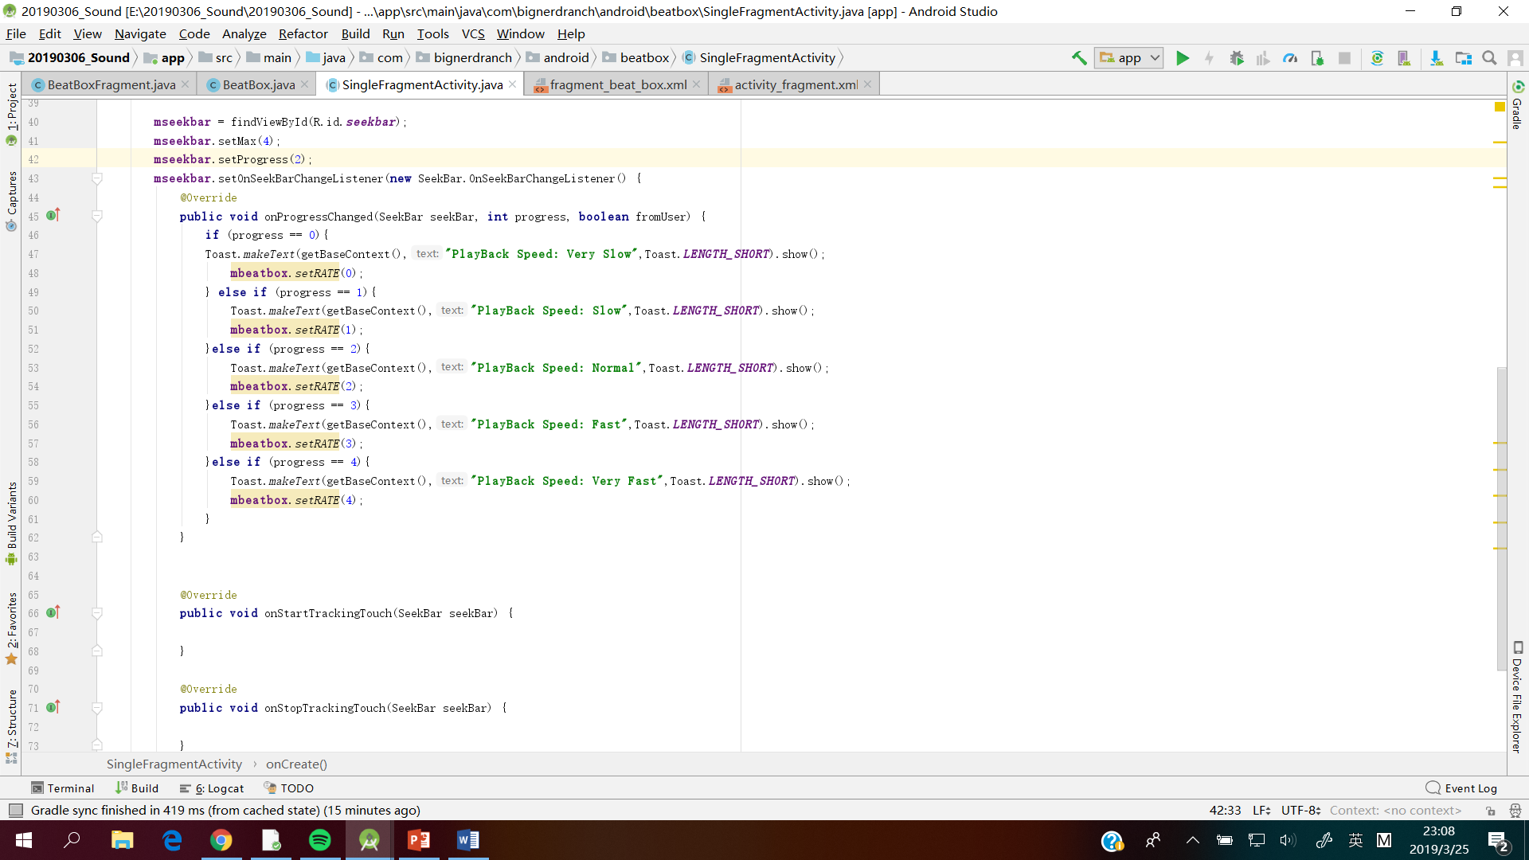

After which, a static integer was created to hold the speed rate changes of the seekbar.

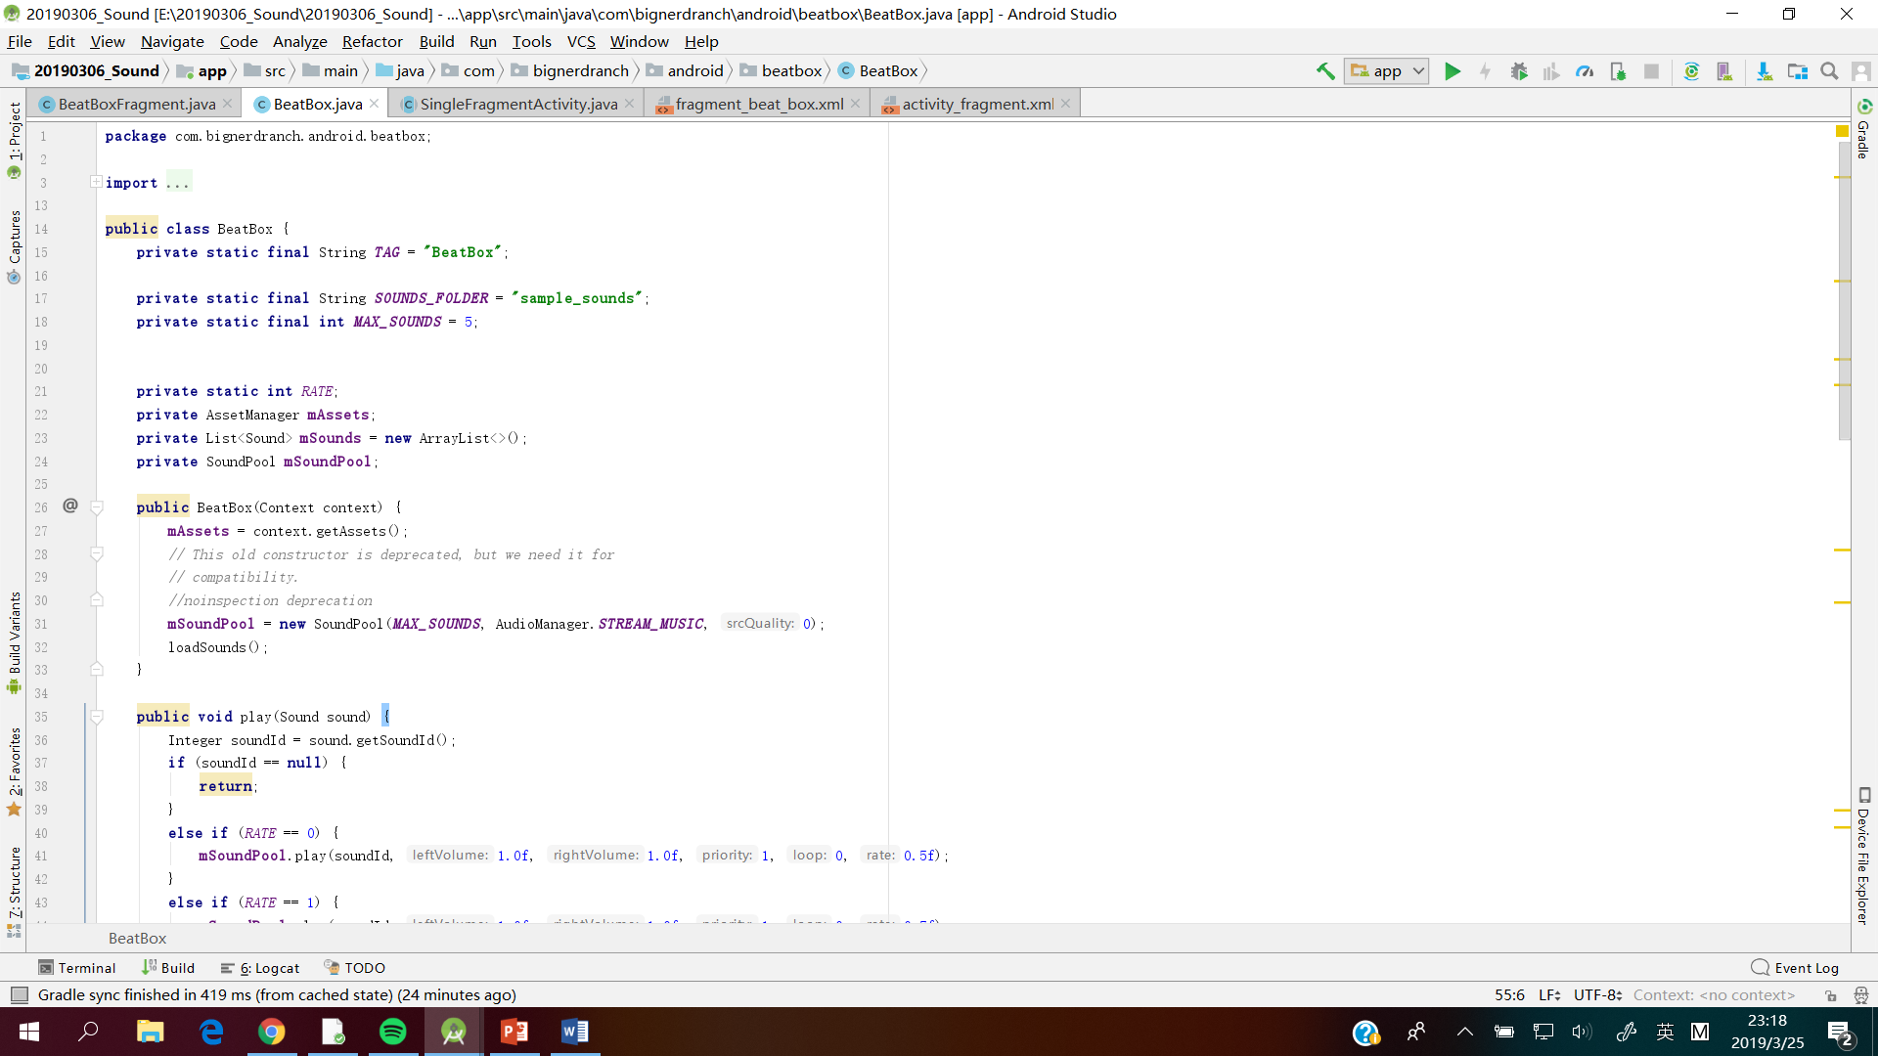

A setter method was created to change the speed rate.

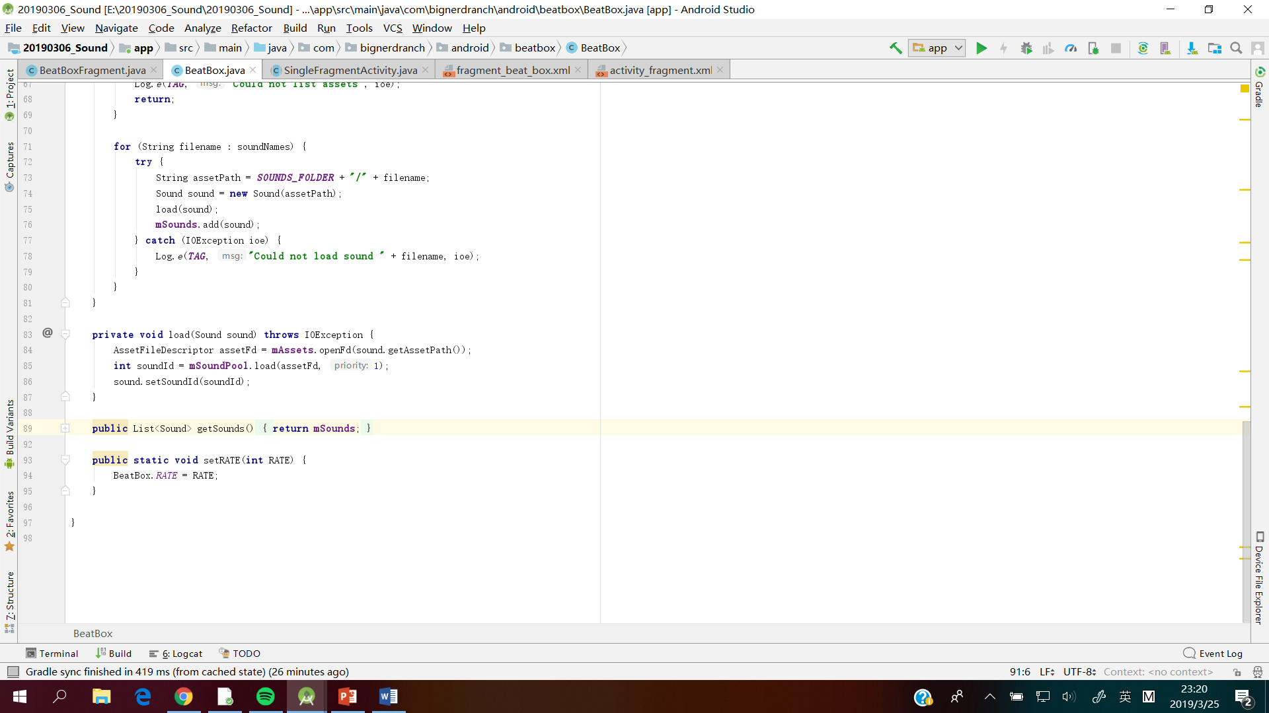

The different playback speed of audios were added to the play method of the BeatBox mood.

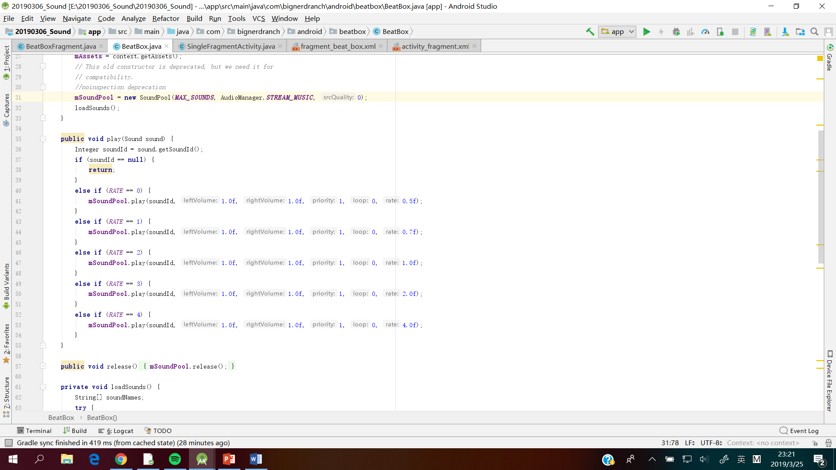

* **Play some music in the background, ref. *MediaPlayer* class**

Background music was added by using the MusicPlayer class.

