ASSIGNMENT 2

180919

20190313_Theme

* **Try to build, run, and understand the app**

SoundPool is an Application that allow users to play different sounds.This version of the application allows users to change the theme of the application.

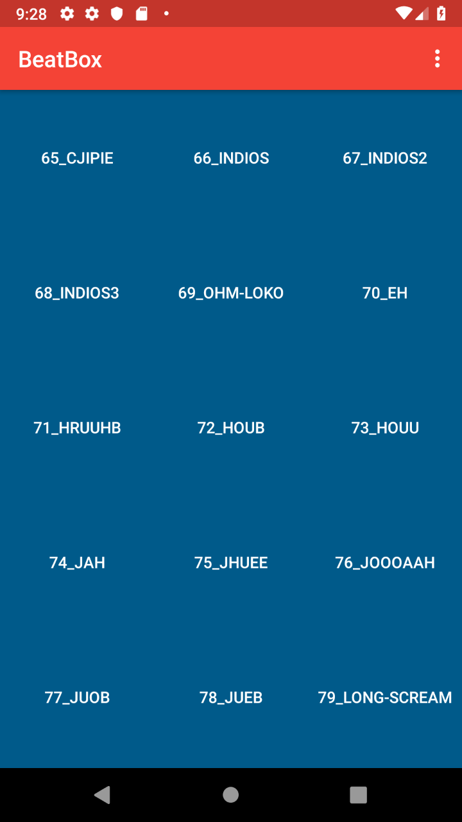

* **Try design other color themes for your widgets**

Other colors were created by adding new colors in the **res/colors.xml** file

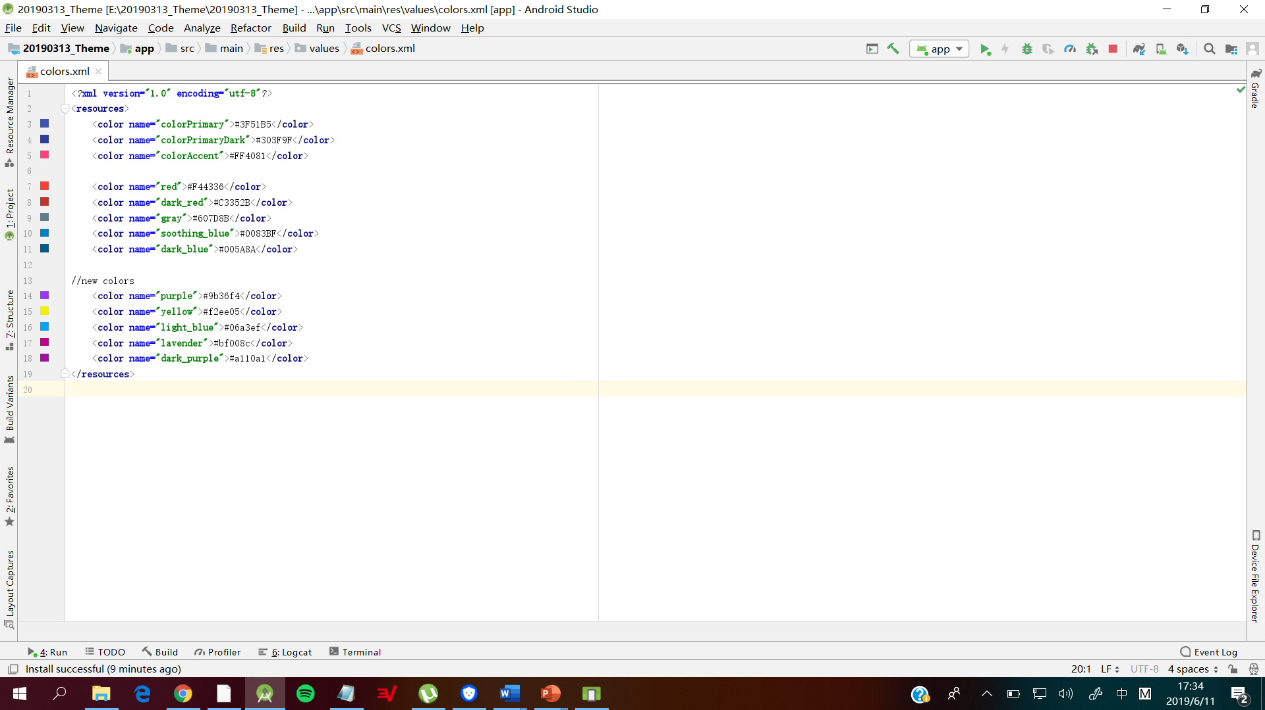

then using that color in the res/style.xml file.

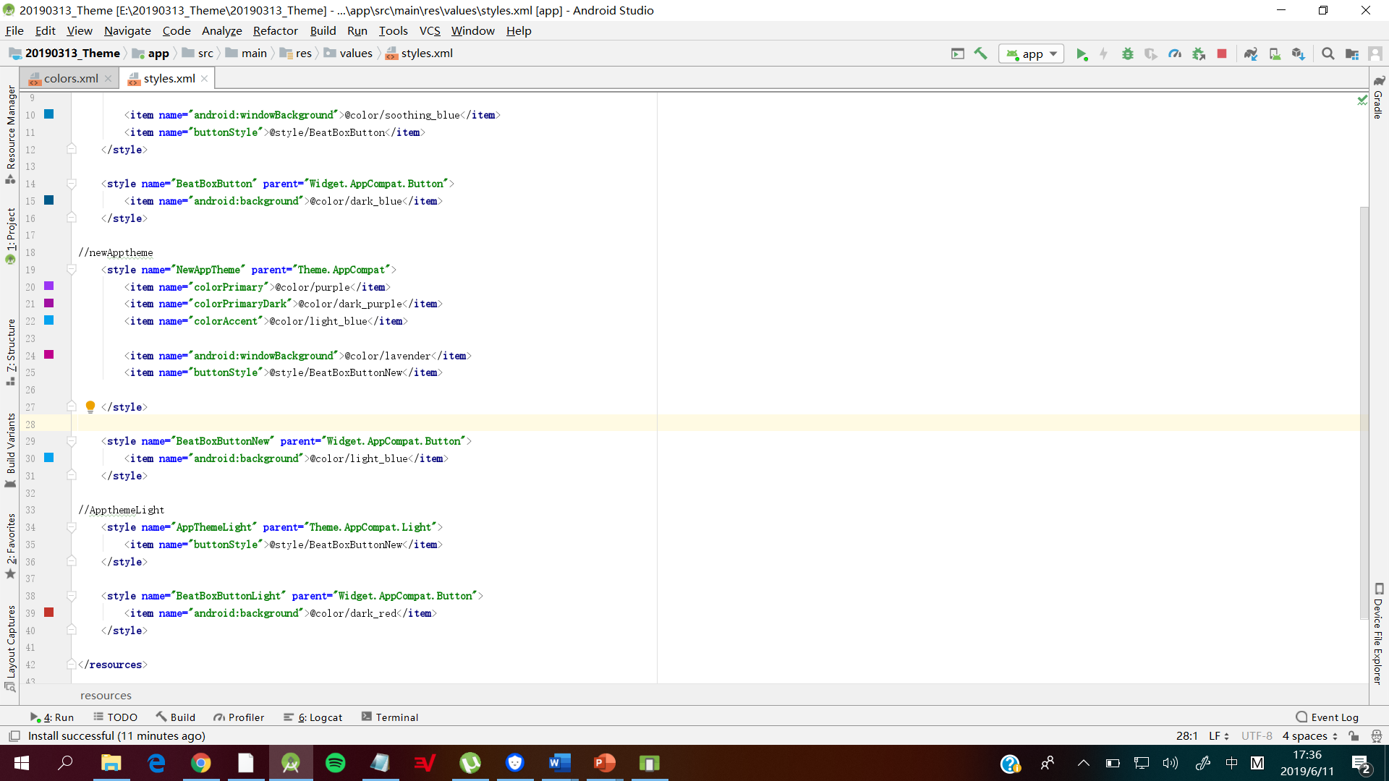

* **Try a global system-built light/dark theme**

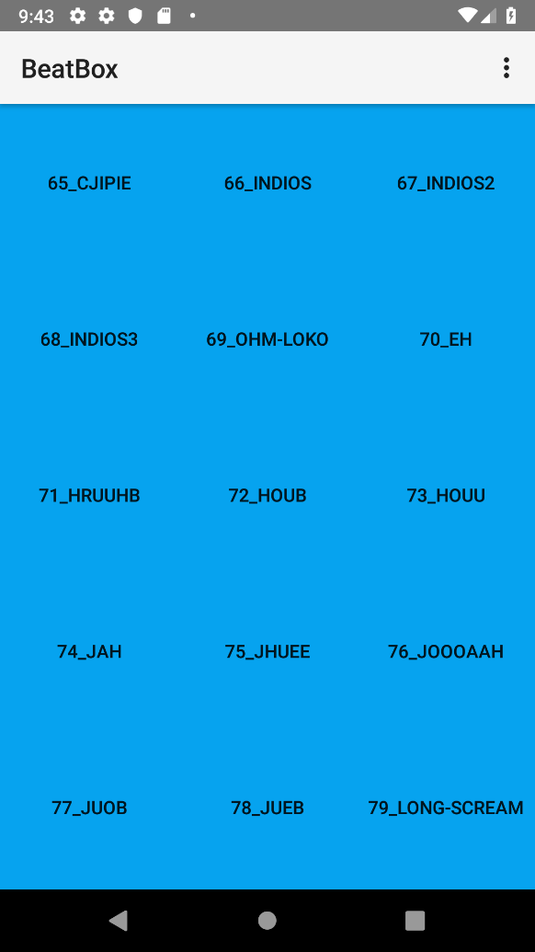

* **Design a preference menu, with different theme choices, choose theme on the fly**

Image below shows the theme selection the preference menu.

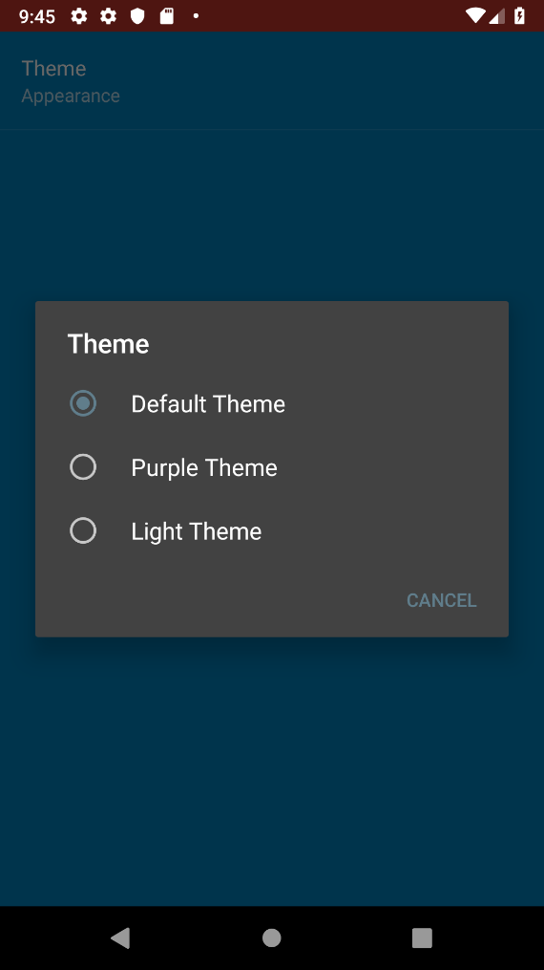

Change in theme.

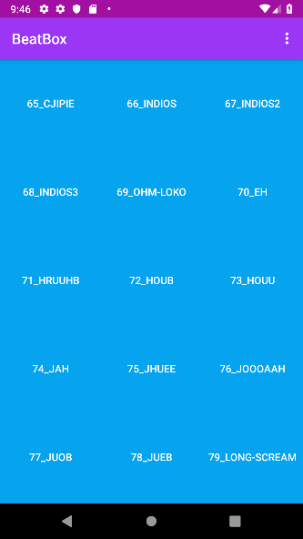

* **Style and theme your previous Android app**

Theme changes are now apart of my previous SoundPool Application.

