ASSIGNMENT 3

180919

* **Try to build, run, and understand the app**

The Application shows a list of launchable apps from the device. It queries the system (using the PackageManager) for launchable applications (which are activities with intent filters that include a MAIN action and a LAUNCHER category).

* **Add scrollable grid layout for displaying the app list**

A scrollable grid layout was added by changing the previous linear layout into a gridLayout format.

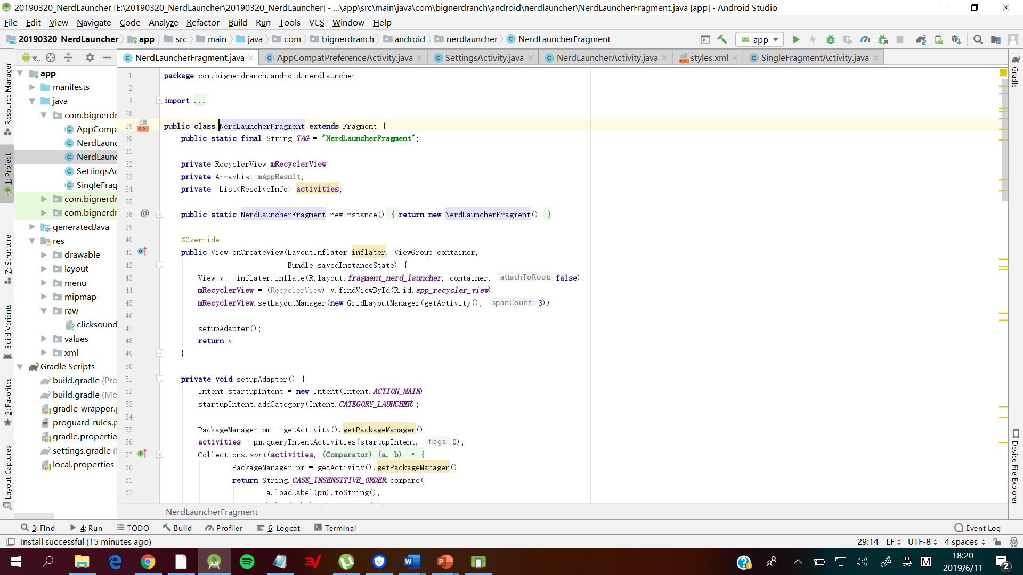

* **Add an icon for each application**

This was accomplished by adding an image view to the layout of the items in the recycler view then retrieving the icons of the launchable main activities of the application. Afterwards the icons are binded to the image view in the recyclerview adapter.

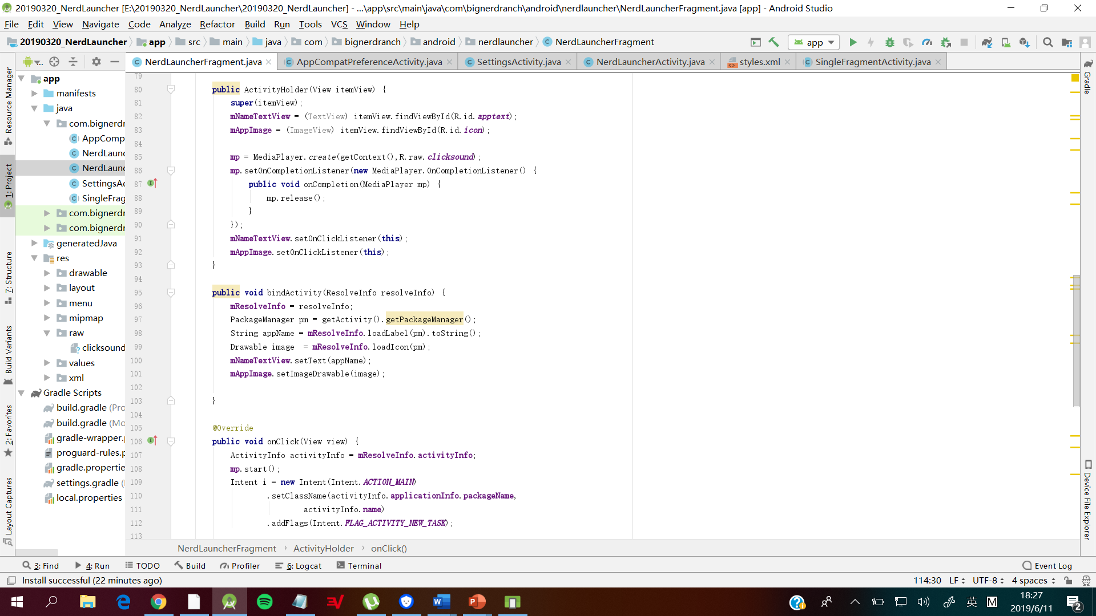

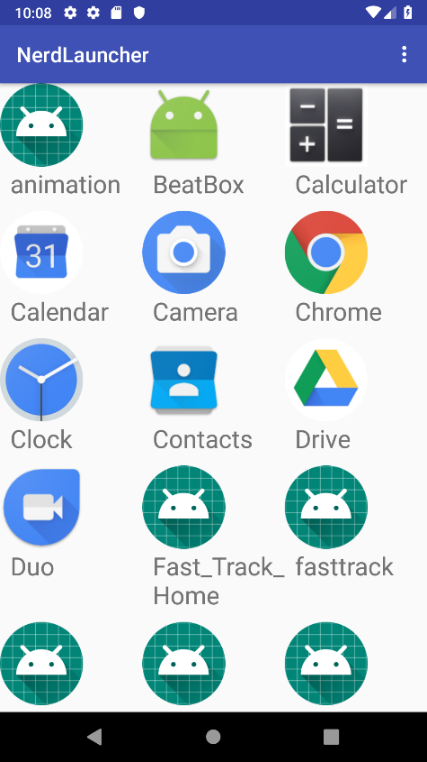

* **Add sound when you open an app**

This was done using the MediaPlayer Class to load the sound then play it every time an icon or text of the launchable application is clicked.

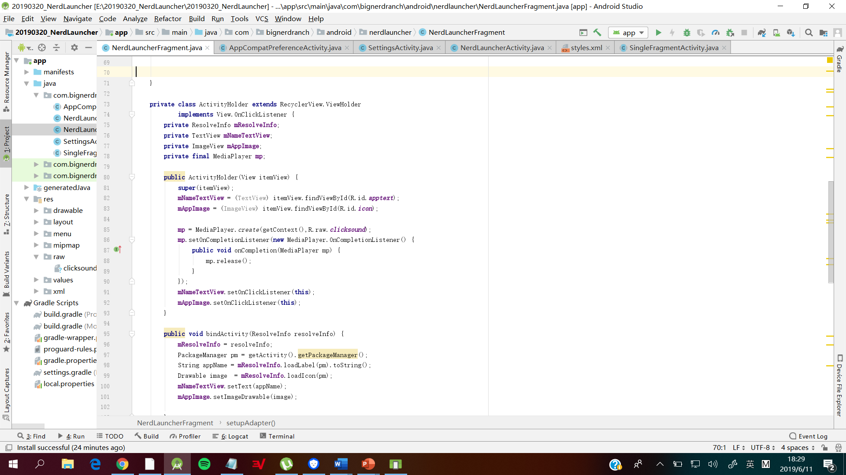

* **Add background images/styles/themes for the launcher**

This was achieved using the skills learned in the previous exercise. Image below shows the theme selection the preference menu.

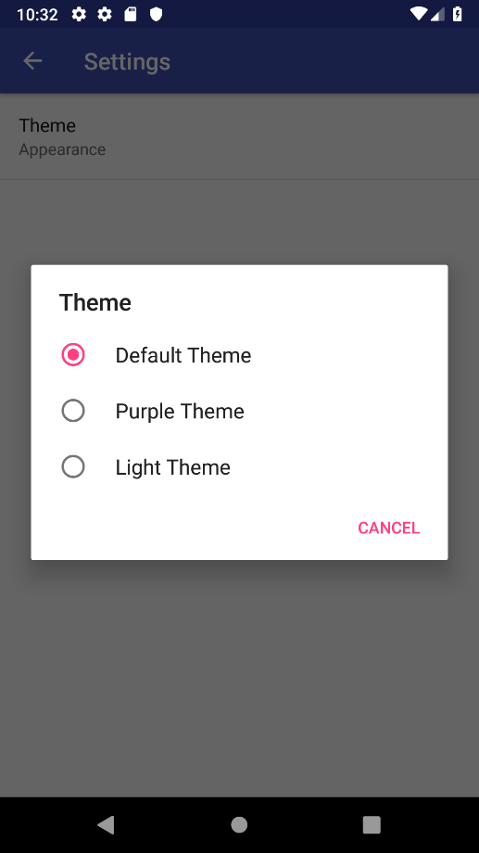

Change in theme.

