ASSIGNMENT 9

180919

20190508_location

* **Try to build, understand and run the gallery search app with location service**

**The search gallery app displays an image based on your current location.**

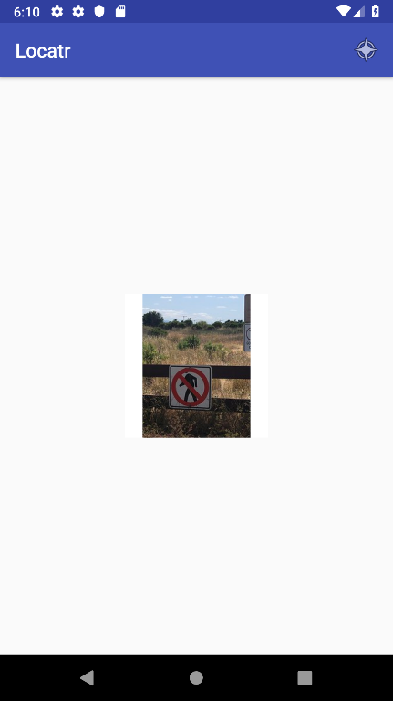

* Understand how to use various location services (coarse/fine/fused) to get the user’s location info, including latitude/longitude/altitude/proximity etc.

**Coarse Location uses GPS, Cell and Wifi signals to give an accurate location of the user. It uses more battery power than the Fine Location. Fine Location uses Cell and Wifi signals to show the location of the user. Fused Location is a location service which combines GPS location and network location to achieve balance between battery consumption and accuracy.**

**In order to get the user’s location information, all implemented location API methods require the Manifest.permission.ACCESS_COARSE_LOCATION or Manifest.permission.ACCESS_FINE_LOCATION permissions. Once those are added to the manifest, the location permission is then checked at run-time; afterwards, operations are then implented according to the permissions granted by the user.**

**Add the dependency of Google Location Service then access its API interface. After creating the Location Services client, you can get the last known location of a user's device by using the fused location provider's** [**getLastLocation()**](https://developers.google.com/android/reference/com/google/android/gms/location/FusedLocationProviderClient.html#getLastLocation())**method. Afterwards, you can get the latitude, longitude, altitude, and the proximy of the user’s device by using the methods getLatitude(), getLongitude(), getAltitude(), and getProximity respectively.**

* Handle what happens if the user choose to deny location permission, either do nothing, or show a warning dialog, or exit the program.

**If the user chooses to deny location permission, a warning dialog will popup imforming the user that images will be inaccessible if there’s no access to their current location.**

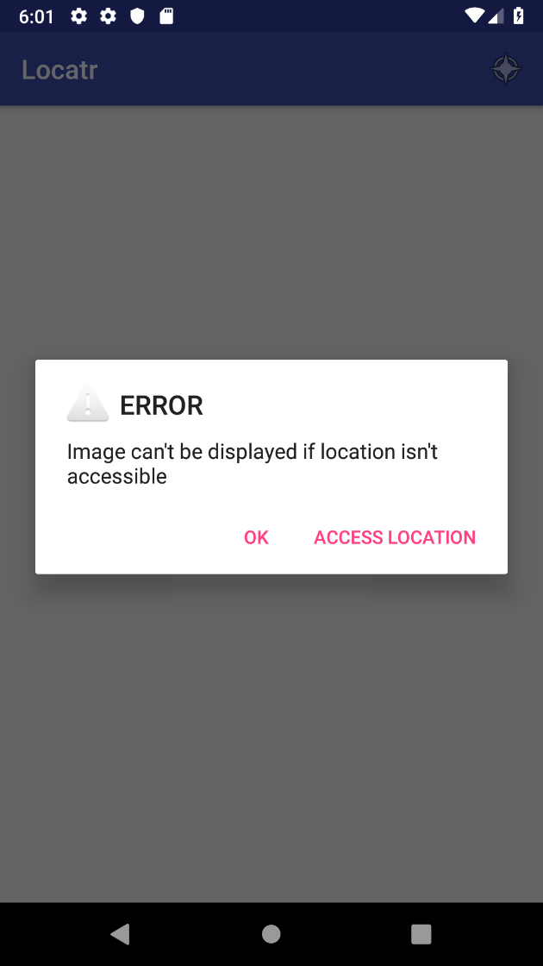

* **Learn to use high precision fused location services from Baidu/Alibaba/Tencent**

*Incomplete….*

* **Refactor the gallery app with BAT location service.**

*Incomplete….*