Currently, I’m missing the option where the organisers can purchase tokens for the participants of their tournaments as discussed. If this was supposed to be achieved in the final milestone let's meet :)

1. Categories should be a dropdown list to select from with multi select. New visitors will never be able to guess what categories you have in the system

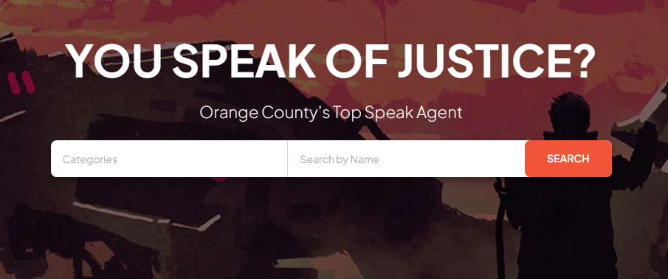

1. this button does not work 404

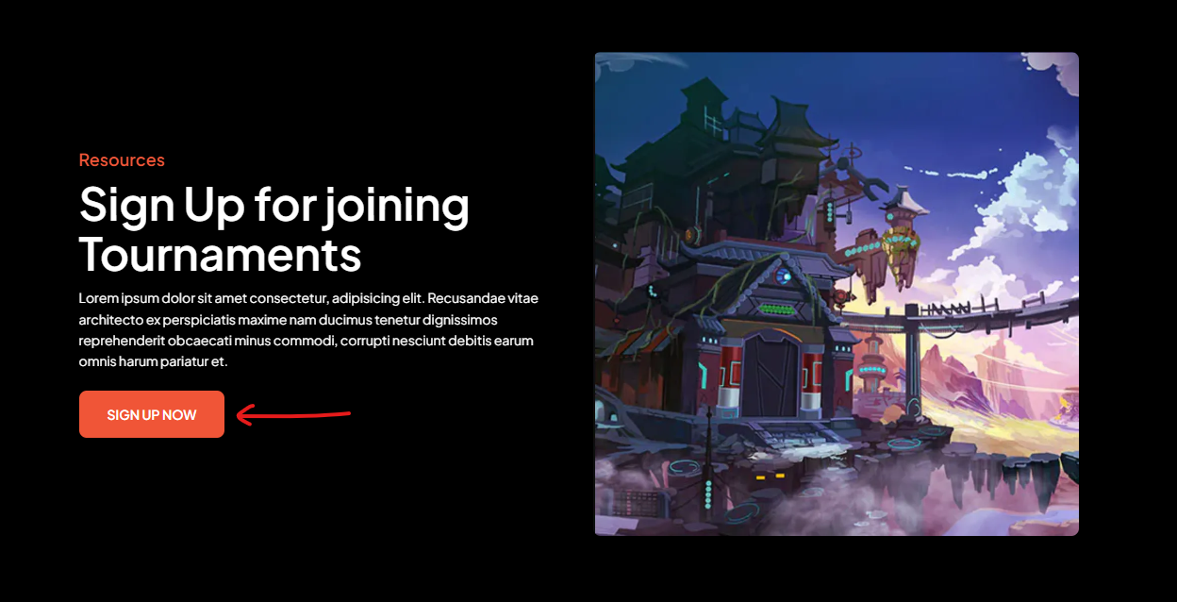

1. this button takes me to google search

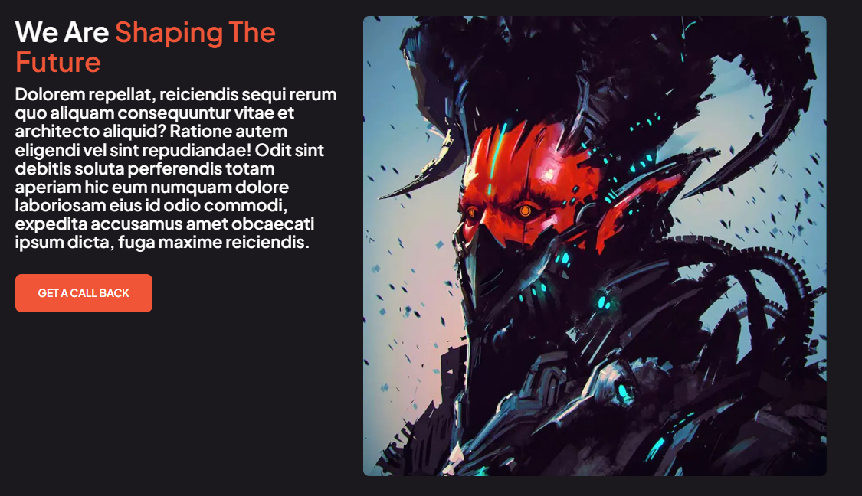

1. same with these buttons

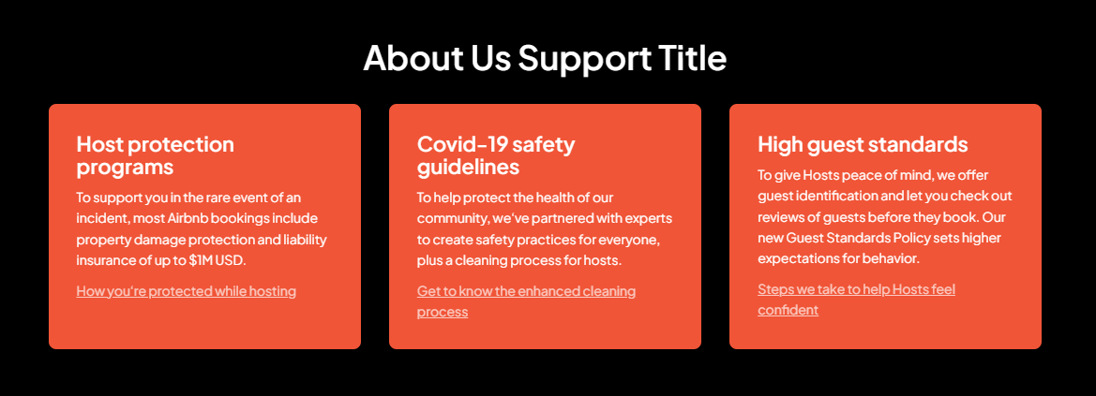

1. We need to add a favicon



1. We can maybe show something like entry fee here? if no entry fee then we can say entry fee: free or something like that, the word free always invited people



1. why signup for your newsletter message is missing, maybe something like "Sign up to our news letter to receive updates on our latest tournament events"



1. My signup code ended up in spam

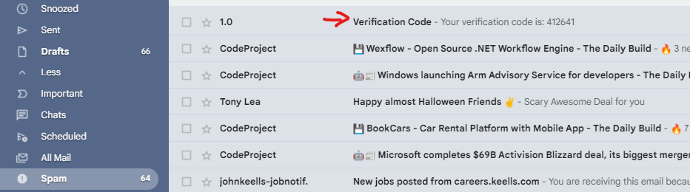

**Dashboard suggestions:**

1. Change photo button doesn't work
2. When I update my profile and click save, it shows a page that doesn't work: <https://eventbrie-frontend.vercel.app/player>
3. The chat part is basically non functioning
4. I was inside the dashboard and when I click on the back button, I came back to my verification page which is weird. Usually when a user signs in the developer has to store the user's authentication token in the browser storage and prevent the user from going back to the sign up process when he clicks back. And should be able to leave the dashboard only when the user logs out

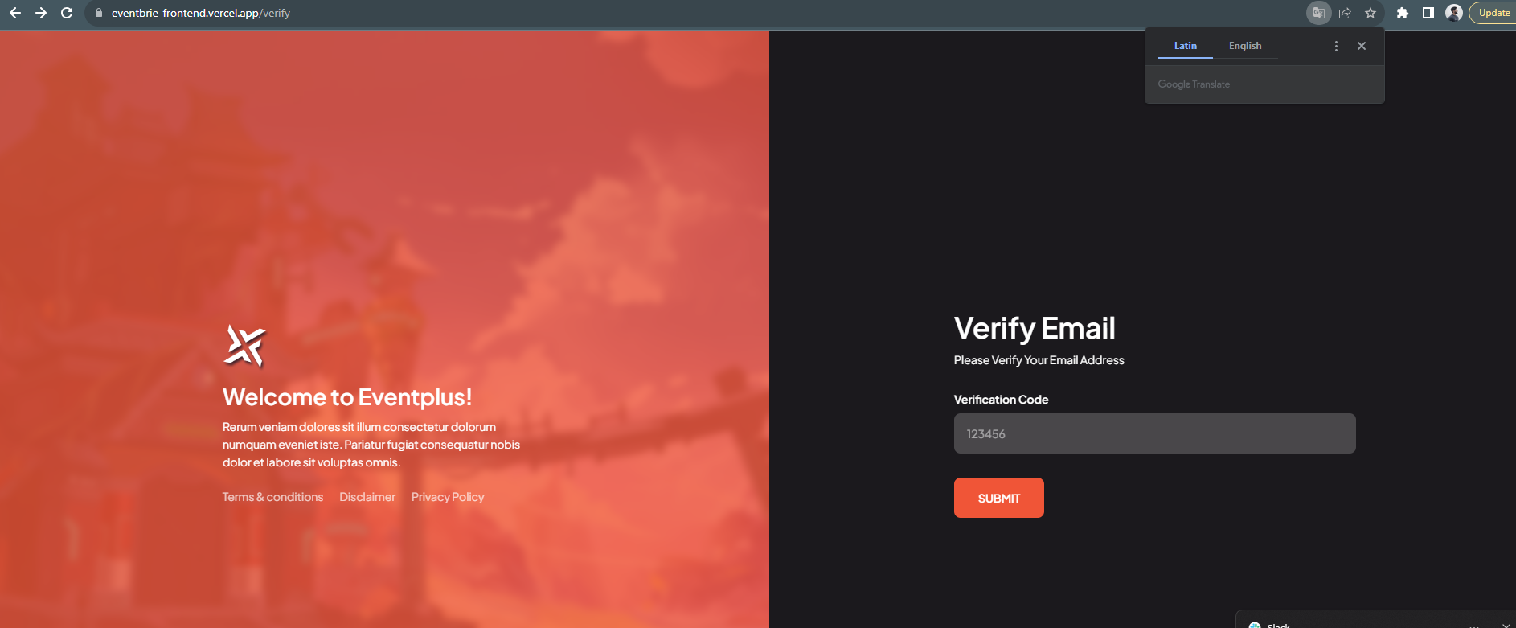

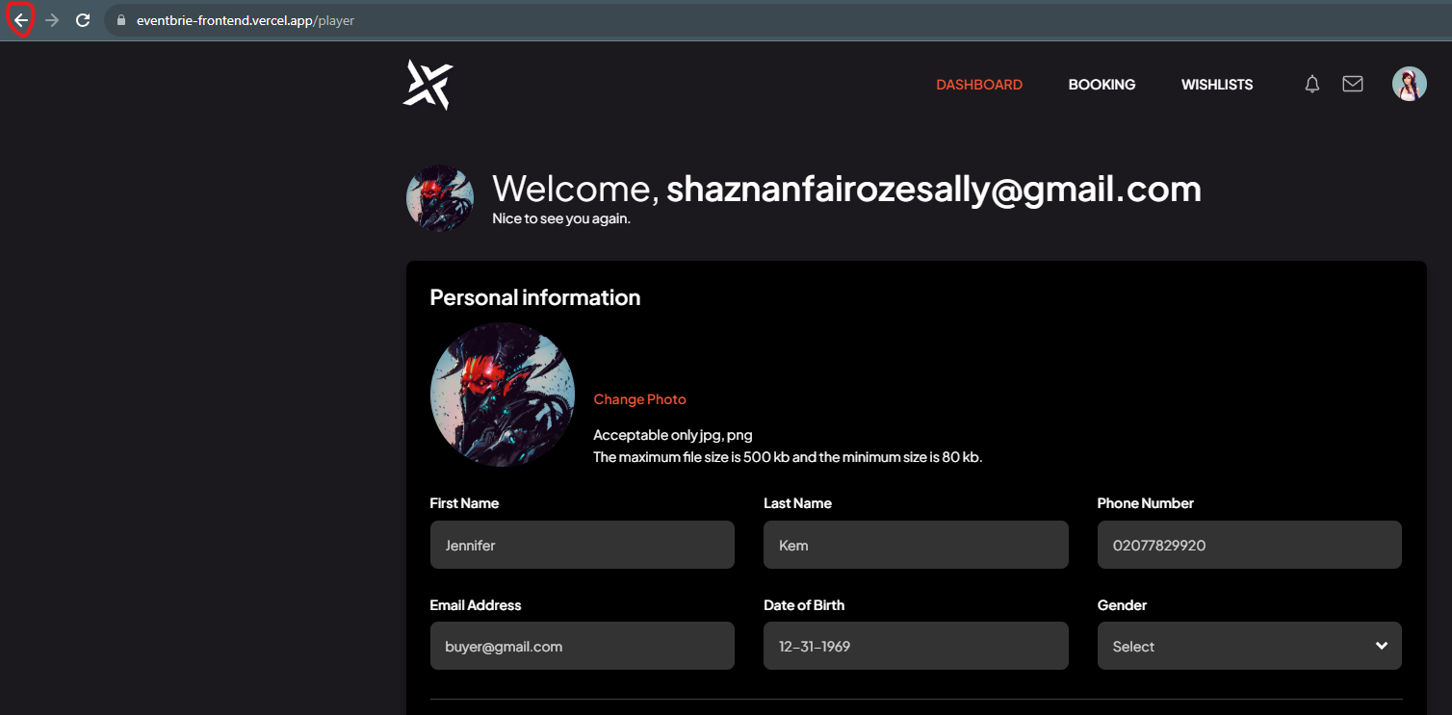

1. <https://eventbrie-frontend.vercel.app/contact> - images didn't load here. Probably a problem with the template links, or something.

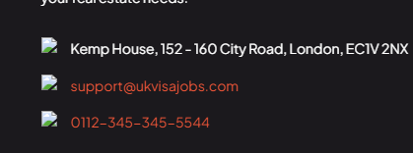

1. Sign up now button don't work yet
2. Verification code to make an account as an organizer works well!
3. Highly suggest this to be as a calendar feature. So a person can pick date from the calendar. There are so many date formats around the world, it could be a mess very fast.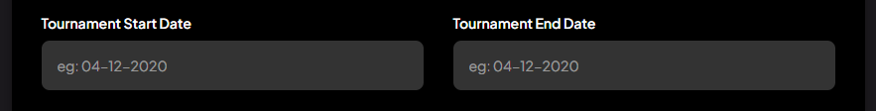
4. Once you logg in, and you click "TOURNAMENTS" on top of the main page <https://eventbrie-frontend.vercel.app/>, you will only see your own tournaments. So when logged in it's impossible to browse through existing tournaments. I don't know if this is intendent, but it doesn't feel right.