Valuation Report

of

Flat No. 402, 4th Floor, Prestige Heights

atPlot No. 12, Road No. 3, Banjara Hills, Hyderabad
Owned by

Dr. Rajesh Sharma

A

Report By

Pro Valuer (OPC) Pvt. Ltd.

Registered Valuer Entity

Reg No: IBBI/RVE-E/01/2020/132

Mob: 8500 8800 13
Contents
Covering Letter 3
1. Preamble 4
2. Executive Summary: 5
3. Summary of all Valuation Properties 6
4. Basis & Methodology of Valuation 7
5. Sales Comparison Method: 9
6. Calculation of Depreciation in this report: 11
Depreciation – Straight Line Method : 11
7. Open Land and Abandoned Semi Completed Apartment complex 12
7.1. Details of the Property 12
7.2. Observations & Location 16
7.3. Location: 16
7.4. Analysis of Market Rate: Open Land 17
7.5. Analysis of Market Rate 2: Under Construction Building: 19
7.6. Value of the property 21
7.7. Circle Rates of the Property 22
7.8. Recent Transactions around this property 23
7.9. Summary of Land and Sale Deeds 24
7.10. Property Photographs 25
8. Valuation – Steps to arrive at Correct Value 26
9. Assumptions 27
10. Caveats & Limitations 28
11. Documents Requested Vs Provided 30

Covering Letter

Ref No: Dt.
VRIN :
To

Dear Sir,

Please find attached the valuation report of the property:

Flat No. 402, 4th Floor, Prestige Heights : Plot No. 12, Road No. 3, Banjara Hills, Hyderabad

Regards,

For
Pro Valuer OPC Pvt Ltd

Director

Preamble
asked M/s Pro Valuer OPC Pvt Ltd to submit a valuation report for the properties mentioned below:

Property at: Plot No. 12, Road No. 3, Banjara Hills, Hyderabad

Accordingly, a diligent exercise is done to value the properties herewith in the following pages.

Executive Summary:
Executive Summary
Name of The Client
Scope of Work
Purpose
Locations of The properties | Property at : Plot No. 12, Road No. 3, Banjara Hills, Hyderabad
Details of Assets Valued | Land and Building
Approaches Adopted
Date of Inspection
Date of Report
Inspection Done by | Mr. Naga Mallik
Person Coordinated for Inspection

Summary of all Valuation Properties

Certified Valuation Assessment
Fair Market Value: INR Rs 88,80,000 ()
Realizable Sale Value (85%): INR Rs 75,48,000 ()
Distress Sale Value (75%): INR Rs 66,60,000 ()
Insurable Value (Total Building Replacement Cost): INR Rs 35,00,000 ()
Assessed Government / Guideline Value: INR Rs 50,00,000 ()
The valuation of the properties mentioned above has been meticulously determined following a diligent exercise that considers numerous factors, including market trends, property conditions, and comparable transactions in the vicinity. This comprehensive approach ensures that the figures accurately reflect the current value of the assets. Below is a summary of the valuation:

Basis & Methodology of Valuation

- Basis of Valuation
- This Valuation is based on the framework and guidelines provided in International Valuation Standards.
- The definition of Fair Market Value as per the International Valuation Standards is as under:
  - “Fair Market value is the price that would be received to sell an asset or paid to transfer a liability in an orderly transaction between market participants at the measurement date.”
  - Liquidation Value : As per businessdictionary.com is Selling price of an asset less the expenses incurred in the sales transaction, and in bringing the asset to the saleable state. It is the net money the bank is going to realize after spending expenses like the arrears in property tax, maintenance charge, legal charges, valuation charges, advertisement expenses, brokerage charges etc.

- Approach and Methodology of Valuation:

- Valuation of Land in this report
The Sales Comparison Method of Valuation under Market Approach is adopted in which due weightages have been given to factors such as:
- The Right to Sell / Transfer / Lease the Land.
- Demand and Prospective buyers for such type of plots of Industrial land.
- Shape, Size, Prominence and Location of Land.
- The Marketability, Utility, Demand and Supply of Residential, Commercial, Industrial land in the surrounding area.
- The Land rates as evident from the Sale Instances of comparable land found upon market enquiry.
- Legal and Physical Encumbrance on Land.
- Freehold or Leasehold nature of Land etc.
- Valuation of Buildings in this Report:
- The replacement cost method is adopted for valuation of buildings in this report where cost of constructing a building with the same utility as the structure being evaluated, using the current construction materials, standards, designs, and layouts.

Sales Comparison Method:

Estimation of market value of Land:
We made market inquiries of Land that have been recently sold or are available for sale in the vicinity of the subject property to estimate capital value of the subject property. Our sources of market survey and enquiries include:

- Government employee of local authorities (Sub Registrar, etc.),
- Landlords,
- Real estate developers,
- Real estate agents, etc.
In order to estimate the market value of the subject property, premiums and discounts have been allocated to the comparable properties taking into consideration some of the parameters for comparison as prescribed by valuation standards. We have compared the subject property with the three comparable instances on the following parameters:

- Physical Attributes of the Site: The intrinsic physical features of a site—namely its size, shape, and frontage—are fundamental determinants of its market value. The land parcel’s size dictates the spectrum of potential uses and development options available, with larger sites affording greater flexibility in design and functionality. A broad frontage enhances the property’s accessibility and exposure, thereby improving its prominence and attractiveness for commercial and residential developments alike. The shape of the plot directly affects the efficiency of land utilization, influencing both the percentage of usable area and the overall development potential of the site.
- Connectivity & Accessibility: Connectivity and accessibility encapsulate the property’s ease of access via various transportation networks and its integration within the broader urban framework. Properties boasting superior connectivity through established roads, public transport links, and supporting infrastructure consistently experience stronger market demand. Enhanced access translates to increased desirability, enabling such properties to command higher capital values and rental yields relative to less connected counterparts.

- Location & Neighbourhood: The location of a property is assessed based on a combination of its administrative context, proximity to major thoroughfares and central business districts, availability of social infrastructure, and the overall environment. The prevailing land uses and physical condition of neighboring properties significantly influence the tangible and perceived quality of the location. A balanced mix of surrounding uses and well-maintained adjacent properties can amplify the site’s appeal and market value, whereas neglect or incompatible uses may detract from it. Assessing connectivity also requires an evaluation of the quality of access, considering factors such as road width, surface condition, traffic density, and typical travel times. These considerations are critical, with their importance weighted according to the intended use of the property or proposed development.
- Age of the Property: The effective lifespan and value retention of a property are largely contingent on its age and ongoing maintenance. The building’s age is a key parameter in determining its depreciated replacement cost and overall utility. Newer constructions generally possess a longer remaining service life, enhancing their attractiveness and marketability. Accordingly, the condition and age of the property are pivotal components in professional valuation assessment

Calculation of Depreciation in this report:

Depreciation – Straight Line Method :
Depreciation refers to the systematic allocation of the cost of a tangible asset over its useful life. It represents the gradual decline in the value of an asset due to wear and tear, obsolescence, or passage of time. For the purpose of this report, depreciation has been calculated using the Straight Line Method (SLM), which is one of the most widely accepted and straightforward methods of computing depreciation.
1. Straight Line Method – Overview
Under the Straight Line Method, the depreciation expense is uniformly spread over the useful life of the asset. The formula used is:
Annual Depreciation = (Cost of Asset – Salvage Value) / Useful Life
Where:
- Cost of Asset is the total purchase cost including any directly attributable expenses to bring the asset to working condition.
- Salvage Value (also known as residual value) is the estimated value of the asset at the end of its useful life.
- Useful Life is the period over which the asset is expected to be used by the entity.
This method ensures equal depreciation expense every year and is particularly suitable for assets that provide consistent utility over their useful lives.
2. Consideration of 10% Salvage Value
In this report, a salvage value of 10% of the original cost has been considered for all depreciable assets. This implies that at the end of the asset’s useful life, it is assumed that the asset will retain 10% of its original cost as residual value, and hence only 90% of the cost is depreciated over its useful life.

Open Land and Abandoned Semi Completed Apartment complex

Details of the Property
Details of the Property
1 |  | Name of the owner(s) and his / their address (es) with Phone no. (details of share of each owner in case of joint ownership) | Dr. Rajesh Sharma  Plot No. 12, Road No. 3, Banjara Hills, Hyderabad
2. |  | Postal address of the property | Plot No. 12, Road No. 3, Banjara Hills, Hyderabad
3. |  | List of documents produced for perusal
4. |  | Whether this property part of Approved Layout or Constructed as per the approved plan from the municipality
5 |  | Whether Property tax and electricity bills being paid in time
6 |  | City / Town / Village
7 |  | Industrial Area \ Residential area \ Commercial Area \ Industrial Area
8 |  | Classification of the area (High / Middle / Poor / Posh)
9 |  | Coming under Corporation limit /Village Panchayat / Municipality
10 |  | Whether covered under any State / Central Govt. enactments (e.g., Urban Land Ceiling Act) or notified under agency area/ scheduled area / cantonment area.
11 |  | Boundaries of the property
S |  | East
 |  | West
 |  | North
 |  | South
12 |  | Extent of the property
13 |  | Extent of the site considered for Valuation
14 | Master Plan provisions related to property in terms of land use
15 | Ordinary status of freehold or leasehold including restriction on transfer
16 | Agreement of easement if any
17 | Notification of acquisition if any
18 | Notification of road widening if any
19 | Heritage restriction, if any
20 | Comment on existing mortgages/ charges/ encumbrances on the property, if any
21 | Comment on whether the owners of the property have issued any guarantee (personal or corporate) as the case may be
22 | Whether property belongs to social infrastructure like hospital, school, old age homes, etc.
23 | Whether Water supply is available
24 | Whether Sewerage/sanitation System Underground or Open
25 | Whether Electricity is available
26 | Proximity to nearest bus station
27 | Proximity to nearest Railway station
28 | Proximity to nearest Airport station
29 | Advantages of this property
30 | Disadvantages of this property

Observations & Location:

Location:

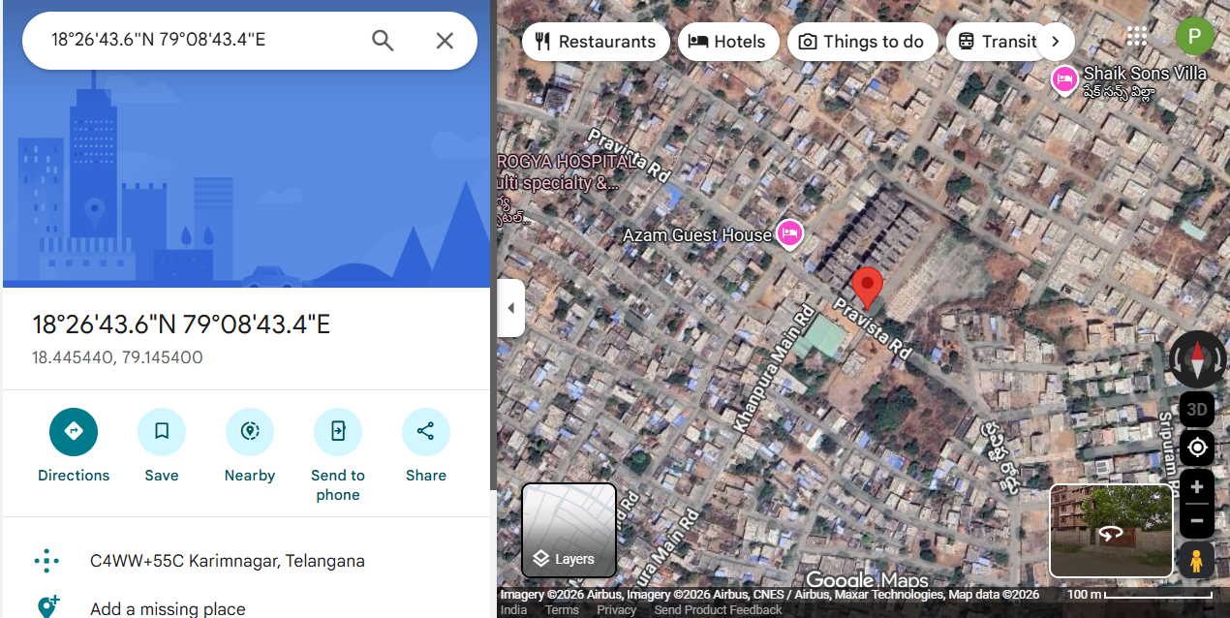

Analysis of Market Rate: Open Land

During the survey, there were limited transacted comparable instances in the catchment area of the subject site at Durgammagadda. Hence, we have considered the following comparable properties available/quoted for sale from the various sources of our enquiry:
Comparable 1 (C1): The comparable property C1 is located at Kissan Nagar, Karimnagar, approximately 2.2 km from the subject property. This open plot abuts a 25’ wide road with north facing, having a saleable area of 128 sq.yd. and a quoted market rate of ₹35,154 per sq.yd. After applying necessary attribute adjustments such as discount negotiation (−15%), location (−5%), size adjustment (−50%), facing (+5%) and corner influence (+5%), the total adjustment worked out to −50%, resulting in an adjusted market rate of ₹17,577 per sq.yd.
Comparable 2 (C2): The comparable property C2 is located at Hussaini, Karimnagar, at a distance of about 1.3 km from the subject property, abutting a 25’ wide road with south facing, a saleable area of 192.66 sq.yd. and a quoted rate of ₹28,028 per sq.yd. After considering discount negotiation (−15%), location (0%), size adjustment (−40%), facing (0%) and other applicable parameters, the total adjustment resulted in −55%, yielding an adjusted market rate of ₹12,613 per sq.yd.
Finally, based on the analysis of the above comparable properties, the analyzed average market value after adjustments works out to approximately ₹15,095 per sq.yd. Considering market trends, demand, and prudence, the fair market value of the subject property is reasonably adopted at ₹15,000 per sq.yd.

Comparative Appraisal Table – Open Land:
 | Subject Property | Comparable I | Comparable II
Property location | Durgammagadda, Karimnagar | Kissan Nagar, Karimnagar | Hussaini, Karimnagar
Type of property | Open Plot | Open Plot | Open Plot
Road / facing width | 40' wide Road | 25' wide road | 25' wide road
Shape of the Property | Rectangular | Rectangular | Rectangular
Property Facing | South | North | South
Distance from the subject property | --- | 2.2 Kms | 1.3 Kms
Floor in which this property is located | - | - | -
Saleable Area of the property (Sqyd) | 10724 Sq.yds | 128 sq.yds | 192.66 sqyds
Quoted rate (Rs) per Sqyd |  | 35,154 | 28,028
Attribute Adjustments |  | - | -
Discount Negociation |  | -15% | -15%
Location |  | 5% | 0%
Size of Abutting Road |  | 0% | 0%
Adjustment for Size |  | -50% | -40%
Adjusting for facing |  | 5% | 0%
Corner or Intermitent |  | 5% | 0%
Total Adjustments |  | -50% | -55%
adjusted rate |  | -17577 | -15415.4
Analysed (after adjustment) |  | 17577 | 12612.6
Analysed Average Value (after adjustment) per Sqyd |  | 15,094.8
Say |  | 15,000

Analysis of Market Rate 2: Under Construction Building:

During the survey, there were limited transacted comparable instances in the catchment area of the subject site at Durgammagadda. Hence, we have considered the following comparable commercial properties available/quoted for sale from the various sources of our enquiry:
Comparable 1 (C1): The comparable property C1 is located at Sarada Homes, Karimnagar, approximately 3.3 km from the subject property. This residential flat on the fourth floor with new construction, having a saleable area of 1,620 sqft and a quoted market rate of Rs. 4,500 per sqft. After applying necessary attribute adjustments such as discount for negotiation (−10%), distance (−5%), building age (−3%), floor level (−2%), the total adjustment worked out to −20%, resulting in an adjusted market rate of Rs. 3,600 per sqft.
Comparable 2 (C2): The comparable property C2 is located at Vijaya Residency, Sapthagiri Colony, Karimnagar, at a distance of about 5 km from the subject property. This residential flat on the fourth floor in a 1-year old building, with a saleable area of 1,620 sqft and a quoted rate of Rs. 3,950 per sqft. After considering discount for negotiation (−10%), location (+5%), distance (+5%), building age (−5%), floor level (+2%), size difference (+5%) and other applicable parameters, the total adjustment resulted in +2%, yielding an adjusted market rate of Rs. 4,029 per sqft.
Finally, based on the analysis of the above comparable properties, the analyzed average market value after adjustments works out to approximately Rs. 3,815 per sqft. Considering market trends, demand, and prudence, the fair market value of the subject property is reasonably adopted at Rs. 3,800 per sqft.
Comparative Appraisal Table - Flats:
 | Subject Property | Comparable I | Comparable II
Property location | Pravista heights, Karimnagar | Sarada Homes, Karimnagar, Karimnagar | Vijaya Residency, Sapthagiri Colony, Karimnagar
Type of property | Residential flat | Residential flat | Residential flat
Building Age | New Construction | New Construction | 1 year
In which Floor this property is located | First floor | Forth floor | forth floor
Distance form Subject property |  | 3.3 kms | 5 kms
Saleable Area of the property (Sqyd) |  | 1166 sft | 1620 sft
Quoted rate (Rs) per Sqft |  | 4,500 | 3,950
Facing |  | North Facing | North facing
Attribute Adjustments |  | - | -
Discount for negotiation |  | -10% | -10%
Location |  | 0% | 5%
Distance form Subject property |  | -5% | 5%
Facing |  | 0% | 0%
Building Age |  | -3% | -5%
Floor level |  | -2% | 2%
Amenities |  | 0% | 0%
Size difference |  | 0% | 5%
Total Adjustments |  | -20% | 2%
adjusted rate |  | -900 | 79
Analysed (after adjustment) |  | 3,600 | 4,029
Analysed Average Value (after adjustment) per Sqyd |  | 3,815
Say |  | 3,800

Value of the property
Valuation of Property (Composite Rate Method)
S.No | Description | Unit | Quantity | Rate (₹) | Amount (₹) | Depreciation (₹) | Fair Value (₹)
1 | Flat No. 402, Main Unit | Sq.Ft | 1,250 | Rs 6,500 | Rs 81,25,000 | Rs 0 | Rs 81,25,000
2 | Interior Works & Woodwork | LS | 1 | Rs 5,00,000 | Rs 5,00,000 | Rs 50,000 | Rs 4,50,000
3 | Covered Car Parking Space | No | 1 | Rs 3,00,000 | Rs 3,00,000 | Rs 0 | Rs 3,00,000
Fair Value Of Property |  |  |  |  |  |  | Rs 88,75,000
Say |  |  |  |  |  |  | Rs 88,80,000
Valuation Parameters Summary
Valuation Parameter | Amount (₹)
Fair Value | Rs 88,80,000
Realizable Value | Rs 75,48,000
Distress Sale Value | Rs 66,60,000
Government Value | Rs 50,00,000
Insurable Value | Rs 35,00,000
Value of the Property
VALUE OF THE PROPERTY | AMOUNT (INR)
Value of Land | INR
Value of Buildings | INR
Total | INR Rs 88,80,000
Say | INR

Circle Rates of the Property
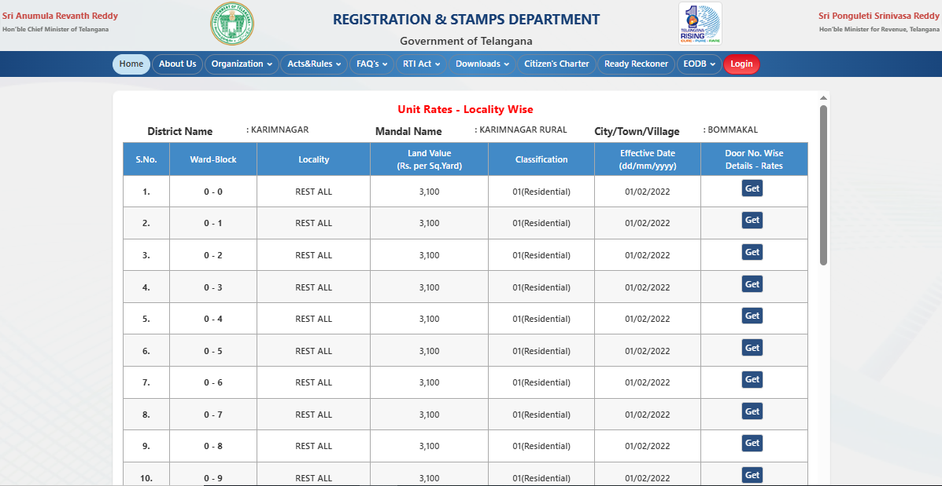

Recent Transactions around this property
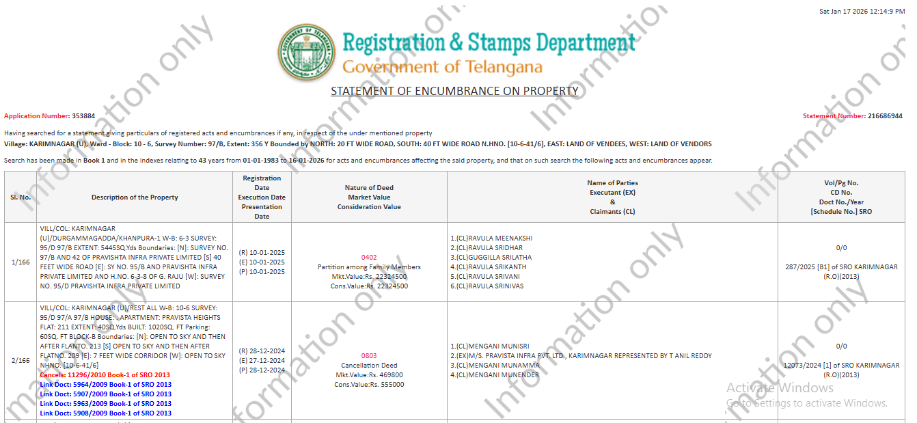

Summary of Land and Sale Deeds
S. No | Sy No | Sale Deed No | Sq.Yds | Name of the holder | Village name
1 | 95/B | 5520/2009 | 5,445 | M/s Pravista Infra Pvt Ltd | Durgamma gadda
2 | 42 | 5907/2009 | 3,751 | M/s Pravista Infra Pvt Ltd | Bommakal
3 | 95/D,97/A&97/B | 5908/2009 | 9,680 | M/s Pravista Infra Pvt Ltd | Durgamma gadda
4 | 97/B | 5963/2009 | 354 | M/s Pravista Infra Pvt Ltd | Durgamma gadda
5 | 97/B | 5964/2009 | 356 | M/s Pravista Infra Pvt Ltd | Durgamma gadda
Total Area |  |  | 19,586

Property Photographs


Valuation – Steps to arrive at Correct Value

The following are the detailed steps followed to arrive at the correct value:
- Govt. Rate-from SRO or internet.
- Document writers where ever available.
- Nearby owners of similarly placed land
- Guidance from firmly value /valuers of the district.
- Information from the local land brokers
- Any important landmark decisions of government affecting the value of this land.
- Internet sites giving the realistic sale value of the lands in the village/vicinity.

Assumptions
- The authenticity of the documents provided was not checked and it is assumed that all the data provided to us is genuine.
- The valuation report is tempered by the exercise of our judicious discretion, taking into account the relevant factors affecting the value of the assets such as existing demand & supply dynamics of the Durgammagadda Village.
- This property is free from all encumbrances, easements and litigations
- It is assumed that no flat in this property is sold and all the property has a clear and transferable title.
- We consider that the valuation is both reasonable and defensible based on the information available and reasonable assumptions made. However, it may be noted that others may place a different value.
- The report assumes that the company/business/assets has complied fully with relevant laws and regulations applicable in its area of operations and usage unless otherwise stated.
- As is the general practice, the sale deeds are executed based on the govt rate and not the market rate, similar transactions are not found surrounding this property at the market rate. Hence the market value is arrived based on the inputs given by the real estate brokers in the area.
- The liquidation value arrived at discounts the fair value as a based on reasonable assumptions of this property.
  - The asset marketing factor,
  - Costs of brokerage & other selling expenses,
  - Negotiation factor & bargaining power of the acquirer (as the seller is compelled to sell) and
  - Potential investments (or lack of it) into the sector in the current scenario.

Caveats & Limitations

- The contents of this valuation report to a third party in any way without first obtaining our written approval to the form and context of the proposed disclosure. No decisions should be taken based on this report by any party other than our client.
- To the best of my knowledge and belief, the statements and opinions in this report are correct and the information provided by others is accurate. However, no responsibility is assumed for its accuracy, which should be checked by appropriate report, search or formal enquiry if required.
- No physical measurements of land were taken by us during the visit to the site.
- This valuation is based upon information reasonably available to the valuer as at the date of this valuation in accordance with usual valuation practices.
- Our report is based on the assumption that there are no legal issues on the property.
- This valuation is current as at the date of valuation only. The value assessed herein may change significantly and unexpectedly over a relatively short period (including as a result of general market movements or factors specific to the particular property).
- I/ We do not accept liability for losses arising from such subsequent changes in value. Without limiting the generality of the above comment I/ we do not assume any responsibility or accept any liability where this valuation is relied upon after the expiration of three months from the date of valuation, or such earlier date if you become aware of any factors that have any effect on this valuation.
- Confirmation on authenticity of ownership of the property through its original Documents is not in the scope and purview of our valuation report.
- We are not responsible for any incidental or consequential actions or any Loss Occurred to anybody, on any false declaration claim or deposition made by the applicant.
- Although every scientific method has been employed in systematically arriving at the value, there is no indisputable single value and the estimate of the value is normally expressed as falling within a likely range. To comply with the RP‟s request, I have provided a single value for the overall Liquidation Value and Fair Value of the assets of the CD, derived as an arithmetic average of the range of Liquidation and Fair Values.
- The actual market price achieved may be higher or lower than our estimate of value depending upon the circumstances of the transaction (for example the competitive bidding environment of the resolution plans), the nature of the business. The knowledge, negotiating ability and motivation of the buyers and sellers will also affect actual market price achieved. Accordingly, our valuation conclusion will not necessarily be the price at which actual transaction will take place.
- We relied on some data from external sources. These sources are considered to be reliable and therefore, I assume no liability for the truth or accuracy of any data, opinions or estimates furnished by others that have been used in this analysis. Where I have relied on data, opinions or estimates from external sources, reasonable care has been taken to ensure the accuracy of such data and that such data has been accurately and correctly extracted from those sources and /or reproduced in its proper form and context.
- The company and its management/representatives warranted to us that the information they supplied was complete, accurate and true and correct to the best of their knowledge. We have relied upon the representations of the owners/clients, their management and other third parties concerning the operational data and maintenance schedule of all buildings, except as specifically stated to the contrary in the report. In no event shall we be liable for any loss, damages, cost or expenses arising any way from fraudulent acts, misrepresentations, or willful default on part of the companies, their directors, employee or agents.
- I am fully aware that based on the opinion of value expressed in this report, I may be required to give testimony or attend court / judicial proceedings with regard to the subject assets, although it is out of scope of the assignment, unless specific arrangements to do so have been made in advance, or as otherwise required by law. In such event, the party seeking my evidence in the proceedings shall bear the cost/professional fee of attending court / judicial proceedings and my tendering evidence before such authority shall be under the applicable laws.
- It should be noted that Liquidation Value could be significantly different from Fair Value or fair market value. Further, Liquidation Value in an orderly sale can be very different from Liquidation Value in a fair sale transaction and Liquidation Value of any individual asset on a standalone basis could be very different from Liquidation Value of any individual asset as a whole. As such, the premise of Liquidation Value for the said purpose in this report is orderly Liquidation Value of the assets in-situ and on a going- concern basis.

Documents Requested Vs Provided
S. No | Details Requested | Status
1 | Approved plan of the apartment complex under construction | Provided
2 | Details of the Flats their saleable and their undivided share of land | Not provided
3 | Clarity on extent of land allocated for the apartment complex under construction | provided
4 | Details on number of flats that were sold | Not provided
5 | Title investigation report (TIR) | Not provided
ADDITIONAL PROPERTY IMAGES

