Prodoscore Chart App

Requirements:
- Node.js
- Restful API
- Next.js
- Typescript
- TanStack Query – Server State Management
- Zustand – Global State Management
- Axios
- Tailwind CSS
- chart.js and react-chartjs-2

- Eslint – Coding Standard, fix problems with your JavaScript code
- Prettier – Code Formatter
- Husky – improves your commits

Task1: Create the the bar charts and table according to the rest api

Back-end Changes:
- Create the rest API using node.js
- Add given JSON file into /assets folder
- Make API endpoints with GET methods
- API should be receive the query params from the front end (next.js) such as from, to date query. API endpoint should return the JSON of employees.json file.

Front-end Changes:
- Create next.js App
- Create page in app routes
- Create Dashboard page, and add two fields such as from, to date range field.
- Create the Zustant store and store the from and to values on it.
- Fetch API according to API endpoint with from and to query params (TanStack Query, Axios).
- Create the bar chart using chart.js and react-chartjs-2, and map the data into according to the response.
  - X Axis – Prodoscore of employee
  - Y Axis – Employee Name
- Create the 3 Table, and It should show employeename and prodoscore of employee according to the above and average and below prodoscore.
- Create the UI with tailwind CSS.

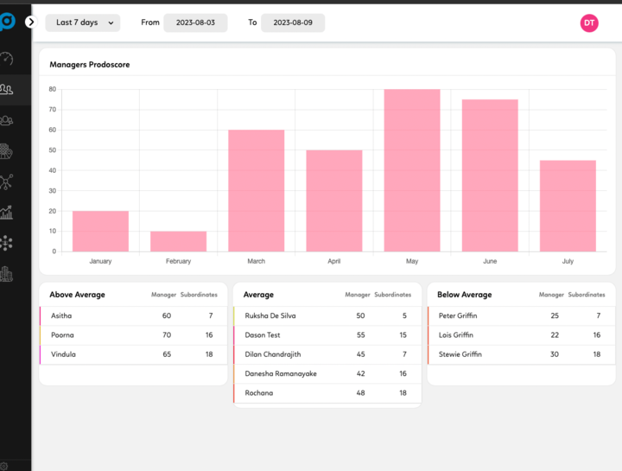
- Merge your UI Like this.

Task 2: Create the ‘/me’ page.

Back-end Changes:
- Add given JSON file into /assets folder
- Make a API endpoint with GET method
- query. API endpoint should return the JSON of me.json file.

Front-end Changes:
- Add page in app routes
- Add Drop down near by date range picker when hover over it, it should be move to another page called ‘me’ page.
- Create me page, add the me profile UI.
- Fetch API ‘/me’ API endpoint. It returns the me profile. (TanStack Query, Axios).
- Create the UI with tailwind CSS.

