🛍️
Customer Shopping Behaviour
Analytics & Predictive Modeling Report
An exploratory data analysis of 3,900 customer transactions,
combined with a machine-learning model comparison for purchase-amount prediction.
Prepared July 2026

1. Executive Summary
This report analyses a dataset of 3,900 retail transactions spanning clothing, footwear, outerwear and accessories. The goal is twofold: (1) understand who is shopping, what they buy, and how they behave — and (2) test whether machine learning can accurately predict how much a customer will spend, using the attributes available in the dataset.
3,900  Customer Records | $59.76  Avg. Purchase (USD) | 4  Product Categories | 3.75 / 5  Avg. Review Rating

💡 Headline Finding
Every regression model tested — from Linear Regression to XGBoost — failed to beat a simple 'guess the average' baseline (all R² scores were negative). This tells us purchase amount, as recorded here, behaves almost like a random number relative to the customer and transaction attributes we have. The demographic and behavioural data is genuinely useful for segmentation and marketing insight, but it does not explain spend amount — that likely depends on product price/quantity data not captured in this dataset.

2. About the Dataset
The raw dataset contains 18 columns describing customer demographics (age, gender, location), the product purchased (item, category, size, colour, season), the transaction (purchase amount, review rating, discount, payment method), and shopping habits (subscription status, previous purchases, shipping type, frequency of purchases).

2.1 Data Cleaning & Feature Engineering
- Missing values: 'Review Rating' had 37 missing entries (~0.9%). These were imputed using the median rating within each product category, rather than a single global median, to preserve category-level rating patterns.
- Redundant column: 'Discount Applied' and 'Promo Code Used' were found to be identical for every single record, so 'Promo Code Used' was dropped to avoid duplicate information.
- Feature engineering — Age Group: customers were split into four equal-sized quartile bins (Young Adult, Adult, Middle Aged, Senior) to support cohort analysis.
- Feature engineering — Purchase Frequency (days): categorical frequency labels (e.g. 'Weekly', 'Quarterly') were converted into a numeric day-count, making the feature usable in regression models.
- Column names were standardised to lower_snake_case for consistency across analysis and modeling notebooks.

3. Exploratory Data Analysis
This section walks through customer demographics, product trends, seasonal patterns and behavioural signals uncovered in the data.

3.1 Who Are the Customers?
The customer base skews male and middle-aged. Ages range from 18 to 70, fairly evenly spread with a slight concentration in the 30–55 range, giving an average age of about 44 years.
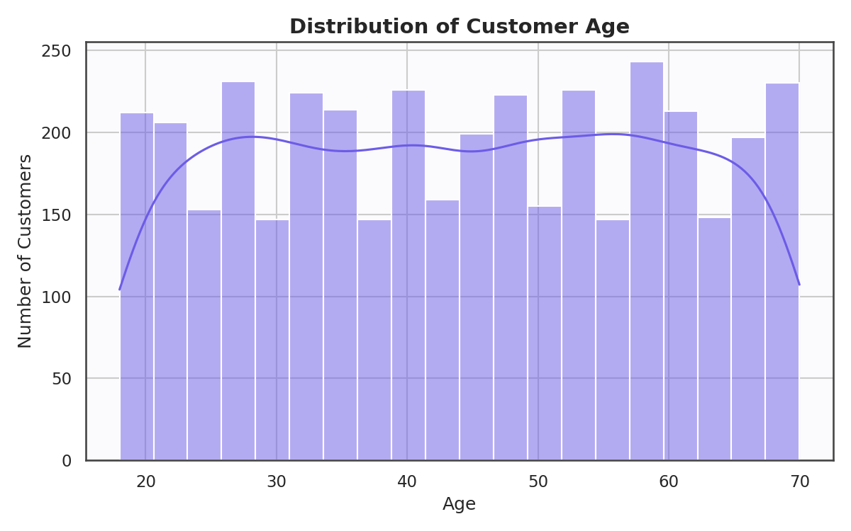
Figure 1. Customer age is broadly spread across the 18–70 range, centred around the mid-40s.
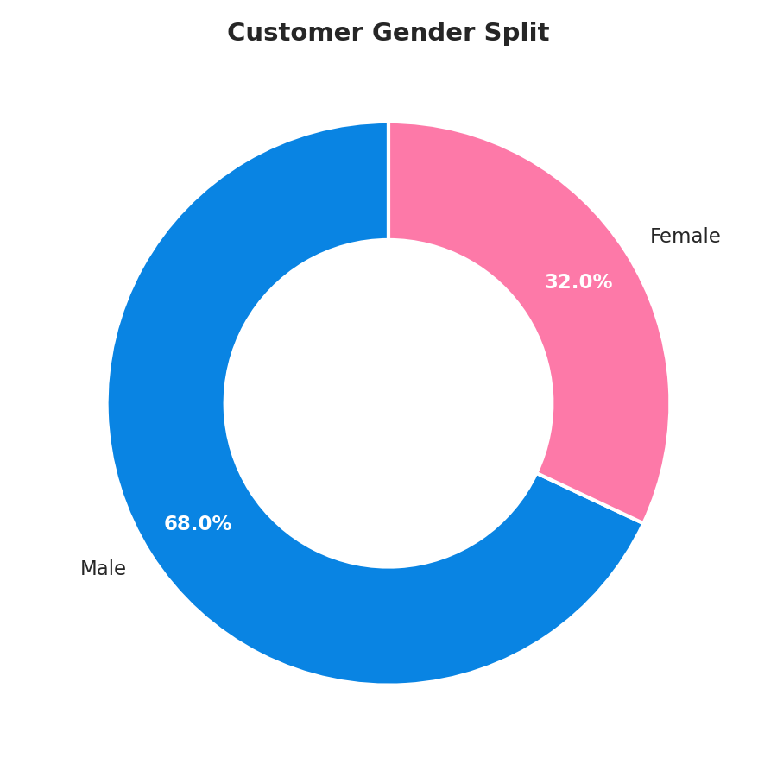
Figure 2. Male customers make up 68% of the dataset versus 32% female — a notably skewed split.

3.2 What Are They Buying?
Clothing dominates purchase volume, followed by accessories, footwear and outerwear. 'Blouse' is the single most purchased item overall.
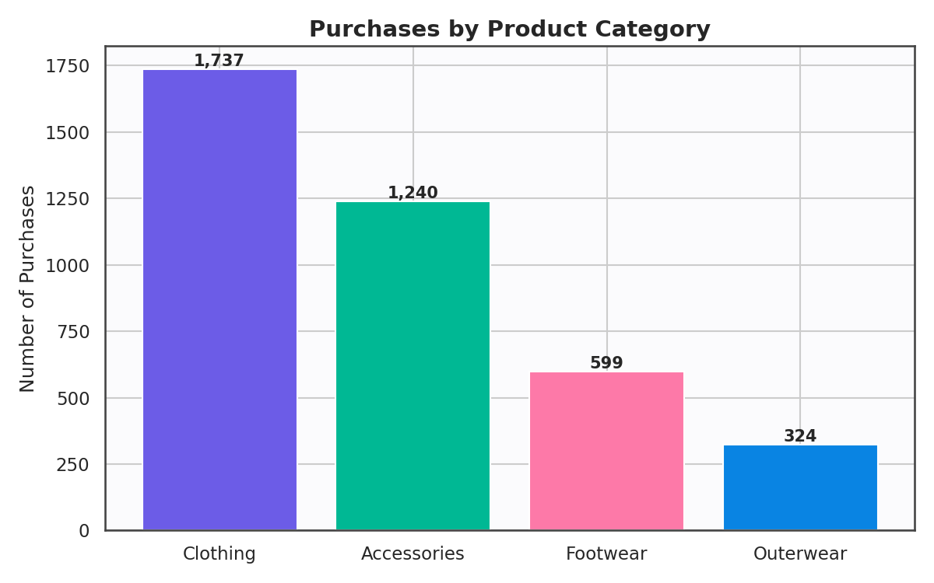
Figure 3. Clothing accounts for nearly 45% of all purchases, more than double the next closest category.
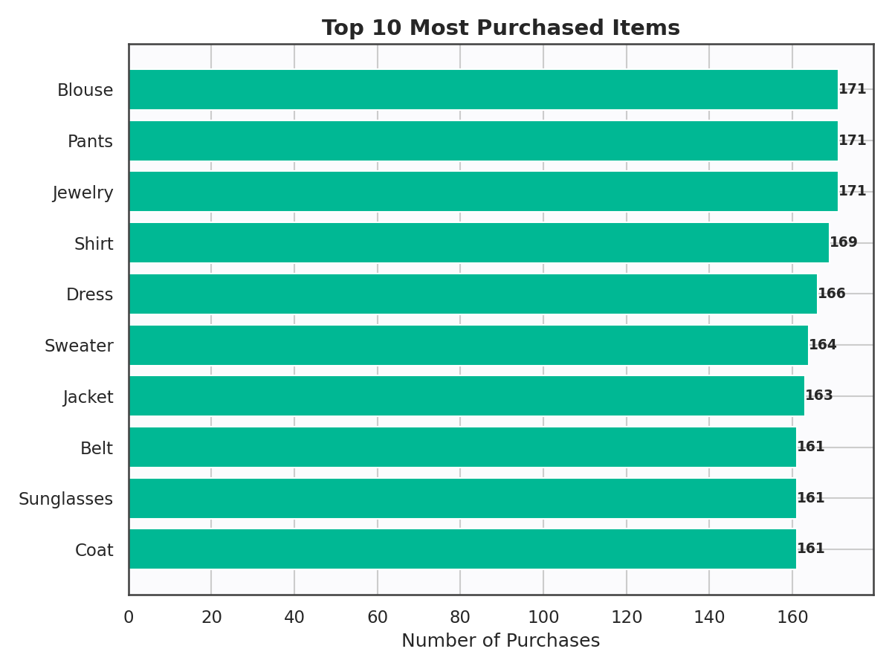
Figure 4. Blouses, jewelry and pants lead the top-10 most purchased items list.
Interestingly, median purchase amount is fairly close across categories, with Outerwear and Footwear commanding a slightly higher typical spend than Clothing and Accessories — though all four categories show wide, overlapping spread.
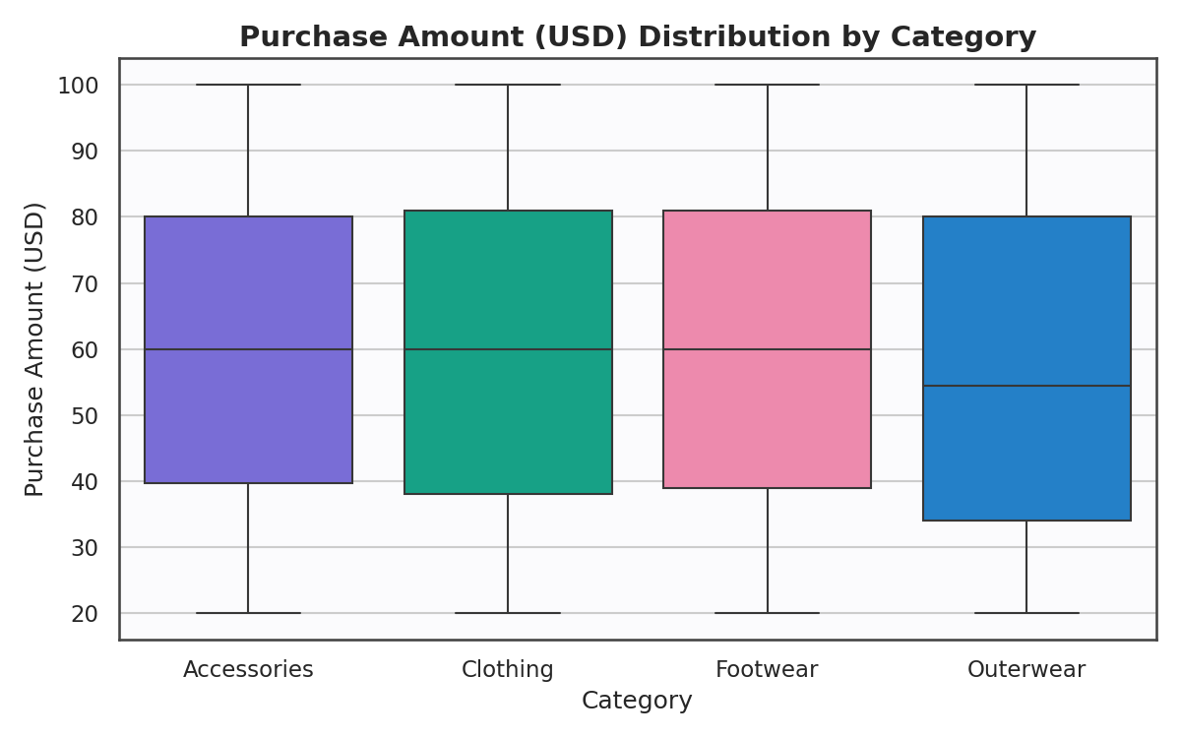
Figure 5. Purchase amount distributions overlap heavily across categories, with only minor median differences.

3.3 Seasonal & Frequency Patterns
Purchase volume is fairly balanced across the four seasons, with only a mild uptick in Spring and Fall, and average spend per transaction barely moves across the year — a signal that seasonality has limited influence on individual transaction value in this dataset.
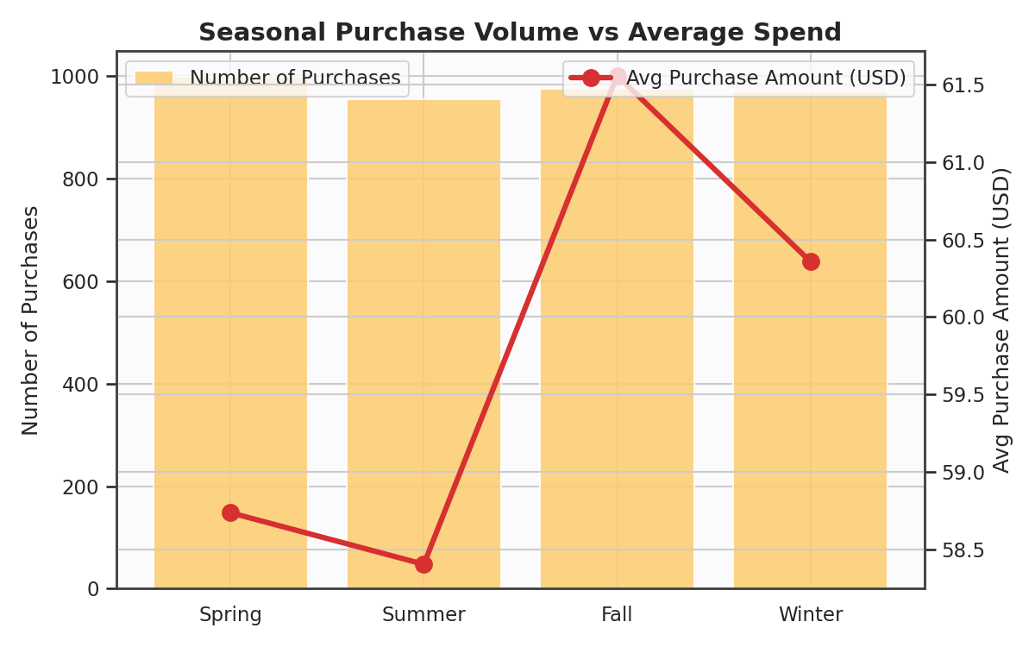
Figure 6. Purchase counts vs. average spend per season — both are remarkably flat across the year.
Shopping cadence is dominated by two extremes: very frequent (weekly/fortnightly) and very infrequent (annual) shoppers, with fewer customers in the middle ranges.
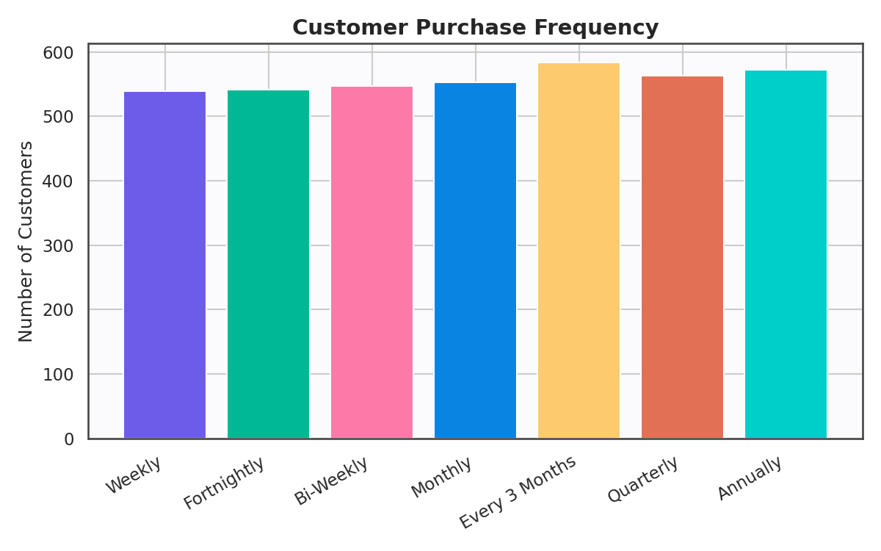
Figure 7. Distribution of self-reported purchase frequency across the customer base.

3.4 Customer Experience & Loyalty Signals
Review ratings cluster between 3 and 5, with very few dissatisfied customers (ratings below 2.5), suggesting a generally positive shopping experience across the board.
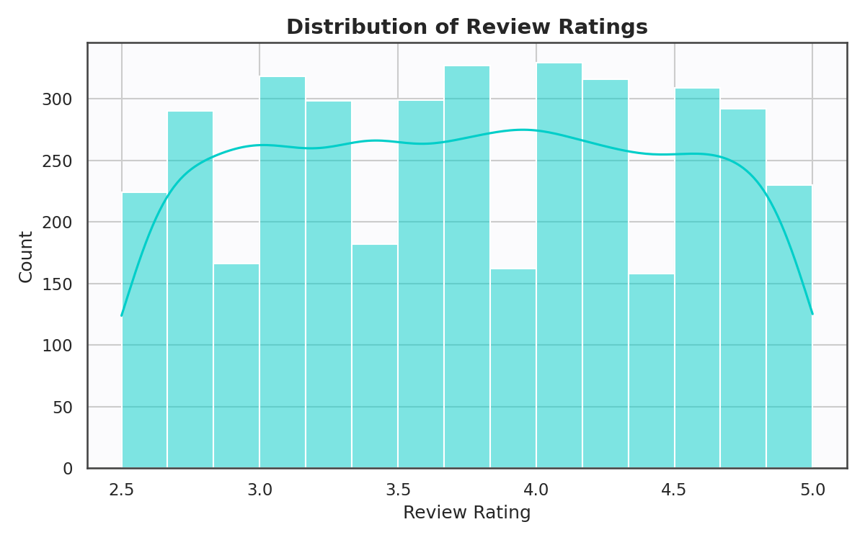
Figure 8. Review ratings are concentrated in the 3.0–4.5 range.
Subscribers and non-subscribers spend almost identically per transaction — subscription does not appear to translate into bigger basket sizes.
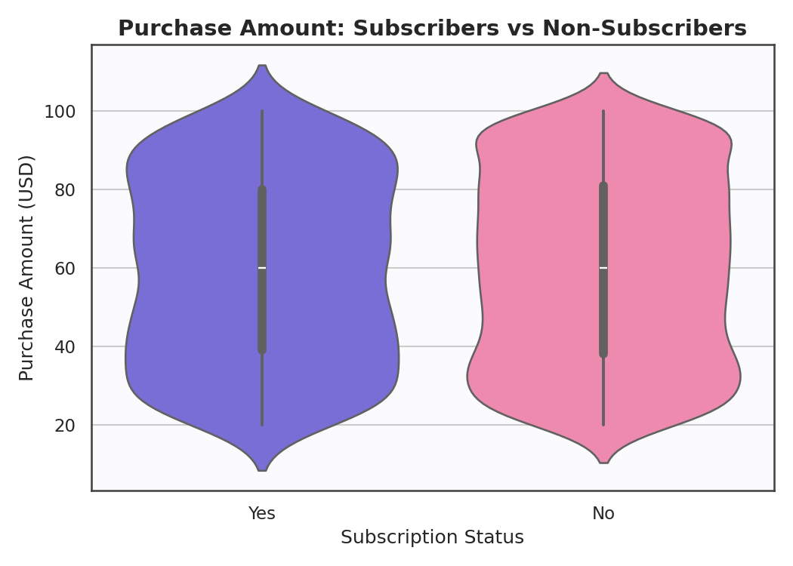
Figure 9. Purchase amount distribution is nearly identical for subscribers vs. non-subscribers.
💡 Unexpected Pattern
Every single subscriber in this dataset (1,053 customers) is Male — there are zero female subscribers among the 1,248 female customers. This is a striking structural pattern in the data. It may reflect a genuine business dynamic (e.g. a subscription programme historically marketed to men), or it may be an artefact of how this dataset was generated/sampled. Either way, it means 'subscription_status' and 'gender' carry almost the same information for modeling purposes, and any model using both should be checked for redundancy.
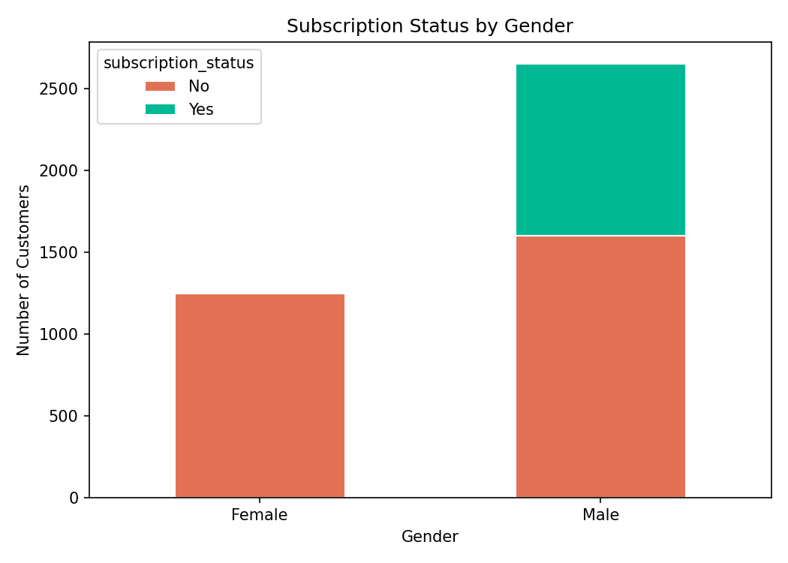
Figure 10. Subscription status is completely male-only in this dataset — a notable structural quirk.

3.5 Discounts, Payments & Geography
Discounts were applied to 43% of transactions. Credit card, PayPal and cash are the three most common payment methods, fairly evenly used, suggesting no single dominant payment preference.
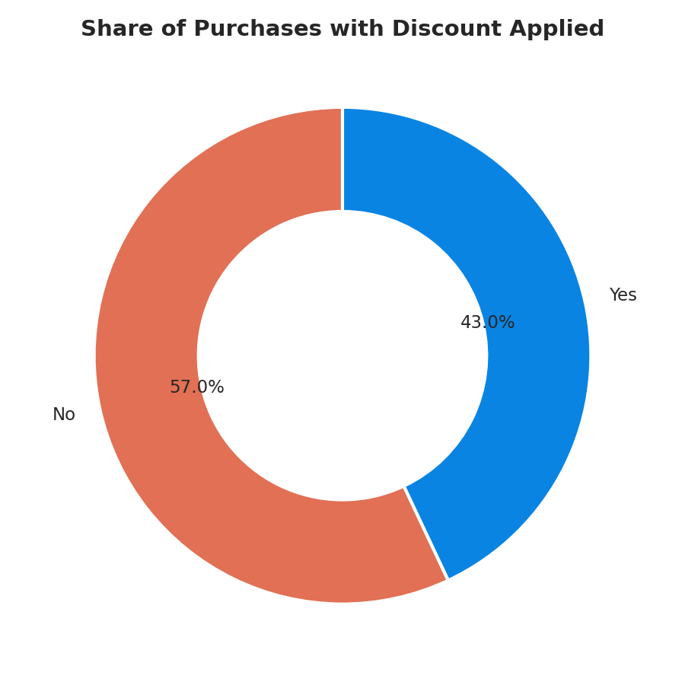
Figure 11. 43% of transactions included a discount.
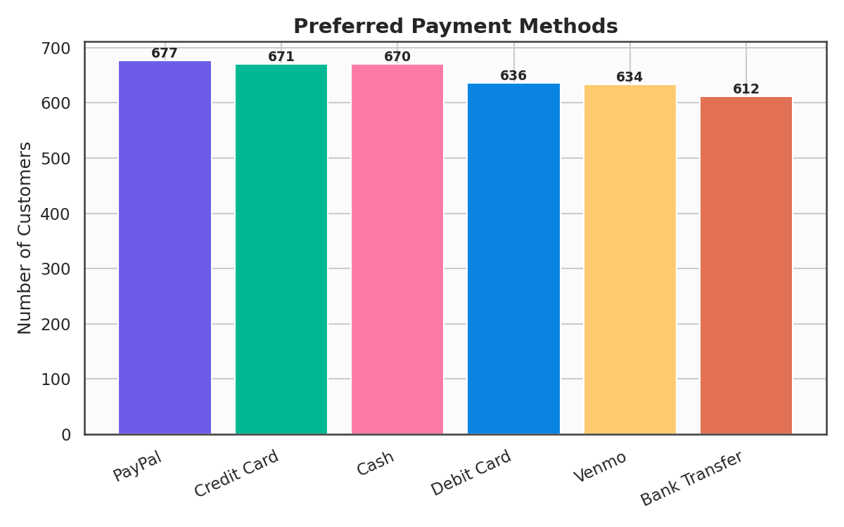
Figure 12. Payment method usage is fairly evenly distributed across six options.
Customers are distributed across nearly every U.S. state, with no single state dominating — Montana leads with 96 customers, only marginally ahead of the rest.
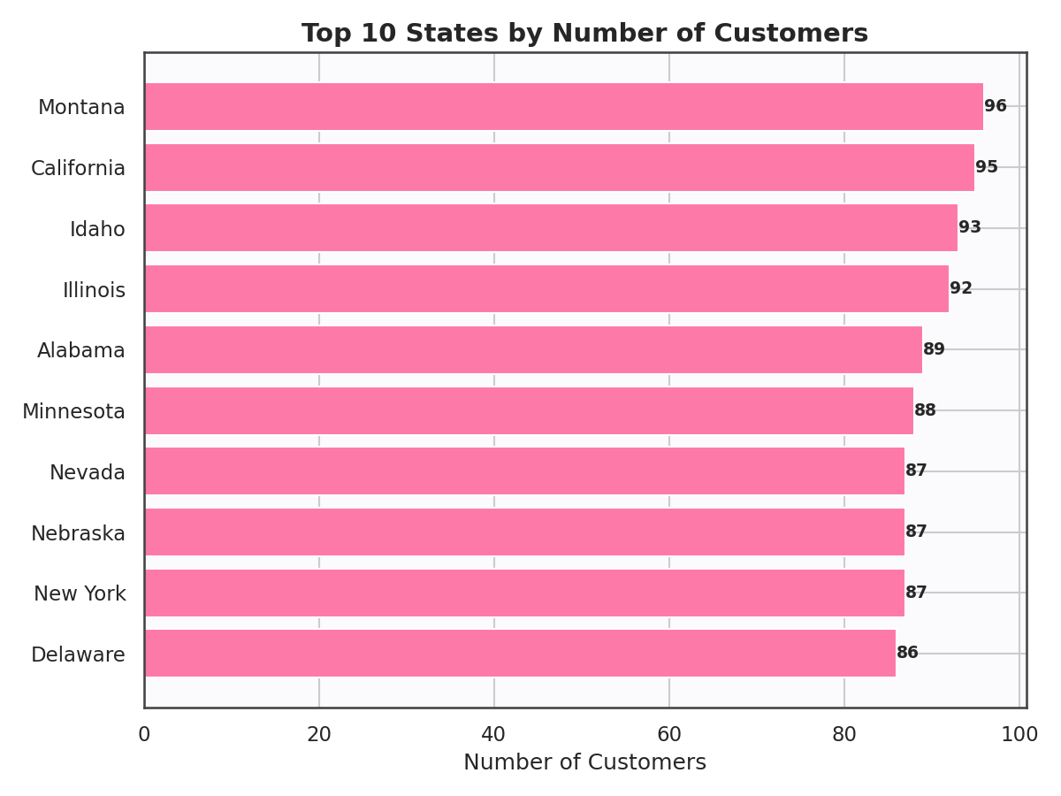
Figure 13. The top 10 states by customer count are closely bunched, indicating broad geographic spread.

3.6 Age Group Spending
Average spend is remarkably flat across age groups — Young Adults, Adults, Middle Aged, and Seniors all spend within a couple of dollars of one another on average, reinforcing the theme that transaction value doesn't vary much with demographic segment.
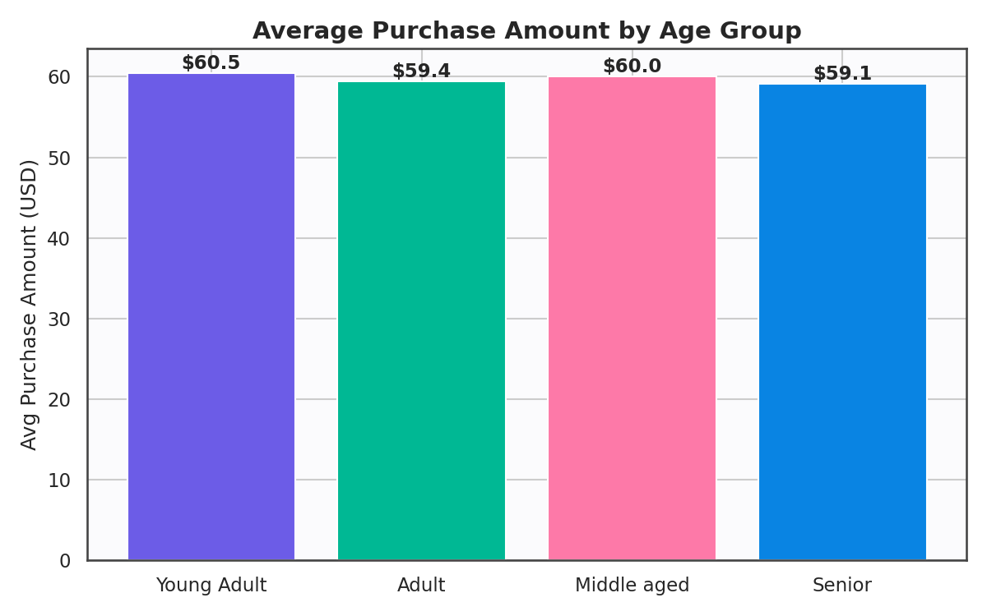
Figure 14. Average purchase amount barely varies across age-group cohorts.

3.7 How Numeric Features Relate to Each Other
A correlation check across the numeric fields (age, purchase amount, review rating, previous purchases, purchase frequency) shows essentially no linear relationship between purchase amount and any other numeric variable — the strongest correlations in the matrix are all close to zero.
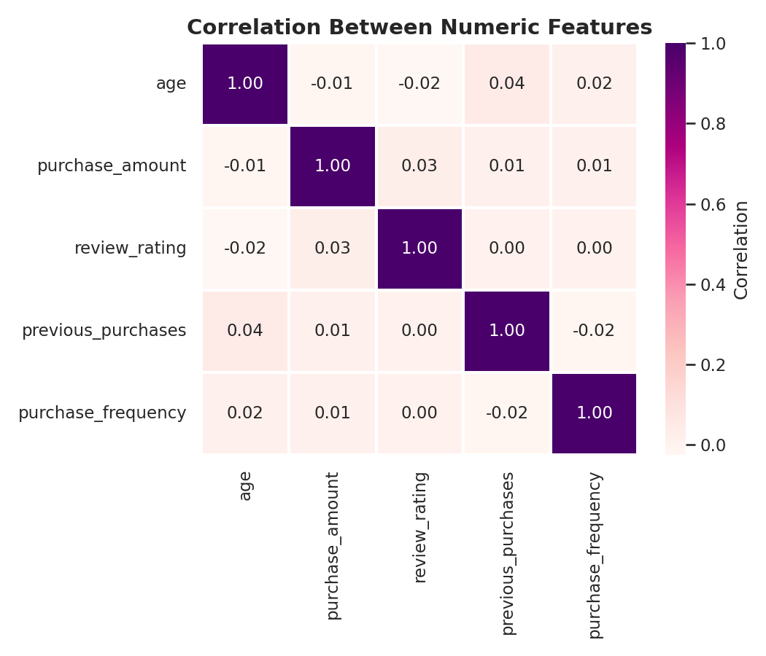
Figure 15. Correlation heatmap — purchase amount shows near-zero correlation with every other numeric feature.

4. Predictive Modeling — Can We Predict Purchase Amount?
Given the EDA showed weak relationships between purchase amount and the available features, the modeling notebook put this to a rigorous test: train several regression algorithms to predict 'purchase_amount' from the remaining customer, product and transaction attributes.

4.1 Modeling Setup
- Target variable: purchase_amount (USD)
- Features used: age, gender, item_purchased, category, location, season, review_rating, subscription_status, shipping_type, discount_applied, previous_purchases, payment_method, purchase_frequency
- Categorical features were label-encoded; data was split 80/20 into train and test sets (random_state=42).
- Seven baseline algorithms were trained: Linear Regression, Decision Tree, Random Forest, Gradient Boosting, SVR, KNN, and XGBoost.

4.2 Baseline Model Comparison
R² score measures how much better a model performs versus simply predicting the average purchase amount for everyone. An R² of 0 means 'no better than guessing the mean'; negative means 'worse than guessing the mean'. Every single model came back negative:
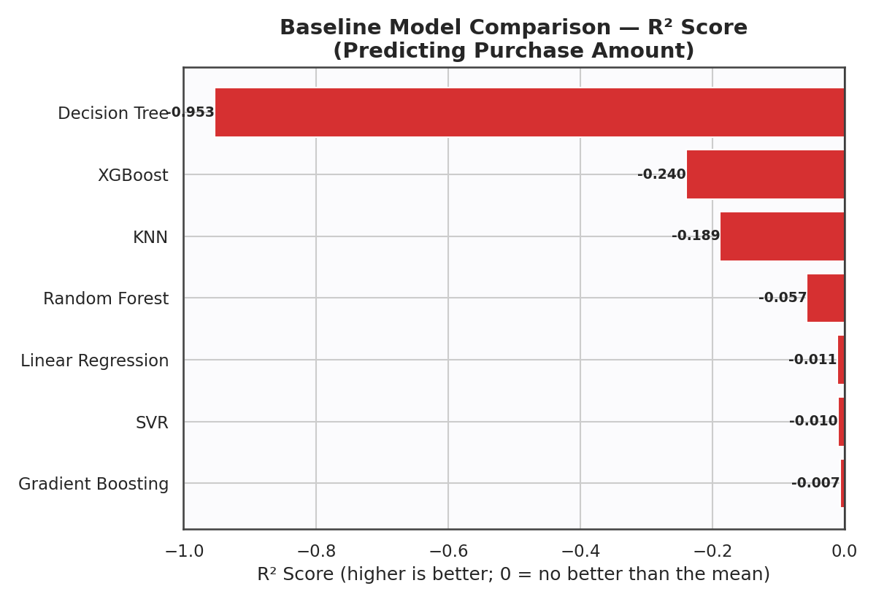
Figure 16. All seven baseline models scored below zero R² — none could beat a flat average-value guess.
Model | MAE | RMSE | R² Score
Gradient Boosting | 20.68 | 23.74 | -0.007
SVR | 20.79 | 23.78 | -0.010
Linear Regression | 20.74 | 23.79 | -0.011
Random Forest | 21.15 | 24.32 | -0.057
KNN | 21.88 | 25.79 | -0.189
XGBoost | 22.05 | 26.34 | -0.240
Decision Tree | 26.98 | 33.06 | -0.953

4.3 Hyperparameter Tuning
To rule out poor default settings as the culprit, the three strongest ensemble models — Random Forest, Gradient Boosting and XGBoost — were tuned via 5-fold GridSearchCV across n_estimators, max_depth, learning_rate and related parameters. Tuning improved each model slightly, but none crossed the zero threshold:
Model (Tuned) | R² | RMSE (USD) | MAE (USD)
Random Forest | -0.0039 | 23.70 | 20.71
XGBoost | -0.0044 | 23.71 | 20.73
Gradient Boosting | -0.0069 | 23.74 | 20.75

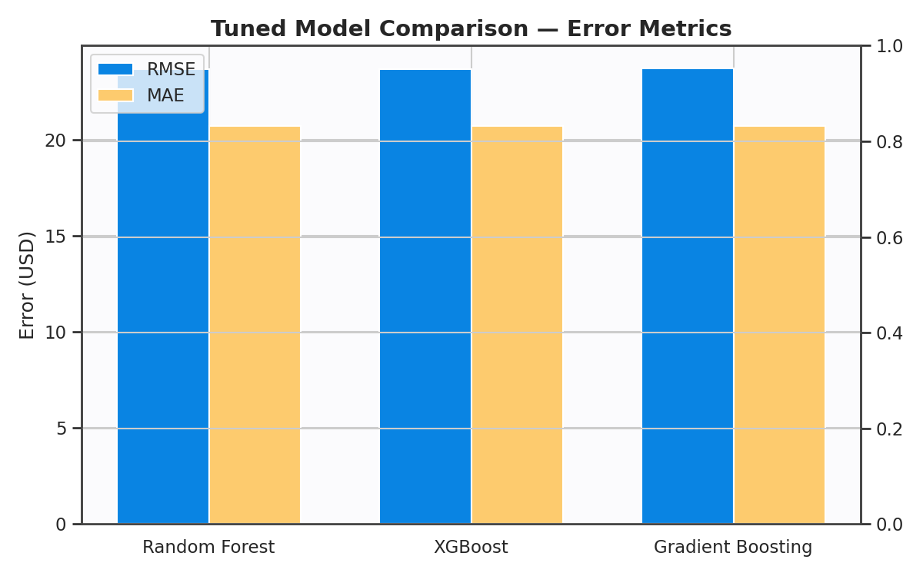
Figure 17. Even after tuning, RMSE and MAE stay essentially flat across the top three ensemble models — roughly $20–24 of average error on transactions averaging $60.

4.4 What Mattered Most (Feature Importance)
Even though the tuned Random Forest couldn't predict spend accurately, its feature-importance ranking is still informative about which signals carried the most (limited) weight:
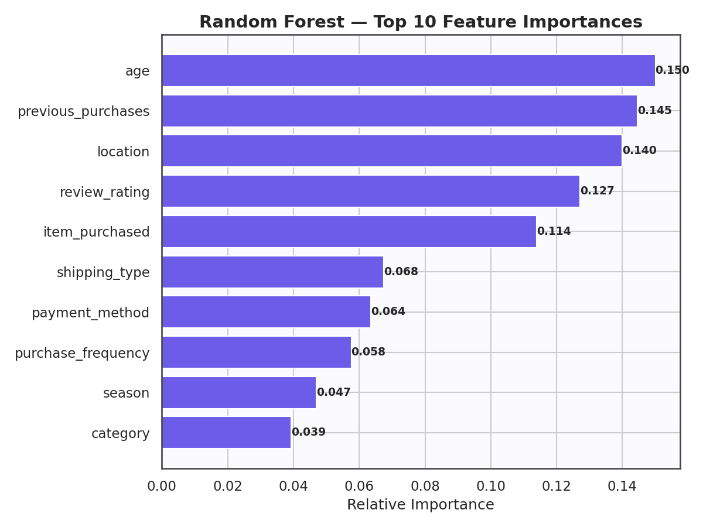
Figure 18. Age, previous purchases and location were the top (though still weak) predictors of purchase amount.
Age, previous purchase count, and geographic location topped the list, with item purchased and review rating close behind. Category and season contributed the least.

5. Conclusions & Recommendations
💡 Why the models underperformed
The R² scores hovering just below zero across every algorithm — even after tuning — is a strong signal that purchase_amount in this dataset does not depend meaningfully on the customer/behavioural attributes provided. This is most likely because the dataset does not include product price, quantity, or SKU-level cost information — the real drivers of transaction value in retail. Demographic and behavioural fields (age, location, ratings, frequency) describe who a customer is, not what a specific item costs.

5.1 Key Takeaways
- The customer base is broadly male (68%), middle-aged on average (~44 years), and generally satisfied (average review rating 3.75/5).
- Clothing is the clear volume leader, but purchase amount is similar across all four categories — this is a volume story, not a value-per-category story.
- Subscription status is entirely confounded with gender in this dataset (all subscribers are male) — a pattern worth validating against the source system before using it in any model or business decision.
- Seasonality, discounts, and payment method show only marginal influence on spend amount or purchase volume.
- No tested regression model — including tuned ensemble methods — could predict purchase amount better than simply guessing the average. This is a data-availability problem, not a modeling-technique problem.

5.2 Recommendations
- Enrich the dataset with product-level price, quantity, and SKU/cost data — without this, purchase-amount prediction is unlikely to improve regardless of algorithm choice.
- Use the current dataset for what it's good at: customer segmentation, satisfaction tracking, and category/geographic trend monitoring — not for spend forecasting.
- Investigate the gender/subscription relationship with the data source team to confirm whether it reflects a real business rule or a sampling artifact.
- If spend prediction remains a priority, consider reframing the problem — e.g. predicting purchase frequency, likelihood to subscribe, or churn risk — where the available features are more directly relevant.

— End of Report —

