Supply Chain EDA & Delivery Risk Analysis Report

1. Executive Summary
This project analyzes a large-scale supply chain dataset containing 180,519 order records. The objective was to identify operational inefficiencies, understand factors affecting profitability, evaluate delivery performance, and build machine learning models capable of predicting delivery risks.
The analysis reveals that delivery delays are the most critical operational issue, affecting more than half of all orders. Although the business remains profitable overall, delayed shipments contribute significantly to financial losses and customer dissatisfaction. Predictive modeling demonstrates that delivery risk can be forecasted with reasonable accuracy, enabling proactive intervention strategies.
Dataset summary: 180,519 records, reduced from 53 original variables to 23 key analytical variables after cleaning and feature selection.

2. Business Problem
Supply chain organizations face three major challenges:
- Delayed deliveries leading to poor customer experience.
- Profit erosion due to logistics inefficiencies.
- Difficulty identifying high-risk orders before shipment.
This analysis addresses these challenges through:
- Exploratory Data Analysis (EDA)
- Data Quality Assessment
- Profitability Analysis
- Delivery Performance Analysis
- Machine Learning-Based Risk Prediction

3. Data Preparation & Cleaning

Initial Dataset
Metric | Value
Total Rows | 180,519
Original Features | 53
Final Features | 23

Major Cleaning Activities

1. Removal of Redundant Columns
The analysis identified duplicate information:
- Benefit per Order
- Order Profit Per Order
Both columns contained identical values and therefore introduced redundancy. One was removed.

2. Removal of Low-Value Variables
Several columns were removed because:
- Excessive missing values
- Irrelevant information
- Single-value categories
Example:
- Product Status contained only one unique value and provided no predictive value.

3. Feature Reduction
Reducing 53 variables to 23 important variables:
- Improved model efficiency
- Reduced dimensionality
- Increased interpretability

4. Key Performance Indicators (KPIs)

Operational KPIs
KPI | Value
Total Orders | 180,519
Late Deliveries | 98,743
Delayed Delivery Rate | 54.7%
On-Time Delivery Rate | 45.3%
Source: EDA summary findings.

Interpretation
More than half of all shipments were delivered late.
This indicates:
- Logistics bottlenecks
- Poor shipment planning
- Capacity management issues
- Potential customer satisfaction risks

Financial KPIs
KPI | Value
Total Profit | ~$7.9 Million
Delay Related Loss | ~$2.1 Million
Profitable Orders | 145,558
Loss-Making Orders | 33,784

Profitability Ratio
Profitable Orders:
145,558 / 180,519 ≈ 80.6%
Loss-Making Orders:
33,784 / 180,519 ≈ 18.7%

Business Interpretation
The company remains profitable overall, but delayed deliveries significantly reduce margins.
Even a modest reduction in delays could recover millions in profit.

5. Delivery Performance Analysis

Delivery Delay Distribution
The analysis showed:
Delay (Days) | Approx Share
Early Delivery | ~24%
On-Time | ~21%
1 Day Delay | ~31%
2 Day Delay | ~16%
3+ Day Delay | ~8%

Key Finding
The most common delay category was:

1-Day Delay (31%)
This suggests that most delays are operational rather than structural.
Typical causes:
- Warehouse dispatch delays
- Route planning inefficiencies
- Last-mile delivery constraints

Severe Delays
Orders delayed by 3+ days showed noticeably lower profitability.

Business Impact
Severe delays generate:
- Higher logistics costs
- Refund requests
- Order cancellations
- Reduced customer retention

6. Profitability Analysis

Profit vs Loss Distribution

Profitable Orders
145,558 Orders

Loss-Making Orders
33,784 Orders

Key Insight
Although most orders generate profit, losses are concentrated within delayed shipments.
This indicates a strong relationship between:
Delivery Delay → Increased Cost → Reduced Margin

Estimated Cost of Delay
Loss attributed to delayed operations:

~$2.1 Million
This is one of the most important findings because it quantifies the business value of improving logistics performance.
Even a 10–15% reduction in delays could save hundreds of thousands of dollars annually.

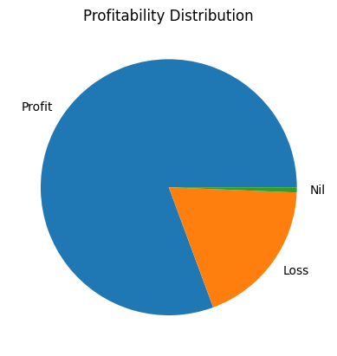
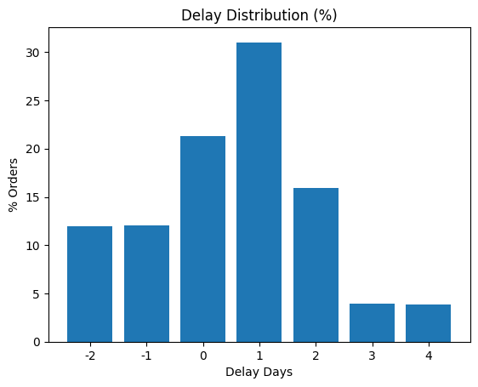

7. Delivery Risk Prediction
Two machine learning models were developed.

Model 1: Random Forest
Performance:
Metric | Score
Accuracy | 74%
Precision | 77%
Recall | 74%

Advantages
- Balanced performance
- Strong recall
- Stable predictions
- Better identification of risky orders

Model 2: XGBoost
Performance:
Metric | Score
Accuracy | 72%
Precision | 85%
Recall | 60%

Advantages
- High precision
- Fewer false alarms

Limitation
Lower recall means many risky deliveries are missed.

8. Model Comparison
Metric | Random Forest | XGBoost
Accuracy | 74% | 72%
Precision | 77% | 85%
Recall | 74% | 60%

Recommended Model

Random Forest
Reason:
Supply chain risk prediction prioritizes identifying as many risky orders as possible.
Higher recall (74%) makes Random Forest more suitable for operational deployment.

9. Business Recommendations

Priority 1: Reduce 1-Day Delays
Since 1-day delays account for the largest category:
Actions:
- Improve warehouse processing
- Optimize dispatch schedules
- Enhance route planning
Expected Impact:
- Immediate improvement in customer satisfaction
- Reduction in logistics costs

Priority 2: Early Risk Detection
Deploy the Random Forest model before shipment.
High-risk orders can be:
- Expedited
- Re-routed
- Assigned premium logistics channels

Priority 3: Logistics Cost Monitoring
Track:
- Shipping cost per order
- Cost per delayed shipment
- Delay-related profit erosion
Recommended KPI:
Cost of Delay per Order

Priority 4: Regional Performance Dashboard
Create dashboards tracking:
- Delay Rate by Region
- Delay Rate by Product Category
- Delay Rate by Shipping Mode
- Profit by Region
- Loss by Delay Severity

10. Strategic Conclusions

Finding 1
Late deliveries are the largest operational challenge, affecting approximately 54.7% of all orders.

Finding 2
The business remains profitable but loses approximately $2.1 million due to delivery-related inefficiencies.

Finding 3
The majority of delays are short-term (1 day), indicating operational inefficiencies rather than systemic failures.

Finding 4
Machine learning can predict delivery risk with 74% accuracy, enabling proactive intervention.

Finding 5
Random Forest provides the best balance between accuracy and recall, making it the preferred model for deployment.

Executive Takeaway
The analysis demonstrates that supply chain profitability is strongly linked to delivery performance. By reducing delay frequency, particularly 1-day delays, and deploying predictive risk models, the organization can improve customer satisfaction, recover lost profit, and create a more resilient logistics operation.

