**REFACTORING OPERATIONS – BUILD 3**

1. **Renamed attackCountry() in IPlayer to normalAttack().**

Refactoring Technique – Rename method

This refactoring is done to make the code more consistent than build2.

1. **Renamed package name**

Refactoring Technique – Rename package name

We renamed Controller to Runner and Model to GameLogic because remove the ambiguity that it is a MVC model.

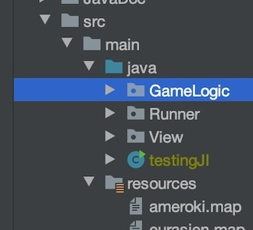

1. **Moved addplayer from Player to GamePlay**

Refactoring Technique – Moving methods among classes

As we need some of the methods from Player to be implemented by different player with different types of behaviours which were introduced in build3, so we moved those methods to GamePlay.

1. **Renamed MapReadWriteAdaptter**

Refactoring Technique – Rename method

Renamed MapReadWriteAdaptter to MapReadWriteAdapter

This refactoring is done to improve code readability. A typo was fixed here



