1. Determine if the survival rate is associated to passenger class

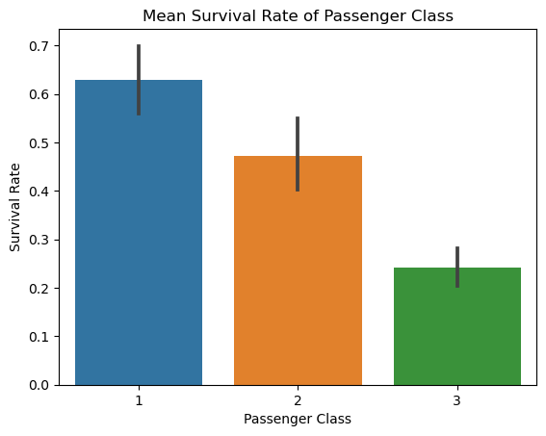

Pclass

1 0.629630

2 0.472826

3 0.242363

From the mean survival rate of each class and the bar graph, it appears that class 1 passengers had higher survival rate than class 2 passengers, which had higher survival rate than class 3 passengers.

*H0 = Survival rate is independent from passenger class*

*Ha = Survival rate is associated with passenger class*

X2: 102.89

p-value: 4.55e-23

DoF: 2 –> **Decision point = 5.99**

X2 of 102.89 is greater than of decision point for DoF of 2 (5.99); therefore, H0 is rejected, and that survival rate is dependent on passenger class.

1. Determine if the survival rate is associated to gender

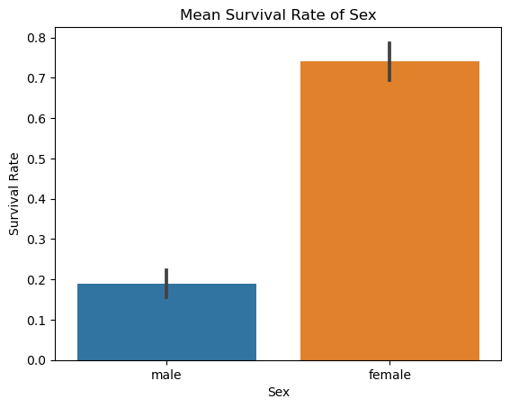

Sex

female 0.742038

male 0.188908

The mean survival rate of female almost quadrupled that of male survival rate according to both the table and the bar graph.

*H0 = Survival rate is independent from gender*

*Ha = Survival rate is associated with gender*

X2: 260.72

p-value: 1.20e-58

DoF: 1 –> **Decision point = 3.84**

As X2 of 260.72 is much greater than of decision point for DoF of 1 (3.84); therefore, H0 is rejected, and that survival rate is significantly dependent on the gender.

1. Determine the survival rate is associated to age

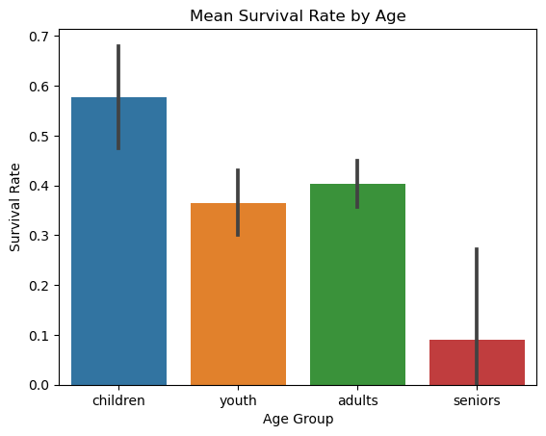

AgeGroup

adults 0.402353

children 0.576923

seniors 0.090909

youth 0.365000

Higher survival rate is observed in children followed by adults, youth, and seniors according to both the table and the bar graph.

*H0 = Survival rate is independent of age*

*Ha = Survival rate is associated with age*

X2: 15.39

p-value: 1.51e-3

DoF: 3 –> **Decision point = 7.82**

X2 of 15.39 is greater than the decision point of 7.82 for DoF of 3; therefore, H0 is rejected. Survival rate is associated with age.