**Suicide Rates High Among Young Adults in Rural Communities in 2015-2019**

Using data from the CDC’s WONDER database and the American Communities Project, I explored suicide rates in different age groups from 2000 to 2019 and focused on the difference between rural and urban communities in 2015 – 2019.

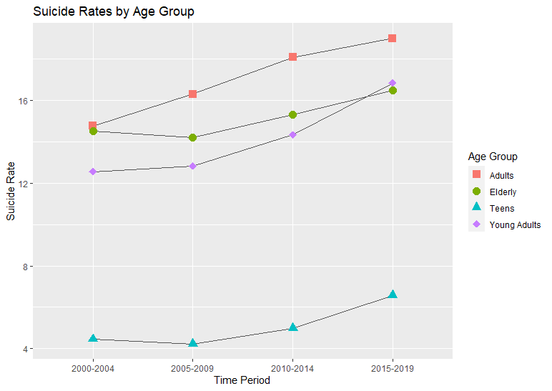

This chart shows our age groups: Teens, Young Adults, Adults, and Elderly. For this analysis, teens are considered ages 10-19, young adults are 20-34, adults are 35-65, and elderly are 65 and older. Since 2000, suicide rates have been rising across all age groups, and spiked for young adults in 2015-2019. That spike inspired further analysis and the introduction of a new variable, urban vs rural.

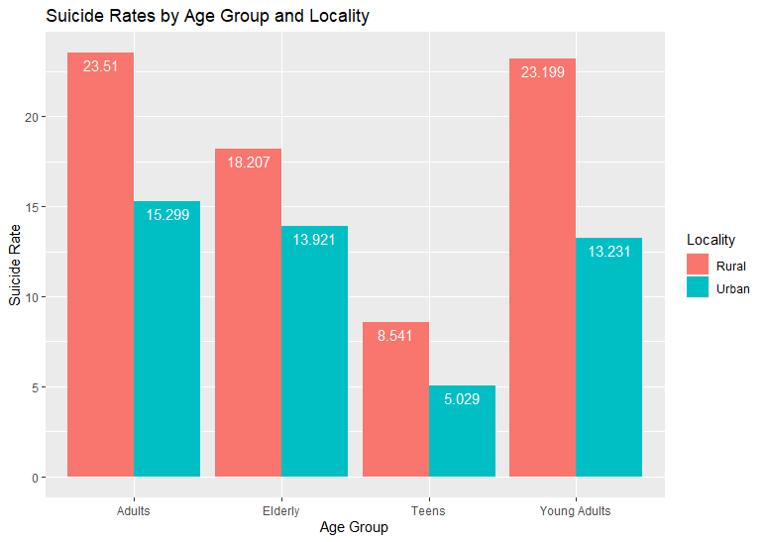

This visualization compares urban and rural locales for all age groups during 2015-2019. The data is clear, rural locales have higher suicide rates than urban ones. For this analysis urban consisted of American Community project region typologies Big Cities (dense and diverse with high incomes, poverty, and crime rates) and Urban Suburbs (educated and densely populated, racially and economically diverse), and rural consisted of Working Class Country (rural, blue-collar America with low income and college graduation rates) and Rural Middle America (mostly white, rural, and with average college graduation rates and income). Descriptions in parentheses are from the American Communities Project.

From this analysis, we can see that mental health outreach efforts should be concentrated in rural areas, with a focus on young adults. Further research and analysis is needed to determine potential causes for the increased suicide rates in young adults, but as a young adult myself, this is a crucial time in our lives and mental health care has never been more important. Over the past few years progress has been made in reducing the stigma around needing and receiving mental health care, but there is still a long way to go, especially in rural communities.