Tweezers Analysis Software v1.03

This program aids in the analysis of data from the tweezers setup. It can either be installed as a standalone or launched in MATLAB from **tweezerStart.m**. Once launched, you are presented with the following screen:

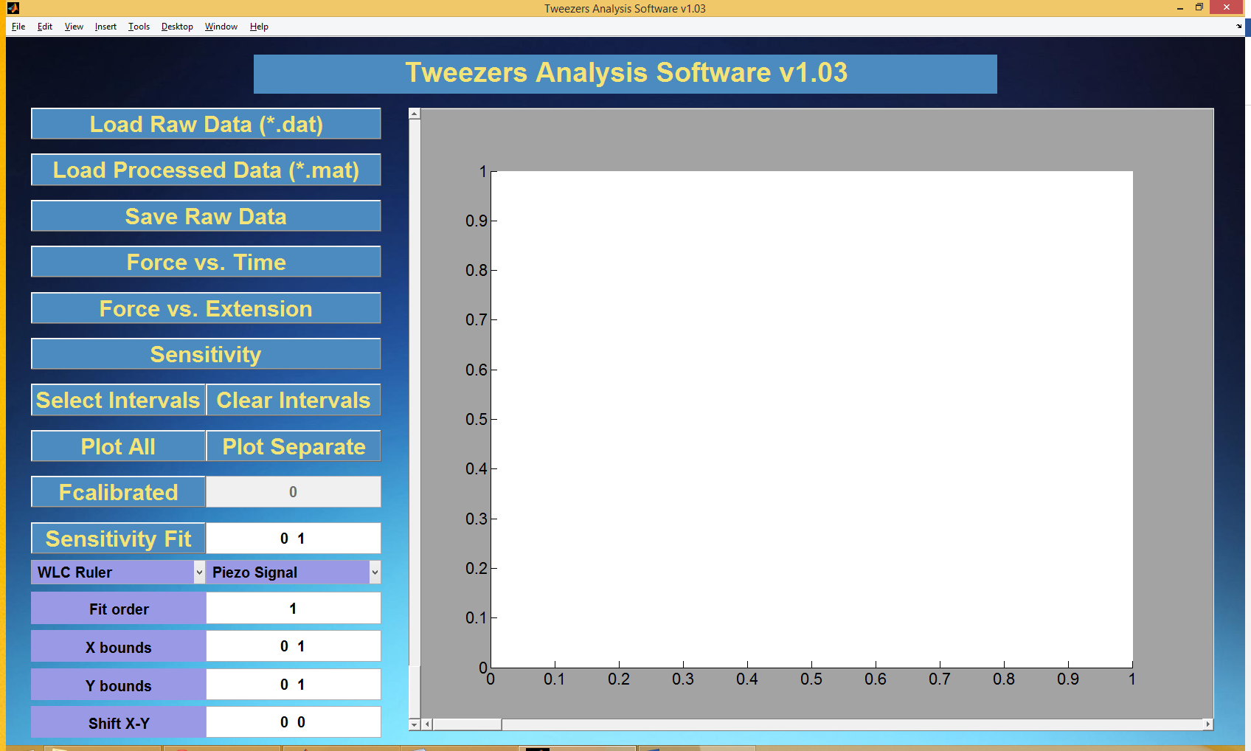

Figure 1: The initial startup screen for the Tweezers Analysis Software

This screen shows on the left side the options for data analysis, and on the right side the axis for plotting your graph of interest.

To start the analysis, either press **Load Raw Data** (in the *.dat format) or previously processed and saved data from the program using **Load Processed Data** (in the *.mat format). If you load raw data, you will also have to specify a path to the comment file, which contains calibrated trap constants. The program will select the last recorded trap constant before the loaded data and up to three trap constants recorded during/after the loaded data. Choose a trap constant and the data will be loaded.

Once loaded, the graph screen will show a **Force vs. Time** graph of the loaded data, generated using the previously chosen trap constant. You can access this graph at any time by pressing the Force vs. Time button. The **X bounds** and **Y bounds** of the graph can be adjusted afterwards by entering their respective minimum and maximum values in the bottom of the screen. This is true for any graph after it is drawn.

By clicking **Select Intervals**, you can select the left and right bounds of for what times you want to plot the Force vs. Extension data. You can finish your selection by pressing enter, or double clicking the last point. By pressing delete, you can delete the previously selected point. If you want to see the Force vs. Extension data for all times, press **Clear Intervals** to clear all previously selected points. By pressing **Select Intervals** a second time, you will also reset the previous selection of points.

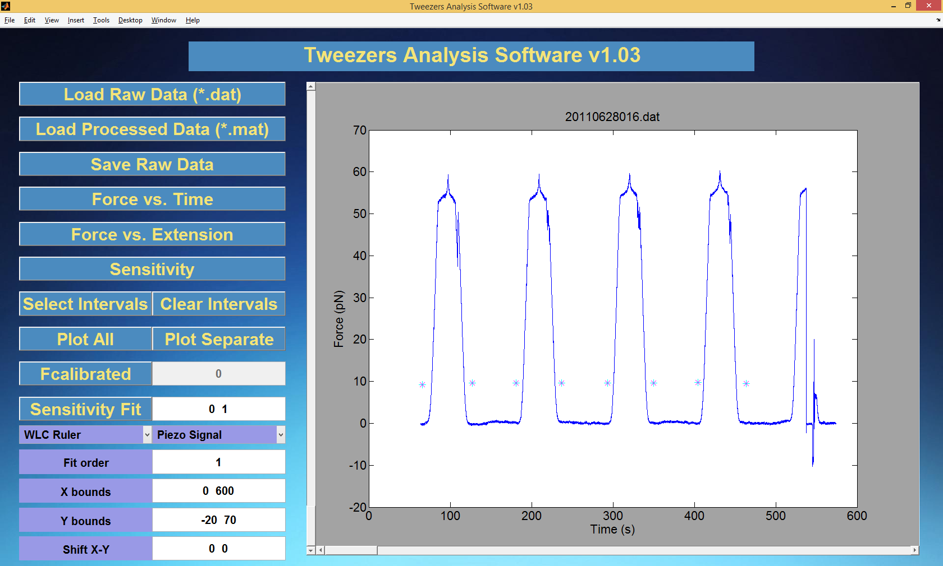

Figure 2: A typical Force vs. Time graph of loaded data. You can see selected intervals from using Select Intervals.

By clicking **Force vs. Extension** the selected Force vs Extension data will be plotted. By default it is plotted together with a **WLC ruler**, this ruler can be adjusted in a drop down menu. Data can be shifted by entering the x and y values (in µm) in **Shift X-Y**, or by dragging the **horizontal** and **vertical** **slider** next to the graph. These sliders update when you release them and will automatically take a range associated with the maximum and minimum value of your data.

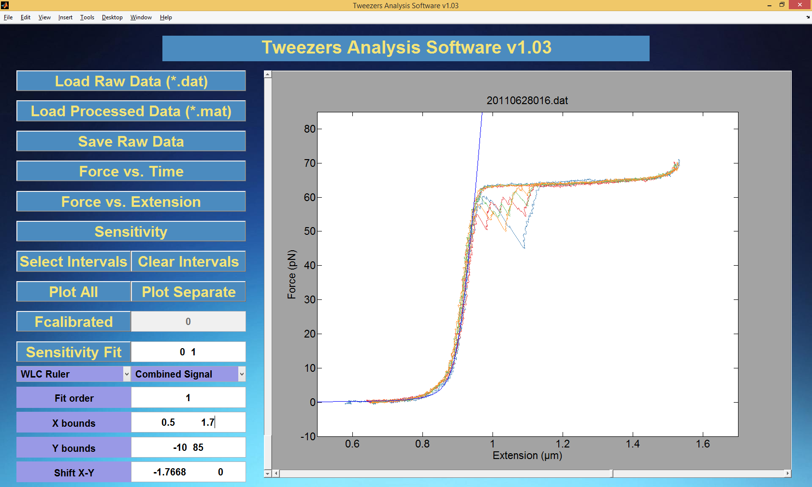

Figure 3: A typical Force vs. Extension graph of loaded data. The WLC ruler is also plotted.

Several other options are available to adjust the data. The first is Fcalibrated/Fnormal, which calculates the force values in two different ways. Fcalibrated calculates the force according to the formula .



Fnormal calculates the force according to the formula .



In these formulas,  is the measured QPD voltage,  the trap constant and the measured sensitivity. The sensitivity can be set in two ways. Either manually by choosing **Sensitivity Value**, or automatically by choosing **Sensitivity Fit**. Sensitivity fit will fit the QPD voltage vs the bead x position for each selected interval with an nth order polynomial. The order can be chosen under **Fit order**. The slope of this fit will be used to

References:

Thesis Peter Vach

Noise calibration Peter Vach