**Software Requirements**

**Specification**

**for**

**Identifying Fake News**

**Version 1.0 approved**

**Marc Anthony Nares**

**Aleo Ralph C. De Leon**

**Wyatt Zues H. Holgado**

# Table of Contents

Table of Contents 2

Revision History 3

1. Introduction 1

1.1 Purpose 1

1.2 Document Conventions 1

1.3 Product Scope 1

2. Overall Description 1

2.1 Product Perspective 1

2.2 Product Functions 2

2.3 Operating Environment, 3

2.4 User Documentation 3

2.5 Assumptions and Dependencies 3

3. External Interface Requirements 3

3.1 User Interfaces 3

3.2 Software Interfaces and Communications Interfaces 3

4. System Features 4

4.1. Identifying Fake News 4

4.2. Reporting a page 4

4.2.1. Description and Priority 4

# Revision History

|  |  |  |  |
| --- | --- | --- | --- |
| **Name** | **Date** | **Reason For Changes** | **Version** |
| Aleo Ralph C. De Leon | 02/02/2018 | Initial draft | 1.0 |
| Aleo Ralph C. De Leon | 03/06/2018 | Final Draft | 2.0 |
| All Members | 03/28/2018 |  |  |

# Introduction

## Purpose

This SRS describes the software functional and nonfunctional requirements for release 1.0 of the Fake News System. This document is intended to be used by the members of the project team that will implement and verify the correct functioning of the system. Unless otherwise noted, all requirements specified here are high priority and committed for release 1.0.

## Document Conventions

The Fake News System will permit Process Impact employees to order meals from the company cafeteria on-line to be delivered to specified campus locations. A detailed project description is available in the Cafeteria Ordering System Vision and Scope Document [1]. The section in that document titled “Scope of Initial and Subsequent Releases” lists the features that are scheduled for full or partial implementation in this release.

## Product Scope

The Fake News System will help social media users to prevent from being tricked by fake news. A detailed project description is available in the Project System Vision and Scope Document. The section in that document titled “Scope of Initial and Subsequent Releases” lists the features that are scheduled for full or partial implementation in this release.

# Overall Description

## Product Perspective

There are many projects which we take it as our reference regarding in Identifying fake news. A lot of fake news identifier is scattering over the internet but the method and how they identify is unknown. Our project is using 3 different known credible sources of fake news links to identify websites that contain false information.

## Product Functions

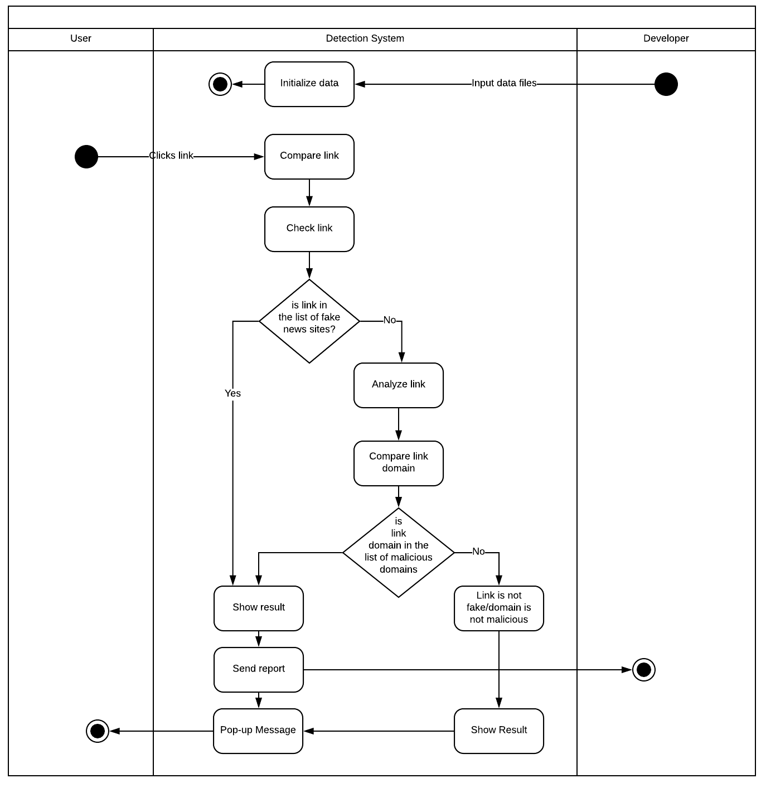The extension will be available in chrome web store anyone can download it. Once the extension is installed it will automatically detect links on user mouse click. Below is the activity diagram for the project.

## Operating Environment,

* OE1- The Fake news identifier system shall operate on the latest Google Chrome Browser.
* OE2- The system shall function even if it’s offline

## User Documentation

* UD1- The system shall start after the user finished installing the extension
* UD2- The system shall start identifying fake news once the user clicks a link
* UD3- The system shall generate a report to the developers of the project

## Assumptions and Dependencies

* AS1- The system shall not be affected by other web plugins
* DE1- The speed of identifying fake news links depends on the load of page

# External Interface Requirements

## User Interfaces

* UI1- The system shall alert the user if fake news is detected
* UI2- The system shall report the page automatically

## Software Interfaces and Communications Interfaces

* SI1- The system shall send the reports from the user to developer’s database
* CI1- The system shall generate a report to the developers about the links that are fake but not have been tagged.

# System Features

# Identifying Fake News

* + 1. **Description and Priority**

The system will identify fake news if a user clicked a link in social media. Priority = High

* + 1. **Stimulus/Response Sequences**

Stimulus: User clicks a link

Response: System will start to identify if it’s a fake news

* + 1. **Functional Requirements**

REQ-1: A link must be clicked first for the system to start identifying fake news

REQ-2: A user must have internet connection

## Reporting a page

## Description and Priority

If a user reported a page the system will generate a report to the developers. Priority = HIGH

* + 1. **Stimulus/Response Sequences**

Stimulus: User reports a link

Response: System will send a report to the developers

* + 1. **Functional Requirements**

REQ-1: User must report a link to send a report to the developers

REQ-2: User must have internet connection to send the report to the developers