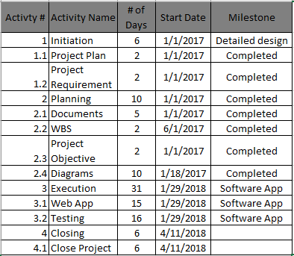**Activity List**

This is a document provides a detailed description all the scheduled activities for this project.

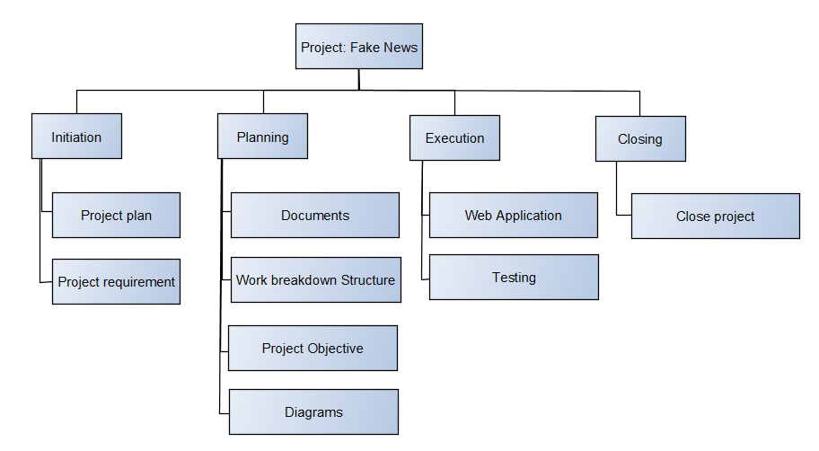**Work Breakdown Structure**

This structure is a hierarchical and incremental decomposition of the project into phases.