

Asia Pacific College

School of Computing and Information Technologies

Magallanes, Makati City

**IDENTIFYING FAKE NEWS**

Project Documentation Submitted

To the Faculty of School of

Computing and Information Technologies

Of

Asia Pacific College

By

Marc Anthony Nares

Aleo De Leon

Wyatt Holgado

BSCS-SS / SS152

To

Dr. Manuel Calimlim

**Contents**

Abstract 3

I. Project Overview 4

A. Project Context 4

B. Purpose and Description 4

C. Objectives 5

3. Scope and Limitations 5

4. Assumptions, Constraints, and Risks 6

5. Project Deliverables 7

II. Project Organization 7

A. Internal Structures 7

B. Roles and Responsibilities 8

III. Managerial Process Plan 8

A. Start-up Plan 8

B. Work Plan 14

C. Project Tracking Plan 18

IV. Quality Management Plan 20

V. Human Resource Management Plan 21

A. Roles and Responsibilities 21

VI. Risk Management Plan 22

A. Risk Management Strategy 22

B. Risk Analysis Summary 23

C. Risk Response Summary 24

VII. Conclusions and Recommendations 26

VIII. Screenshot 27

IX. References 28

# Abstract

The fake news identifier extension aims to inform online users whether a web article is fake or not. It is a web application that determines whether an article is fake base on the URL, Title and Content of the web page. This document will provide the objective of this project and how it will be solved. This will also look after the time and investment which will involve under entire development work such as analysis, system design, coding, testing and maintenance work. The entire detailed plan of this project will also be provided.

KEYWORDS: Fake news, Project Management

## I. Project Overview

### Project Context

Fake news is a deliberate misinformation or hoax that spreads via traditional print, broadcast news media or online social media (Novotny, 2017). It misleads people and makes the world less informed. It harms the community and the industry at an alarming level (Stecula, n.d.). A secretary of the Presidential Communications Operations Office (PCOO) shared a post of a Duterte supporter which claimed that a young girl was murdered due to the drug problem in the Philippines. She was reportedly outraged as to why the Commission on Human Rights didn’t focus on the incident. However, the link showed a photo of a nine-year-old Brazilian girl who was raped and murdered in 2014. BBC called her on it and she later took down the post (ARIAS, 2017). This project will identify fake news based on the link of the web article, the content of the page and the title. With the way on how fake news is spreading, it would be ideal to have an application that will help identify fake news online.

### Purpose and Description

Fake news is a news article that gives false information intentionally and could mislead readers. It was created for the purpose of making political gains, harming the reputation of businesses, increasing advertising revenues by creating a clickbait headlines, and the intention of getting huge amount of attention. The purpose of this project is to let online users know whether a news article may contain false information. The proposed solution for the project is to create a web extension that will inform the user if the said article is contains false information.

### Objectives

The objectives of this study are:

1. To inform online users about fake news.
2. To create a web extension that can identify whether a link clicked by a user leads to a fake news article or not.

### Scope and Limitations

The study is about identifying fake news. The researchers will use web programming languages to create a web extension for identifying fake news. The gathered datasets will come from two online websites (kaggle.com,Opensources). The web extension will only work on the latest and upcoming versions Google Chrome and it will not work on any other browsers.

This study is only limited in identifying fake news on social media sites and it will not identify fake news on other sites.

### Assumptions, Constraints, and Risks

In this table, shows the description for assumptions, constraints, and risks. It also explains the process that could cause the impact for the project to trigger those risks, either in execution or expected results.

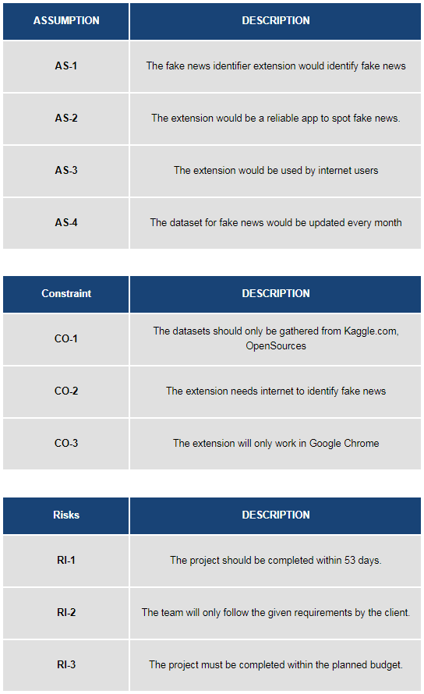

### Project Deliverables

The time and delivery method needed for the project deliverables to accomplish.

## II. Project Organization

This chart is designed to define the project organization chart, the roles, and the relationships of the project team

### Internal Structures

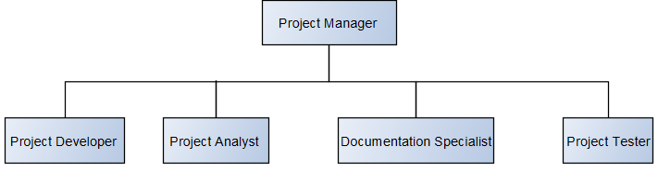

### Roles and Responsibilities

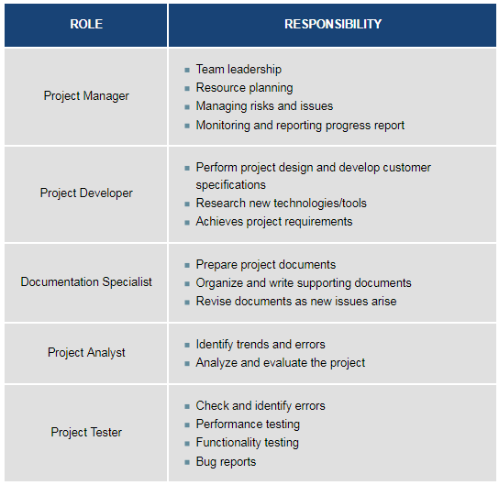

## III. Managerial Process Plan

This plan defines the goal for company’s future direction and determining the missions of the project. This will also tackle the resources needed to achieve the goal.

### A. Start-up Plan

#### 1.Fish-bone Diagram

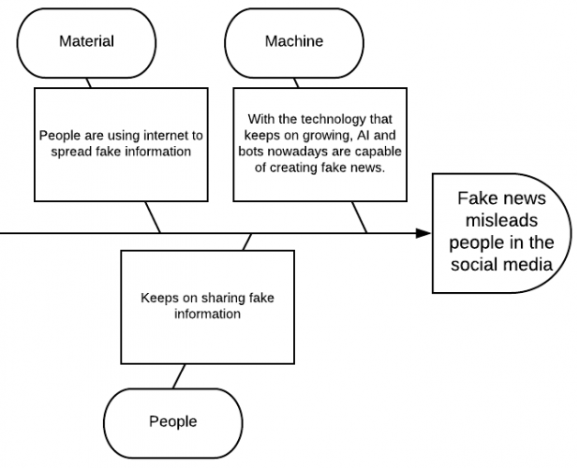

#### Five Whys

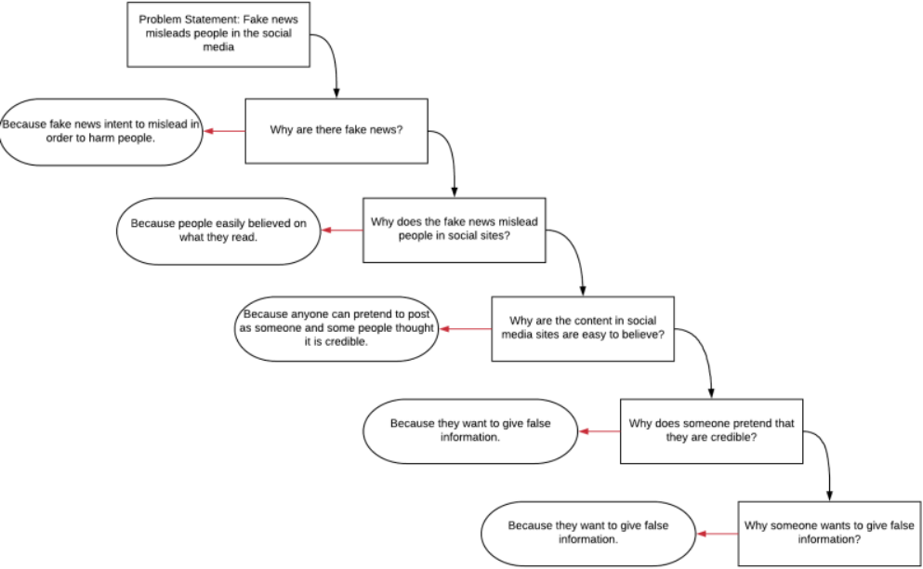

#### Estimates

This involved the approximation cost of project costs, duration, participants, and the task needed for the project.

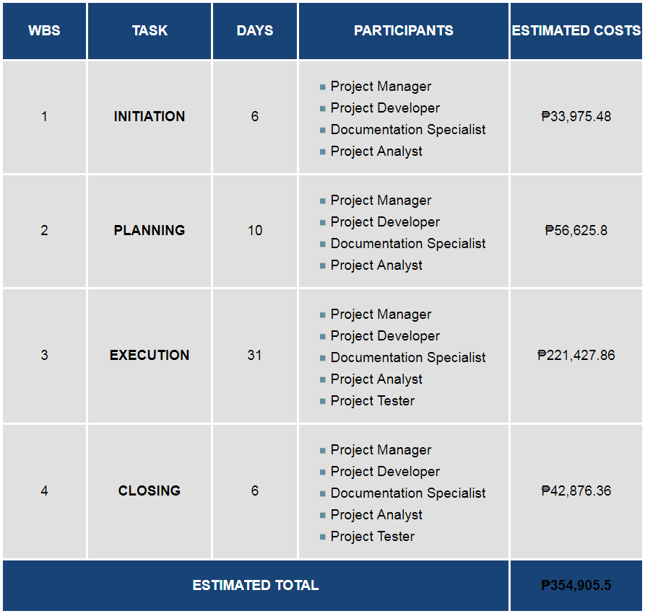

*Based on Project Manager, Information Technology (IT) Salary (PH) from payscale.com

*Based on Documentation Specialist Salary (PH) from payscale.com

*Based on Web Designer & Developer Salary (PH) from payscale.com

*Based on Project Analyst Salary (PH) from payscale.com

#### Staffing

This involved the requirement needed to hire for a certain role. Effective staffing is essential to ensure the workplace runs smoothly and efficiently, and that the right employees are in the right positions.

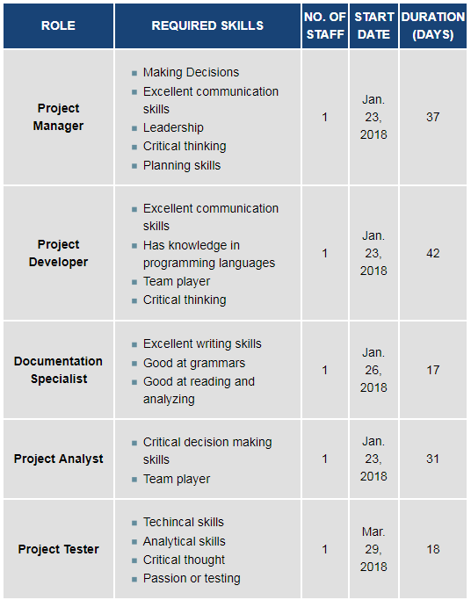

#### Procurement Plan

This is the process of deciding what to buy, and from what source. The procurement method is assigned and the expectations for fulfillment of procurement requirements determined.

Table 1

*Based on Project Manager, Information Technology (IT) Salary (PH) from payscale.com

*Based on Documentation Specialist Salary (PH) from payscale.com

*Based on Web Designer & Developer Salary (PH) from payscale.com

*Based on Project Analyst Salary (PH) from payscale.com

Table 2

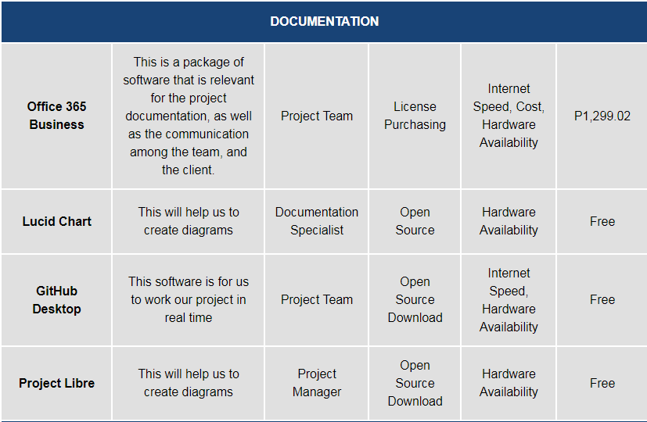

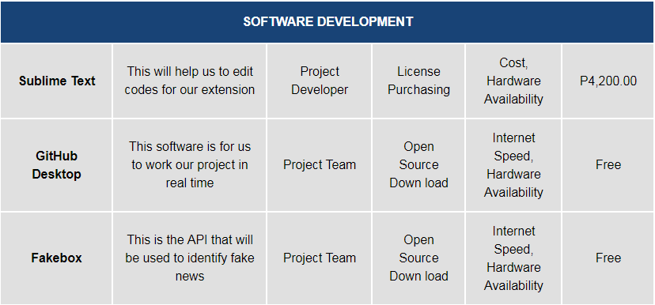

### B. Work Plan

#### Work Breakdown Structure

A deliverable needed to organize the project team’s work into a four sections of management plan.

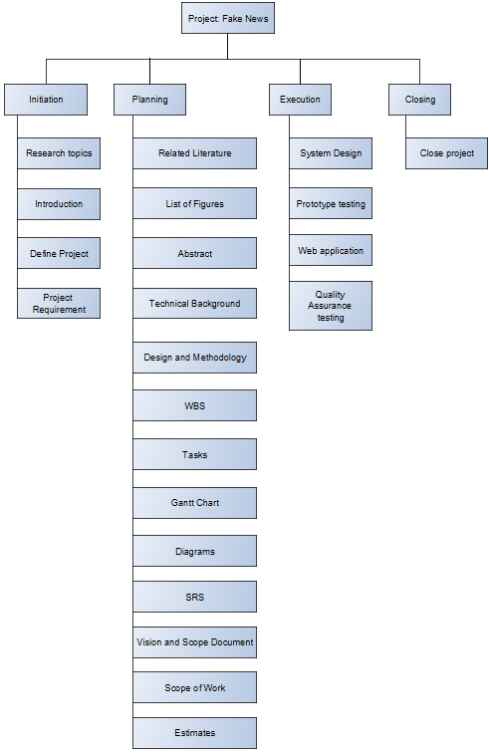

#### Budget Allocation

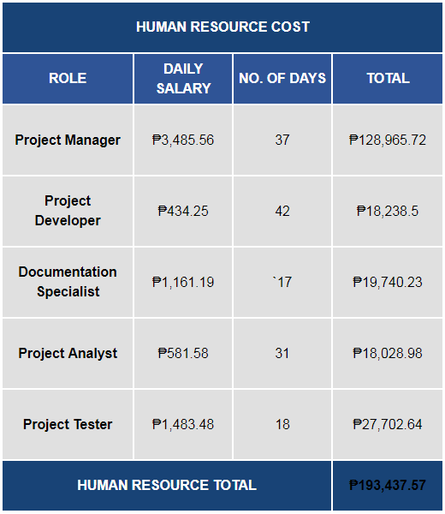

*Based on Project Manager, Information Technology (IT) Salary (PH) from payscale.com

*Based on Documentation Specialist Salary (PH) from payscale.com

*Based on Web Designer & Developer Salary (PH) from payscale.com

*Based on Project Analyst Salary (PH) from payscale.com

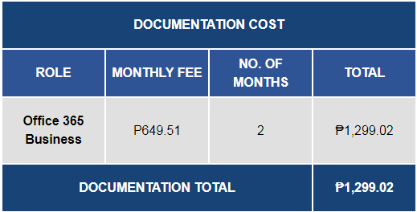

*Based on Microsoft Office 365 monthly fee of P649.51 per user from office365.com

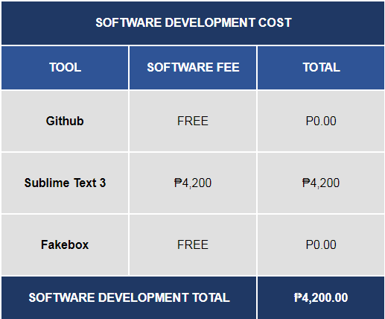

*Based on github.com, sublimetext.com/buy and machinebox.io

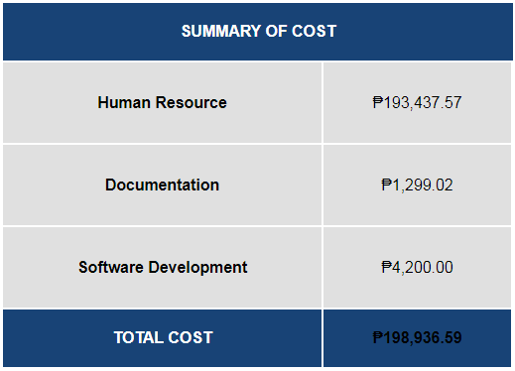

#### Contingency Plan

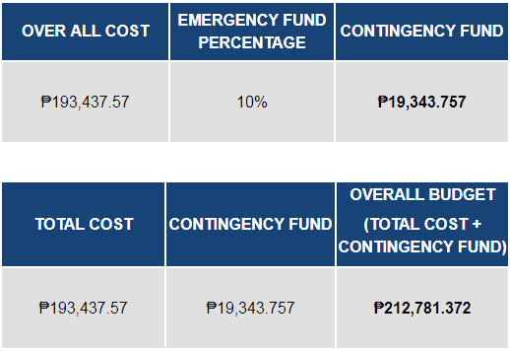

### Project Tracking Plan

#### Requirements Management

Managing, prioritizing, analyzing and tracking of the requirements to effectively manage also the focus and objectives of the project.

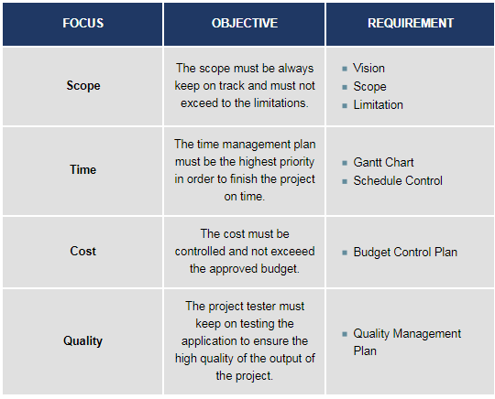

#### Schedule Control

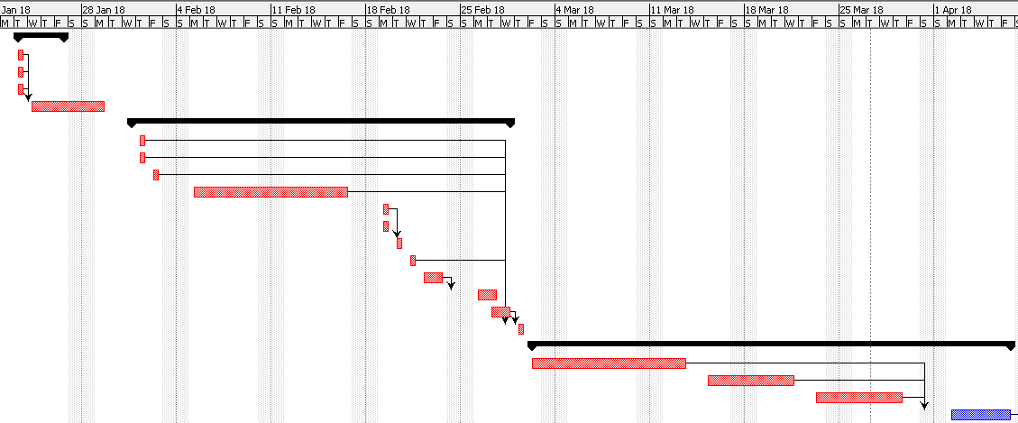

#### Communications Plan

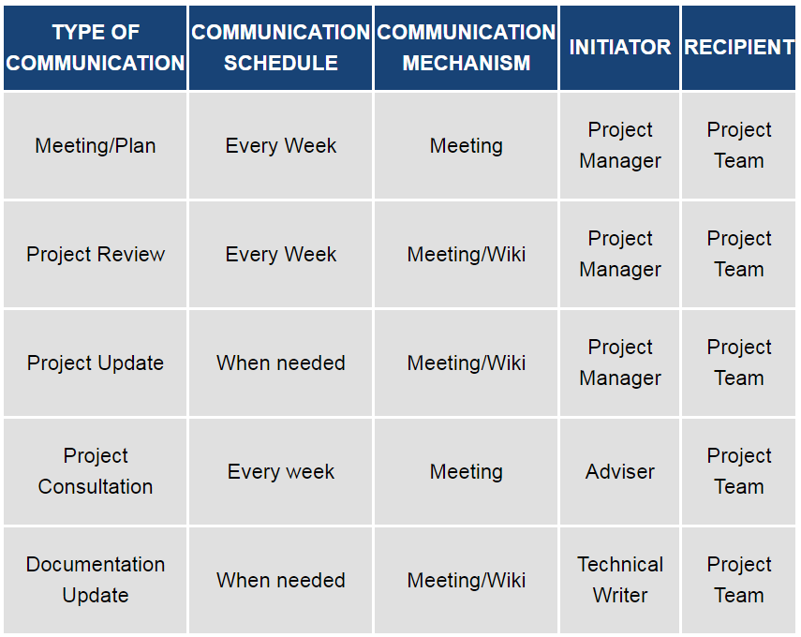

## IV. Quality Management Plan

The quality management plan of Identifying Fake News will focus on the process and procedures for ensuring quality of the Identifying Fake News in terms of monitoring the project during the testing process.

The purpose of this plan is to:

* Ensure high quality output of the project.

-To assure the quality of the system there will be numerous types of testing that will be done by software testers.

* Define the quality objectives of the project

## V. Human Resource Management Plan

The Human Resource Management Plan allows the researchers, project manager and members to classify and understand the roles and responsibilities of each project team member. The role of this plan is to recognize the roles and responsibilities of the different positions and skills needed for the project. The purpose of the Human Resources Management Plan is to ensure that the project has the correct human resources with the right set of skills to finish the project.

This will guarantee the value and effectiveness of assigning tasks or activities to each team member in order to complete the project requirements and deliverables.

### Roles and Responsibilities



## VI. Risk Management Plan

### Risk Management Strategy

**1. Risk Identification Process**

The team must identify, define the risks. To evaluate each risk that will carry out the project implementation to success. By identifying risks, the team will determine how the risks will affect the project plan, implementation and execution. For every risk, the team will prepare a solution that will decrease the chance of triggering it.

**2. Risk Evaluation and Prioritization**

The team will estimate how the risks will delay the project management plan to execution plan. The team will prioritize on preparing the web extension application for more risks like bugs, security, compatibility and interface.

**3. Risk Mitigation Options**

The team will develop a risk mitigation plan and quality plan will focus on the process and procedures for ensuring quality and risks of Identifying Fake News project in terms of monitoring during the testing process.

**4. Risk Plan Maintenance**

To assure the methods for maintaining or updating the risk plan of the project there will be numerous types of testing that will be done by software testers to ensure the high quality of the output of the project.

### Risk Analysis Summary

The team provided six risks including their corresponding impact level and time frame based on the overall possessed impact description of the risk.

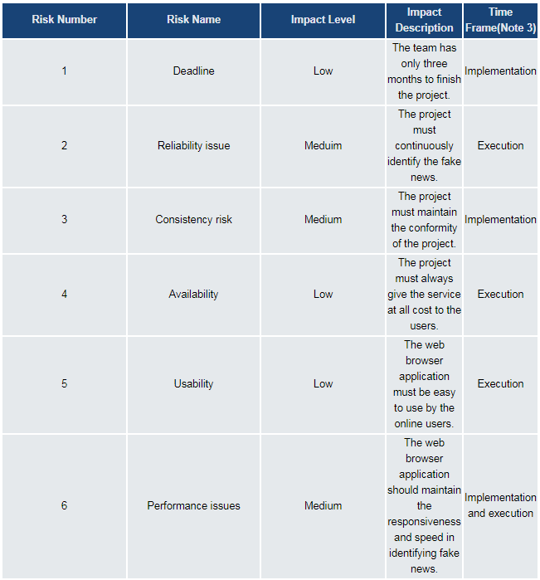

*Low = Low impact level/priority

*Medium = Meduim level/ priority

*High = High level/ priority

### Risk Response Summary

The team based the risk priority on the impact level of the risk analysis summary.

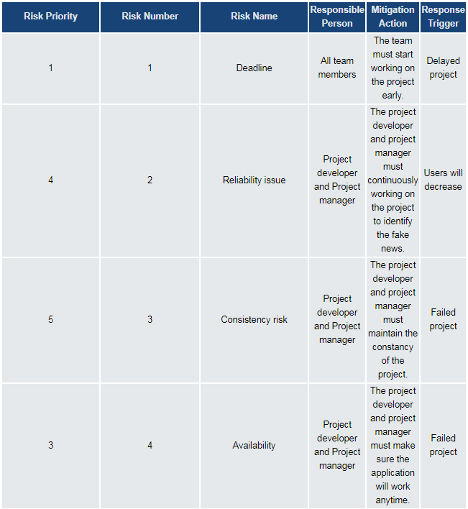Table 1

Table 2

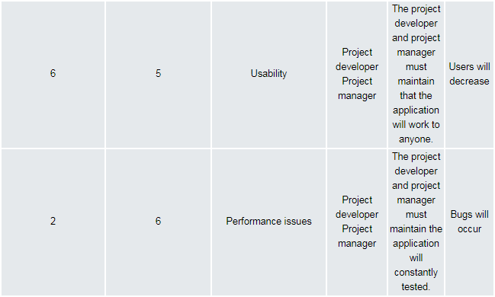

## VII. Conclusions and Recommendations

Fake news can be lessened or better yet eliminated, since people keep falling prey for such posts; it needs to be stopped. This paper is meant to do just that; the program we are proposing is meant to detect if the news posted in your social media websites, which would literally get marked as a fake if it is one. To identify fake news, one must check URL. This program will be a plugin for the users’ internet browsers, but will only work for social media sites, and will not detect if posted news are fake from other websites. If this program could be implemented, there will definitely be a big change in how news would be spread, since users will no longer fall for faulty news articles and posts. This extension will also help users from falling to a phishing sites. For the basis for costing and several details, we gathered the information from the reliable sources about the average costing in the Philippines and we estimated it. For example, the researchers used the average costing for project manager, web developer, and document specialist and divided it for 12 months and divided it again by 22 working days then multiplied it by the number of days.

To help increase the accuracy of the extension, the researchers recommend adding more features for classifying data and to work not only in chrome but also on other browsers.

## VIII. Screenshot

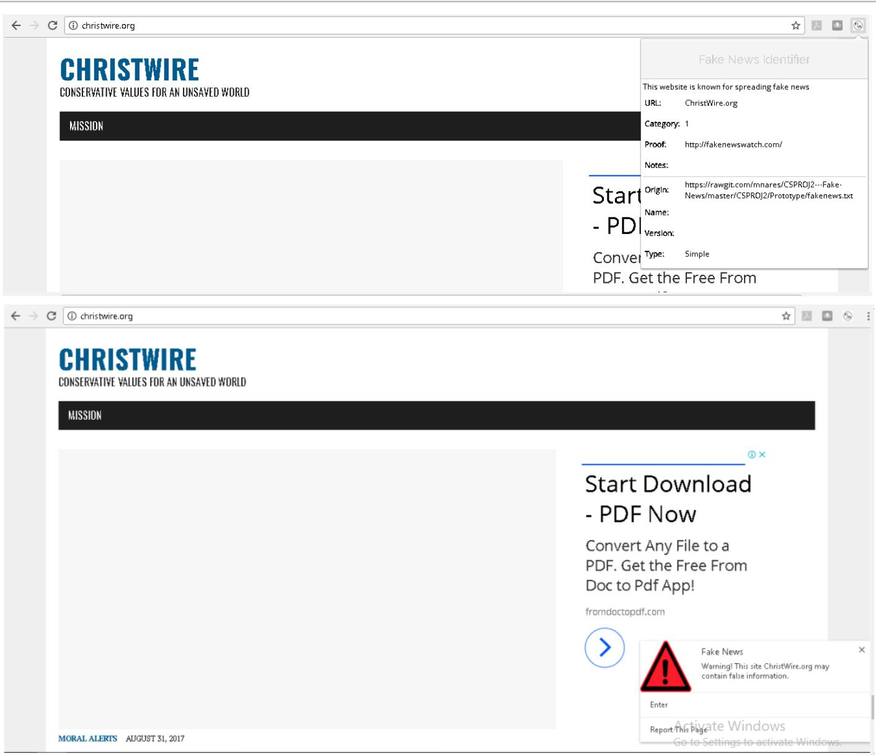

## IX. References

ARIAS, J. (2017, October 4). Inquirer.net. Retrieved from Preen:

http://preen.inquirer.net/58185/a - list-of-mocha-usons-fake-news-posts

Baljit Singh Saini, A. B. (n.d.). A Review of Bot Protection using CAPTCHA for Web Security.

IOSR Journal of Computer Engineering.

Bisson, D. (2015, September 13). The State of Security. Retrieved from tripwire: https://www.tripwire.com/state-of-security/security-data-protection/cyber-security/most-suspicious-tlds-revealed-by-blue-coat-systems/

Dezyre. (2017, June 20). Retrieved from dezyre:

https://www.dezyre.com/article/top-10-machine-learning-algorithms/202

Eugene Kiely, L. R. (2016, November 18). FactCheck .org. Retrieved

from

http://www.factcheck.org/2016/11/how -to-s pot-fake-news/ Google. (n.d.). Retrieved from Google reCAPTCHA: https://www.google.com/recaptcha/intro/android.htm l Greg. (2017, January 24). yhat. Retrieved from yhat:

http://blog.yhat.com/posts/why - support-vector-machine.html

Howell, J. (n.d.). Research Gate. Retrieved from Research Gate: https://www.researchgate.net/scientific

contributions/10074391_Jon_Howell IBM. (n.d.). Retrieved from IBM knowledge center:

https://www.ibm.com/support/knowledgecenter/en/SS3RA7_15.

0.0/com.ibm.spss.modeler.help/s vm_howwork.htm Machine Learning 101. (n.d.). Retrieved from Medium:

https://medium.com/machine-learning-101/chapter-2-svm -support - vector-machine-theory-f0812effc72

Mark Verstraete1, D. E. (n.d.). Identifying and Countering fak e news. Retrieved from https://webcache.googleusercontent.com/search?q=cache:JZsN3vbXxE4J:https://law.a rizona.edu/sites/default/files/asset/document/fakenewsfinal.pdf+&cd=2&hl=en&ct =clnk&gl=ph

McIntire, G. (n.d.). Machine Learning Finds “Fak e News” with 88% Accuracy. Retrieved from KDnugget: http://www.kdnuggets.com/2017/04/machine -learning-fake-news-accuracy.html

Media Insight Project. (2016, March 17). American Express Institute. Retrieved from https://www.americanpressinstitute.org/publications/reports/survey -research/trust-news/

Novotny, E. (2017, August 1). PennState. Retrieved from libraries.

Opensources. (n.d.). Retrieved from OpenSources: http://www.opensources.co/

Palmisano, S. (2016, December 29). EagleNews. Retrieved from eaglenews:

htp://eaglenews.org/opinion/fake-news-leads-to-real-problems/

Patag, K. J. (2017, October 4). Phil Star Global. Retrieved from Phil Star Global: http://www.philstar.com/headlines/2017/10/04/1745491/no -govt-agency-monitoring-fake-news-social-media-nbi-exec-says

Rappler. (2017, April 10). Retrieved from http://www.rappler.com/technology/social - media/166326-how-to-spot-fake-news-facebook

Sathyanarayana, S. V. (n.d.). Data classification using Support vector. Data classification using Support vector.

stack exchange. (n.d.). Retrieved from crossvalidated:

https://stats.stackexchange.com/questions/23391/how-does-a-support-vector-machine-s vm -work

Stack exchange. (n.d.). Retrieved from ComputerScience: https://cs.stackexchange.com/questions/10304/which-classifier-is-more-accurate-for-a-s vm-classification

Stecula, D. (n.d.). The conversation. Retrieved from theconversation: http://theconversation.com/the -real -

consequences-

of-fake-news-81179

Zimdars, M. (n.d.). Opensources. Retrieved from Opensources.co: <http://www.opensources.co/> Giovanni, C.(Feb. 2017)

educated.Retrieved from: <https://www.japantimes.co.jp/news/2017/02/07/business/facebook-google-testing-apps-spot-fake-news-experts-say-key-educated/#.WlM6JlWWZpg>and <http://technology.inquirer.net/58483/fighting-fake-news-isnt-just-facebook-google>

Fillipo, M. (Dec. 2016) Indiana University researchers launch tool to understand spread of fake news. Retrieved from: <http://archive.news.indiana.edu/releases/iu/2016/12/iu-hoaxy.shtml>

PayScale.com. Project Manager, Information Technology (IT) Salary (Philippines). Retrieved from: https://www.payscale.com/research/PH/Job=Project_Manager%2C_Information_Technology_(IT)/Salary

PayScale.com. Documentation Specialist Salary (Philippines). Retrieved from: https://www.payscale.com/research/PH/Job=Documentation_Specialist/Salary

PayScale.com. Web Designer & Developer with PHP Skills Salary (Philippines). Retrieved from: https://www.payscale.com/research/PH/Job=Web_Designer_%26_Developer/Salary

PayScale.com. Project Analyst Salary. Retrieved from: https://www.payscale.com/research/PH/Job=Project_Analyst/Salary

Office365.com. Office 365 business premium. Retrieved from: https://www.microsoft.com/en-us/store/b/office365