**MODULE NAME**: Automated Middleman for Online Transactions

**AUTHOR**: De Leon, Aleo Ralph

Holgado, Wyatt Zeus

Nares, Marc Anthony

# 1. Version History

|  |  |  |  |
| --- | --- | --- | --- |
| **Author** | **Date** | **Version** | **Changes** |
| De Leon, Aleo Ralph  Holgado, Wyatt Zeus  Nares, Marc Anthony | July 7, 2018 | 1.0 | Initial Business Requirements Document (BRD) creation |
| De Leon, Aleo Ralph | July 15, 2018 | 1.1 | Revised BRD – added more Use Cases, Detailed Business Requirements (DBR) and screenshots for the new UI look and feel. |

**2. Overview Description**:

This document is a Specific Business Requirement Document (BRD) for the Online Buyers & Sellers Automated Middleman System. This system will provide the following feature and service payment gateway & transaction method, profile verification, login and sign up.

## 2.1 Scope-Purpose

The purpose of this application is to help online buyers and sellers to transact safely. Using automated middleman website application, scammers will be lessen. Transacting online will be less hassle and more convenient. Our project will be limited to a website application only and will focus in handling of payment and item of the buyers and sellers.

.

High level features include:

* ability to signup/login to the website by both buyer and seller
* ability to verify the seller’s credibility by the buyer
* ability to give comments, feedbacks, ratings to the seller by the buyer
* ability to manage payment and transaction methods of the buyer and seller
* ability to choose either buyer or seller

## 2.2 Background

A middleman is a person who arranges deals between other people. A middleman will receive and hold the buyer’s currency and will only be released to the seller once the buyer approves that he received the item. This application will help the buyers and sellers to transact online much safer and easier. This application will be automated unlike the traditional 3rd party person which is doubtful and sometimes lead to a fraud.

## 2.3 Objective

* To prevent being defraud by a middleman
* To provide a secured online transaction
* To make middleman transactions faster

## 2.4 Impacted User activities

* Users can create an account and can choose either he/she is a buyer or seller
* Users can login to the website homepage
* Users can check the credibility of the seller by its profile
* Users can give comments, feedbacks, ratings to the sellers’ profile
* Users can choose what type of payment and transaction method

## 2.5 Business Requirements

### 2.5.1 Sign Up/ Login

* The user can create an account, signup, log in and edit their user profiles

### 2.5.2 Profile Verification

* The user can review the other user’s profile so they can verify the seller or buyer’s credibility.

### 2.5.3 Giving comments, feedbacks, and ratings

* The user should also be able to give comments, feedbacks and ratings to the seller and buyer’s profile.

**2.5.4 Managing payments and transactions**

* The user can manage their payments and transaction methods safely.

## 2.6 Use Case/User Stories

**Use Case #1**

**Scenario:** The user wants to register

**Level**: User goal

**Primary Actor**: Buyer/Seller

**Stakeholders and Interest**:

**Preconditions**: The user must have access to the internet and the website.

**Post conditions**: The user should be able to login

Basic Flow:

1. Access to internet and website

2. Create username and password

3. Input personal details

4. Verify email

**Use Case #2**

**Scenario**: The user wants to buy an item

**Level**: User goal

**Primary Actor**: Buyer

**Stakeholders and Interest**:

**Preconditions**: The user must have an account and the details of the item

**Post conditions**: The user should be able to buy the item in the list

Basic Flow:

1. The buyer will search for an item

2. The buyer will choose his/her desired item

3. Then click buy

4. Wait for the seller’s verification

**Use Case #3**

**Scenario**: The user wants to sell an item

**Level**: User goal

**Primary Actor**: Seller

**Stakeholders and Interest**:

**Preconditions**: The seller must have an account and the details of the item

**Post conditions**: The seller should be able to add the item in the list

Basic Flow:

1. The seller will add the item that he/she wants to sell

2. The seller will add details about the item

3. Wait for the verification

4. End of use case

**Use Case #4**

**Scenario**: The buyer wants to choose his or her desired payment method

**Level**: User goal

**Primary Actor**: Buyer

**Stakeholders and Interest**:

**Preconditions**: The buyer must have an account

**Post conditions**: The buyer should be able to choose any of the payment method

Basic Flow:

1. The buyer will choose his/her desired item.

2. The/buyer will choose any of the method of payments

3. Wait for the verification

4. End of use case

**Use Case #5**

**Scenario**: The system will hold the items and the payment

**Level**: System goal

**Primary Actor**: System

**Stakeholders and Interest**:

**Preconditions**: The seller/buyer must have verified account

**Post conditions**: The system should be able to hold both of the seller/buyer/s items and payments

Basic Flow:

1. The system will verify the seller/buyer’s account

2. The system will hold the items and payments

3. End of use case

**Use Case #6**

**Scenario**: The system will verify the items

**Level**: User goal

**Primary Actor**: Buyer

**Stakeholders and Interest**:

**Preconditions**: The seller/buyer must have a verified account

**Post conditions**: The system should be able to verify the items

Basic Flow:

1. The system will verify the seller/buyer’s account

2. The system will then verify the items

3. End of use case

# 2.7 Use Case Diagram

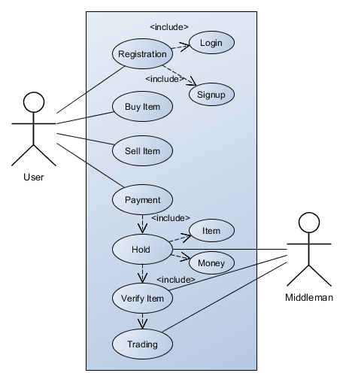

# 2.8 Wireframes

