**MODULE NAME**: Automated Middleman

**AUTHOR**: De Leon, Aleo Ralph

Holgado, Wyatt Zeus

Nares, Marc Anthony

# 1. Version History

|  |  |  |  |
| --- | --- | --- | --- |
| **Author** | **Date** | **Version** | **Changes** |
| De Leon, Aleo Ralph  Holgado, Wyatt Zeus  Nares, Marc Anthony | July 7, 2018 | 1.0 | Initial Business Requirements Document (BRD) creation |
|  |  | 1.1 | Revised BRD – added more Use Cases, Detailed Business Requirements (DBR) and screenshots for the new UI look and feel. |

**2. Overview Description**:

This document is a Specific Business Requirement Document (BRD) for the Online Buyers & Sellers Automated Middleman System. This system will provide the following feature and service payment gateway & transaction method, profile verification, login and sign up.

## 2.1 Scope-Purpose

The purpose of this application is to help online buyers and sellers to transact safely. Using automated middleman website application, scammers will be lessen. Transacting online will be less hassle and more convenient. Our project will be limited to a website application only and will focus in handling of payment and item of the buyers and sellers.

.

High level features include:

* ability to signup/login to the website
* ability to verify the seller’s credibility
* ability to give comments, feedbacks, ratings to the seller
* ability to manage payment and transaction methods of the users
* ability to choose either buyer or seller

## 2.2 Background

## 2.3 Objective

## 2.4 Impacted User activities

## 

* Users can create an account and can choose either he/she is a buyer or seller
* Users can login to the website homepage
* Users can check the credibility of the seller by its profile
* Users can give comments, feedbacks, ratings to the sellers’ profile
* Users can choose what type of payment and transaction method

## 2.5 Business Requirements

### 2.5.1 Sign Up/ Login

* The user can create an account, signup, log in and edit their user profiles

### 2.5.2 Profile Verification

* The user can review the other user’s profile so they can verify the seller or buyer’s credibility.

### 2.5.3 Giving comments, feedbacks, and ratings

* The user should also be able to give comments, feedbacks and ratings to the seller and buyer’s profile.

**2.5.4 Managing payments and transactions**

* The user can manage their payments and transaction methods safely.

## 2.6 Use Case/User Stories

**Use Case #1**

**Scenario:** The user wants to register

**Level**:

**Primary Actor**: User

**Stakeholders and Interest**:

**Preconditions**: The user must have an access to the internet and the website.

**Post conditions**: The user should be able to login

Basic Flow:

1. Access to internet and website

2. Create username and password

3. Input personal details

4. Verify email

**Use Case #2**

**Scenario**: The user wants to buy an item

**Level**:

**Primary Actor**: User

**Stakeholders and Interest**:

**Preconditions**: The user must have an account and the details of the item

**Post conditions**: The user should be able to buy the item in the list

Basic Flow:

1. The user will search for an item

2. The user will choose his/her desired item

3. Then click buy

4. Wait for the seller’s verification

# 2.7 Use Case Diagram

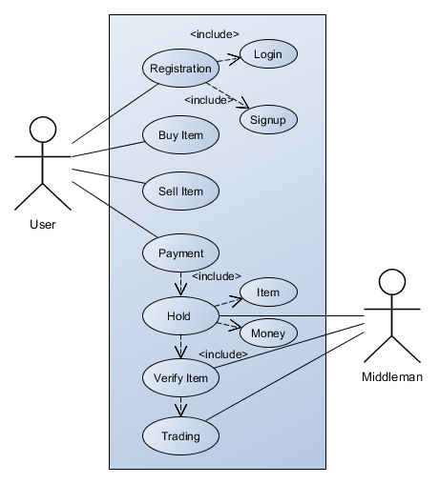

# 2.8 Wireframes

